The effects of drought and grazing pressure on the physiology and morphology of the protégé species A. cytisoides in South-east Spain.

Kasper Eising k.eising.1@student.rug.nl

Supervisors:
Dr. ir. C. Smit MSc M. Verwijmeren
Assistant Professor PhD Candidate
Community and Conservation Ecology group Environmental Sciences
Centre for Ecological and Evolutionary Studies Copernicus Institute of Sustainable Development
University of Groningen Utrecht University

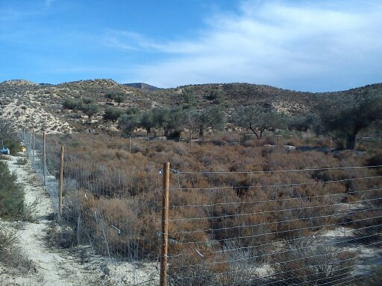

Table of contents
1. Abstract 3
2. Introduction 4
2.1. Interaction shifts and its causes 4
2.2. Application of the SGH on Mediterranean plant communities 5
3. Methods 6
3.1. Study area 6
3.2. Study design 6
3.3. Physiological measurements 7
3.4. Morphological measurements 7
3.5. Data analysis 8
4. Results 8
4.1. Physiological measurements 8
4.2. Morphological measurements 10
5. Discussion 14
6. References 17
7. Appendix 19

- Abstract
Climate models predict a decrease in precipitation and prolonged dry seasons in large parts of the Mediterranean. Combined with grazing pressure these prolonged dry seasons impose high levels of stress on plant communities within arid ecosystems. This stress may cause loss of biodiversity due to a lack of adaptability within plant species. Interspecific facilitation may increase the sustainability of these communities. However, high stress levels may induce competition as well. The phenological and physiological changes that these interactions cause under such conditions, may provide useful information on the evolutionary development of plant communities.
To determine these phenological and physiological changes we conducted a field experiment on the morphology and physiology of a protégé species. We tested this effect using the protégé species Anthyllis cytisoides and a facilitating species Artemisia barrelieri. Furthermore, a combination of treatments was applied using different grazing intensities, additional water and presence of a nurse to examine the physiological and phenological alterations of the protégé.
From these treatments we found that protégé plants get a significant temporal boost in water and nitrogen content as a consequence of adding water. Grazing pressure and presence of a nurse did, however, not affect physiological traits. Furthermore, we found no direct effects of the added water on morphological traits of the protégés. Height of the protégés was found to be negatively correlated to grazing intensity, while diameter was not. In general, conditions have been exceptionally dry which we expect to have caused the facilitator to become a passive factor within the interspecific interactions leading to a decreased facilitative and competitive ability. The results we found are signals of the incapability of plant communities to cope with the extended drought periods. This may cause biodiversity loss if environmental conditions fail to improve.

- Introduction

Climate models predict a decrease in precipitation and prolonged duration of dry seasons in large parts of the Mediterranean (Giorgi and Lionello, 2008). These climatic developments pressurise local plant life, forcing changes in physiology, phenology and dispersion (Thuiller et al., 2005). Combined with the grazing pressure of local wildlife and/or domestic goats, stress levels may accumulate even more. Following this accumulation of stress, changes in plant physiology and phenology are likely to increase further. Such changes may affect the outcome of interactions between plant species, which then affects the structure, diversity and functioning of plant communities (Callaway et al., 2003). The outcome of interactions is based on plants using the phenology or physiology of other plant species either by compensation for their less efficient traits (facilitation) or by the ability to use more efficient traits to exploit general resources better than other plant species (competition). As stress levels increase, such as in the Mediterranean zone, with increased drought and increased grazing pressure, the phenology and physiology of plants may change and thus interactions within plant communities are expected to change as well.

  - Interaction shifts and its causes
The importance of interspecific facilitation lies in both increased biodiversity (Callaway et al., 2005) and higher survival rates of plant communities (Alhamad and Alrababah, 2013). Facilitation between plants may occur by nurse plants providing physical barriers against grazing pressure (Callaway et al., 2005), improving soil quality by adding nutrients (Moro et al., 1997) and, in the case of severe drought, decreasing water loss by protection against irradiation (Raffaele and Veblen, 1998). This causes plant species to ameliorate their environment which allows for the facilitation of other ‘protégé’ species. Several facilitation studies indeed show a higher performance in density, growth, fecundity and survival in protégé plants when accompanied by a facilitator (Maestre et al., 2005, Gomez-Aparicio et al., 2004).

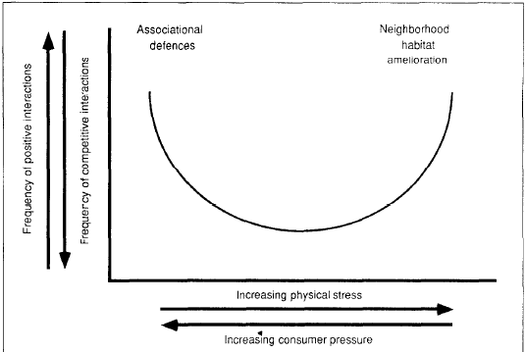
How environmental conditions cause either a domination of facilitative or competitive interactions is a key topic in community ecology. The Stress Gradient Hypothesis (SGH) (Bertness and Callaway, 1994) states that plant interactions change over a stress gradient (Figure 1). For example, plant communities which are assumed to be confronted by low abiotic (e.g. drought) or biotic (e.g. grazing) stress are characterised by negative interactions (competition) rather than positive interactions (facilitation), whereas with increasing abiotic or biotic stress, facilitative interactions are predicted to become more frequent (Bertness and Callaway, 1994). However, follow up studies showed that very high grazing intensities and extreme drought may result in a loss of facilitative effects or even a shift towards competitive interactions (Friedman and Orshan, 1975, Smit et al., 2007).
Figure 1. Conceptual model of the occurrence of positive interactions in natural communities. Positive interactions are predicted to be rare under mild physical conditions and low consumer pressure. Neighbour amelioration of physical stress and association defences, however, are hypothesized to lead predictably to positive interactions under harsh physical conditions and intense consumer pressure. respectively. (Bertness and Callaway, 1994)

In environments with both increased consumer pressure as well as increased physical stress, such interactions become even more complex (Smit et al., 2009, Soliveres et al., 2011, Soliveres et al., 2012).
At these high combined stress levels both facilitation intensity and vegetation density need to maintain adequate levels (Verwijmeren et al., 2013), since it is predicted to decrease the risk of a discontinuous transition from a vegetated to a desert state (Kefi et al., 2007).
Therefore stress levels may result into a shift in interactions towards an earlier collapse of the plant communities (Maalouf et al., 2012, Verwijmeren et al., 2013).
Even though these studies provide a good answer for the general dynamics of the ecological interactions within the ecosystem, they lack an approach on the underlying physical and phenological responses of the protégé plants that undergo the increased biotic and abiotic stress. This is a vital step in understanding what implications the changing environmental conditions have since differences in physiology and phenology cause differences in adaptation to the environment. These may result in genetic changes (Campalans et al., 1999) and therefore evolutionary change or adaptations of the population to be able to withstand new environmental conditions. This is particularly relevant in Mediterranean plant communities, because of the high pace at which the climate changes in these areas and the resulting change in plant community composition.

  - Application of the SGH on Mediterranean plant communities
Following the SGH one expects physiological and morphological traits of a protégé species to be best adapted to its environment when exposed to intermediate amounts of abiotic and biotic stress.
Communities exposed to little abiotic and biotic stress are predicted to suffer from high levels of competition (Figure 1). I expect the protégé to prioritise adaptations to increased competition over development of physiological and morphological adaptations to grazing and drought.
At intermediate stress levels facilitative effects are expected to increase (Figure 1), thus providing ameliorating effects which allow protégés to increase development of physiological and morphological adaptations. At high stress levels a rapid decline in growth and the development of physiological/morphological adaptations is expected. I expect this effect to be enlarged because of competition caused by the “facilitator” and lack of ameliorating effects because of a decreased condition of the facilitator.
When we apply this hypothesis on semi-arid, grazed Mediterranean ecosystems we predict the following:
Protégés in semi-arid ecosystems are exposed to high irradiation and drought and when shaded by a facilitator will benefit by reduced water loss. This is proven to result in increased nutrient uptake (Casper and Jackson, 1997), increased enzymatic activity (Lawlor and Cornic, 2002) and thus in increased growth. Thus protégés that are facilitated in dry areas are likely to be wider and taller than protégés that are not being facilitated. The shading, however is also likely to cause competition between protégé and facilitator for sunlight. The protégé, because it is smaller, is likely to be affected most by this. Therefore it is expected that the protégé prioritises growing tall branches over the facilitator to compete with its facilitator.
Secondly, protégés in grazed environments that are being facilitated are expected to be taller and wider due to the physical protection via thorns, toxicity or unpalatability of the facilitator which decrease grazing pressure. The effects are expected to be similar to the abiotic amelioration.
Not having to invest into replenishment of tissue allows for growth within the plant itself. Thus one could expect that plants that are not being grazed, due to facilitation, are likely to be able to optimize nutrient subtraction using larger root networks.

We conducted a study to test the effects of facilitation on the physiology and morphology of a protégé species, in a semi-arid Mediterranean environment with abiotic stress (drought) and biotic stress (grazing pressure). Specifically, we hypothesized that a) At low stress levels a protégé prioritises competitive adaptations. b) At intermediate stress level the protégé prioritises developments to grazing and abiotic stress. c) At high levels of stress a prioritisation of adaptations to competition. For this experiment we used previously set-up plots in the semi-arid hills in the south-east of Spain. We studied the effects of facilitation using two species. Artemisia barrelieri, a shrub from the Asteracaea family which was observed to be unpalatable for grazers and to provide shade and thus may act as a facilitator (K. Eising, personal observation) and Anthyllis cytisoides, a deciduous shrub from the Fabacaea family, which showed a spatial relationship towards A. barrelieri and acts as a protégé species under grazed condition as it is highly palatable for both goat and rabbits, due to its high nutrient content To disentangle the effects of abiotic and biotic stress on the protégé we measured differences in multiple physiological an morphological traits between sets of plants that underwent different grazing treatments (ungrazed, low goat grazed, high goat grazed, rabbit grazed), drought treatments (watered and unwatered) and microsite treatments (open vs under shrub).

- Methods

  - Study area
During April and May of 2014 we conducted a field experiment in the mountainous area of Cordillera Sur south of Cabezo de la Plata (37°57'43.4" N, 1°00'11.1" W) (See Appendix). The area is of a Mediterranean semi-arid climate with an average precipitation of 300 mm/year and an average annual temperature of 17.8 ⁰C (Ministerio de Agricultura, 2014). Most precipitation falls during September until May at which most plant growth takes place. Despite the fact that the soils are dominated by nutrient poor, loam to sandy loam regosols much of the area is cultivated for lemon, orange, olive, pomegranate and almond orchards. To do so, terraces were built and extensive irrigation systems were laid out with varying success (Calatrava et al., 2011). The terraces which turned out to be failing were often abandoned, which allowed for succession by local plant species. While the surrounding hill slopes are dominated by fully grown Stipa tenacissima, A. barrelieri, A. cytisoides and woody perennial herbs such as Rosmarinus officinalis and Thymus vulgaris. The terraces are mainly dominated by A. barrelieri bushes and annual species with A. cytisoides only present as smaller saplings. Both on the hills as well as on the terraces plants were standing individually or in small groups (patches) surrounded by bare non-vegetated areas (typical patch – interpatch structure of (semi)arid systems). These plant communities are subject to regular grazing pressure by a substantial rabbit (Oryctolagus cuniculus) population. Moreover the abandoned terraces were grazed by goats (Capra hircus) from local herdsmen adding to the biotic stress. In an ongoing study spatial relationships were found between fully grown Artemisia barrelieri shrubs and the saplings of Anthyllis cytisoides under grazed conditions (Verwijmeren et al, in prep). This spatial relationship was then used to set up an experimental study on the effect of abiotic and biotic stress on certain growth variables in the plant.

  - Study design
The experiment consisted out of four terraces with a similar vegetation type, with on each terrace four adjacent 20x20m areas. Within each of these areas we applied four different grazing treatments: 1) a rabbit grazing treatment by leaving the area open to the local rabbit population, 2) high intensity goat grazing by 6 goats for 6 hours by fencing off the area to prevent the goats from escaping (enclosure), 3) low intensity goat grazing by 3 goats for 6 hours (enclosure) and 4) an area protected from grazing by rabbits and goats. At both the high goat grazed, low goat grazed and ungrazed plots, rabbits where excluded by a fine meshed fence that was dug into the soil for half a meter depth. Within each of these areas 80 A. cytisoides saplings were planted (obtained from a local nursery, grown in 10 cm deep trays filled with turf). Half of these saplings were planted underneath A. barrelieri patches and the other half was planted at interpatches (at least 0.5 meters away from vegetated patches). We tested the effect of drought by comparing two protégé groups, half of the sapling were left in the ambient drought and half of the A. cytisoides saplings were watered to decrease the drought effects(Table 1). The first watering event took place before the grazing (April 13th until April 16th) and the second after (May 3rd until May 5th). in both the patches and interpatches 1.5 litres of water was used, corresponding with 11,9 mm of precipitation.

 | Intensive goat grazing | Mild goat grazing | Intensive rabbit grazing | Ungrazed
+ Facilitator  + Hydration | 20 | 20 | 20 | 20
+ Facilitator  - Hydration | 20 | 20 | 20 | 20
- Facilitator  + Hydration | 20 | 20 | 20 | 20
- Facilitator  - Hydration | 20 | 20 | 20 | 20

Table 1. An overview of the treatments applied and the amount of individuals per treatment per plot.

3.3. Physiological measurements

A series of physiological traits were measured to test the effects of drought. Relative water content (RWC) for osmotic regulation in the protégé (Morgan, 1984), Nitrogen content to measure the response in enzymatic activity (Lawlor and Cornic, 2002) and/or nitrogen uptake (Casper and Jackson, 1997) and Foliar density to measure leaf morphology changes (Ogaya and Penuelas, 2006). For the RWC we selected protégés with at least 5 to 10 green leaves of which we used three young, but fully grown, leaves to measure differences in water uptake between each treatment. We used this criterion to minimize damage for the plant so they could be used for additional research. A total of two control plots and three low-goat grazing plots on 3 terraces were selected with enough plants to gain sufficient data for statistical analysis. We were able to gather RWC-data from a total of 128 protégés with 3 measurements per plant, resulting in a total of 384 leaves. Three days after watering, leaves were taken from the plants at sunrise (7:30) to prevent evaporation, the leaves were then transported to the laboratory using a cool box. At the laboratory freshweights of the samples were measured and the leaves were kept in 5 ml Eppendorf containers with demi water to soak the leaves. The leaves were soaked for 24 hours, dried with tissue paper and then weighed. After weighing, the leaves were put in paper bags and dried in an oven at 65C⁰ for 24 hours after which leaves were weighed again.
We measured nitrogen content on protégés with at least 1,5 mg of leaf material to determine effects of drought and grazing on nutrient intake by the protégé. Foliar density of the leaves was measured on the same leaves before they were used for the nitrogen content determination. For both determinations we used a sub selection of protégés with a minimum amount of 15 living leaves (yellow or green) due to the increased biomass that was necessary to determine nitrogen content. This limited the sample size to the control plot on site 4. Within site 4 no suitable plants were found that were unwatered and situated under a facilitator, therefore we left these plants out of the measurements. These leaves were taken 10 to 15 days after the second watering and measured in the 3 days after. A total of 26 plants were used in the Nitrogen and foliar density measurements.
Scans were made in the lab and software from the program WinRHIZO was used to calculate leaf area. These leaves were then used for the experiment for nitrogen-content using the Kjeldahl method.

3.4. Morphological measurements
The morphological indicators we used were height, the diameter of the widest part of the plant (canopy diameter) and height-diameter proportions. Lengths were measured by stretching the longest branch out, the canopy diameter was estimated by measuring the distance between the two largest extremities of the plant. We measured canopy diameters of 1067 plants and protégé heights on alive plants at two time periods, one before the grazing treatment by goats (April 23rd) and one after the grazing treatment by goats (May 2nd) in order to measure effect of the grazing treatments. Height/Diameter proportions were calculated using the heights measured on April 23rd and divided by the Canopy diameter data of 1064 individuals.
These measurements provide information about the growth limitations that drought and grazing impose on the growing capacity of these plants and how the protégé morphologically responds to these stressors (Sala, 1988, Zhang et al., 2004).

3.5. Data analyses
For comparing differences in RWC, nitrogen content and foliar density between watering treatments, grazing treatments and microsite we used fixed effect models for a two-way analysis of variance and normal distributions. For the protégé heights and canopy diameter that were measured on multiple terraces the data were pooled per treatment for all terraces and the effect of the terrace was added as a random effect. When significant effects were found in at least one variable we used TukeyHSD test as a post-hoc analysis. For all statistical analyses, we used R 3.1.0 (R Core Team, 2014).

4. Results
4.1. Physiological measurements
- Relative water content
We found significant differences between the two watering treatments except for plot 3C (Table 2). Average water content for unwatered plants lies between 30-45% while watered plants range up to 60-75%. When we take plot 3C out of consideration the results also show no effects by microsite and grazing treatment (Figure 2).

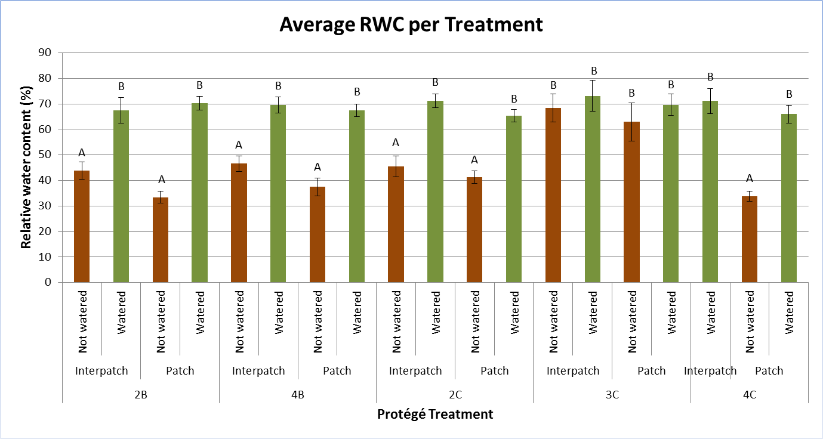
Figure 2. Average relative water content ± 1 SE grouped for each plot, treatment and microsite. Different plot are marked by the numbers at the bottom of the treatments and include the letters which define grazing treatments (C for low intensity goat grazing and B for the control group) Watered plants are indicated by a green colour whilst groups that were not watered are marked by a brown colour. The letters above the bars indicate significant differences at p≤0,05 from the Tukey-test.

Average RWC | P-Value | DF | F-Value
Plot | <0,001 | 4 | 8,5433
Watering | <0,001 | 1 | 175,6223
Plot x Watering | <0,001 | 4 | 7,9568

Table 2. Results from the generalized linear model analysis on the Average Relative water content with normally distributed data.

- Nitrogen content
The results show that the watering treatment increased Nitrogen percentage of the protégés in the interpatch (Figure 3, Table 3). The data also show no effect of the microsite for nitrogen content in protégés within patches due to large fluctuations within the group.
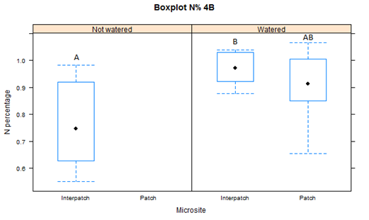
Figure 3. Average Nitrogen contents and standard errors grouped per watering treatment and microsite. Letters indicate significant differences of p<0,05 from a Tukey-test.

-Foliar density
We found no effect of either watering treatment or microsite on foliar density (Figure 4, Table 3).

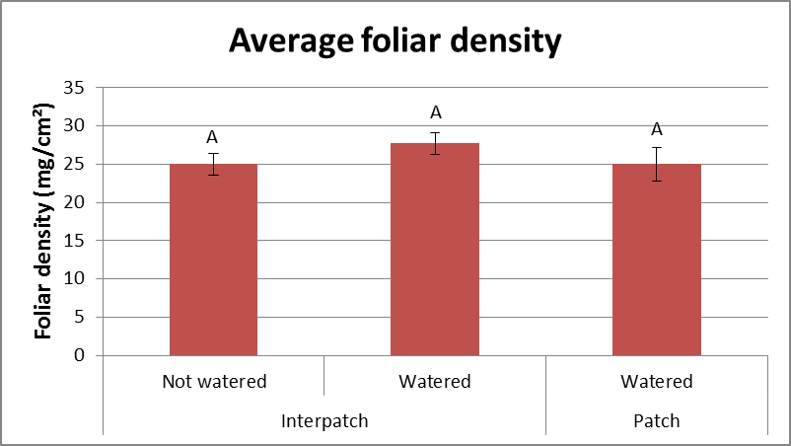
Figure 4. Average foliar density ± 1 SE. Data is grouped for watering treatment and microsite with letters indicating significant differences of p<0,05 between groups from a TukeyHSD-test.

N-content | P-Value | DF | F-Value
Microsite | 0,361 | 1 | 0,866
Watering | 0,00246 | 1 | 11,559
Foliar Density | P-Value | DF | F-value
Microsite | 0,574 | 1 | 0,325
Watering | 0,249 | 1 | 1,397

Table 3. Results from the generalized linear model analysis on the Nitrogen content and Foliar density with normally distributed data.

4.2. Morphological measurements.
-Protégé heights
The watering treatment did not affect plant heights in any combination of treatment (figure 5 and figure 6). However microsite did affect height significantly (Table 4) in a way that plants inside patches were higher for both goat treatments as well as for the rabbit treatment. For the non-grazed plot heights we found no differences in plant height between the two microsites. We also found a significant difference between grazing treatments (P<0,001) with smallest plants within the high-goat grazed plots and highest plants in the ungrazed plots. No significant interactions were found between factors. Finally no significant differences were found between both measurement moments (i.e. April and May).

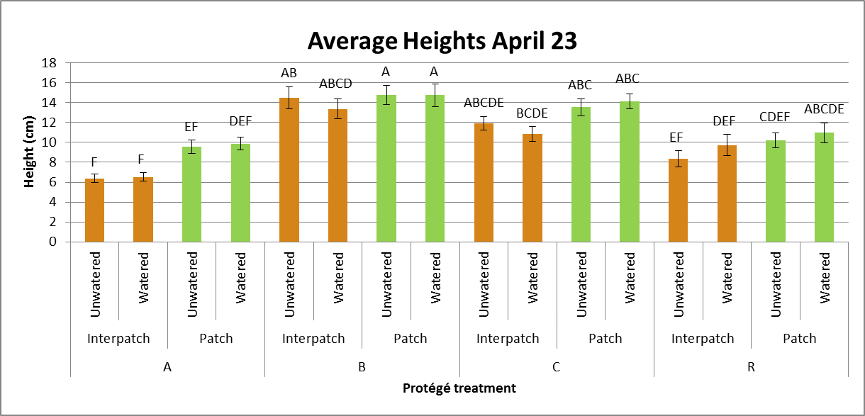
Figure 5. Average heights measured on April 23rd ± 1 SE, Different grazing treatments are coded for A (High-goat grazing), B (No grazing), C (Low-goat grazing) and R (Rabbit grazing). Letters mark significant differences of p<0,05 from the TukeyHSD-test. Protégé heights within the patch were marked in green and protégé heights outside the patch marked in brown.

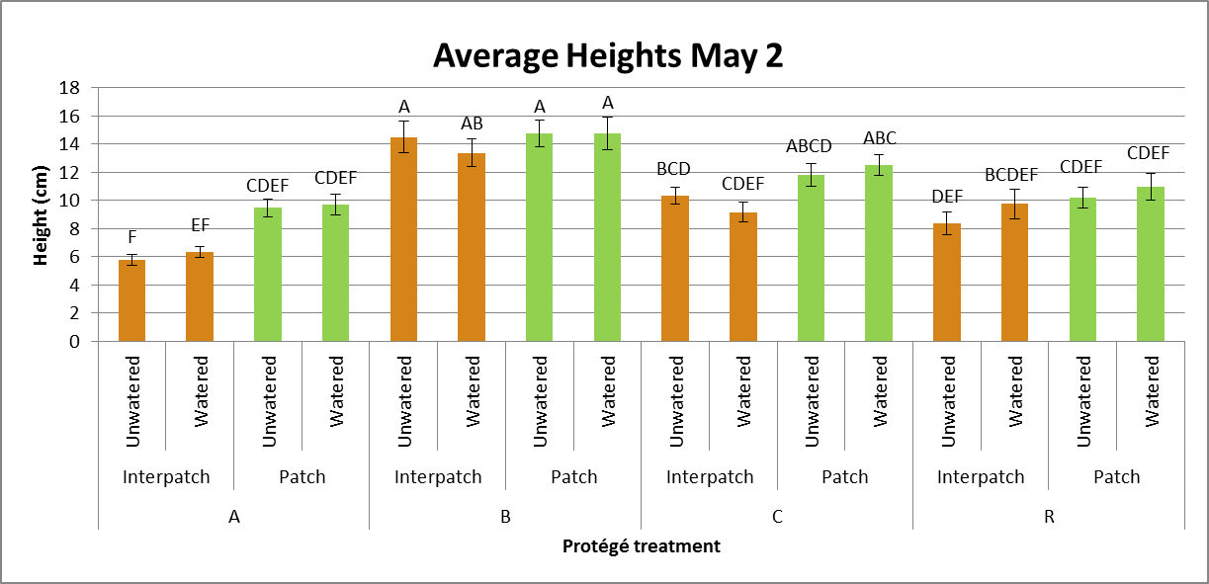
Figure 6. Average heights measured on May 2nd ± 1 SE, Different grazing treatments are coded for A (High-goat grazing), B (No grazing), C (Low-goat grazing) and R (Rabbit grazing). Letters mark significant differences of p<0,05 from the TukeyHSD-test. Protégé heights within the patch were marked in green and protégé heights outside the patch marked in brown.

Height 23 April | P-Value | DF | F-Value
Grazing | <0,001 | 3 | 50,547
Microsite | <0,001 | 1 | 30,680
Watering | 0,936 | 1 | 0,006
Grazing x Microsite | 0,169 | 3 | 1,683
Grazing x Watering | 0,562 | 3 | 0,684
Microsite x Watering | 0,374 | 1 | 0,791
Grazing x Microsite x Watering | 0,798 | 3 | 0,338
Height 2 May
Grazing | <0,001 | 3 | 50,673
Microsite | <0,001 | 1 | 33,417
Watering | 0,833 | 1 | 0,044
Grazing x Microsite | 0,096 | 3 | 2,117
Grazing x Watering | 0,516 | 3 | 0,761
Microsite x Watering | 0,430 | 1 | 0,623
Grazing x Microsite x Watering | 0,652 | 3 | 0,544

Table 4. Results from the generalized linear model analysis on the plant heights measured on the 23rd of April and the 2nd of May with normally distributed data.

-Canopy diameters
We found no effect of watering treatment and microsite on the diameter of the protégés. We did find significant differences between grazing treatments (Table 5) with higher diameters in the ungrazed and low-goat grazed plots and lower diameters in both the rabbit grazed and high-goat grazed plots. No significant interactions between different factors were found.

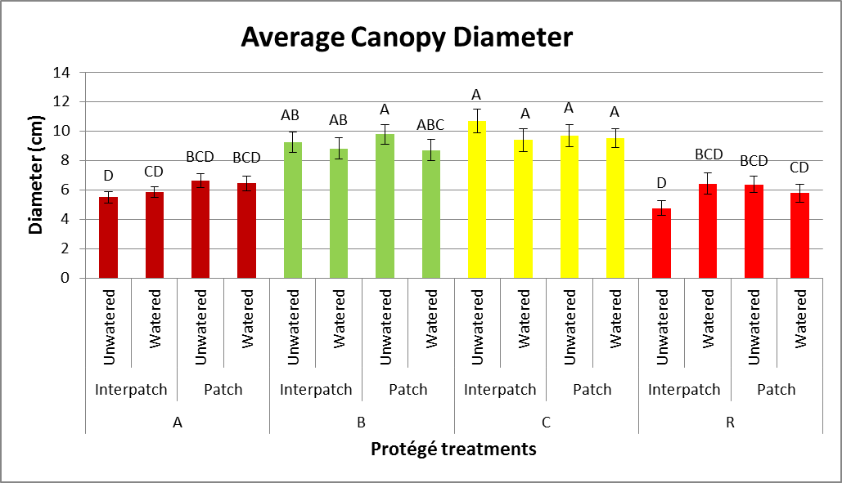
Figure 7. Average Canopy diameters measured before the grazing event ± 1 SE. Different grazing treatments are coded for A (High-goat grazing), B (No grazing), C (Low-goat grazing) and R (Rabbit grazing). Letters mark significant differences of p<0,05 from the TukeyHSD-test.

Diameter | P-Value | DF | F-Value
Grazing | <0,001 | 3 | 45,630
Microsite | 0,375 | 1 | 0,787
Watering | 0,411 | 1 | 0,677
Grazing x Microsite | 0,276 | 3 | 1,292
Grazing x Watering | 0,579 | 3 | 0,657
Microsite x Watering | 0,633 | 1 | 0,229
Grazing x Microsite x Watering | 0,217 | 3 | 1,487
Table 5. Results from the generalized linear model analysis on the Canopy diameters with normally distributed data.

-Height/Diameter proportions
We found a higher Height/Diameter proportion for more intensely grazed (High goat grazing, Rabbit grazing) individuals and lower proportions for individuals that are not grazed or only by low goat grazing (Table 6). We did not find any effects of watering treatment or microsite.

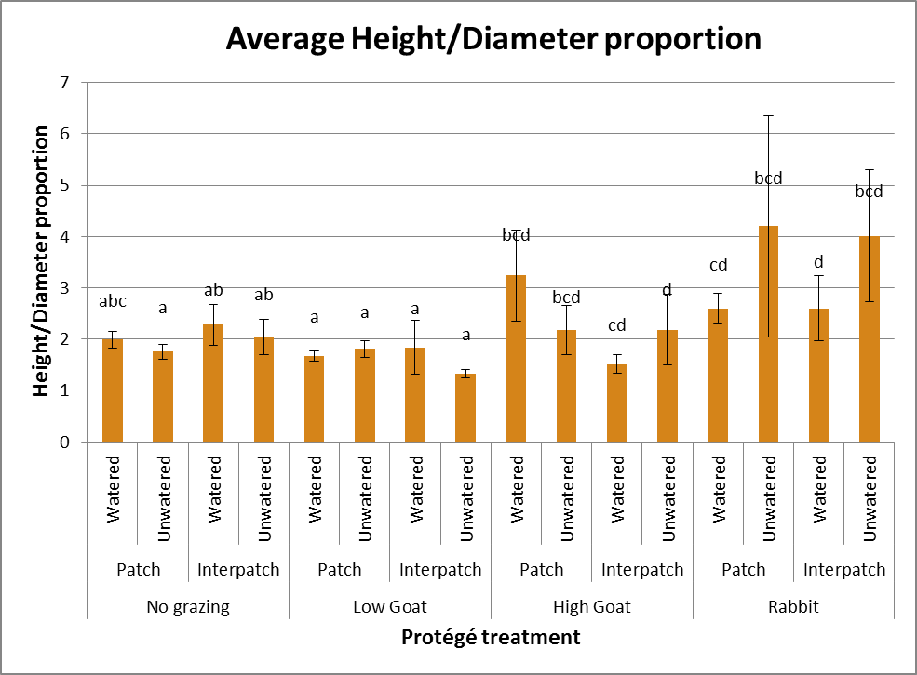
Figure 8. Average height/diameter proportions calculated using the heights and diameters at April 23rd before the grazing event ± 1 SE. Letters mark significant differences of p<0,05 from the TukeyHSD-test.

Height/Diameter | P-Value | DF | F-Value
Grazing | 0,005 | 3 | 4,299
Microsite | 0,537 | 1 | 0,381
Watering | 0,756 | 1 | 0,096
Grazing x Microsite | 0,597 | 3 | 0,628
Grazing x Watering | 0,226 | 3 | 1,451
Microsite x Watering | 0,692 | 1 | 0,156
Grazing x Microsite x Watering | 0,542 | 3 | 0,717

Table 6. Results from the generalized linear model analysis on the Height/Diameter proportions using normally distributed data.

- Discussion

We studied the effects of drought and grazing on the morphology and physiology of A. cytisoides and hypothesized that intermediate stress levels would cause the protégé to be best adapted to its environment. Further, we expected that high levels of drought and grazing pressure would accumulate to a great decay in the development of such traits.
Contrary to our expectations, we found that RWC was not affected by microsite and grazing pressure. However, the added water from our treatments improved RWC in plants by at least 25%, but in a similar way for both microsites Data from the Nitrogen content showed a similar pattern in which the watering treatment improved Nitrogen content within the leaves. Foliar density data suggest no effect by either watering or microsite.
The morphological measurements show that heights and canopy diameter of A. cytisoides were unaffected by our watering treatment. We found increased heights of facilitated protégés while diameter was unaffected by the facilitator. A negative correlation between grazing pressure and protégé height was found with high-intensity goat grazing and Rabbit grazing causing protégés to be shortest, while protégés under low-intensity goat grazing and no grazing treatment grew tallest. A similar correlation was found for canopy diameters. This caused higher height/diameter proportions as a consequence of high-intensity goat grazing and rabbit grazing. In the following paragraphs we discuss the findings of our measurements.

-Physiology
Despite the evidence that has been found for the ameliorating character of facilitators on the abiotic environment (Alhamad and Alrababah, 2013) we found no physiological benefits for the protégé when accompanied by a facilitator. Most likely cause is the long drought period (Figure 9), with a total of 77.6mm precipitation between January until September 2014, which caused both A. cytisoides as well as A. barrelieri to resort to leave senescence and ultimately abscission as a method to decrease transpiration (Munne-Bosch and Alegre, 2004). This water preservation method is similar to that in other plants (Werner et al., 1999). Direct consequence of abscission is the loss of facilitative effects such as the protection from irradiation causing the A. barrelieri to lose its facilitating properties. The fact that A. barrelieri is a drought tolerant species would mean that abscission is a drastic way to evade transpiration, despite its phenology to avoid doing so. I therefore expect abscission to be a consequence of the prolonged drought season that occurred, however a study over multiple years in which such drought periods reoccur to see whether this abscission is a common mechanism to drought.
Figure 9. On the left side an overview of terrace 3 on April 2014. On the right an overview of terrace 3 on March 2013. Showing the effects of prolonged drought of 2014 on the condition of the plant community. With no flowering or green plants on the left image, and yellow patches of flowering plants on the right image.

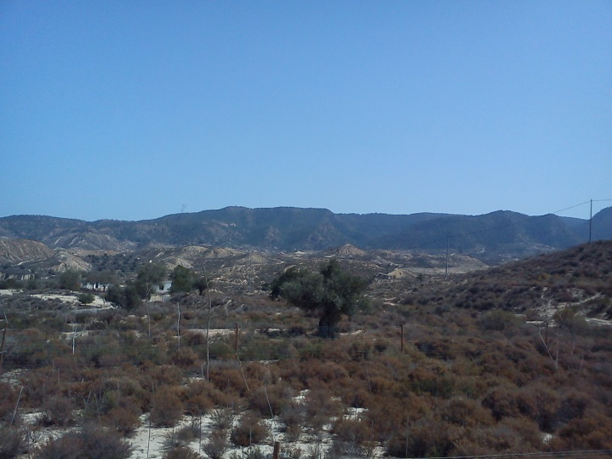
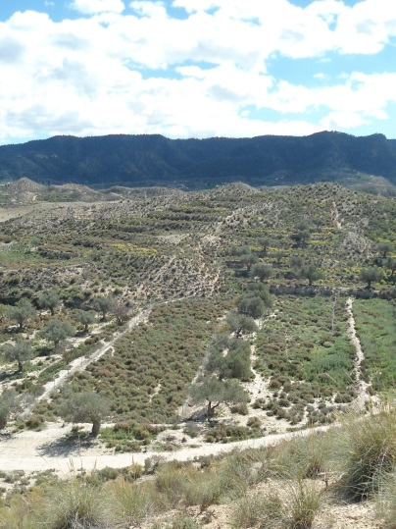
The lack of interactions when looked at the watering effect can be explained due to complementing root systems, since A. barrelieri is known to have dimorphic root system with a larger vertical root for water uptake in lower dirt layers and horizontal roots for mineral uptake(Prieto et al., 2010) while A. cytisoides depends on a more horizontal root system (De Baets et al., 2007). Root competition may thus override other positive effects such as shading by the nurse canopy. Another explanation for the lack of effect of microsite on RWC is found in evidence of changes in the mycorrhizal status in A. barrelieri as a consequence of drought that was found in other studies (Martinez-Garcia et al., 2012). Decreased amounts of vesicles and increased amounts of arbuscules were found after drought periods which suggests a loss of water storage capability over increased water transport capability. These shifts in mycorrhizal morphology may influence root interactions during drought periods between protégé and facilitator since the facilitator is now subject to different uptake speeds and concentrations of water. Considering the importance of mycorrhizal in water uptake rate (RuizLozano and Azcon, 1995) and nutrient uptake (Marschner and Dell, 1994), which could improve water uptake rates of the plant too, it may prove useful to include analyses of the soil surrounding the root system as it is expected to affect below-soil plant-plant interactions. Furthermore we did not find effects of grazing pressure on RWC despite its strong effect on plant heights. Literature regarding the effect of defoliation on root growth suggest a long-term negative effect (Oesterheld, 1992). We found no effects of such a kind, possibly due to either low capability to prioritise above-ground growth or due to the higher importance of maintaining a large root-system in dry areas.
Finally we have to take into account that the watering treatment may not be as effective as was previously assumed. From our RWC measurements we can conclude that A. cytisoides is able to absorb the available water, but it remains unclear for which time period this increased water content is present in the plant and at which rate water content decays. Furthermore our measurements did not include measurements on water content in A. barrelieri which may provide us with additional information about the competition between nurse and protégé and the effectiveness of the watering treatment as a whole since the watering treatment may not be sufficient for watering both or may not penetrate to deeper ground layers which are exploited by A. barrelieri.
The increased nitrogen concentration in protégés that were watered coincide with the idea of increased uptake as a result of higher water concentrations (Casper and Jackson, 1997), or with higher enzymatic activity as a result of higher water content (Lawlor and Cornic, 2002) and thus a bigger demand for nitrogen uptake. These higher nitrogen and water concentrations are expected to improve the plant performance by higher survival and growth rates (Weih and Karlsson, 1999). However, our results show no evidence of increased performance over the long run (e.g. higher and wider plants). Possible causes may be that grazers are able to locate plants with higher water content, which is a strategy applied by other ungulates to cope with water deficits (Manser and Brotherton, 1995), and thus decrease performance of the plants by increased grazing pressure. The performance increase and grazing attractiveness may, in this study, require further research since our measurements spanned a period of 2 weeks and thus cannot prove any long-term effects. Final explanation that should be considered is the increased drought period to affect plant activity to be low and therefore cause the plant to not being able to utilize the increased nitrogen uptake. Foliar density has been proven to increase as a result of increase irradiation (Mendes et al., 2001), however foliar density in our sample size was found to be unaffected by either a facilitator which decreases irradiation. This could be the possible result of a lack in plasticity or response for this species of protégé.

-Morphology
On the part of the morphological measurements we found decreased heights with increased grazing pressure and with the facilitator decreasing this effect. This aligns with earlier research resulting a dominant effect of biotic stress (Graff and Aguiar, 2011) and partially confirm our hypothesis for plant performance at high stress levels which suggests that plants require to grow taller to compensate for shading competition. Interesting to see is how the two different grazing types which we expected to be resulting in high stress did this in similar quantities. While smaller mammals such as rabbits are known to have more specialized diets and larger mammals such as goats to be less selective (Rueda et al., 2013) their impact remained the same. Possible causes for such similarities could be that rabbits, despite better access to the A. cytisoides saplings because of their size, prefer other plants or only fresh shoots. This would leave the protégé relatively unscathed. On the other hand we can conclude that A. herba-alba has limited facilitative effects because the increased grazing pressure impacted plant height of facilitated protégés as well. Short observations of goats during the grazing period confirmed this idea, even though goats dislike going through Artemisia bushes to reach for saplings underneath them they will still do so. Whether this was the consequence of a lack of easily accessible food or a general phenomenon requires further study. More favourable conditions for A. herba-alba may make it harder for goats to reach protégés because of extra covering and the increased unpalatability of the facilitator. Furthermore an abundance of other food sources may divert grazing pressure from the protégés. Regarding the facilitative effect I consider camouflaging effects of a facilitator an important factor, we expect goats to rely on sight to estimate high-quality food. Most protégés during our research were covered in a layer of dust, making them seem unattractive to herbivores and relatively hidden against the similar-coloured A. herba-alba shrub and soil. On behalf of the lower grazing intensities the hypothesis is confirmed as both plants with no grazing pressure and under low-intensity goat grazing show equal heights suggesting that associational resistance becomes more important at intermediate biotic stress, which agrees with previous findings on facilitation intensities (Smit et al., 2007).
For canopy diameters we found no differences in microsite or treatment at all, while stem elongation and a horizontal growing focus is a common phenotypic response of a protégé underneath a facilitator (Callaway et al., 2003). We did not find these effects in protégés dealing with lower grazing pressures. This suggests that other processes than phenology affect morphology. In this case grazing pressure may be focussed on the sideway branches of the protégé as a result of the morphology of the facilitator which only protects branches growing upwards inside the A. barrelieri bush with the sideway branches exposed to grazing. Similar to protégé heights we found no difference in rabbit and high-goat grazing. Lastly we elaborate on height-diameter proportions. No large deviations were found related to the previously discussed heights and diameters. High intensity grazing (high-goat and rabbit) still showed more lateral-focussed protégés while protégés in lower grazing intensities are more horizontally focussed. This is expected to be the cause of the lacking horizontal facilitating space mentioned earlier.

-Synthesis
In general we expected to find clear physiological and morphological responses of the protégé plants to the applied abiotic and biotic stressors in this study. However, we did not find any strong effects, except for morphology at high grazing intensities. We think that the significant drought during our study disabled any physiological effects of the facilitator on the protégé leaving mainly associational resistance as an effect. However it has been shown that seasonal variation in precipitation, temperature and other environmental conditions influences plant-plant interactions drastically (Soliveres et al., 2011) meaning that additional studies during different time periods with different circumstances are necessary to project the full effects of drought and grazing. Furthermore it is important to see how plant species other than the two species we studied would respond to prolonged drought periods and subsequently the changed interactions with the environment. Studies on other species may show how representative the species we studied are for the entire community and its response as a whole. When we reflect on the theoretical framework that formed the basis of the hypotheses we can conclude that associational resistance forms the main positive effect between the nurse and the protégé, while amelioration of the micro-environment served no role in environments at high abiotic stress levels. These results supports the idea that microhabitat amelioration is of no effect at extreme aridity stress, however increased consumer pressure still results in positive interactions despite the abiotic stress.

- References

ALHAMAD, M. N. & ALRABABAH, M. A. 2013. The impacts of biologically induced micro-environments on biodiversity in a dry Mediterranean grassland. Plant Ecology & Diversity, 6, 279-288.
BERTNESS, M. D. & CALLAWAY, R. 1994. POSITIVE INTERACTIONS IN COMMUNITIES. Trends in Ecology & Evolution, 9, 191-193.
CALATRAVA, J., BARBERA, G. G. & CASTILLO, V. M. 2011. FARMING PRACTICES AND POLICY MEASURES FOR AGRICULTURAL SOIL CONSERVATION IN SEMI-ARID MEDITERRANEAN AREAS: THE CASE OF THE GUADALENTIN BASIN IN SOUTHEAST SPAIN. Land Degradation & Development, 22, 58-69.
CALLAWAY, R. M., KIKODZE, D., CHIBOSHVILI, M. & KHETSURIANI, L. 2005. Unpalatable plants protect neighbors from grazing and increase plant community diversity. Ecology, 86, 1856-1862.
CALLAWAY, R. M., PENNINGS, S. C. & RICHARDS, C. L. 2003. Phenotypic plasticity and interactions among plants. Ecology, 84, 1115-1128.
CAMPALANS, A., MESSEGUER, R., GODAY, A. & PAGES, M. 1999. Plant responses to drought, from ABA signal transduction events to the action of the induced proteins. Plant Physiology and Biochemistry, 37, 327-340.
CASPER, B. B. & JACKSON, R. B. 1997. Plant competition underground. Annual Review of Ecology and Systematics, 28, 545-570.
DE BAETS, S., POESEN, J., KNAPEN, A., BARBERA, G. G. & NAVARRO, J. A. 2007. Root characteristics of representative Mediterranean plant species and their erosion-reducing potential during concentrated runoff. Plant and Soil, 294, 169-183.
FRIEDMAN, J. & ORSHAN, G. 1975. DISTRIBUTION, EMERGENCE AND SURVIVAL OF SEEDLINGS OF ARTEMISIA-HERBA ALBA ASSO IN NEGEV DESERT OF ISRAEL IN RELATION TO DISTANCE FROM ADULT PLANTS. Journal of Ecology, 63, 627-632.
GIORGI, F. & LIONELLO, P. 2008. Climate change projections for the Mediterranean region. Global and Planetary Change, 63, 90-104.
GOMEZ-APARICIO, L., ZAMORA, R., GOMEZ, J. M., HODAR, J. A., CASTRO, J. & BARAZA, E. 2004. Applying plant facilitation to forest restoration: A meta-analysis of the use of shrubs as nurse plants. Ecological Applications, 14, 1128-1138.
GRAFF, P. & AGUIAR, M. R. 2011. Testing the role of biotic stress in the stress gradient hypothesis. Processes and patterns in arid rangelands. Oikos, 120, 1023-1030.
KEFI, S., RIETKERK, M., VAN BAALEN, M. & LOREAU, M. 2007. Local facilitation, bistability and transitions in arid ecosystems. Theoretical Population Biology, 71, 367-379.
LAWLOR, D. W. & CORNIC, G. 2002. Photosynthetic carbon assimilation and associated metabolism in relation to water deficits in higher plants. Plant Cell and Environment, 25, 275-294.
MAALOUF, J. P., LE BAGOUSSE-PINGUET, Y., MARCHAND, L., TOUZARD, B. & MICHALET, R. 2012. The interplay of stress and mowing disturbance for the intensity and importance of plant interactions in dry calcareous grasslands. Annals of Botany, 110, 821-828.
MAESTRE, F. T., VALLADARES, F. & REYNOLDS, J. F. 2005. Is the change of plant-plant interactions with abiotic stress predictable? A meta-analysis of field results in arid environments. Journal of Ecology, 93, 748-757.
MANSER, M. B. & BROTHERTON, P. N. M. 1995. ENVIRONMENTAL CONSTRAINTS ON THE FORAGING BEHAVIOR OF A DWARF ANTELOPE (MADOQUA-KIRKII). Oecologia, 102, 404-412.
MARSCHNER, H. & DELL, B. 1994. NUTRIENT-UPTAKE IN MYCORRHIZAL SYMBIOSIS. Plant and Soil, 159, 89-102.
MARTINEZ-GARCIA, L. B., MIRANDA, J. D. & PUGNAIRE, F. I. 2012. Impacts of changing rainfall patterns on mycorrhizal status of a shrub from arid environments. European Journal of Soil Biology, 50, 64-67.
MENDES, M. M., GAZARINI, L. C. & RODRIGUES, M. L. 2001. Acclimation of Myrtus communis to contrasting Mediterranean light environments - effects on structure and chemical composition of foliage and plant water relations. Environmental and Experimental Botany, 45, 165-178.
MINISTERIO DE AGRICULTURA, A. Y. M. A. 2014. Valores climatológicos normales. Alcantarilla, Base Aérea [Online]. [Accessed 17 July 2014].
MORGAN, J. M. 1984. OSMOREGULATION AND WATER-STRESS IN HIGHER-PLANTS. Annual Review of Plant Physiology and Plant Molecular Biology, 35, 299-319.
MORO, M. J., PUGNAIRE, F. I., HAASE, P. & PUIGDEFABREGAS, J. 1997. Mechanisms of interaction between a leguminous shrub and its understorey in a semi-arid environment. Ecography, 20, 175-184.
MUNNE-BOSCH, S. & ALEGRE, L. 2004. Die and let live: leaf senescence contributes to plant survival under drought stress. Functional Plant Biology, 31, 203-216.
OESTERHELD, M. 1992. EFFECT OF DEFOLIATION INTENSITY ON ABOVEGROUND AND BELOWGROUND RELATIVE GROWTH-RATES. Oecologia, 92, 313-316.
OGAYA, R. & PENUELAS, J. 2006. Contrasting foliar responses to drought in Quercus ilex and Phillyrea latifolia. Biologia Plantarum, 50, 373-382.
PRIETO, I., MARTINEZ-TILLERIA, K., MARTINEZ-MANCHEGO, L., MONTECINOS, S., PUGNAIRE, F. I. & SQUEO, F. A. 2010. Hydraulic lift through transpiration suppression in shrubs from two arid ecosystems: patterns and control mechanisms. Oecologia, 163, 855-865.
R CORE TEAM 2014. R: A language and environment for statistical computing. Vienna, Austria.: R Foundation for Statistical Computing.
RAFFAELE, E. & VEBLEN, T. T. 1998. Facilitation by nurse shrubs of resprouting behavior in a post-fire shrubland in northern Patagonia, Argentina. Journal of Vegetation Science, 9, 693-698.
RUEDA, M., REBOLLO, S. & GARCIA-SALGADO, G. 2013. Contrasting impacts of different-sized herbivores on species richness of Mediterranean annual pastures differing in primary productivity. Oecologia, 172, 449-459.
RUIZLOZANO, J. M. & AZCON, R. 1995. Hyphal contribution to water uptake in mycorrhizal plants as affected by the fungal species and water status. Physiologia Plantarum, 95, 472-478.
SALA, O. 1988. The effect of herbivory on vegetation structure. Plant form and vegetation structure, 317-330.
SMIT, C., RIETKERK, M. & WASSEN, M. J. 2009. Inclusion of biotic stress (consumer pressure) alters predictions from the stress gradient hypothesis. Journal of Ecology, 97, 1215-1219.
SMIT, C., VANDENBERGHE, C., DEN OUDEN, J. & MULLER-SCHARER, H. 2007. Nurse plants, tree saplings and grazing pressure: changes in facilitation along a biotic environmental gradient. Oecologia, 152, 265-273.
SOLIVERES, S., ELDRIDGE, D. J., HEMMINGS, F. & MAESTRE, F. T. 2012. Nurse plant effects on plant species richness in drylands: The role of grazing, rainfall and species specificity. Perspectives in Plant Ecology Evolution and Systematics, 14, 402-410.
SOLIVERES, S., GARCIA-PALACIOS, P., CASTILLO-MONROY, A. P., MAESTRE, F. T., ESCUDERO, A. & VALLADARES, F. 2011. Temporal dynamics of herbivory and water availability interactively modulate the outcome of a grass-shrub interaction in a semi-arid ecosystem. Oikos, 120, 710-719.
THUILLER, W., LAVOREL, S., ARAUJO, M. B., SYKES, M. T. & PRENTICE, I. C. 2005. Climate change threats to plant diversity in Europe. Proceedings of the National Academy of Sciences of the United States of America, 102, 8245-8250.
VERWIJMEREN, M., RIETKERK, M., WASSEN, M. J. & SMIT, C. 2013. Interspecific facilitation and critical transitions in arid ecosystems. Oikos, 122, 341-347.
WEIH, M. & KARLSSON, P. S. 1999. The nitrogen economy of mountain birch seedlings: implications for winter survival. Journal of Ecology, 87, 211-219.
WERNER, C., CORREIA, O. & BEYSCHLAG, W. 1999. Two different strategies of Mediterranean macchia plants to avoid photoinhibitory damage by excessive radiation levels during summer drought. Acta Oecologica-International Journal of Ecology, 20, 15-23.
ZHANG, X. L., ZANG, R. G. & LI, C. Y. 2004. Population differences in physiological and morphological adaptations of Populus davidiana seedlings in response to progressive drought stress. Plant Science, 166, 791-797.

- Appendix
Image of the study site:

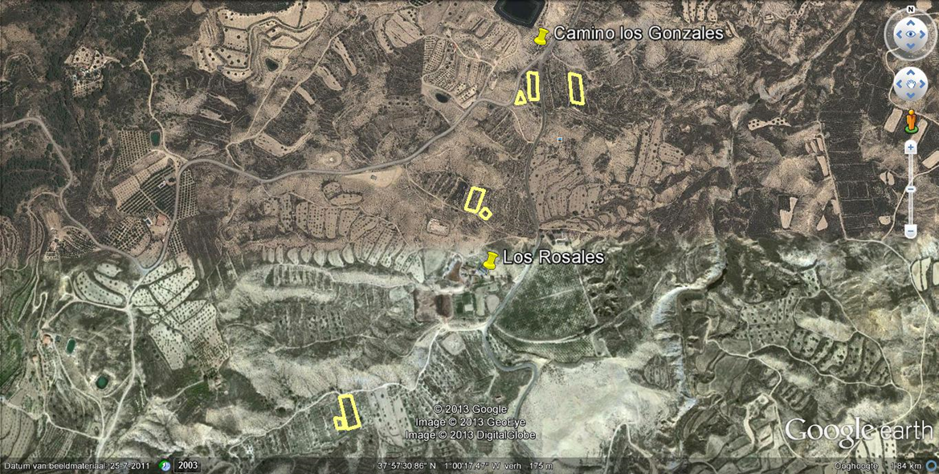
Figure 11: Satellite images of the study area with the selected terraces highlighted.

