Student: Andrius Jakovlevas
Supervisors: Dr. Marco de Bruyn and Prof. Dr. Hans W. Nijman

Infiltration of T-cell Subsets in Ovarian Cancer Tissue
Table of Contents

ACKNOWLEDGEMENTS 2
ABSTRACT 3
INTRODUCTION 4
Ovarian Cancer 4
Etiology of ovarian cancer 5
Treatment of epithelial ovarian cancer 6
Tumour immunology and immunotherapy 6
Fluorescent staining 7
T-cell subsets 8
MATERIALS AND METHODS 9
Antibodies and tissues samples 9
Fluorescent, IHC and H&E staining 10
Microscopy and acquisition 12
Analysis 15
RESULTS 16
Filter sets and fluorophores 16
Quadruple Control staining on tonsil tissue 17
Quadruple staining on ovarian cancer tissue 18
Quadruple staining on ovarian cancer tissue + H&E overlay 19
Quadruple staining on ovarian cancer tissue and different T-cell subsets 20
DISCUSSION 20
APPENDIX 22
Protocol for IHC and quadruple fluorescent staining + DAPI 22
REFERENCES 24

ACKNOWLEDGEMENTS

I would like to express my biggest gratitude to my daily supervisor Dr. Marco de Bruyn for his advice, daily supervision and for the help in the laboratory during my internship. I would also like to thank my internship supervisor prof. dr. Hans W. Nijman for setting up this internship possibility and providing advice together with Prof. Dr. Steven de Jong. Furthermore, I would like to thank PhD students Maartje C. A. Wouters and Stephanie van de Wall for their sincere help and advice.

ABSTRACT

Ovarian cancer is one the most poorly understood and known as the most lethal gynaecological malignancy having lower than 50% survival rate. It is categorised into four different FIGO stages I, II, III and IV. Moreover ovarian cancer diagnosis in different stages has significant difference in survival rate (earlier stage – better prognosis). One of the markers for better prognosis is infiltration of different T-cell subsets into cancer tissue. We adjusted a protocol for immunofluorescent staining and used it to identify different T-cell subsets in ovarian cancer combining it with other staining techniques (Immunohistochemistry and Haematoxylin and eosin staining). For our experiments we have chosen three different markers and performed quadruple staining of specific cells combining CD3, CD8, CD27 and nuclear markers. Eight different cell subtypes were found (four T-cell subtypes and four non T-cell subtypes). Using our adjusted protocol of staining we were able to overlay acquired pictures and see distribution of all T-cell subtypes in ovarian cancer tissue using a few combined techniques. We were able to recognise different T-cell subtypes that can help in prognosis, prediction and further investigation.

INTRODUCTION

Ovarian Cancer
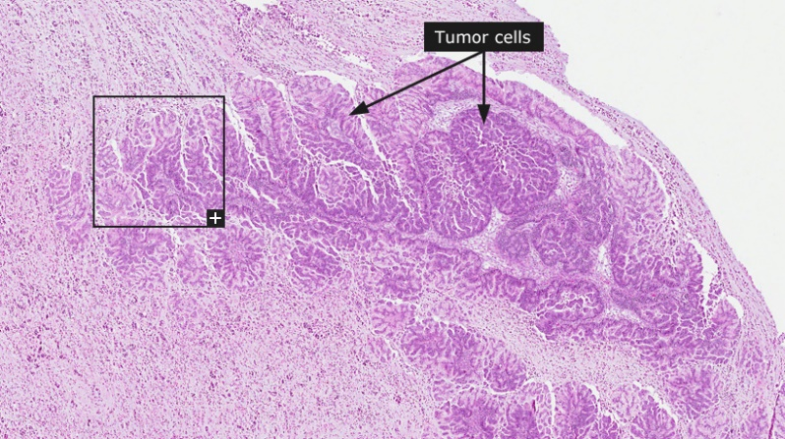
Ovarian cancer is one of the most poorly understood and most lethal gynaecological malignancy. The most common type of ovarian cancer is epithelial ovarian cancers (EOC) and comprise about 80-90% of all ovarian cancers (Leffers, 2009). 5% of all ovarian cancers are derived from germ cell tumours or sex-cord stromal tumours. The remaining cases are derived from a primary malignancy elsewhere in the tumour. Most patients with EOC are diagnosed at a late stage due to a lack of specific symptoms that present with the disease. As a result, according to data from the World Health Organisation (WHO), more than 50% of ovarian cancer cases are lethal even in developed countries like the United States etc. Within the group of epithelial ovarian cancers, a further subdivision can be made based on histology and gene expression data. Specifically, EOC is divided histologically into high-grade serous, endometrioid, clear cell and mucinous cancers. High-grade serous EOC (HGSC) is by far the most common form of ovarian cancer and is characterized by a high mortality rate and disease relapse. Genetic studies have identified a further 4-6 groups of HGSC, including the so-called “immunoreactive”, “differentiated”, “proliferative”, and “mesenchymal” types. Kurman and Shih (2010) proposed an idea and categorised epithelial ovarian cancer into main groups - type I and type II (Table 1). Moreover, not long ago it was thought that origin of ovarian carcinomas was deriving from mesothelium although recent data suggests that “epithelial ovarian carcinoma arises in extra-ovarian sites and involves the ovaries secondarily” (Kim et al. 2012).
Figure 1. Highly differentiated mucinous adenocarcinoma in ovaries. Adopted from: The Human Protein Atlas: Ovarian Cancer website.

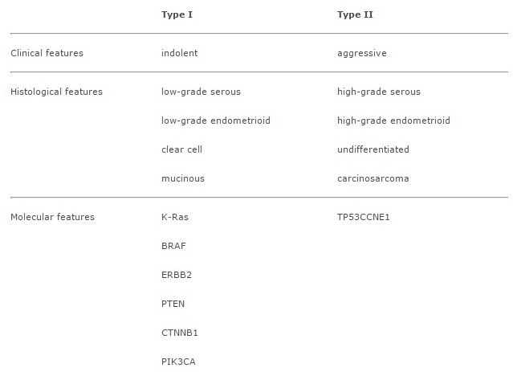
Table 1. Characteristics of type I and type II tumours. Adopted from: Kim et al. Journal of Experimental & Clinical Cancer Research 2012.

Etiology of ovarian cancer
Epithelial ovarian cancer is a development of abnormal cells in epithelial layer (covering) of ovaries causing loss of function in cells and tissue. Different EOC stages are categorised into FIGO stages: FIGO stage I, II, III or IV. FIGO classification is based on mostly clinical examination. First FIGO stage (FIGO I stage) means that tumour is limited and exists only in ovaries although one or both ovaries can be affected where second stage describes tumour extension to the local (bellow the pelvic brim) peritoneal area including one or both ovaries. Third and fourth FIGO stages describes further metastasis. Under the third stage (FIGO III stage) tumour is spread just outside the pelvis while under FIGO IV stage tumour is expanded into distant metastasis (Society of Gynecologic Oncology – SGO, 2014). Diagnosis of each stage has a significant difference in survival rates, although early stage diagnosis (stage I or II) is rare (by Kim et al. (2012) less than 25% of all cases) due to the “lack of effective screening programs”. Therefore, a lot of studies are being held in order to diagnose and treat ovarian cancer as early as possible (in earlier stages).

Treatment of epithelial ovarian cancer
Dependent on a different ovarian cancer stage various treatment options are chosen. One of the first steps in all stages treating ovarian cancer is surgery or debulking. Most of the time in stage I of epithelial ovarian cancer (tumour grade 1 - 2) after surgery treatment is not necessary, although patients are carefully watched for any further necessary treatments. Stage I (grade 3) cancer is usually treated with chemotherapy after surgery. In the same manner Stage II ovarian cancer is treated with recommended chemotherapy after surgery. During the surgery staging (widespread of cancer) is estimated therefore the level of treatment (chemotherapy) can be adjusted to the patient after surgery. Stage III ovarian cancer is treated similarly to Stage II cancer followed by removal of both ovaries, uterus and fallopian tubes. The main goal of surgery and debulking is to remove as much tumour as possible (with remaining less than 1 cm of tumour called optimal debulking). After the surgery combined chemotherapy is given to the patient usually using carboplatin (or cisplatin) and a taxane (American Cancer Society, 2014). Different drugs are used to treat different germ cell tumours. Chemotherapy can be applied through the blood (bloodstream) to reach all organs to treat metastases or intraperitoneally (straight into abdominal cavity) which makes chemotherapy more concentrated to the primary tumour and through the bloodstream drugs still can reach other organs. However, despite intensive research into new treatment options over the past decades, the five-year disease specific survival of EOC has barely improved and remains low at 41%. Innovative novel treatment modalities are therefore urgently needed to improve prognosis for these patients. One promising new treatment modality is immunotherapy.

Tumour immunology and immunotherapy
Only recently studies showed increased interest in immune cells infiltration in tumours and their significance in survival rates “in tumours with high numbers of tumour-infiltrating T cells the expression of monokines induced by IFN-γ, macrophage-derived chemokines and secondary lymphoid-tissue chemokines were significantly increased as compared with tumours lacking T cells, indicating that these chemokines may be involved in the antitumor response” (Zhanget al., 2003). The main infiltrating T cell type that is associated with immediate responses in tumours is CD8 cytotoxic T cells that “recognize antigens displayed in the context of MHC (HLA) class I molecules expressed on ovarian cancer cells” (Preston et al., 2011). CD8 positive T cells releases perforins and granzymes to alter apoptosis in cancer target cells. Other specific subsets of T cells or other antitumor immune effectors like CD4⁺ Th cells, NK subsets and CD4⁺ T reg cells have also been studied although with same not fully understood results. It is clear now that different T cell subtypes has their own important roles in changing the course of disease. Moreover, immune recognition and immune cell infiltration in tumours is being associated with better survival rates (Figure 2).
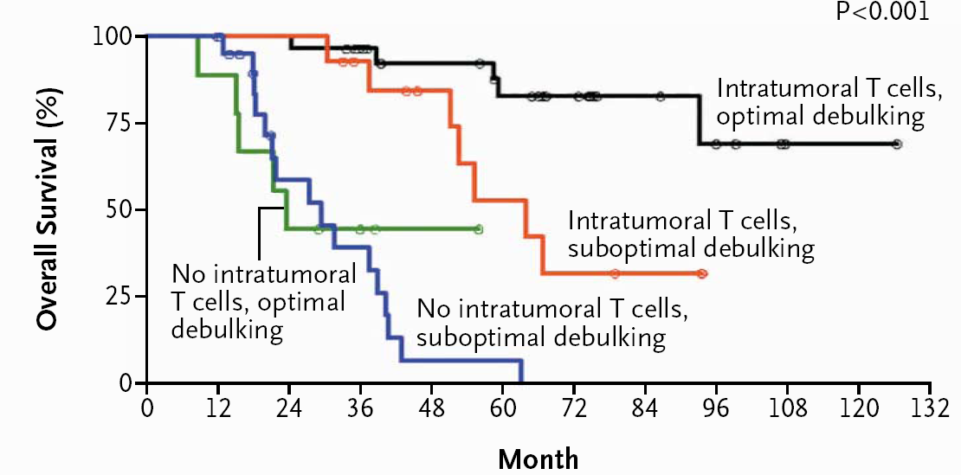
Figure 2: Importance of intratumoural T cell infiltration with optimal or suboptimal debulkink against overall survival rate.

This leads to a wider range of possibilities in treating tumours using possible immunotherapies. Importantly, the concept that immune recognition of the tumour is associated with a better prognosis in patients with EOC has been demonstrated frequently, but the precise composition of the immune infiltration and possible therapeutic targets remain largely unknown. This requires more investigation, particularly to identify promising T cell molecules for targeting in immunotherapy. A comprehensive analysis of the tumour microenvironment using multicolour fluorescent analysis of immune cell populations can be used to achieve this.

Fluorescent staining
Fluorescent microscopy is widely used in biology for imaging structural components, cell populations and genetic cell material. The main principle of fluorescent microscopy is emission of excited light by the sample under specific filter that allows certain length light-waves to pass it and make it visible (in colour dependent on filter).

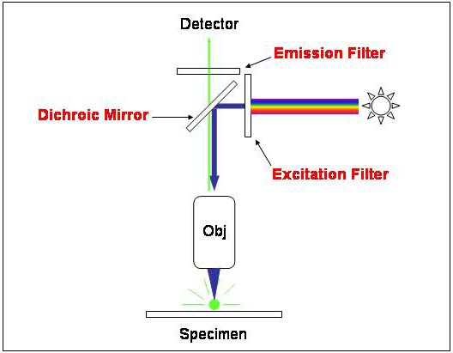

Figure 3: Fluorescent microscopy. Adopted from: Microbial life educational recourses – Fluorescent microscopy website

The sample (most of the time secondary antibodies) is labelled with fluorophores that absorbs illumination light and emits different length light-wave that passes through certain filters and can be separated and visible. Therefore specific antibodies can be chosen to be labelled with certain fluorophores and different cell lines or subsets can be traced. Every specimen can be stained with specifically labelled secondary antibodies for only certain markers to be visible.

Figure 4: Immunofluorescent staining of CD27 possitive cells (red) in tonsil tissue. Green colour represents nucleus.

In figure 4 CD27+ lymphocytes in tonsil tissue are stained in colour red using CD27 as a primary antibody and anti-CD27 secondary antibody labelled with Alexa Fluor 594 fluorophore. Green colour stained nuclear material using Sytox fluorophore which stains genetic material in nucleus directly. As mentioned before Fluorescent staining technique is used for imaging cell populations therefore it is useful technique to examine certain and specific cells (in this case lymphocytes) that can infiltrate into different carcinomas like ovarian cancer. It is known that infiltration rate of immune cells into certain cancer tissues correlates with survival rates. Higher infiltration rate – higher survival rate.

T-cell subsets
Immunofluorescence could be used to trace specific subsets of infiltrating T-cells in ovarian carcinomas in order to predict more accurate and precise prognosis for cancer patients or find a valid treatment target. In experiments set out in this article immunofluorescence is used as main staining technique to trace specific T-cell subsets in ovarian cancer tissue. We used three different cell markers (CD3, CD8 and CD27) to examine every different cell subset and its distribution in ovarian cancer tissue. CD3 was chosen because of its role as a key component of the main T-cell receptor for recognition of cancer cells. CD8 marker has been selected because of its known ability to play a major role in antitumor activity and increasing survival rates of T-cells, while CD27 expressed on naïve and recently activated T cells correlates with improved prognosis in clinical trials, where patients are treated with tumour-infiltrating T cells as a form of adoptive cell therapy.

MATERIALS AND METHODS

Antibodies and tissues samples
Control slides:
Control slides were separated into 2 groups: Positive and Negative. Firstly, each primary antibody was checked for its positive signal on positive cell lines for CD3, CD8 and CD27 with secondary antibodies Alexa Fluor 488, Alexa Fluor 660/Cy5 and Cy3 respectively using IHC (Immunohistochemical) staining. Later same cell lines were used to determine strength of fluorescence signal to check binding of secondary antibodies to the primaries (using fluorescent microscopy). After results obtained negative cell lines were used for negative controls applying same secondary antibodies and observing them under fluorescent microscope. Continuing with negative controls iso-type staining’s were performed to measure the level of non-specific background signals (initial iso-types of primary antibodies mentioned below in the table “Antibodies”). Each primary antibody thus different iso-type were stained separately using same secondary antibodies on FFPE (Formalin Fixed Paraffin Embedded) tonsil tissue. The last control was performed on Tonsil FFPE tissue using quadruple staining (CD3 with AF488, CD8 with AF660/Cy5, CD27 with Cy3 and DAPI for nuclear staining.
Experimental slides:
For main experimental slides ovarian cancer FFPE tissue were used. As mentioned before in control slides section for negative controls same secondary antibodies been used to check for auto-fluorescence or any necessary background signals, although this time on ovarian cancer FFPE tissue. Same tissue (other slices) been also used for iso-type controls. Different iso-type primary antibodies stained using same secondary antibodies for aspecific signals. In the end a quadruple staining was performed on ovarian cancer FFPE tissue using initial antibodies (primary and secondary) + DAPI for nuclear staining and later washing the tissue and counterstaining it with H&E.

Table 2. Antibodies used
Primary antibodies: | Secondary antibodies:
- CD3 (rat IgG1) | - Alexa Fluor 488 (goat anti-rat)
- CD27 (rabbit polyclonal) | - Cy3 (goat anti-rabbit)
- CD8 (mouse IgG1) | - Alexa fluor 660 (goat anti-mouse)
 | - DAPI

Table 3. Tissue samples used:
Control slides: | Experimental slides:
- Quadruple staining of Tonsil FFPE tissue (Formalin Fixed Paraffin Embedded). | - Quadruple staining on ovarian cancer tissue slide (FFPE) (with DAPI).
- Iso-type staining of Tonsil (FFPE) tissue (negative controls). | - Quadruple staining on ovarian cancer tissue slide (FFPE) (with H&E counterstain).
- Each antibody stained on separate Tonsil (FFPE) tissue (bleed through check on different filters) | - Iso-type staining of ovarian cancer tissue (FFPE).
- Positive Cell lines for CD3, CD8 and CD27. | - Negative controls.
- Negative controls.

Fluorescent, IHC and H&E staining
All protocols for Fluorescent, IHC and H&E staining are included in appendix section.
Deparaffination and rehydration:
For deparaffination and rehydration process tissue was washed in xylene and different concentration of alcohol solutions (100%, 96% and 70%) for 5 min repeating each step twice. Xylene removes most of the paraffin left on the tissue while alcohol and last wash in Demi water rehydrates it. While last steps of washing were performed preparation for the next step was done (pre-heating buffer for antigen retrieval). Tissue was kept hydrated after all steps and all the time before the next step was started.
- Xylene
- 100% alcohol
- 96% alcohol
- 70% alcohol
- Demi water
Antigen retrieval:
Antigen retrieval step is usually used to unmask the proteins (unfolding proteins) which helps antibodies to recognise the target by revealing epitopes. 5 min before first step was finished (Deparaffination and dehydration) citrate buffer pH 6 was preheated under max output in the microwave to reach boiling temperature. Slides were immersed in buffer for another 15 min of constant heating under 400 W of output in the microwave (conditions specified in the protocol provided in appendix). After this step washing was performed using PBS (x1) + 0.05% Tween-20 solution. 3 times for 5 min slides were immersed in the solution. As experiments showed Tween-20 helped in reducing background signals
- Citrate buffer (10mM, pH 6)
- PBS (x1) (Phosphate Buffered Saline)
- 0.05% Tween-20

Staining:
Before applying antibodies certain tissue epitope blocking steps were done. This was done to reduce background signal and unspecific staining. Otherwise antibodies may bind to non-specific epitopes. Proceeding with IHC staining or combining both IHC and Fluorescent staining peroxidase blocking step was performed. 0.75 ml of H2O2 was poured into 50 ml of PBS and slides were immersed in the solution for 30 min (container should be in complete dark, could be wrapped with foil etc.). Washing step was performed again as explained in previous step. After washing the slides AB – BSA blocking solution was added onto the slides by pipetting few drops on each tissue fragment for 30 min before another washing step. In the last part of staining procedure primary and secondary antibodies were added onto the tissue fragment again by pipetting. Antibodies, before applying them to the tissue, were mixed with PBS + 1% BSA + 1% AB serum (concentrations may vary dependent on antibody: specified in appendix section, protocol provided). After addition of primary antibody slides were kept in complete dark over the night in 4º C temperature. The washing step was performed afterwards and secondary antibodies were added in the same manner as primary antibodies and kept for 30 min in the dark. After half an hour DAPI were added in the same manner and slides were kept in dark for 20 min more. Slides were washed again and dried before putting the mounting medium with plastic pipette and adding coverslips.
- Endogenous peroxidase block:
- 0.75 ml H2O2
- 50 ml PBS (x1)

- PBS (x1) + 0.05% Tween-20
- AB – BSA blocking solution
- PBS (x1)
- Add 1% of BSA (Bovine Serum Albumin)
- Add 1% of AB serum (?)

- Primary antibodies (listed above in the table of “antibodies used”)
- Secondary antibodies (listed above in the table of “antibodies used”)
- Mounting medium “Prolong Gold Anti-Fade”
H&E counterstaining:
After acquisition of the tissue fragments from previous step H&E counterstaining was applied. H&E counterstain can help to trace the cells in the tissue and confirm positive cells later when previous acquired pictures and pictures acquired after H&E staining were overlaid. This counterstaining gave a change to do a double confirmation (by strong nuclear staining) on cells that were particularly expressing one or another marker. Moreover, it gave a chance to see (in overlaid pictures) tissue cells from two different perspectives in one picture: fluorescent and light microscopy.
Coverslip from previous staining was washed away by pouring PBS slowly onto the slide. After washing, slides still contained mounting media that was carefully washed in DEMI water until all the mounting media was gone. When all the trace of mounting media was washed away slides were stored in a glass jar containing haematoxylin for 10 min. Haematoxylin was used for staining cell nucleus (can be reused more than a few times). After 10 min in haematoxylin, slides were washed in tap water and immersed in eosin for another 2 min. Eosin was used for cytoplasm staining. After 2 min in eosin slides were washed in alcohol for dehydration: two times in 96% of alcohol and later two times in absolute alcohol. When slides were dry after the alcohol wash, coverslip and Eukit mounting media was applied using plastic pipette.
- Haematoxylin
- Eosin

Microscopy and acquisition
Carl Zeiss Axio Observer Z1 was used together with “TissueFaxs” software to acquire images for further analysis. Settings used in the software depends on different tissue fragment and varies all the time. Both fluorescent and light microscopy requires adjustment of main settings.

- Bright-field or Fluorescent microscopy
- Right set of filters (DAPI, GFP, Cy3 and Cy5) (Only for fluorescent microscopy)
- Adjustment of focal range
- Areas of interest (areas to acquire)
- Manual or Auto-focus (optional)
- Acquired area per single focal adjustment (for example 5x5 area with single focus or 1x1 area with single focus – less area, better quality of acquisition)
- Etc.

For fluorescent acquisition certain filter set was used. Every filter was matched together with fluorophore (with secondary antibody) used. DAPI fluorophore was observed using emission filter on 460 nm wavelength with 50 nm frame. Colour of column shows the observed colour on a particular wavelength in colour spectrum. DAPI was used for nuclear staining.
Figure 5. DAPI emission filter
To observe and acquire CD3 positive cells (Alexa Fluor 488 fluorophore) GFP filter was used. It emits green colour at 525 nm wavelength within 50 nm range in colour spectrum. All CD3 positive cells were seen in green colour.
Figure 6. GFP emission filter

To observe and acquire CD27 positive cells (Cy3 fluorophore) Cy3 filter was used. It emits yellowy-red colour at 605 nm wavelength within 70 nm range in colour spectrum. All CD27 positive cells were seen in yellowy-red colour.
Figure 7. Cy3 emission filter

To observe and acquire CD8 positive cells (Alexa Fluor 660 fluorophore) Cy5 filter was used. It emits red colour at 700 nm wavelength within 70 nm range in colour spectrum. All CD8 positive cells can be seen in red colour.
Figure 8. Cy5 emission filter

Analysis
Analysis was performed using “Photoshop” software. Same fragments of acquired tissue were analysed to count certain positive, double positive or triple positive cells (CD3, CD8, CD27 or any combination between them). Every colour can be taken of the picture or only one colour can be left. This can show which cell is double or triple positive. Any area of the tissue fragment can be analysed to distinguish different T-cell subset in different area of the tissue. In this case which T-cell sub-types were tend to infiltrate ovarian cancer more than the others or to analyse T-cell subset distribution in ovarian tissue/ovarian cancer tissue.

RESULTS

Filter sets and fluorophores

Figure 9. Fluorophores used in the experiments. Blue (DAPI) fluorophore – nuclear staining. Green (AF488) – CD3⁺ cell staining. Yellow (Cy3) – CD27⁺ cell staining. Red (AF660) – CD8⁺ cell staining.

Fluorophores used in experiments were initially conjugated to the secondary antibodies used. Although our chosen fluorophores and their wavelengths (Figure 9) in the colour spectrum often clashes with one or more fluorophores spectrum (for example Cy3 fluorophore sometimes bleed through Cy5 filter and cause aspecific signal due to sensitive Cy5 filter) causing fluorophore bleed-through from its own to other channel resulting in unwanted signal expression under other (nearby) filter (Figure 10).
Figure 10. Filter sets used. DAPI, GFP, Cy3 and Cy5

Quadruple Control staining on tonsil tissue

Paraffin embedded tonsil tissue was used as a positive control for quadruple staining of different T-cell subsets containing different markers: CD3, CD27 and CD8 (DAPI was used for nuclear staining). Under GFP filter CD3⁺ cells were observed emitting green fluorescent light stained using Alexa Fluor 488 secondary antibodies (Figure 11A). CD3⁺ cells were mostly distributed in stromal area. Acquired tonsil tissue fragment contained follicle and stromal areas. In Figure 11B CD27⁺ cells emitted red fluorescent light under Cy3 emission filter stained with Cy3 secondary antibodies. CD27⁺ cells were observed in follicle and stromal regions of tonsil compared with other cell sub-types investigated. Figure 11C shows CD8⁺ cells that emitted rose-red colour under Cy5 emission filter stained using Alexa Fluor 660 secondary antibodies where cells are distributed in stromal area around follicle. In the last picture (Figure 11D) all three CD3, CD27 and CD8 positive cell pictures under different filters were overlaid.
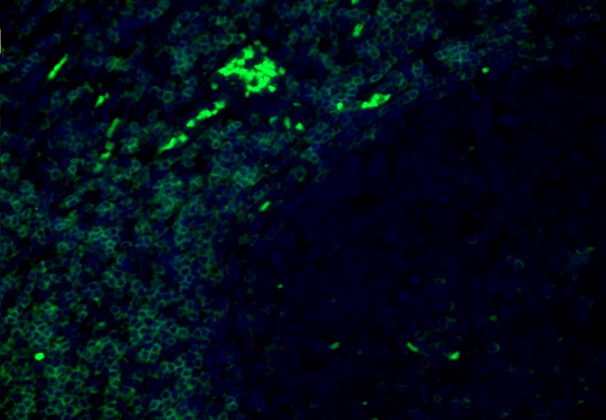
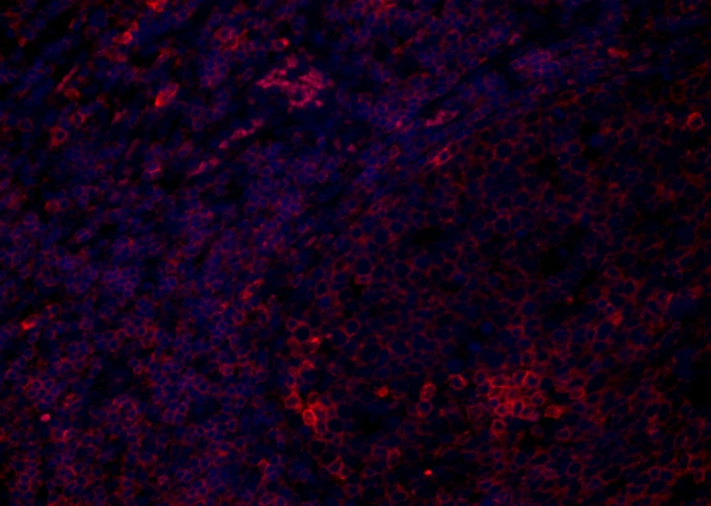
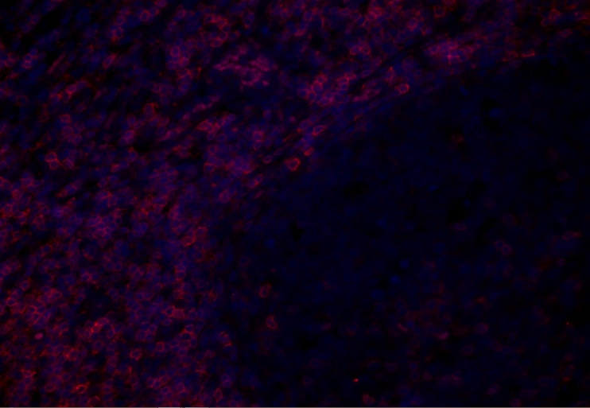
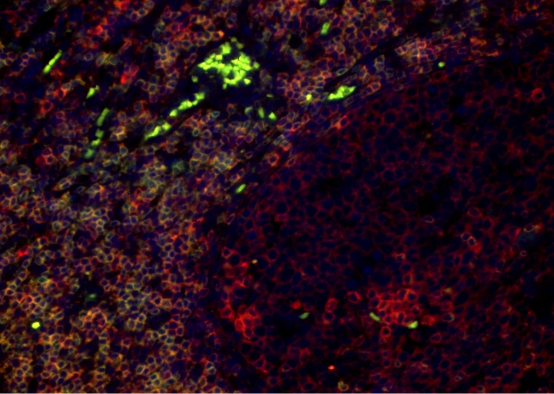
B
A

C
D

Figure 11. CD3⁺ cells emitting green fluorescent light (excluding auto-fluorescent bright green-filled spots) (A). CD27⁺ cells emitting red fluorescent light (B). CD8⁺ cells emitting rose-red fluorescent light (C). Overlay of pictures under different emission filters (CD3⁺, CD27⁺ and CD8⁺ cells overlaid) (D).

Quadruple staining on ovarian cancer tissue
Same markers, emission filters and secondary antibodies were used in quadruple staining of different T-cell sub-types in ovarian cancer tissue. In first picture (Figure 12) all four emission filters were used to observe all CD3, CD27 and CD8 positive cells plus DAPI nuclear staining. Stromal area and cancer regions were observed.
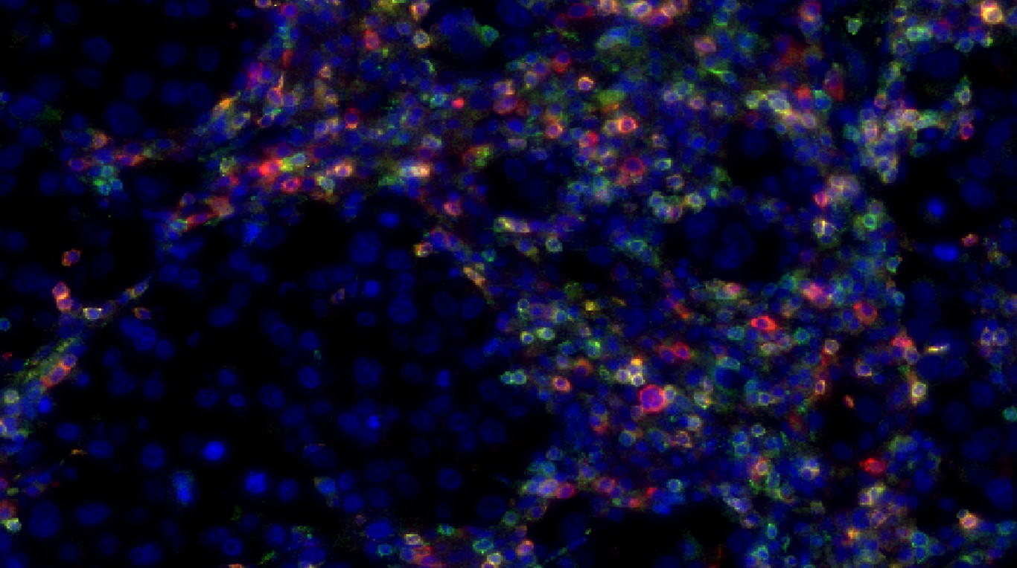

Qua

Figure 12. CD3⁺, CD27⁺ and CD8⁺ cells emitting green, red and yellow lights respectively. DAPI (blue colour) used for nuclear staining. CD3⁺ cells under GFP emission filter (green light) stained with Alexa Fluor 488 secondary antibodies. CD27⁺ cells under Cy3 emission filter (red light) stained with Cy3 secondary antibodies. CD8⁺ cells under Cy5 emission filter (yellow light) stained with Alexa Fluor 660 secondary antibodies.

Quadruple staining on ovarian cancer tissue + H&E overlay
Pictures in figure 13 represent separate acquisition of each cell subsets under different filter sets. Once again same markers, emission filters and secondary antibodies were used in quadruple staining of different T-cell sub-types in ovarian cancer tissue. Stromal area was observed. In first picture (Figure 13A) green light was emitted by CD3 markers and CD3⁺ cells (some auto-florescence can be observed) where in pictures figure 13B and 13C emitted light was from CD27 and CD8 positive cells (DAPI staining is removed to get clearer view of positive cells itself). In the last picture (Figure 13D) all three pictures (Figure 13A, B and C) were overlaid to create a general view of different cell subsets in the same area of ovarian cancer tissue. Therefore, different colour of the cell could show if it is single, double or even triple marker positive cell.

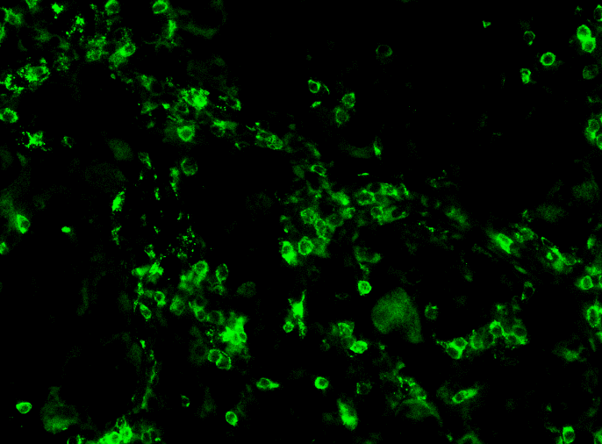
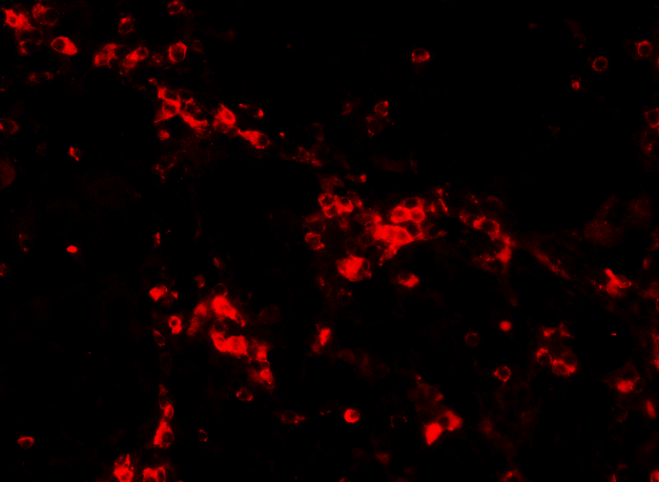
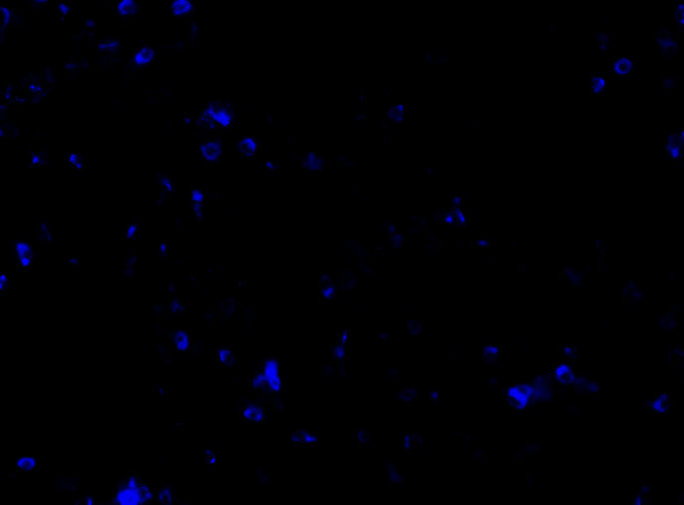
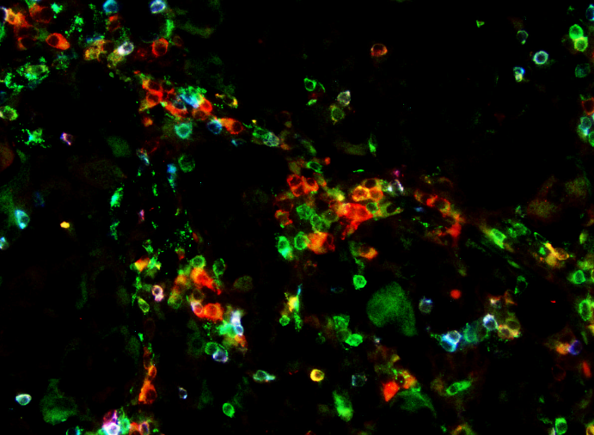
A
B

D
C

Figure 13. CD3⁺ cells emitting green fluorescent light (A). CD27⁺ cells emitting red fluorescent light (B). CD8⁺ cells blue fluorescent light (C). Overlay of pictures under different emission filters (CD3⁺, CD27⁺ and CD8⁺ cells overlaid) (D).

After acquiring pictures in figure 13 the slide with ovarian cancer tissue was quenched and counterstained with Haematoxylin and Eosin in order to have more properties (together with DAPI) in tracing stained cells that contained nucleus. After quenching and counterstaining same tissue fragment was acquired and pictures overlaid as shown in figure 14.
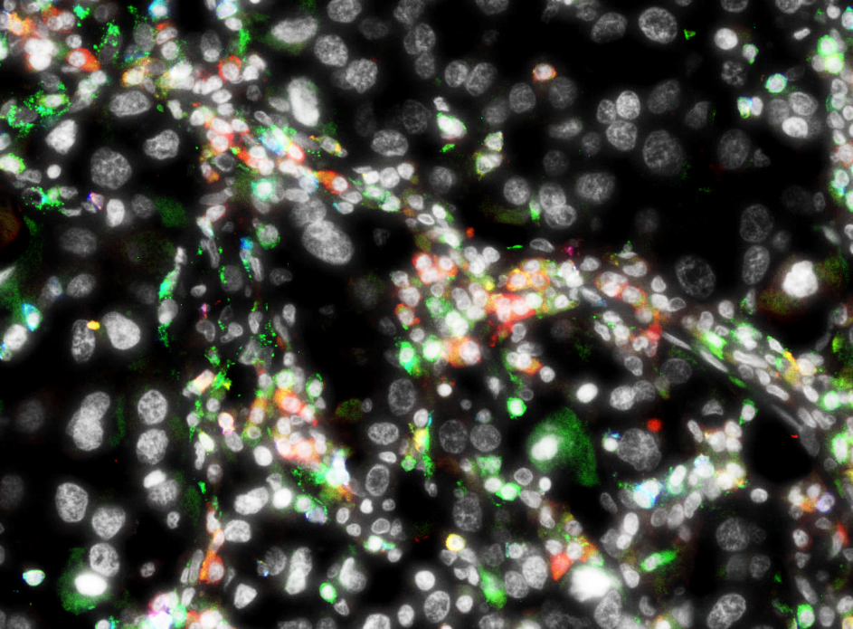

Figure 14. Overlaid fluorescent and H&E stained pictures.

Quadruple staining on ovarian cancer tissue and different T-cell subsets
Different colour emitted by specific marker showed if it is a single, double or even triple positive cell. In this case pictures acquired and shown in figure 13A, B and C were overlaid in different order overlaying two of them or all three (results are not shown). Therefore different cell subsets can be recognised. In addition of H&E and DAPI staining cell that have nucleus can be confirmed positive. Possible cell subsets that were found are shown in table 4.
Table 4. Cell subsets.
T-cell subsets: | Not a T-cells:
CD3+ CD8+ CD27+ | CD3- CD8- CD27+
CD3+ CD8+ CD27- | CD3- CD8- CD27-
CD3+ CD8- CD27+ | CD3- CD8+ CD27+
CD3+ CD8- CD27- | CD3- CD8+ CD27-

DISCUSSION

Different T-cell subsets and their localization in cancer tissues (in this case in ovarian cancer tissue) can reveal certain prognosis for ovarian cancer patients. In this work we recognised several T-cell subtypes in ovarian cancer tissue using fluorescent staining and combining it with H&E (multiplex microscopy). Although, further research needs to be done to evaluate those subtypes whether they infiltrate inside cancer tissue itself and what possible prognosis it can initiate. Though usage of fluorescent staining and possibly combining it with H&E or other staining techniques gives us a wider range of approach for further investigation of specific T-cell subsets infiltrating ovarian cancer and not only specifically ovarian cancer. Although not all of the cells observed under fluorescent microscopy that gave signal for chosen markers were T-cells.
CD3 is the main marker for T-cell recognition (Kuby et al., 2007) which is required for T-cell activation where CD3 associates with T-cell receptor (TCR) and creates activation signal. Therefore CD3 marker was selected in order to recognise T-cells in our experiments. Other type of T-cells expressing CD8 markers been selected because of its known ability to play a major role in antitumor activity and increasing survival rates (Bachmayr-Heyda et al., 2013), (Stumpf et al., 2009). CD8⁺ cells are a type of CD3⁺ T-cells also known as cytotoxic T-cells although not only CD3⁺ cells can co-express CD8 markers. Some cell subtypes already mentioned in results section like CD3⁻ CD8⁺ CD27^{-/+} are CD3 negative like Natural Killer cells (NK cells). CD8 markers can also be expressed on dendritic cells and cortical thymocytes (Baldwin et al., 2004) though CD3⁻ CD8⁺ CD27^{-/+} cells observed in our experiments and showed in results section are most probably NK cells relying on their location and shapes. In our control and ovarian cancer tissue results most CD8⁺ cells correlates with CD3⁺ cells showing cytotoxic T-cells. Moreover, in control slides (tonsil tissue) there are more CD8⁺ cells (Figure 11C) compared with ovarian cancer tissue (Figure 13C). This could be expected because tonsil contains higher levels of cytotoxic T-cells and works as a storage for T-cells while ovarian cancer tissue contain spars distribution of CD8⁺ cells where most of them are cytotoxic T-cells and only few of them could be NK cells. CD27 is a less differentiated marker comparing with CD3 and CD8. Mainly literature describes CD27 as a main B-cell marker (Agematsu et al., 2000) which would explain higher density and brighter signal of CD27⁺ cells in follicle area of tonsil (Figure 11B) where B-cells are mainly stored. Other articles (Kobafta et al., 1994), (Hintzen et al., 1995) suggests that CD27 is expressed on majority of T cells, B cells, and NK cells and plays an important role in T-cell activation. Therefore, majority of cells in tonsil tissue (Figure 11B) are positive and emits signal for CD27 marker. Similar results observed in ovarian cancer tissue (Figure 13B) where around 85% of T-cells cells are CD27⁺. As mentioned before CD27⁺ cells that are CD3⁻ or CD3⁻ CD8⁺ CD27⁺ subtypes are most probably NK cells where CD3⁻ CD8⁻ CD27⁺ could be other type of B-cells like immunoglobulin producing ones.
To conclude the results, it is seen that dominant subtype of T-cells in this experiment in ovarian cancer tissue are CD3⁺ CD8⁻ CD27⁺ where CD8+ cells are sparsely distributed. As mentioned before CD8+ and NK cells are correlated with better prognosis in ovarian cancer patients. As it is seen from the pictures and results obtained combining fluorescent staining together with picture overlaying and adding H&E staining we managed to adjust protocol (provided in appendix) for fluorescent staining combining it with other techniques that showed explicit results and helped us to clearly identify specific T-cell subsets in ovarian cancer tissue. Most popular technique used in tumour infiltrating cell tracing is IHC staining (immunohistochemical staining) therefore majority of our workflow was focused on adjusting fluorescent staining protocol to obtain clear results on specific markers using and combining different technique. More experiments should be done using higher quantity specific markers useful for identification and to have more properties to rely on analysing possible outcomes and prognosis. In recent literature there are very few cases that EOC has been assessed using multiplex fluorescent microscopy identifying immune cells and specifically their subtypes. In most of the cases experiments are highly specific for one or few markers and its association with disease and possible treatments. Multiplex fluorescent microscopy using multiple markers (fluorophores) and cell subsets in this case different T cell subsets infiltrating EOC is rare. Multiple identification of specific T cell subsets in EOC has been showed before many times although using immunohistochemistry (Giannakakis et al, 2014; Clarke et al., 2008; Webb et al 2014). As it is mentioned above most of these studies also more specific to one or few subsets comparing with our experiments showing 4 different parameters in one picture therefore identifying wider range of T cell subsets. However, wide range of available techniques and possibility to combine them can increase specificity and precision in order to detect specific tumour infiltrating cells and ovarian carcinomas in earlier stages.

APPENDIX

Protocol for IHC and quadruple fluorescent staining + DAPI
- Deparaffinize and rehydrate:
-Dewax in xylene (2x 10 min)
-100% alcohol
-96% alcohol
-70% alcohol
-Demi water

- Antigen retrieval:
-Preheat buffer in microwave (always 4 containers including buffer) until bubbling. Then insert slides into buffer container and keep heating for 15 min on 400W mark 10 mM Citrate buffer (pH 6)
-15 min cool down outside microwave (inside buffer container)
-Wash with PBS+0.05% Tween-20 (5 min, 3x)

- Staining:
-Block endogenous peroxidase: 0.75 ml H2O2 in 50 ml PBS (30 min)
-Wash with PBS+0.05% Tween-20 (5 min, 3x verversen)
-Dry thoroughly until all drops of liquid are gone
-Block slides with PBS 1% BSA, 1% AB serum, 30 min. at RT.
-Incubate with primary antibody (80 ul), (1:20 - 1:50 for most of our abs in PBS 1% BSA, 1% AB serum), overnight at 4°C (cold room).
-Wash with PBS+0.05% Tween-20 (5 min, 3x)
-Dry thoroughly until all drops of liquid are gone
-Incubate with secondary antibody, (1:150 for most of our abs in PBS 1% BSA, 1% AB serum) (Combination of DAPI, AF488, Cy3 and AF660/Cy5 is optimal in our hands), 30 min. at RT in the dark.
-Wash with PBS+0.05% Tween-20 (5 min, 3x) in the dark (tinfoil)
-Dry thoroughly until all drops of liquid are gone
-Add DAPI (1:100 – 1:1000) from stock solution, 20 min. at RT in the dark.
-Wash with PBS+0.05% Tween-20 (5 min, 3x) in the dark (tinfoil)
-Dry thoroughly until all drops of liquid are gone
-Add Prolong Gold Anti-fade mounting medium (Invitrogen) and cover with coverslip
-Store in the dark at 4°C (cold room).

H&E counterstain:
- -Wash the slide with PBS (by pouring PBS on it) until the coverslip is off
-Wash with demi water until slide is clean (from mounting media)
-Take a glass jar and store slide in Hematoxylin for 10 min (pour back Hematoxylin back to the bottle)
-Wash the slide in tap water
-Store the slide in Eosin for 2 min (pour back Eosin back to the bottle)
-Wash with alcohol (dehydrate)
-96% alcohol (Fles 1)
-96% alcohol (Fles 2)
-100% alcohol (Fles 1)
-100% alcohol (Fles 2)
(Pour the alcohol back into each of its bottles after use)
-Let the slide to dry out for 15 – 20 min
-Put the coverslip using Eukit mounting media

REFERENCES

Books:
Kindt J. T., Goldsby A. R., Osborne A. B. and Kuby J. (2007) Kuby immunology. W.H. Freeman, San Francisco, USA.
Leffers N. (2009) Targeted Immunotherapy for Ovarian Cancer. PrintPartners Ipskamp, Enschede, Netherlands.
Journals:
Agematsu K., Hokibara S., Nagumo H. et al. (2000) CD27: a memory B-cell marker. Immunology Today. 21(5): 204-206.
Bachmayr-Heyda A., Aust S., Heinze G. et al. (2013) Prognostic impact of tumor infiltrating CD8+ T cells in association with cell proliferation in ovarian cancer patients - a study of the OVCAD consortium. BMC Cancer. 13(422).
Baldwin T. A., Hogquist K. A., Jameson S. C. (2004) The fourth way? Harnessing aggressive tendencies in the thymus. J Immunol. 173(11): 6515–20.
Clarke B., Tinker A., Lee C., (2008) Intraepithelial T cells and prognosis in ovarian carcinoma: novel associations with stage, tumor type, and BRCA1 loss. Modern Pathology. 2008: 1-10.
Giannakakisa A., Karapetsasa A., Dangaj D. et al. (2014) Overexpression of SMARCE1 is associated with CD8+ T-cell infiltration in early stage ovarian cancer. Int. J. Biochem. Cell Biol. Vol 53: 389–398.
Hintzen R. Q., Lens S. M., Lammers K. et al (1995) Engagement of CD27 with its ligand CD70 provides a second signal for T cell activation. J Immunol. 154(6): 2612-23.
Kim A., Ueda Y., Naka T. et al (2012) Therapeutic strategies in epithelial ovarian cancer. J Exp Clin Cancer Res. 31:14.
Kobata T., Agematsu K., Kameoka J. et al. (1994) CD27 is a signal-transducing molecule involved in CD45RA+ naive T cell costimulation. J Immunol. 153(12): 5422-32.
Kurman R. J. and Shih M. (2010) The origin and pathogenesis of epithelial ovarian cancer: a proposed unifying theory. Am J Surg Pathol. 34(3):433-43.
Preston C. C., Goode E. L., Hartmann L.C., (2011) Immunity and Immune Suppression in Human Ovarian Cancer. Immunotherapy. 2011;3(4):539-556.
Stumpf M., Hasenburg A., Riener M. O., et al. (2009) Intraepithelial CD8-positive T lymphocytes predict survival for patients with serous stage III ovarian carcinomas: relevance of clonal selection of T lymphocytes. British Journal of Cancer. 101(9):1513-1521.
Webb J. R., Milne K., Watson P. (2014) Tumor-infiltrating lymphocytes expressing the tissue resident memory marker CD103 are associated with increased survival in high-grade serous ovarian cancer. Clin Cancer Res. 20(2):434-44.
Zhang L, Conejo-Garcia JR, Katsaros D et al.: Intratumoral T cells, recurrence, and survival in epithelial ovarian cancer. N. Engl. J. Med. 348(3), 203–213 (2003).
Websites:
“BioLegend” (2014) [Online] http://www.biolegend.com/alexa-fluor-647-anti-human-cd340-erbb2-her-2-antibody-3769.html [Accessed on 14-12-2014]
“Microbial Life: Educational Resources” (2013) [Online} http://serc.carleton.edu/microbelife/research_methods/microscopy/fluromic.html [Accessed on 14-12-2014)
“Society of Gynaecologic Oncology” (2014) [Online] https://www.sgo.org/wp-content/uploads/2012/09/FIGO-Ovarian-Cancer-Staging_1.10.14.pdf [Accessed on 14-12-2014]
“The Human Protein Atlas” (2014) [Online] http://www.proteinatlas.org/learn/dictionary/cancer/ovarian+cancer+2/detail+1 [Accessed on 14-12-2014]
“Treatment of invasive epithelial ovarian cancers, by stage” (2014) [Online] http://www.cancer.org/cancer/ovariancancer/detailedguide/ovarian-cancer-treating-by-stage [Accessed on 03-10-2015]

