Sterre Koops

S2365618, supervisor: prof. dr. J.C. Billeter, may 2016
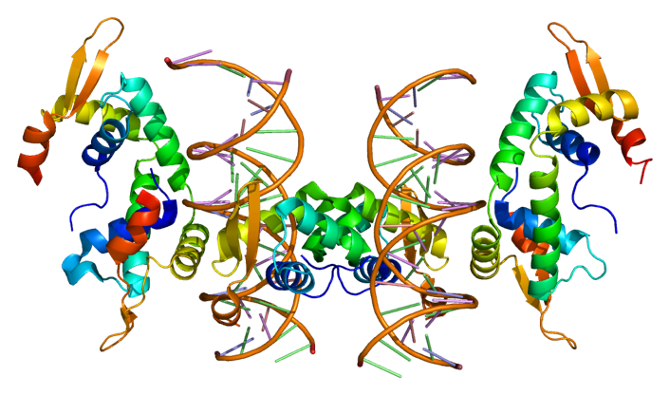
Faculty of Mathematics & Natural Sciences
University of Groningen

FOXP2

The language gene?

  - AN ANALYSIS OF THE ROLE THE FOXP2 GENE PLAYS IN THE DEVELOPMENT OF LANGUAGE IN HUMANS

B A C H E L O R T H E S I S

F O X P 2
The language gene?

An analysis of the role the
FOXP2 gene plays in the development
of language in humans

Sterre Koops
S2365618
May, 2016
Supervisor: Prof. Dr. J.C. Billeter
Faculty of Mathematics & Natural Sciences
University of Groningen
Source front page image: PyMOL, created by Emw, 2009

Word count: 6191

Table of Content

Inhoudsopgave
Table of Content 3
Abstract 4
Introduction 5
The evolution of mankind 5
The evolution of language 6
The Gossip Theory of Language 6
What is language? 8
Communication versus language 8
The biology of language 9
Grammar & complex syntax 10
FOXP2 11
Results 11
FOXP2, the gene 11
Evolutionary story of FOXP2 12
Mechanisms through which FOXP2 affects language 13
Comparison of the above with the biological mechanisms of language 15
Other genes involved in language 16
Childhood Apraxia of Speech (CAS) 16
Stuttering 17
Specific Language Impairment (SLI) and Dyslexia 17
Epilepsy-Aphasia Spectrum Disorders (EAS) 18
Conclusion 18
Acknowledgements 22
Further reading tips 22
Sources 23

Abstract

Language played a remarkable role in the evolution of humans and our culture, but to what extent does genetics relate to language? A gene, FOXP2, was found to have influence on the development of language and was soon named ‘the language gene’ among the more popular reports about FOXP2. If FOXP2 genuinely affects the development of language, it must play a role in the components that distinguish language from other forms of communication. Those components are grammar and complex syntax. Grammar most probably evolved due to the increase in group size in which humans lived, an idea grasped by the gossip theory of language. The human form of FOXP2, however, evolved before the group sizes were thusly big that grammar was needed. It therefore seems to play a role in communication as a whole, and not specifically to language. After examining the evolutionary story of FOXP2, the mechanisms through which FOXP2 affects language and other genes that seem to be involved in language, we can conclude that the evolution of the human form of FOXP2 was a necessary spark to ignite the origin of language, but there is much, much more to language. FOXP2 is a necessary gene for language, but cannot be presumed more important than certain other – cultural, biological, genetic – factors that contributed to the origin of language.

Introduction
Any reader of this paper has a vocabulary of his or her primary language containing around 50 000 words. We have the knowledge to understand the meaning of those words, and possess the ability to combine the words in a correct, understandable sentence. About a fourth of our vocabulary is already in our possession at the age of six. (Hurford, 2011) Language is a remarkable, often presumed uniquely human, quality. It can be viewed as a phenotype, which indicates that there is also a genetic architecture at the base of the quality. Unravelling this genetic architecture would allow us to understand the origin and evolution of language. And rather recently a gene was found that seems to play a role in speech production, opening up our view of that genetic architecture. That gene is FOXP2. This thesis will take a closer look at the genetic architecture and evolution of language in general and at the influence of FOXP2 in particular. To what extent does genetics relate to language? But first, we must define language, what makes it different from other forms of communication and why we consider language uniquely human. (Nowak, 2000) To do so, we will begin by taking a step back and look at how language evolved. After all, the light of evolution is needed to illuminate the context in which language came about, and traits – especially as complex as language – don’t suddenly arise out of nothing. Our closest relatives must have had access to – perhaps other, perhaps similar – forms of language.

The evolution of mankind
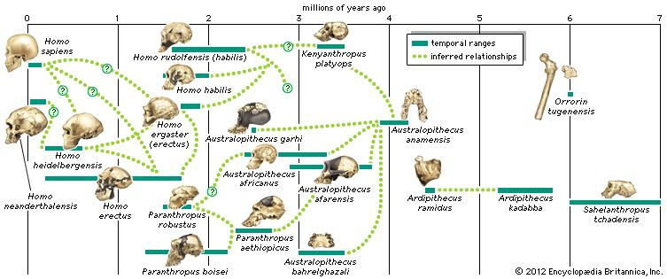
The species homo diverged from the apes somewhere between 7 to 13 million years ago, and branched into several species, including erectus, habilis, neanderthalensis and sapiens, as displayed in figure 1. But out of all those species, only one appears to have developed the ability to communicate in a very refined way, namely via language as we know it today: Homo sapiens. (Harari, 2012)
Figure 1: An illustration of the trunk on the tree of life that displays the lineage from which homo sapiens arose.

The evolution of language
The origin of language is a topic that initiated many discussions over many centuries, but no consensus has yet been reached. (Dunbar, 1996; Fitch, 2004; Goodall, 1986; Muller, 1885; Paget, 1930; Premack & Premack, 1984; Rappaport, 1999; Trivers, 1971) As Steels (2012) puts it: “Language and language processing is extraordinary complex and as we probe deeper into its origins we find more complexity than anyone ever imagined.” The main problem making the origin of language such a difficult topic, is the lack of direct evidence about its origin. (Steels, 2012) We can merely speculate about the forms of language that were used by our relatives, since no forms of physical records or evidence survived (if they ever existed). All arguments are based on inferences. (Tallerman & Gibson, 2011) Still, many theories try to unravel the emergence of this unique feature of mankind. (Dunbar, 1996; Fitch, 2004; Goodall, 1986; Muller, 1885; Paget, 1930; Premack & Premack, 1984; Rappaport, 1999; Trivers, 1971) Out of those theories, there is one which attracted my attention because it combines an evolutionary approach with the fact that humans are amongst the most social of animals. This theory is the gossip theory of language. (Dunbar, 1996)

The Gossip Theory of Language
Language is used to transfer information, whether this concerns the whereabouts of a predator, or creative ideas. The gossip theory of language argues that the most relevant information to transfer specifically via language is information about other people. This theory states that language evolved as a medium for gossip. Homo sapiens are very social animals and our social abilities helped us survive, thrive and climb up the food chain. Knowledge about other individuals and their social relationships (with yourself and others) is very important for creating a stable, coherent society. As individuals, we will never be stronger than a lion, but as a group, our combined intellect and strength can outsmart any animal. (Dunbar, 1996; Harari, 2012)

As shown in figure 2, group size has increased exponentially since the evolution of Homo erectus, a phenomenon that put a tremendous amount of pressure on the coherency of groups of Homo. This rapid increase in group size might have created an evolutionary pressure to develop a more efficient way for social interaction. Up until then, social grooming was probably the way used to bond social groups, but research has found that the maximum amount of time primates spend on this activity is 20% of waking hours. The time spent on social grooming would need to increase to 43% of the day for the group size typical to modern humans (figure 3).

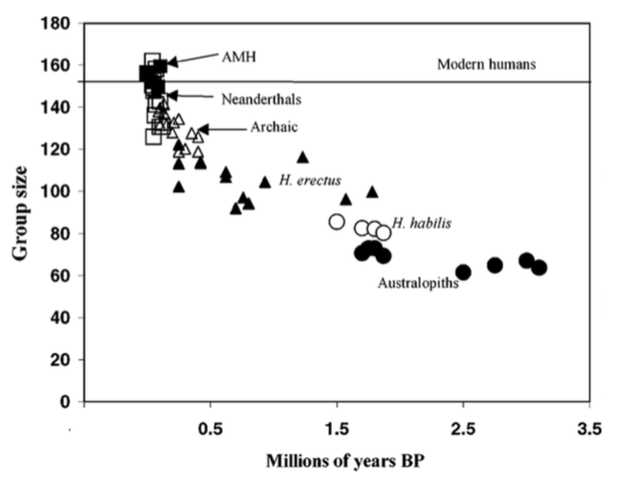
Figure 2: How average group size probably increased during the evolution of Homo. AMH = Anatomically Modern Humans.
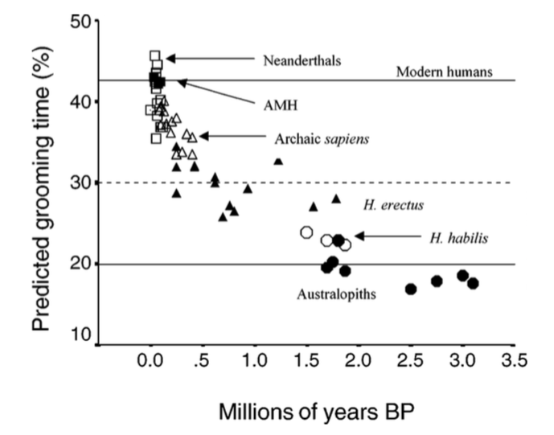

Figure 3: The predicted grooming time per Homo species, in percentage per day. The x-axis displays the millions of years ago that the named species lived. AMH = anatomically modern humans
“In the course of our human evolution, as we’ve been trying to evolve bigger and bigger groups to cope with the challenges that the world has thrown at us, we needed some additional mechanism to allow us to breakthrough what was effectively a glass ceiling”
Robin Dunbar
Dunbar is stating here that language probably evolved to bridge that gap in bonding time requirement, because it allowed time to be used more efficiently, because of three key features of language (Dunbar, 1996):
- Several individuals can be ‘groomed’ at once
- It is possible to timeshare with speech in a way that is not possible with grooming
- Language allows exchanging information about events within our social network that happened during our absence.
Sapiens most probably developed the best form of language, compared to their relatives, allowing them to extent their smaller groups the most and develop a closer and more refined collaboration. Because even though Neanderthals possessed the same version of FOXP2 as modern humans, and might have already possessed the physiological requirements for speech, it is likely that it was not at the same level as that of modern humans. Their maximum group size, as shown in figure 2, was still lower than the maximum group size of modern humans. (Dediu & Levinson, 2013; Harari, 2012)

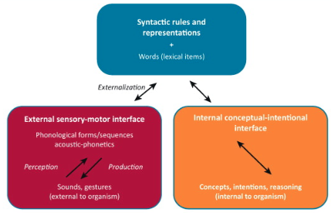
What is language?
All animals have some sort of communication, and some of them – like bees and ants – are even capable of very refined communication. (Harari, 2012) What is the difference between the language we speak, and the communication forms that other animals use?

Communication versus language
The grivet, or African green monkey, uses different types of alarm calls to alert the others for a specific type of predator. Grivets know whether they are being warned for lions (they would all hastily climb trees), or for eagles (and they would look fearful to the skies). (Harari, 2012) But even though grivets can be rather specific concerning the type of predator that is coming, we do not consider that to be language. We consider that to be communication. Language specifies the method of human communication in which words are phrased that are used in a structured and conventional way. It is one of many systems within the spectrum of communication, as shown in figure 4. But what is the key module that represents the beginning of language among this spectrum?
Figure 4: The basic design of communication. Most animals only communicate according to the red box, some animals’ communication also fits the description in the orange box, whereas the blue box is only represented in human’s main form of communication: language. (Berwick, 2013)

A person needs to master several components, before he or she has a proper native tongue. There is the biological aspect, making someone biologically capable of producing and hearing language, and there is the linguistic component, allowing someone to comprehend what the other is saying and producing correct sentences that others can understand. The latter involves components like vocabulary, pronunciation and grammar.

The biology of language
Several anatomical changes appeared in early Homo, in between the time period of 2.5 to 0.8 million years ago (see figure 1). Changes needed for the biological ability to acquire speech arose since the australopithecines, who developed a more L-shaped vocal tract necessary for speech-like vocalization. Other developments among other Homo-species were a smaller trachea, lowered larynx and finer muscle control of our face, all necessary for many of the sounds that modern humans can produce. The Neanderthal was most likely already anatomically able to speak. (Dediu & Levinson, 2013; Fitch, 2000; Krause et al., 2007b) Even the auditory system of modern humans evolved to create our improved perception of sounds within the 2-4 kHz range, which is the range in which the human voice lies. Besides these anatomical changes, our brain is also refined to deal with the complexity that is language. (Aronoff & Rees-Miller, 2001; Graham, Deriziotis, & Fisher, 2015; Johansson, 2006; Nowak, 2000)

Two brain areas are mostly associated with language, namely Broca’s area and Wernicke’s area (Figure 5). Broca’s area is concerned with the production of speech, while Wernicke’s area is involved with the comprehension of speech, and using the proper words to express our thoughts. Together they allow us to truly communicate with others, because we could not speak without Broca’s area, and we could not understand speech without Wernicke’s area. It is debatable whether these areas are uniquely human. Similar brain structures have been found in other animals, mainly mammals including primates, but since those animals are not capable of producing language, the question remains whether those areas are functional and not only anatomically similar between species, or whether they serve a completely different purpose. (Kean, 2016)

Although these biological aspects contribute to our ability to produce speech, this ability is useless if we don’t understand what the other is saying, or if one is misunderstood. This is why grammar is so important for language.
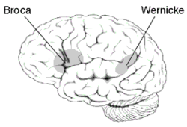

Figure 5: The location of broca’s area and wernicke’s area in the human brain. both areas are most often located in the left hemisphere. broca’s area is situated in the left inferior frontal gyrus, and wernicke’s area lies in the left posterior superior temporal gyrus. Source: carta.antrhopogeny.org, 2016.

Grammar & complex syntax
Syntax are the rules needed to construct a proper sentence, while grammar involves syntax among other sets of rules. Grammar is the overall term that involves all sets of rules in any given language. (Literary devices, 2016) Grammar, and then especially complex syntax, are the most valuable features of language. Without grammar, it does not matter whether we understand the words, because we might not understand the sentence. Grammar is therefore an important feature that separates human language from the broad spectrum of animal communication.

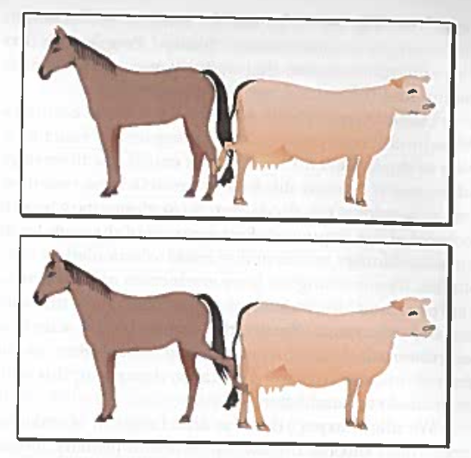
Grammar has been essential in the development of coherent, large societies. According to the gossip theory, language evolved to help us live in larger groups. But for gossip to work, it is important that information conveyed through language is truthful. Otherwise, gossip would never help us increase group coherence, because we would still not know who to trust and who not. Dishonest language is not an evolutionary stable strategy and would thus be expected to quickly be selected against, while it would not be beneficial for the increased group sizes in which humans live. Grammar is required for the information to be transferred truthfully. Many false conclusions can be drawn if someone cannot make up from a gossip whom is doing something to or with whom. The significance of grammar can become clear if we look at the assessment of grammatical ability among patients who suffer from Broca’s aphasia. Patients who suffer from Broca’s aphasia experience difficulty with producing fluent speech and also face trouble understanding complex grammatical constructs. (Carlson, 2014) When shown the picture in figure 6 and ask which one depicts a horse kicking a cow, patients with Broca’s aphasia often fail to show the picture in which ‘the horse kicks the cow’. (Berwick, Friederici, Chomsky, & Bolhuis, 2013; Carlson, 2014; Dunbar, 1996)
Figure 6: Assessment of grammatical ability. A person needs to show the picture in which ‘the horse kicks the cow’. source: Carlson, 2014

FOXP2
Even though there is still much debate concerning the origin of language, by now it is widely accepted that speech is an innate capacity of the human brain, and this innate capacity allows us to learn a language.

Genetic changes may underpin the reason why humans evolved language, but our relatives did not. (Matsuzawa, 2013) Despite other apes also being rather social animals, humans seem to be unique in the extent of their social drive, which increased the benefit-to-cost ratio of developing this complex and demanding communication system. A search for the genetic underpinning of language has therefore been of high interest. And in 1998 the genetic basis of this capability was thought to be found. (Vargha-Khadem, Gadian, Copp, & Mishkin, 2005) Half of the KE family suffered from a severe speech disorder, called developmental verbal dyspraxia, indicating that this speech disorder has a genetic basis following a dominant mode of inheritance. Geneticists from the University of Oxford identified the gene responsible for their condition, and named the gene FOXP2. Although we do not yet fully understand how the disruption of one copy of FOXP2 could induce such a severe speech and language disorder, it has become clear that FOXP2 plays a significant role in the most complex mechanical motion that the human body can execute: the fine muscle movements needed to produce speech. Most probably, FOXP2 has influences in our brain’s basic learning circuitry, allowing us to learn these fine muscle movements but exactly how remains an unanswered question. (Schreiweis et al., 2014)

Results

FOXP2, the gene
FoxP2 is located on chromosome 7 (see figure 7) and belongs to a gene family that produces proteins containing forkhead-box domains (Carlsson & Mahlapuu, 2002), known to have transcription factors function and hence to regulate gene expression. Indeed, FOXP2 controls the expression of target genes resulting in expression of other proteins in a temporally and spatially regulated manner. ‘FOXP2’s therefore function to regulate a cascade (or cascades) of other genes’. (Marcus & Fisher, 2003)

FOXP2 is not unique to Homo Sapiens. Mice and chimpanzees also have a version of FOXP2. That of mice is 93.5% identical to the human version. (Enard, Fisher, et al., 2002) However, a mouse squeaks, and – except maybe Mickey Mouse– no mouse ever spoke in words. So how did FOXP2 evolve to the similar yet significantly different versions between mice, apes and humans?
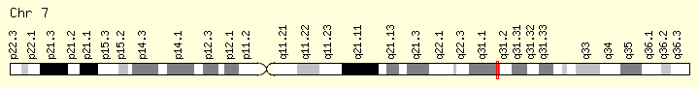

Evolutionary story of FOXP2
Due to the increasing availability of genome sequences, we can compare the human FOXP2 to versions of the gene found in other vertebrate species, including primates and two extinct hominid species, which are contemporary of early Homo sapiens, namely the Neanderthals and the Denisovans. (Gaya-Vidal and Alba 2014). The mouse lineages diverged from chimpanzee, gorilla and rhesus monkeys 75 million years ago, yet these two lineages have just one altered amino acid in the protein encoded by FOXP2, as seen in figure 8. The human FOXP2 differs in two amino acids from the chimpanzee’s, gorilla’s and rhesus monkey’s. (Enard, Fisher, et al., 2002) Research suggests that FOXP2 was already of significance in the development of the common ancestor of the humans and mice’s brain, probably for the development of certain aspects of motor control. (Krause et al., 2007)

Figure 7: The red line in the cytogenetic band displays the location of FOXP2, located at 7q31.1. Source: genecards.org
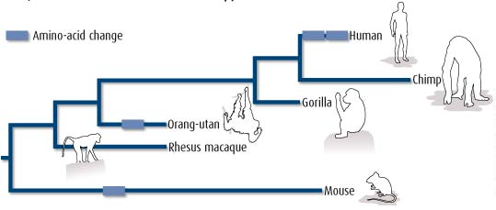
Figure 8: The lighter blue bars represent amino acid changes. One bar euqals one amino acid change. Source: Nature, vol. 418, P.869

The next step is the two mutations that took place at the time of the divergence of humans and chimpanzees, some 7 million years ago.

It is now thought that probably only one of these two changes is evident for speech development, while the second mutation may do nothing. This is evidenced by the observation that other mammals, mainly carnivores such as dogs and wolves, independently evolved this other “human” FOXP2 mutation, yet they do not show the necessary (neuro-)anatomical changes needed to produce speech. (Callaway, 2011)

Neanderthals might have been chattier than we initially realised, since both mutations that occurred in Homo sapiens have also been found in Neanderthals, indicating that the mutations arose before both hominid populations diverged, 500,000 years ago. (Krause et al., 2007b) Neanderthals were therefore probably also able to make the finer muscle movements needed to produce language.

Even though the fine muscle movements partially resulted in FOXP2 to be labelled as a language gene, the gene is expressed in several more parts of the human body, such as the brain, heart, lung, gut (Lai, Fisher, Hurst, Vargha-Khadem, & Monaco, 2001; Marcus & Fisher, 2003; Shu, Yang, Zhang, Lu, & Morrisey, 2001; Vargha-Khadem et al., 2005) and several tissues. (Lai et al., 2001) Yet, we will concern ourselves with those parts that are of influence on language.

Mechanisms through which FOXP2 affects language
The exact role of FOXP2 in regulating certain genes, and thus certain pathways in the brain, remains unknown. Yet, research has been able to identify some genes that are most probably regulated by FOXP2. (Vernes et al., 2011)

Vernes (2011) and her team have used genome-wide techniques to identify FOXP2’s major targets. All the target genes have been categorised, as shown in figure 9. Their main finding was that FOXP2 effects mostly genes – directly and indirectly – that are involved with modulating the wiring of neural connections, by altering the length and branching of neuronal projections. Because of this, FOXP2 can be linked to specific pathways within the brain and therefore might take a cardinal place in the language and speech network of the brain. Indeed, FOxP2 seems to regulate the genes that are responsible for the wiring of neural connections between different language-related regions in the brain. (Vernes et al., 2011)

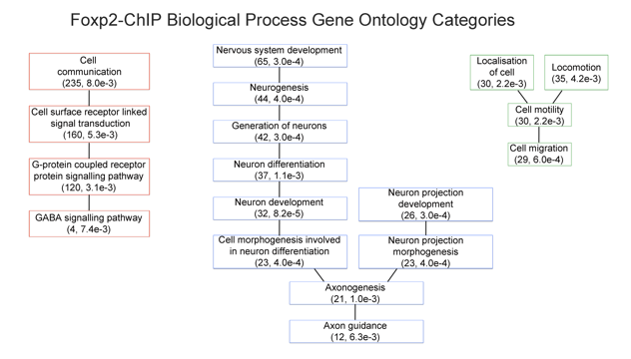
Figure 9: Gene ontology categories in which FOXP2 is most probably involved. Beneath the category is stated how many genes were found per category, and the P-value, respectively.

Despite the fact that the exact role of FOXP2 in language development is still unknown, implications have been made for its role in developing and modulating pathways. (Lai et al., 2001) A closer look into the differences between affected and unaffected family members of the KE-family helped determine probable neuronal circuits in which FOXP2 almost certainly plays a role. (Vargha-Khadem et al., 2005) A broad voxel-based morphometry (VBM) analyses displayed bilateral abnormalities in several motor-related regions, such as the caudate nucleus, which was reduced in volume. (Vargha-Khadem et al., 1998; Watkins et al., 2002) The results from the analyses implied a relationship between the unusual development of the caudate nucleus and the deterioration of oromotor control and articulation among the affected KE-family members. Abnormally low levels of grey matter in Broca’s area, the precentral gyrus, the temporal pole, the head of the caudate nucleus and the ventral cerebellum were observed, along with a high level of grey matter in Wernicke’s area, the angular gyrus and the putamen. (Salmond, Ashburner, Vargha-Khadem, Gadian, & Friston, 2000)

Functional neuroimaging studies during human speech revealed a typical left-dominant pattern of activation involving Broca’s area and a more bilateral distribution were found in the unaffected KE-family members, whereas the affected family members displayed a more posterior and more extensively bilateral pattern of activation. The affected family members also showed significantly less activation in Broca’s area and in the putamen, compared to unaffected family members. Finally, the affected family members displayed overactivation in regions that normally are not involved in language, such as the postcentral, posterior parietal and occipital regions, implying a possible form of compensation by other neuronal circuits, or extra cognitive effort that was required by the affected family members to perform the tasks.

All these findings suggested that a point mutation in the FOXP2 gene affects the development of two main neural circuits, namely the fronto-striatal and fronto-cerebellar circuits, which are shown in figure 10. The fronto-striatal circuit lets the frontal cortex interplay with the accumbens nucleus. The fronto-cerebellar circuit is a one-way lap, beginning and ending in the frontal cortex, and going via the cerebellum and the thalamus. Both networks engage with learning and performing manual and other motor sequences. The language related processes they are evidential for are learning, planning and the execution of orofacial and speech motor sequences. (Li, Weidenfeld, & Morrisey, 2004; Shu et al., 2001)

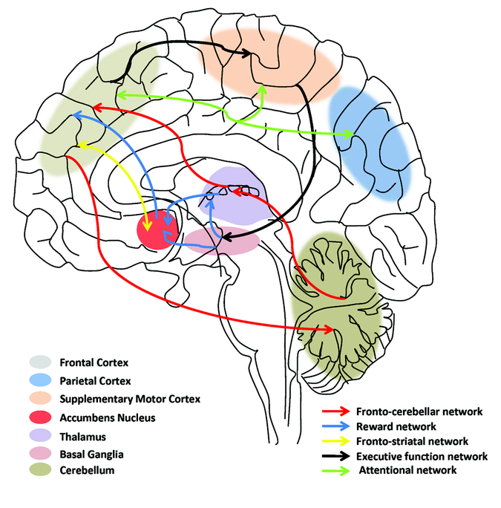

Figure 10: The fronto-cerebellar network connects the frontal cortex to the cerebellum and the cerebellum via the thalamus back to the frontal cortex (see the red arrows). The fronto-striatal network connects the frontal cortex to the accumbens nucleus (see the yellow arrows). Source: Pediatric research (2011) 69, 69R-76R.

So, even though the way in which FOXP2 affects those circuits is still not determined, a mutation of the gene does have a great effect on those many different regions within the brain. (Lai et al., 2001) “I’m not a person who necessarily believes that one gene is going to tell us everything, but this was really quite remarkable and does place FOXP2 in a relatively central position,” says Geschwind. He talks about how FOXP2 is partially responsible for quite some networks previously associated with language. Especially since those networks seem to cover rather a lot about our understanding of language. But how influential does FOXP2 remain if we take a closer look at the weight of those networks for the development of language? (Konopka et al., 2009a)

Comparison of the above with the biological mechanisms of language
We just looked at the neural processes in which FOXP2 is involved. The most prominent processes being the fronto-striatal and fronto-cerebellar networks, and networks evidential for the learning, planning and execution of orofacial and speech motor sequences. Now we will place those processes on the scale to get a better understanding of just how important they are for the development of speech and language.

Fronto-striatal circuits are involved in motor, cognitive and behavioural functions within the brain. If one looks at the executive functions of this circuit – selection and perception of important information, manipulation of information in working memory, planning and organization, behavioural control and decision making (Vargha-Khadem et al., 2005) – it sounds logical that it would also involve language, even though language is probably just one point within the broad spectrum of tasks that can be partially defined by this circuit. All those executive functions can be related to language and speech in one way or another.

The same goes for the fronto-cerebellar networks. The left hemisphere version of this circuit is responsible for activating responses to stimuli, while the right version searches for the response that is given for certain stimuli. Again, this might be involved with language – considering responses that need to be given and received in a conversation – but probably among many other tasks. Even though the pathways of both networks are partially similar, they do mainly touch upon different parts of the human brain, as shown in figure 10.

Next, FOXP2 was also involved with the networks that are evidential for learning, planning and the execution of orofacial and speech motor sequences. Learning and planning are both, once more, very relevant for language, but are also essential for other characteristics. And even though most functions are often applicable for multiple features, it also makes for not being able to exclude other options in defending the purpose or main target of a gene.

The influence of FOXP2 on the execution of orofacial and speech motor sequences marks for a more framed argument. The fine muscle movement is of high significance for our ability to produce speech, and most other functions that are executed by these movements, could probably still be executed even if the muscle were less refined. This is not the case for language. For language, those muscle movements need to be extremely refined in order for us to pronounce all the words correctly and make ourselves understandable. (Vargha-Khadem et al., 2005)

Other genes involved in language
FOXP2 is the first gene to be discovered that has to do with language and speech, but our abilities for language and speech most probably have a complex genetic architecture. And just like the situation that lead to the discovery of the FOXP2 gene, most genes underpinning human speech and language were found via studies of developmental communication disorders. (Graham et al., 2015) What will follow is a brief overview of the genes found or presumed to be associated with certain disorders that can be placed in the collective developmental communication disorders.

Childhood Apraxia of Speech (CAS)
CAS is a motor speech disorder, that gives children trouble pronouncing words, due to the fact that their brain has difficulty planning the movements of body parts that are necessary for speech, such as the lips, jaw and tongue. However, it is not a muscle weakness. This is also the disorder that the affected half of the KE family has been diagnosed with. (Fisher, Vargha-Khadem, Watkins, Monaco, & Pembrey, 1998)

Even though a small amount of people suffering from CAS also have a mutation in their FOXP2 gene, the BCL11A gene is probably of higher importance. BCL11A is a transcription factor which plays a role in regulating the expression of hemoglobine. (Kuo, Hong, & Hsueh, 2009; Sankaran, Xu, & Orkin, 2010)

The ERC1 gene seems also related to language, and a deletion of it was found in patients who suffered from delayed speech development, and who had been therefore diagnosed with CAS. (Thevenon et al., 2013) Unbalanced 4q;16q translocation and microdeletions in 16p11.2 have also been found to probably increase the risk of CAS. (Newbury et al., 2013; Raca et al., 2013)

It is difficult to state how many cases of CAS are caused by a mutation in the FOXP2 gene, since most published studies are looking into a rather small amount of cases. (MacDermot et al., 2005) This also results in an uncertainty on whether other genes might play a bigger role in the development of CAS than FOXP2, even though it is thought that the BCL11A gene is probably of higher importance. Fact remains that also in the research of the BCL11A gene, the sample size consisted of a handful of cases. (Kuo et al., 2009; Sankaran et al., 2010)

Stuttering
Stuttering is a disease that affects the fluency of someone’s speech, often by repeating the first sound of words. However, most of the time affected individuals have no further issues concerning their language, cognition or motor function. (Barnes et al., 2016)

The GNPTAB, GNPTG and NAGPA genes are affected in patients who stutter. Linkage studies in several populations have been performed, implicating multiple genomic loci and different modes of inheritance. (Domingues et al., 2014; Kang & Drayna, 2011; Hashim Raza et al., 2013; Hashim Raza, Amjad, Riazuddin, & Drayna, 2012) After a linkage peak was found on chromosome 12, sequencing of all the genes in that specific region resulted in identifying a missense mutation in the GNPTAB gene. (Kang et al., 2010) Further targeted sequencing found even more missense variants in GNPTAB, and in the related genes GNPTG and NAGPA. Yet the mechanisms that lie behind these mutations and how they result in stuttering remain unclear. (Barnes et al., 2016; Kang et al., 2010)

They are all involved with enciphering enzymes that affect the mannose-6-phospate pathway for lysosomal enzyme targeting. (Coutinho, Prata, & Alves, 2012)

More current research by the same team as Kang et al found an excess of rare coding variants in GNPTAB and NAGPA. (Han et al., 2014) Another team, Barnes et al (2016), showed that mice with a human GNPTAB stuttering mutation let out fewer vocalizations and had longer pauses between the vocalizations.

However, most research is still conducted by the same research group, and more independent replication research should be done concerning this theme. Currently, we cannot yet determine what the overall contribution to stuttering is of the mutations in the GNPTAB, GNPTG and NAGPA genes.

Specific Language Impairment (SLI) and Dyslexia
SLI is a disorder in which a child is unable to develop language normally, while not suffering from a general slow development, physical abnormality of the speech apparatus or other disorders and diseases which otherwise could have caused it.

Someone with dyslexia has trouble reading which is, just like with SLI, not related to slow development or general problems with overall intelligence. Because SLI and dyslexia have high levels of comorbidity, it is thought that the nature of the flaws in the genetic architecture might be similar. (Pennington & Bishop, 2009)

Over a decade ago, the first leads to the genetic architecture underpinning these disorders were identified via linkage studies. Via association screening of polymorphic markers within the target interval, KIAA0319, DCDC2, and MRPL19/C2ORF3 were identified as involved genes with dyslexia and for SLI CMIP and ATP2C2 were found. (Anthoni et al., 2007; Francks et al., 2004; Meng et al., 2005; Newbury et al., 2009)

These genes seem to be mostly located in non-coding regions of the genome, which makes any further research difficult since the biological role of much non-coding DNA is poorly understood. This is mainly an issue in designing appropriate assays to further test these genes. (Graham et al., 2015)

But many studies have tried to test these candidate genes and the results are varied. (Carrion-Castillo, Franke, & Fisher, 2013; Paracchini, 2011; Paracchini et al., 2008; Scerri et al., 2011) Some studies support the claim of association of the candidate genes with either dyslexia or SLI, while others disagree. It has been implied that this might be partially due to arbitrary statistical thresholds or that the first studies that looked at the genetic architecture of these disorders presented false-positives. (Carrion-Castillo et al., 2013; Newbury, Monaco, & Paracchini, 2014)

Epilepsy-Aphasia Spectrum Disorders (EAS)
EAS disorders is the collective name for patients suffering from epilepsy that affiliated with language impairments.

It is not yet quite clear what the genetic foundations are for EAS disorders, but in 10 – 20 % of the cases in which patients suffered from EAS, heterozygous disruptions of GRIN2A have been found (Carvill et al., 2013; DeVries & Patel, 2013; Lemke et al., 2013; Lesca et al., 2013), a gene that – when mutations have occurred – disrupts the ability of the ion channel to open and close. This channel is central to synaptic plasticity. (Fan, Jin, & Wang, 2014; Lesca et al., 2013)

All in all, these studies that often contradict mostly show the place in which the research to the genetic architecture of language disorders is – still in its infancy. But one way to progress might be via larger sample sizes with the use of GWAS studies – genome-wide association studies to examine the common genetic variations among different individuals.

Conclusion
We now have tried to grasp a small part of the immense and complex evolution of language, especially its origins, by examining the role of a specific gene, FOXP2, in the development of language. How did this gene come about, and how does this relate to the evolution of language?

After examining the current research on the approximate dates of the development of the human version of FOXP2 and grammar, I created a timeline, shown in figure 11. The evolution of the human FOXP2 was probably critical for the development of speech, and to a further extent for the development of fully human society and cognition. (Enard, Przeworski, et al., 2002) FOXP2 lay down the basis for language, and allowed it to grow, but it remains part of communication as a whole, and specifically to language.

Figure 11: The figure above displays a rough timeline of the history of the evolution of language. FOXP2 developed to its human form before the divergence of Neanderthals and Homo sapiens. However, grammar did not evolve until after that divergence, proposing that FOXP2 has not been directly involved with the evolving of grammar with the homo sapiens society.

Most of the neuronal circuits regulated by FOXP2 are not only (or mainly) language-specific. The fronto-striatal and the fronto-cerebellar networks support functions such as decision making or planning and organization. And while this is a common feature of circuits within the brain, in the case of FOXP2, a gene of which its function is the heart of this debate, it marks only the difficulty of framing the function of FOXP2, without actually progressing the debate.

FOXP2’s role in the fronto-cerebellar network does not automatically causally link with its role in the development of language. The fronto-cerebellar network is also found in non-human primates (Krienen & Buckner, 2009), despite their inability to produce language. This network controls many motor functions among the non-human primates. Due to the rather broad function of the fronto-cerebellar network, this is not disturbing for its role in language and speech, but depicts once more the trouble of giving FOXP2 the partial responsibility for language. FOXP2 does seem to play an evidential role in in the networks involved with learning, planning and executing orofacial movements and speech motor sequences. But we defined language as speech that involves grammar, so this is still not a clear argument to build the case for FOXP2 as ‘the gene for language’.

FOXP2 has an overarching function and possibly regulates thousands of genes, and those genes might include the other genes involved with language or communication. But the research into the function of these other genes is still in its infancy, and therefore the debate on the true function of these genes remains unresolved. To add to this insecurity, it remains difficult to know to what extent these genes act upon their own, or whether they are directly or indirectly governed by FOXP2. This might imply that for now FOXP2 does remain the most significant language related gene, due to its overarching function, but they all remain parts of the greater whole that is language. In the end it seems that FOXP2 is not responsible for language, but for communication. (Konopka et al., 2009b; Spiteri et al., 2007; Vernes et al., 2007)

Language was made possible by the invention of grammar. But ‘how much grammar does it take to sail a boat?’ asks David Gil (2005): ‘Virtually none’ is the answer. Those practical tasks such as building a boat might have been made easier thanks to grammar, but we would not have needed it. And the ability to built ships is not what made the Homo sapiens thrive the way they did – It is very likely that Homo erectus already built seaworthy rafts. (Gil, 2005) Grammar would, however, be evolutionary favoured if the group in which the species lives grows ‘too’ big. That is what happened with the Homo sapiens. And by the time that grammar became favourable within our species’ society, we already gained the ability to produce words thanks to the fine motor skills developed due to the (probably one of the) final two mutations in the FOXP2 gene. But even though FOXP2 handed us the ability to talk, it probably did not induce language. Our genetic evolution created the necessities to acquire and produce language, but it has been a cultural change that allowed for language to truly develop.

The connection between the human-specific FOXP2 and speech or language remains tricky. What we can learn from the KE-family is that FOXP2 is definitely necessary for speech development. But the crux of the problem remains: FOXP2 is a multifunctional gene, and it should not rigidly be matched to such a complex, high level phenotype as language. Language encompasses so many pathways and demands support from macro to micro levels, from muscles to cells. According to Preuss (2013) ‘it is not even realistic to think that the development of such systems has simple genetic triggers’. Language is just too complex, and too many systems are involved in allowing a person to produce normal language, and get involved in conversations with others, that it seems highly unlikely that one gene could be held responsible for all that. It is more likely that a genetic architecture that underpins language is as complex as language itself. (Preuss, 2013)

In the end, we are left with many theories about the role of FOXP2, and also about the origin of language, but scarce evidence to support them. However, looking at the direct and indirect evidence I gathered in this thesis, I would like to conclude with a final metaphor, one that is also displayed in figure 12. Imagine language being the house we surround ourselves with, it is our home which door allows us to invite people into our lives and socialize. Before we could build that house, we took hold of all the materials needed. Some of those materials will be used to create the foundation of the house. Other material will be used to build the rest of the house – stones, glass for the windows, tiles for the roof. Other genes, and other biological adaptations might have been the stones necessary to build the walls, and FOXP2 might have been the foundation on which the rest could be built. But not until we had enough manpower could and did we truly built the house.

Figure 12: Language is displayed as a house, that is created from several building blocks (language genes other than FOXP2, biological adaptations and other smaller cultural changes), which we gained throughout time. And the house needed foundations (the human-specific FOXP2). But those foundations and building blocks never became a house, if it weren’t for the manpower needed to truly build it.

Not until we, humans, were with enough people did we develop language, even though we already had all the building blocks long before that moment arrived. But that does not diminish the value of FOXP2, hence why it is viewed as the foundation of the house. It might not have been responsible for our development of language, but it was of great necessity.

Acknowledgements
I would like to thank prof. Dr. J.C. Billeter for his clear and helpful feedback and his many useful tips during this writing process.

Further reading tips
Origins of the Modern Mind – Merlin Donald

Doctor Dolittle’s Delusion: Animals and the Uniqueness of Human Language – Stephen R. Anderson

From animals into Gods. A Brief History of Humankind – Yuval Noah Harari

Grooming, Gossip, and the Evolution of Language – Robin Dunbar

Sources

Anthoni, H., Zucchelli, M., Matsson, H., Müller-Myhsok, B., Fransson, I., Schumacher, J., … Peyrard-Janvid, M. (2007). A locus on 2p12 containing the co-regulated MRPL19 and C2ORF3 genes is associated to dyslexia. Human Molecular Genetics, 16(6), 667–77. http://doi.org/10.1093/hmg/ddm009
Aronoff, M., & Rees-Miller, J. (2001). The Handbook of Linguistics. Retrieved May 30, 2016, from https://leseprobe.buch.de/images-adb/8e/cd/8ecd6d18-8b9a-4f86-b929-aa1ae68402e5.pdf
Barnes, T. D., Wozniak, D. F., Gutierrez, J., Han, T.-U., Drayna, D., & Holy, T. E. (2016). A Mutation Associated with Stuttering Alters Mouse Pup Ultrasonic Vocalizations. Current Biology, 26(8), 1009–1018. http://doi.org/10.1016/j.cub.2016.02.068
Berwick, R. C., Friederici, A. D., Chomsky, N., & Bolhuis, J. J. (2013). Evolution, brain, and the nature of language. Trends in Cognitive Sciences. http://doi.org/10.1016/j.tics.2012.12.002
Callaway, E. (2011). “Language gene” speeds learning. Nature. http://doi.org/10.1038/nature.2011.9395
Carlson, N. R. (2014). Physiology of Behavior. Retrieved May 30, 2016, from https://www.pearsonhighered.com/product/Carlson-Physiology-of-Behavior-11th-Edition/9780205239399.html
Carlsson, P., & Mahlapuu, M. (2002). Forkhead Transcription Factors: Key Players in Development and Metabolism. Developmental Biology, 250(1), 1–23. http://doi.org/10.1006/dbio.2002.0780
Carrion-Castillo, A., Franke, B., & Fisher, S. E. (2013). Molecular genetics of dyslexia: an overview. Dyslexia (Chichester, England), 19(4), 214–40. http://doi.org/10.1002/dys.1464
Carvill, G. L., Regan, B. M., Yendle, S. C., O’Roak, B. J., Lozovaya, N., Bruneau, N., … Mefford, H. C. (2013). GRIN2A mutations cause epilepsy-aphasia spectrum disorders. Nature Genetics, 45(9), 1073–6. http://doi.org/10.1038/ng.2727
Coutinho, M. F., Prata, M. J., & Alves, S. (2012). A shortcut to the lysosome: the mannose-6-phosphate-independent pathway. Molecular Genetics and Metabolism, 107(3), 257–66. http://doi.org/10.1016/j.ymgme.2012.07.012
Dediu, D., & Levinson, S. C. (2013). On the antiquity of language: the reinterpretation of Neandertal linguistic capacities and its consequences. Frontiers in Psychology, 4, 397. http://doi.org/10.3389/fpsyg.2013.00397
DeVries, S. P., & Patel, A. D. (2013). Two patients with a GRIN2A mutation and childhood-onset epilepsy. Pediatric Neurology, 49(6), 482–5. http://doi.org/10.1016/j.pediatrneurol.2013.08.023
Domingues, C. E. F., Olivera, C. M. C., Oliveira, B. V, Juste, F. S., Andrade, C. R. F., Giacheti, C. M., … Drayna, D. (2014). A genetic linkage study in Brazil identifies a new locus for persistent developmental stuttering on chromosome 10. Genetics and Molecular Research : GMR, 13(1), 2094–101. http://doi.org/10.4238/2014.March.24.13
Dunbar, R. I. M. (1996). Grooming, Gossip and the Evolution of Language. Retrieved May 30, 2016, from http://www.christopherseddon.com/2009/05/grooming-gossip-and-evolution-of.html
Enard, W., Fisher, S. E., Przeworski, M., Lai, C. S. L., Wiebe, V., Kitano, T., … Pääbo, S. (2002). Molecular evolution of FOXP2, a gene involved in speech and language. Nature, 418(6900), 869–72. http://doi.org/10.1038/nature01025
Enard, W., Przeworski, M., Fisher, S. E., Lai, C. S. L., Wiebe, V., Kitano, T., … Pääbo, S. (2002). Molecular evolution of FOXP2, a gene involved in speech and language. Nature, 418(6900), 869–72. http://doi.org/10.1038/nature01025
Fan, X., Jin, W. Y., & Wang, Y. T. (2014). The NMDA receptor complex: a multifunctional machine at the glutamatergic synapse. Frontiers in Cellular Neuroscience, 8, 160. http://doi.org/10.3389/fncel.2014.00160
Fisher, S. E., Vargha-Khadem, F., Watkins, K. E., Monaco, A. P., & Pembrey, M. E. (1998). Localisation of a gene implicated in a severe speech and language disorder. Nature Genetics, 18(2), 168–70. http://doi.org/10.1038/ng0298-168
Fitch, W. (2000). The evolution of speech: a comparative review. Trends in Cognitive Sciences, 4(7), 258–267. Retrieved from http://www.ncbi.nlm.nih.gov/pubmed/10859570
Fitch, W. T. (2004). Kin Selection and "Mother Tongues’': A Neglected Component in Language Evolution. Retrieved May 30, 2016, from http://groups.lis.illinois.edu/amag/langev/paper/fitch04kinSelection.html
Francks, C., Paracchini, S., Smith, S. D., Richardson, A. J., Scerri, T. S., Cardon, L. R., … Monaco, A. P. (2004). A 77-kilobase region of chromosome 6p22.2 is associated with dyslexia in families from the United Kingdom and from the United States. American Journal of Human Genetics, 75(6), 1046–58. http://doi.org/10.1086/426404
Gil, D. (2005). Isolating-Monocategorial-Associated Language. Retrieved May 30, 2016, from http://email.eva.mpg.de/~gil/complexity/abstracts/Gil.pdf
Goodall, J. (1986). The Chimpanzees of Gombe: Patterns of Behavior. Retrieved May 30, 2016, from https://www.goodreads.com/book/show/822658.The_Chimpanzees_of_Gombe
Graham, S. A., Deriziotis, P., & Fisher, S. E. (2015). Insights into the genetic foundations of human communication. Neuropsychology Review, 25(1), 3–26. http://doi.org/10.1007/s11065-014-9277-2
Han, T.-U., Park, J., Domingues, C. F., Moretti-Ferreira, D., Paris, E., Sainz, E., … Drayna, D. (2014). A study of the role of the FOXP2 and CNTNAP2 genes in persistent developmental stuttering. Neurobiology of Disease, 69, 23–31. http://doi.org/10.1016/j.nbd.2014.04.019
Harari, Y. N. (2012). Sapiens: A Brief History of Humankind. Retrieved May 30, 2016, from http://www.ynharari.com/
Hurford, J. R. (2011). The Origins of Grammar. Retrieved May 30, 2016, from https://global.oup.com/academic/product/the-origins-of-grammar-9780199207879?cc=nl&lang=en&
Johansson, S. (2006). Origins of Language: Constraints on Hypotheses. Retrieved May 30, 2016, from https://www.jstor.org/stable/4143902?seq=1#page_scan_tab_contents
Kang, C., & Drayna, D. (2011). Genetics of speech and language disorders. Annual Review of Genomics and Human Genetics, 12, 145–64. http://doi.org/10.1146/annurev-genom-090810-183119
Kang, C., Riazuddin, S., Mundorff, J., Krasnewich, D., Friedman, P., Mullikin, J. C., & Drayna, D. (2010). Mutations in the lysosomal enzyme-targeting pathway and persistent stuttering. The New England Journal of Medicine, 362(8), 677–85. http://doi.org/10.1056/NEJMoa0902630
Kean, M. L. (2016). Broca’s and Wernicke's Aphasia. Retrieved May 30, 2016, from http://www-rohan.sdsu.edu/~gawron/intro/course_core/lectures/aphasia_cases_slides.html
Konopka, G., Bomar, J. M., Winden, K., Coppola, G., Jonsson, Z. O., Gao, F., … Geschwind, D. H. (2009a). Human-specific transcriptional regulation of CNS development genes by FOXP2. Nature, 462(7270), 213–7. http://doi.org/10.1038/nature08549
Konopka, G., Bomar, J. M., Winden, K., Coppola, G., Jonsson, Z. O., Gao, F., … Geschwind, D. H. (2009b). Human-specific transcriptional regulation of CNS development genes by FOXP2. Nature, 462(7270), 213–7. Retrieved from http://dx.doi.org/10.1038/nature08549
Krause, J., Lalueza-Fox, C., Orlando, L., Enard, W., Green, R. E., Burbano, H. A., … Pääbo, S. (2007a). The derived FOXP2 variant of modern humans was shared with Neandertals. Current Biology : CB, 17(21), 1908–12. Retrieved from http://www.cell.com.proxy-ub.rug.nl/article/S0960982207020659/fulltext
Krause, J., Lalueza-Fox, C., Orlando, L., Enard, W., Green, R. E., Burbano, H. A., … Pääbo, S. (2007b). The derived FOXP2 variant of modern humans was shared with Neandertals. Current Biology : CB, 17(21), 1908–12. http://doi.org/10.1016/j.cub.2007.10.008
Krienen, F. M., & Buckner, R. L. (2009). Segregated fronto-cerebellar circuits revealed by intrinsic functional connectivity. Cerebral Cortex (New York, N.Y. : 1991), 19(10), 2485–97. http://doi.org/10.1093/cercor/bhp135
Kuo, T.-Y., Hong, C.-J., & Hsueh, Y.-P. (2009). Bcl11A/CTIP1 regulates expression of DCC and MAP1b in control of axon branching and dendrite outgrowth. Molecular and Cellular Neurosciences, 42(3), 195–207. http://doi.org/10.1016/j.mcn.2009.07.006
Lai, C. S. L., Fisher, S. E., Hurst, J. A., Vargha-Khadem, F., & Monaco, A. P. (2001). A forkhead-domain gene is mutated in a severe speech and language disorder. Nature, 413(6855), 519–523. http://doi.org/10.1038/35097076
Lemke, J. R., Lal, D., Reinthaler, E. M., Steiner, I., Nothnagel, M., Alber, M., … von Spiczak, S. (2013). Mutations in GRIN2A cause idiopathic focal epilepsy with rolandic spikes. Nature Genetics, 45(9). Retrieved from https://pub.uni-bielefeld.de/publication/2625613
Lesca, G., Rudolf, G., Bruneau, N., Lozovaya, N., Labalme, A., Boutry-Kryza, N., … Szepetowski, P. (2013). GRIN2A mutations in acquired epileptic aphasia and related childhood focal epilepsies and encephalopathies with speech and language dysfunction. Nature Genetics, 45(9), 1061–6. http://doi.org/10.1038/ng.2726
Li, S., Weidenfeld, J., & Morrisey, E. E. (2004). Transcriptional and DNA binding activity of the Foxp1/2/4 family is modulated by heterotypic and homotypic protein interactions. Molecular and Cellular Biology, 24(2), 809–22. Retrieved from http://www.pubmedcentral.nih.gov/articlerender.fcgi?artid=343786&tool=pmcentrez&rendertype=abstract
MacDermot, K. D., Bonora, E., Sykes, N., Coupe, A.-M., Lai, C. S. L., Vernes, S. C., … Fisher, S. E. (2005). Identification of FOXP2 truncation as a novel cause of developmental speech and language deficits. American Journal of Human Genetics, 76(6), 1074–80. http://doi.org/10.1086/430841
Marcus, G. F., & Fisher, S. E. (2003). FOXP2 in focus: What can genes tell us about speech and language? Trends in Cognitive Sciences, 7(6), 257–262. http://doi.org/10.1016/S1364-6613(03)00104-9
Matsuzawa, T. (2013). Evolution of the brain and social behavior in chimpanzees. Retrieved May 30, 2016, from http://langint.pri.kyoto-u.ac.jp/ai/en/publication/TetsuroMatsuzawa/Evolution_of_the_brain_and_social_behavior_in_chimpanzees.html
Meng, H., Smith, S. D., Hager, K., Held, M., Liu, J., Olson, R. K., … Gruen, J. R. (2005). DCDC2 is associated with reading disability and modulates neuronal development in the brain. Proceedings of the National Academy of Sciences of the United States of America, 102(47), 17053–8. http://doi.org/10.1073/pnas.0508591102
Muller, F. M. (1885). Lectures on the science of language. Retrieved May 30, 2016, from https://archive.org/details/lecturesonscien07mlgoog
Newbury, D. F., Mari, F., Sadighi Akha, E., Macdermot, K. D., Canitano, R., Monaco, A. P., … Knight, S. J. L. (2013). Dual copy number variants involving 16p11 and 6q22 in a case of childhood apraxia of speech and pervasive developmental disorder. European Journal of Human Genetics : EJHG, 21(4), 361–5. http://doi.org/10.1038/ejhg.2012.166
Newbury, D. F., Monaco, A. P., & Paracchini, S. (2014). Reading and language disorders: the importance of both quantity and quality. Genes, 5(2), 285–309. http://doi.org/10.3390/genes5020285
Newbury, D. F., Winchester, L., Addis, L., Paracchini, S., Buckingham, L.-L., Clark, A., … Monaco, A. P. (2009). CMIP and ATP2C2 modulate phonological short-term memory in language impairment. American Journal of Human Genetics, 85(2), 264–72. http://doi.org/10.1016/j.ajhg.2009.07.004
Nowak, M. A. (2000). Evolutionary biology of language. Philosophical Transactions of the Royal Society of London. Series B, Biological Sciences, 355(1403), 1615–22. http://doi.org/10.1098/rstb.2000.0723
Paget, R. (1930). Human Speech - Some observations, experiments. Retrieved May 30, 2016, from http://www.abebooks.co.uk/book-search/title/human-speech/author/paget-r/
Paracchini, S. (2011). Dissection of genetic associations with language-related traits in population-based cohorts. Journal of Neurodevelopmental Disorders, 3(4), 365–73. http://doi.org/10.1007/s11689-011-9091-6
Paracchini, S., Steer, C. D., Buckingham, L.-L., Morris, A. P., Ring, S., Scerri, T., … Monaco, A. P. (2008). Association of the KIAA0319 dyslexia susceptibility gene with reading skills in the general population. The American Journal of Psychiatry, 165(12), 1576–84. http://doi.org/10.1176/appi.ajp.2008.07121872
Pennington, B. F., & Bishop, D. V. M. (2009). Relations among speech, language, and reading disorders. Annual Review of Psychology, 60, 283–306. http://doi.org/10.1146/annurev.psych.60.110707.163548
Premack, D., & Premack, J. (1984). The Mind of an Ape. Retrieved May 30, 2016, from http://www.amazon.com/Mind-Ape-David-Premack/dp/0393301605
Preuss, T. M. (2013, January 25). Human Brain Evolution: From Gene Discovery to Phenotype Discovery. National Academies Press (US). Retrieved from http://www.ncbi.nlm.nih.gov/books/NBK207158/
Raca, G., Baas, B. S., Kirmani, S., Laffin, J. J., Jackson, C. A., Strand, E. A., … Shriberg, L. D. (2013). Childhood Apraxia of Speech (CAS) in two patients with 16p11.2 microdeletion syndrome. European Journal of Human Genetics : EJHG, 21(4), 455–9. http://doi.org/10.1038/ejhg.2012.165
Rappaport, R. A. (1999). Ritual and Religion in the Making of Humanity. Retrieved May 30, 2016, from http://www.cambridge.org/us/academic/subjects/anthropology/social-and-cultural-anthropology/ritual-and-religion-making-humanity
Raza, M. H., Amjad, R., Riazuddin, S., & Drayna, D. (2012). Studies in a consanguineous family reveal a novel locus for stuttering on chromosome 16q. Human Genetics, 131(2), 311–3. http://doi.org/10.1007/s00439-011-1134-2
Raza, M. H., Gertz, E. M., Mundorff, J., Lukong, J., Kuster, J., Schäffer, A. A., & Drayna, D. (2013). Linkage analysis of a large African family segregating stuttering suggests polygenic inheritance. Human Genetics, 132(4), 385–96. http://doi.org/10.1007/s00439-012-1252-5
Salmond, C. H., Ashburner, J., Vargha-Khadem, F., Gadian, D. G., & Friston, K. J. (2000). Detecting bilateral abnormalities with voxel-based morphometry. Human Brain Mapping, 11(3), 223–32. Retrieved from http://www.ncbi.nlm.nih.gov/pubmed/11098800
Sankaran, V. G., Xu, J., & Orkin, S. H. (2010). Advances in the understanding of haemoglobin switching. British Journal of Haematology, 149(2), 181–94. http://doi.org/10.1111/j.1365-2141.2010.08105.x
Scerri, T. S., Morris, A. P., Buckingham, L.-L., Newbury, D. F., Miller, L. L., Monaco, A. P., … Paracchini, S. (2011). DCDC2, KIAA0319 and CMIP are associated with reading-related traits. Biological Psychiatry, 70(3), 237–45. http://doi.org/10.1016/j.biopsych.2011.02.005
Schreiweis, C., Bornschein, U., Burguière, E., Kerimoglu, C., Schreiter, S., Dannemann, M., … Graybiel, A. M. (2014). Humanized Foxp2 accelerates learning by enhancing transitions from declarative to procedural performance. Proc. Natl. Acad. Sci. U. S. A., 111(39), 14253–8. http://doi.org/10.1073/pnas.1414542111
Shu, W., Yang, H., Zhang, L., Lu, M. M., & Morrisey, E. E. (2001). Characterization of a new subfamily of winged-helix/forkhead (Fox) genes that are expressed in the lung and act as transcriptional repressors. The Journal of Biological Chemistry, 276(29), 27488–97. http://doi.org/10.1074/jbc.M100636200
Spiteri, E., Konopka, G., Coppola, G., Bomar, J., Oldham, M., Ou, J., … Geschwind, D. H. (2007). Identification of the transcriptional targets of FOXP2, a gene linked to speech and language, in developing human brain. American Journal of Human Genetics, 81(6), 1144–57. Retrieved from http://www.sciencedirect.com/science/article/pii/S0002929707637653
Steels, L. (2012). Interactions between cultural, social and biological explanations for language evolution. Physics of Life Reviews. http://doi.org/10.1016/j.plrev.2011.11.003
Tallerman, M., & Gibson, K. R. (2011). The Oxford Handbook of Language Evolution. Oxford University Press. Retrieved from http://www.oxfordhandbooks.com/view/10.1093/oxfordhb/9780199541119.001.0001/oxfordhb-9780199541119
Thevenon, J., Callier, P., Andrieux, J., Delobel, B., David, A., Sukno, S., … Faivre, L. (2013). 12p13.33 microdeletion including ELKS/ERC1, a new locus associated with childhood apraxia of speech. European Journal of Human Genetics : EJHG, 21(1), 82–8. http://doi.org/10.1038/ejhg.2012.116
Trivers, R. L. (1971). The evolution of reciprocal altruism. Retrieved May 30, 2016, from http://greatergood.berkeley.edu/images/uploads/Trivers-EvolutionReciprocalAltruism.pdf
Unknown. (2016). Syntax - Examples and Definition of Syntax. Retrieved May 30, 2016, from http://literarydevices.net/syntax/
Vargha-Khadem, F., Gadian, D. G., Copp, A., & Mishkin, M. (2005). FOXP2 and the neuroanatomy of speech and language. Nature Reviews Neuroscience, 6(2), 131–138. http://doi.org/10.1038/nrn1605
Vargha-Khadem, F., Watkins, K. E., Price, C. J., Ashburner, J., Alcock, K. J., Connelly, A., … Passingham, R. E. (1998). Neural basis of an inherited speech and language disorder. Proceedings of the National Academy of Sciences of the United States of America, 95(21), 12695–700. Retrieved from http://www.pubmedcentral.nih.gov/articlerender.fcgi?artid=22893&tool=pmcentrez&rendertype=abstract
Vernes, S. C., Oliver, P. L., Spiteri, E., Lockstone, H. E., Puliyadi, R., Taylor, J. M., … Fisher, S. E. (2011). Foxp2 regulates gene networks implicated in neurite outgrowth in the developing brain. PLoS Genetics, 7(7), e1002145. http://doi.org/10.1371/journal.pgen.1002145
Vernes, S. C., Spiteri, E., Nicod, J., Groszer, M., Taylor, J. M., Davies, K. E., … Fisher, S. E. (2007). High-throughput analysis of promoter occupancy reveals direct neural targets of FOXP2, a gene mutated in speech and language disorders. American Journal of Human Genetics, 81(6), 1232–50. Retrieved from http://www.pubmedcentral.nih.gov/articlerender.fcgi?artid=2276341&tool=pmcentrez&rendertype=abstract
Watkins, K. E., Vargha-Khadem, F., Ashburner, J., Passingham, R. E., Connelly, A., Friston, K. J., … Gadian, D. G. (2002). MRI analysis of an inherited speech and language disorder: structural brain abnormalities. Brain : A Journal of Neurology, 125(Pt 3), 465–78. Retrieved from http://www.ncbi.nlm.nih.gov/pubmed/11872605

