Variation in Parental Food Provisioning of Arctic Tern Chicks in the High Arctic
Report master project by H.I. van Noort, University of Groningen (RUG), December 2016

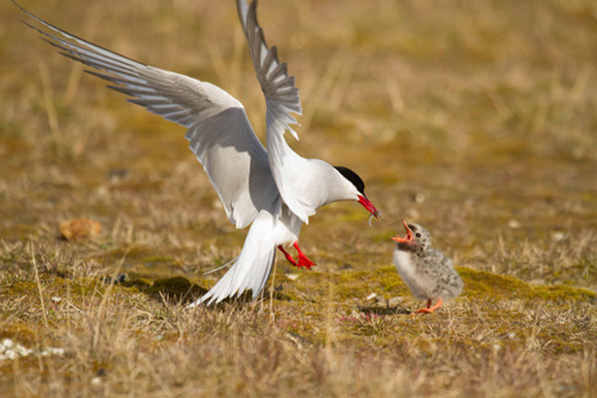
Supervisor: M.J.J.E. Loonen (Arctic Centre, RUG)
Supervisor: C. Both (Institute for Evolutionary Life Sciences, RUG)

Index
Abstract………………………………………………………………...3
Introduction…………………………………………………………….4
Current research and research questions ……..………………...7
Hypotheses……………………………………………………...8
Material and Methods……………………………………………….....9
Study area……………………………………………………......9
Nest observations……………………………………………....10
Arctic tern chick diet…………………………………………...12
Parenting behavior……………………………………………...13
Data preparation………………………………………………..13
Statistics………………………………………………………..15
Results…………………………………………………………………15
Caloric intake…………..………………………………………15
Feeding rate…...………………………………………………..18
Prey type………………………..………………………………21
Discussion……………………………………………………………..26 Conclusion……………………………………………………...28
Improvements and future research……………………………..28
Acknowledgements……………………………………………………39
References……………………………………………………………..31
Appendix………………………………………………………………37

Abstract
The Arctic tern is the only tern species nesting on Svalbard. A breeding area to which they return each year after an incredible annual return migration distance of up to 90.000 km measured from their overwintering grounds in the Antarctic. Once arrived in the Arctic, they have to cope with harsh and unpredictable conditions comparable to those in the Antarctic and affecting both their chick survival as their own. These conditions are expected to become increasingly unpredictable due to the adverse effects of climate change which has a heavier impact in the Arctic than anywhere else. In addition, the Arctic tern might be more sensitive to these changes in their breeding grounds due to a foraging strategy which is relatively vulnerable to these changes compared to other marine birds in this region. Despite these concerns, practically no research has been carried out involving the diet of Arctic terns in the high Arctic. Most of the studies involving Arctic terns in this region are population and migratory studies, only in the more temperate regions has their diet and feeding behavior been studied more intensively. Additional information about their Arctic diet is invaluable however, not only because of climate change and the lack of information about their diet as of yet, but also because several species that are known to be key prey species of the Arctic tern in areas where their diet has been studied, are currently in decline in the high north. Therefore, this study aims to gain a better insight into the diet of Arctic tern chicks in the high Arctic, with specific emphasis on variation in parental food provisioning in relation to changes in a number of environmental factors.
Data on the diet of Arctic tern chicks were collected in Ny-Ålesund in July and August 2014 through daily nest observations with a telescope. A number of 11 nests were frequently observed for which information about delivered prey items was obtained. In concurrence with these dietary data, environmental variation in precipitation, wind speed, and tidal stages were monitored. Furthermore, nest specifics and parenting behavior were taken into account for the purpose of making a distinction between the individual nests observed for this project.
The results of this study show significant correlations of predominantly the weather circumstances in Ny-Ålesund with the diet composition, feeding rate and caloric supply of Arctic tern chicks. The tidal stages had only a minor impact on food provisioning and on diet composition. Amongst the most evident results of this study are the diet composition of the Arctic tern chicks which was mostly made up out of crustaceans (51.6 % of known prey) with a proportion that is much higher than that of Arctic terns or congeners in other regions. Furthermore, this proportion of crustaceans as well as the feeding frequency were significantly positively affected by increasing wind speeds. Overall, these results stress the importance of small crustacean prey items as the main food source for Arctic tern chicks in the high Arctic. Also, they indicate the negative impact that rain and wind have on foraging conditions and therewith likely on foraging and breeding success of Arctic terns in this region.
Introduction:
During the breeding season, seabirds are confronted with a difficult trade-off between brooding their eggs or chicks, nest attendance and defense, and exploiting marine resources for food provisioning (Uttley, 1992; Anderson et al., 2005; Robinson et al., 2001). Allocating more time to one parental task naturally reduces the time that can be allocated to another. Hence, in order to divide their time as efficient as possible, and to increase chick survival, breeding grounds with high marine productivity and low predation pressure are preferred.
For that specific reason, a high number of migratory seabirds raise their chicks in the Arctic where marine productivity is particularly high during spring and summer (Mehlum and Gabrielsen, 1993; Egevang and Frederiksen, 2011; Loeb et al., 1997; Denlinger, 2006; Weydmann et al., 2013), and where many of them have ample opportunity to nest in large colonies in the vicinity of these highly productive areas (Egevang and Frederiksen, 2011; Vigfusdottir et al., 2013; Stephensen et al., 2002; Hobson and Welch, 1992; Denlinger, 2006; Burton and Thurston, 1959; Garthe et al., 2000; Madsen et al., 2009; Gabrielsen et al., 1987). In addition, they can profit from the continuous daylight during the summer season, allowing unlimited foraging (Denlinger, 2006; Fijn et al., 2013; McKnight et al., 2013; Burton and Thurston, 1959; Egevang et al., 2010; Steiger et al., 2013).
One of these migratory seabird species that experiences more hours of daylight, and also covers a larger migratory distance than any other bird due to overwintering in the Antarctic and breeding in the Arctic, is the Arctic tern Sterna paradisea (Denlinger, 2006). The Arctic tern covers a distance of up to 90.000 km annually (Fig. 1), which is registered as the longest seasonal movement ever recorded in any animal (Egevang et al., 2009; Egevang et al., 2011, Fijn et al., 2013).
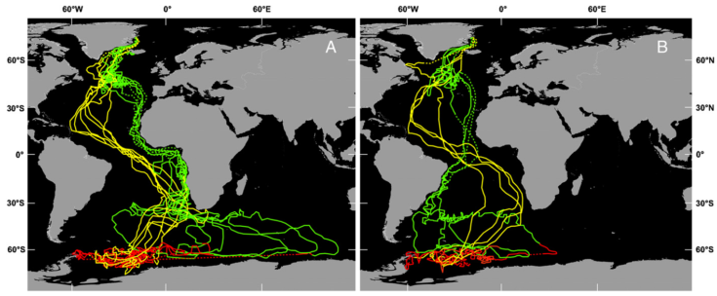
However, during the breeding season in the Arctic region, the Arctic tern usually nests in colonies in relative close vicinity to its foraging grounds as to reduce predation and foraging distance respectively (Vigfusdottir and Gunnarson, 2013; Whittam and Leonard, 2000; Isaksen and Bakken, 1995; Suddaby and Ratcliffe, 1997; Robinson et al., 2001; Egevang and Frederiksen, 2011). Therewith, despite its outstanding circumpolar migration distance, the Arctic tern actually covers relatively small distances in its northern breeding region compared to foraging distances in the Antarctic and also compared to other Arctic bird species with overlapping breeding distributions (Table 1) (Garthe et al., 2000; Hobson et al., 1992; Barrett and Furness, 1990; Burtt, 1974; Pearson, 1968; Robertson et al., 2014). Also, in addition to a small foraging range during the breeding season, this species employs shallow dives, rarely exceeding 0.5 m below the surface during short submersion (Schwemmer et al., 2009; Haney and Stone, 1988; Pearson, 1968; Robertson et al., 2014). Other Arctic birds make significantly deeper dives such as fulmars with a diving depth of up to 3 m, and gannets that can reach a depth of 22 m (Table 1) (Hobson and Welch, 1992; Garthe et al., 2000).
Figure 1. Traveled routes by 11 Arctic terns were traced through geolocation starting in breeding colonies in Greenland (n= 10 terns) and in Iceland (n= 1 tern). Colors are depicted as followed; green=autumn migration towards winter areas (August-November), red=winter area tracks (December-March), and yellow=spring migration to breeding areas (April-May). Two southward migration tracks were observed in the South Atlantic, being A following the West African coast (n=7 terns) or B along the Brazilian coast. Dotted tracks are locations during the equinoxes. Source: Egevang et al., 2010
The limited diving ability of the Arctic tern and distribution on mostly higher latitudes, reflects on its diet which holds a larger proportion of crustaceans than the diet of its congener the Common tern whose distribution largely overlaps with the Arctic tern (Boecker, 1976; Frick and Becker, 1995; Schwemmer et al., 2009; Robertson et al., 2014). Hence, why the Arctic tern can often be found feeding near glacier edges, where the outflow of glacier meltwater creates temporal variation in the abundance of zooplankton (Weslawski and Legezynska, 1998; Weydmann et al., 2013; Zajaczkowski and Legezynska, 2001; Otterlei et al, 1999; Carscadden et al., 2001).
Despite the circumpolar distribution of this bird species and its very specific foraging behavior, practically no research has been carried out involving their diet during the breeding season in the Arctic (Fig. 2). The majority of the studies on Arctic terns in the Arctic are population and migratory studies, whereas their diet and feeding behavior is a frequent topic of research in the more temperate regions (Egevang et al., 2004; Egevang et al., 2010; Egevang and Frederiksen, 2011; Fijn et al., 2013; Burton and Thurston, 1959; Vigfusdottir et al., 2013; Ashpole et al., 2015; Robinson et al., 2001; Robinson and Hamer, 2000; Monaghan et al., 1992; Rock et al., 2007; Pearson, 1968; Uttley, 1992; Frick and Becker, 1995). However, information
Table 1. An overview of the foraging ranges and diving depths of several marine Arctic bird species, as well as congeners of the Arctic tern . Ranges have been indicated as the average minimum-maximum, average, < average, and in between brackets maximum foraging range. a = mean maximum foraging distance. Also, the numbers behind the foraging ranges and diving depths refer to the literature sources.

Species | Foraging range (km) | Diving depth (m)
Sternidae
Arctic tern | 7-10 (< 30)^{[1][6]} | < 0.5-1^{[2]}
Common tern | 4.5-22 (< 30)^{[1][6]} | < 0.8^{[2]}
Roseate tern | 12.2 (< 30)^{[6]} | < 1.2^{[2]}
Sandwich tern | 11.5-25 (< 54)^{[1][6]}
Non-Sternidae
Northern gannet | 92.5-500 (< 590) ^{[2][6][11]} | 4.6-22.0^{[8]}
Northern fulmar | 47.5 (< 580)^{[6]} | 0.8-3.0^{[9]}
Arctic skua | 6.4 (< 75)^{[6]} | -
Great skua | 10.9^{a [6]} | -
Black-legged kittiwake | 24.8 (< 120)^{[6]} | 0.5-1.0^{[10]}
Common guillemot | 37.8 (< 135)^{[6]} | 34.1-70^{[7]}

on the Arctic diet of the geographically bound Arctic tern is invaluable to gain an insight in their feeding behavior during the breeding season and might also shed a light on their preferences for these higher latitudes. Also, in view of current climate change, which has a stronger effect in the Arctic than anywhere else, future food availability and Arctic tern population numbers may be compromised (Mcknight et al., 2013; Vigfusdottir et al., 2013). This addresses another dilemma; in order to assess current and future trends in prey availability, fish stock surveys and plankton abundance measurements are required. This type of information is readily available for areas such as the North Sea and the North Atlantic Ocean. Less is known about past and current fish stocks in the waters around some of the most important Arctic tern breeding grounds. Nevertheless, few studies that have been conducted in these areas show strong declines and shifts in the trends of some of the Arctic tern’s main prey species as known from diet studies in slightly more temperate areas (Vikingsson et al., 2015; Bonanomi et al., 2015). These tendencies are related to both climate change and overfishing.
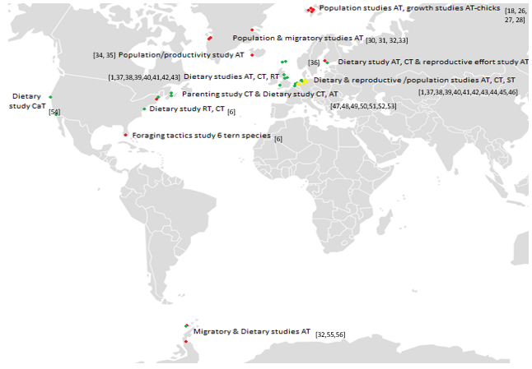
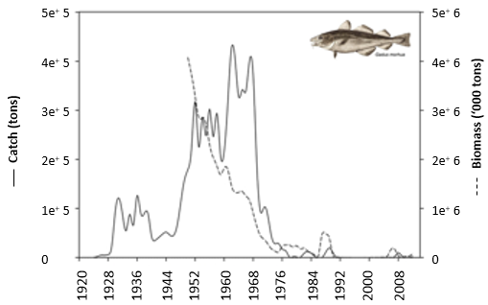
For example, in the waters around Greenland, polar cod (Arctogadus glacialis) numbers have dropped in the past few decennia since 1968 due to overfishing (Bonanomi et al., 2015) (Fig. 3). This is likely to have a negative impact on the Arctic tern since Greenland, together with Iceland, is one of its major breeding grounds. Furthermore, around Iceland, the numbers of great sandeel (Hyperoplus lanceolatus) in stomachs of haddock have decreased significantly since at least 1998 (Fig. 4). An increase in ocean temperature has been suggested as a possible cause for this decline (Vikingsson et al., 2015). Similarly, Black Kittiwakes (Rissa tridactyla), foraging along the west coast of Svalbard, were found to have replaced part of their diet with a new species, being capelin (Mallotus villosus). Capelin showed up in their diet in 2006, whereas the amount of polar cod in their diet was significantly lower since then. This arrival of capelin in their diet can be related to an increase in sea water temperature along the west coast of Svalbard, which has expanded the distribution of capelin more up north. This is likely to have an effect on the diet composition of the Arctic tern as well, since capelin is usually a part of their diet in regions beneath the Arctic (Devlin, 2006; Pearson, 1968; Vigfusdottir et al., 2013).
Figure 2. A number of locations where research was conducted on either Arctic terns (AT), Caspian terns (CaT), Common terns (CT), Roseate terns (RT), or Sandwich terns (ST). The type of research has been color-coded with “red” for a study including AT, “green” for a dietary study, and “yellow” if neither AT or diet were involved.
Figure 3. Atlantic cod Biomass and commercial catch in West-Greenland since 1920. Source: Bonanomi et al., 2015
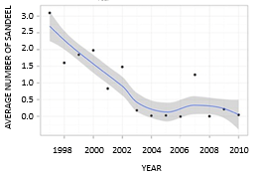
Climate change and overfishing are examples of anthropogenic factors impacting the abundance and accessibility of prey over the course of years. However, apart from long-term, large scale changes in their environment, Arctic terns are also being subjected to local and more frequently occurring fluctuations affecting their behavior. Environmental conditions such as the tides and weather would not only affect food provisioning, but also cause a shift in the parental effort that can be invested in foraging, brooding, and nest guarding. In addition, there are the nest-related factors like chick age and number of chicks per nest that affect the partitioning between the three main parental tasks during the breeding season (Burton and Thurston, 1959; Devlin, 2006; Dunn, 1975; Egevang et al., 2011; Frick and Becker., 1995; Hall et al., 2012; Haney and Stone, 1988; Klaassen et al., 1989a; Klaassen et al., 1989b; Lemmetyinen, 1976; Monaghan et al., 1992; Robinson and Hamer, 2000; Robinson et al., 2001; Robinson et al., 2002; Suddaby and Ratcliffe, 1992; Uttley, 1992). By investigating the effects of these rapidly fluctuating environmental conditions and nest-related factors on parental behavior of Arctic terns, we can not only improve our knowledge of Arctic terns in the Arctic during the breeding season, but we can also make a potential assessment of their resilience as a species under the current effects of climate change.
Figure 4. Average number of sandeel found in haddock stomachs during Icelandic groundfish surveys since 1998. Source: Vikingsson et al., 2015

Current research and research questions In order to determine the factors involved in parental food provisioning of Arctic tern chicks in the high Arctic, Arctic terns with chicks were observed in Ny-Ålesund, Svalbard in the summer of 2014. The Arctic tern is the only tern species nesting on Svalbard, and the delivery of prey items to chicks, in particular by a single prey loader, makes it relatively easy to study their diet (Stienen et al., 2015). For this research, the following research question was formulated:

- How can we explain variations in the food provisioning of Arctic tern chicks in the Arctic?

Subquestions:

- What environmental conditions determine Arctic tern chick food provisioning?
- How do nest-specific factors such as chick age and number of chicks affect food provisioning?

The main focus of this study lies on the impact of environmental conditions on food provisioning, whereas the second sub-question with regards to nest-specific factors is included to make a distinction between the individual nests observed for this project.

Hypotheses As mentioned earlier, the parental effort of Arctic terns during the breeding season, is mainly divided between three major tasks being brooding, food provisioning, and nest guarding (Fig. 5). However, nest guarding was not included in this research due to an expected small effect on food provisioning, and is therefore left undiscussed further in this report.
Brooding behavior was studied, because of an anticipated strong correlation with chick age and therewith also indirectly with food provisioning. This correlation between the amount of brooding and chick age is hypothesized to be negative, in favor of food provisioning with increasing chick age.
With the chicks growing older, the separate elements that make up food provisioning, being feeding rate, prey type, prey length, and most importantly caloric intake, will be affected as well. They presumably all have a positive correlation with chick age, and prey species might be altered over time in favor of the more nutritious species with a higher fat content (Anderson et al., 2005; Robertson et al., 2014; Klaassen et al., 1989a; Klaassen et al., 1989b; Oswald et al., 2012; Hall et al., 2012; Wiggins and Morris, 1987; Rock et al., 2007).
This is hypothesized to be similar with an increase in number of chicks per nest. A higher number of chicks should mean an increase in overall feeding rate, but not necessarily per chick and the same holds true for the caloric intake. Prey items are expected to be smaller in order to evenly spread caloric intake (Mehlum and Gabrielsen, 1993; Nordström et al., 2003).
For the main environmental factors, weather and tide, another distinction is made. Weather is divided into wind, temperature, and precipitation, and the tides are divided into 4 stages. Both weather and the tides are expected to affect prey availability with weather having a stronger but also more irregular impact than the tides.
During harsh weather circumstances such as high wind speeds and precipitation, prey are expected to be harder to obtain due to bad foraging conditions and a lower prey abundance and accessibility. Thus, a reduced feeding rate is anticipated and a lower caloric intake (Haney and Stone, 1988; Schwemmer et al., 2009; Taylor, 1983; Weslawki et al., 1991; Frank and Leggett., 1986; Rock et al., 2007; Burton and Thurston, 1959; Gabrielsen et al., 1987; Isaksen and Bakken, 1995; Oswald et al., 2012; Robinson et al., 2002; Dunn, 1975). In addition, bad weather circumstances will also stimulate brooding behavior to prevent cooling down of the chicks, particularly the younger ones (Robinson et al., 2002; Denlinger, 2006; Hopkins and Wiley, 1972; Anderson et al., 2005; Uttley, 1992; Klaassen et al., 1989a).
Trade-off
Trade-off
Brooding
Prey provisioning
Nest guarding
Figure 5. The 3 main parental tasks during the breeding season.
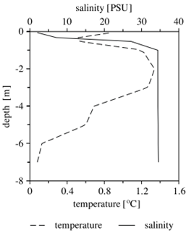
Finally, the effect of the tides on prey abundance and availability is hypothesized to be less significant than in the temperate regions due to a lack of mudflats, but is still expected to play some role with the effect the tides might have on the stratification in the Arctic due to the outflow of fresh water (Taylor, 1983; Anderson et al., 2005; Frick and Becker, 1995; Zamon, 2003; Hall et al., 2012; Schwemmer et al., 2009; Anderson et al., 2007; Denlinger, 2006; Dunn, 1975; Hobson and Welch, 1992) (Fig. 7). More specifically, the effect of the tidal stages and also weather conditions may be particularly complex in the Arctic due to the presence of glacial meltwater and consequently the upwelling of local plankton. Along glacier edges, glacier melting creates an often significant outflow of fresh water into the bay, decreasing the local salinity (Fig. 6). Local plankton is then affected by this low salinity in a process that is called “osmotic shock” which paralyzes the plankton and also causes plankton mortality (Weslawski and Legezynska, 1998; Weydmann et al., 2013; Zajaczkoswki and Legezynska, 2001; Otterlei et al, 1999; Carscadden et al., 2001). This in turn, increases the availability of plankton in the top water layer for Arctic terns.
Figure 6. Overview of the temperature and salinity gradient measured at the edge of the Kongsbreen glacier in Kongsfjorden, Ny-Ålesund in 1999 and 2000 (Zajaczkawski and Legezynska, 2002).
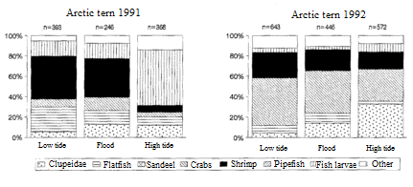
Figure 7. Diet composition of Arctic terns in relation to tide on Minsener Oldeoog in 1991 and 1992. Source: Frick and Becker, 1995
Material & Methods
Study area
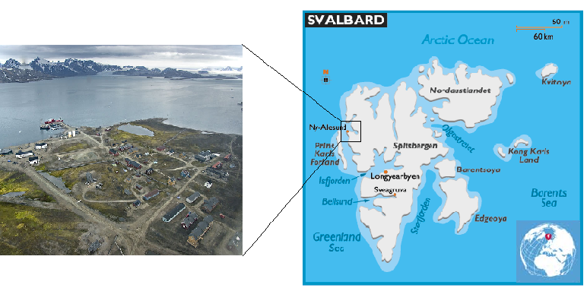
Prey deliveries to Arctic tern chicks were studied in Ny-Ålesund, Svalbard (79 °N, 12 °W), between 16 July and 14 August 2014 (Fig. 8). In total 11 nests were observed with clutch sizes of respectively 1 or 2 chicks (Appendix Table 2A). Nest locations varied, but most nests were located at the east border of the town, in the vicinity of the dog kennels, and a few at the southern edge (Fig. 9). GPS data on the majority of the nest sites had already been collected by fellow researchers earlier in the breeding season, together with laying dates, hatch dates and information on predation of either eggs or chicks. Furthermore, two nests in the northwestern part of the area were situated on the roof of an empty factory building and were therefore shielded from potential nest predation by Arctic foxes (Vulpes lagopus). One nest more to the east was located within an oil drum section which was surrounded by fences and therefore also shielded from nest predation by Arctic foxes. Due to predation stress and human proximity to the ground-based nests, the location of tern families was often not permanent. This resulted in short-range chick dispersal on several occasions, but never exceeded more than 20 m (Appendix Table 2A).
Figure 8. Research location from a global, more regional, and local viewpoint.

Nest observations
Arctic terns with chicks were observed with an ATS80 Swarovski telescope. Observations were conducted at a distance ranging from 10-30 meters from the nest, with the exception of nests that required a smaller range. Both roof nests and the oil drum nest could not offer an observation range of more than 5 meters due to structures in the line of sight. Due to the resulting distress that such a short observation range usually caused, data gathering only commenced when the parenting couple would stop alarming and carrying out attacks. In addition, the roof nest on the east side and the nest in the oil drums section were both observed making use of a portable bird hide tent to reduce the amount of distress and to minimize the possible impact on feeding behavior.
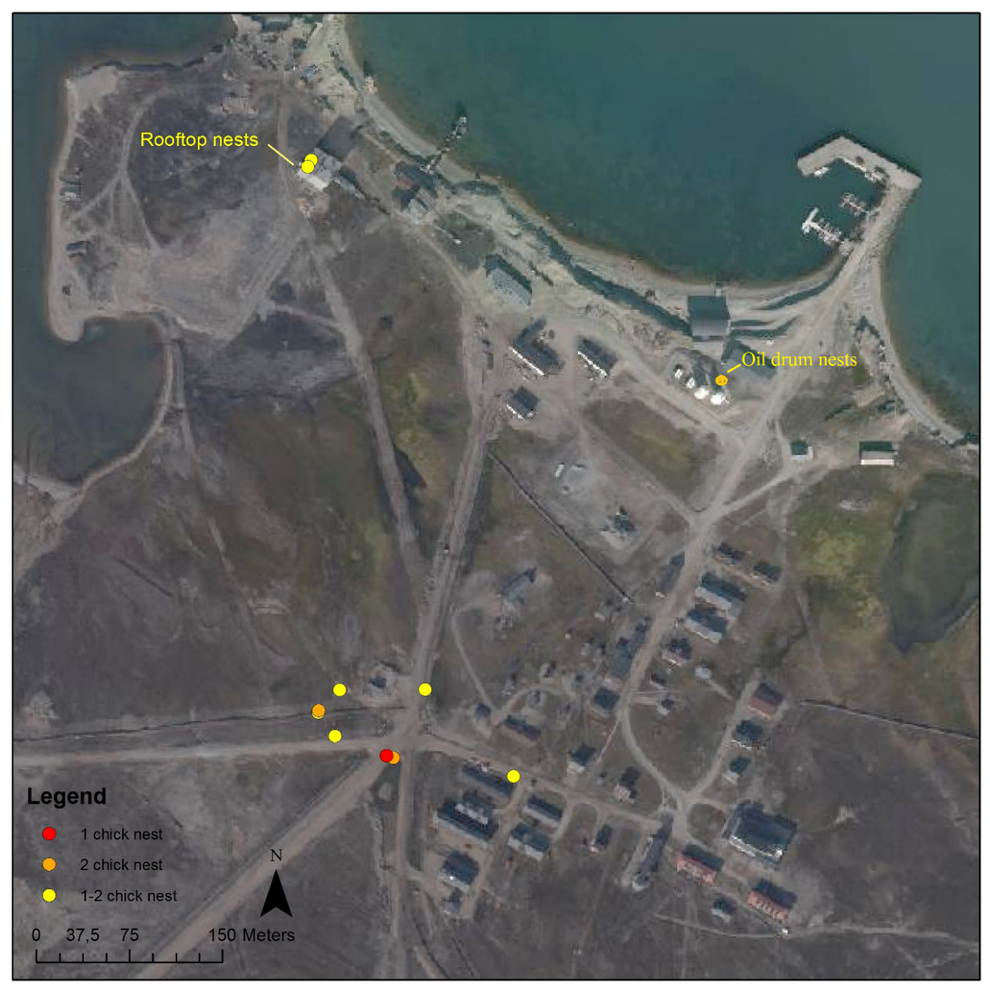
The number of nests observed each day ranged from 1-4 nests, and the duration of each observation lasted 30-163 minutes, depending on the amount of hatched nests available (Appendix table 2A). During these observations, data were collected on chick feeding frequency, prey species, prey length, duration of brooding, distance of parents to their chicks, and number of attacks by parenting Arctic terns towards congeners. As mentioned previously, nest guarding was not further analyzed in this study and thus, the data on parent distance and attacks by parenting Arctic terns was left unused. Furthermore, since the outcome of these observations may vary with chick age, this was taken into account by spreading nest observations in such a way that an approximate equal amount of each chick age could be represented. However the initial observations concerned nests that had already hatched earlier in the season, and the majority of chicks were therefore at least several days old. Newly hatched nests were followed from day one through to postfledging dispersal, chick mortality, or the end of the observation period. Since a number of nests were predated only a few days after hatching, and only two chicks had fledged by 14 August, the younger ages are more represented and observations of chicks > 20 days old are relatively rare (Appendix Table 2A).
Figure 9. Overview of the 11 nest sites in Ny-Ålesund that were used for this study. Number of chicks in the nest is indicated by color and may fluctuate due to chick mortality (1-2 chick nest).

In order to relate dietary data to environmental factors, data on the timing of tidal stages and weather conditions were collected for each day. For weather conditions this included the average temperature, precipitation, and wind speed (m/s) covering the hours of observation,.

Arctic tern chick diet

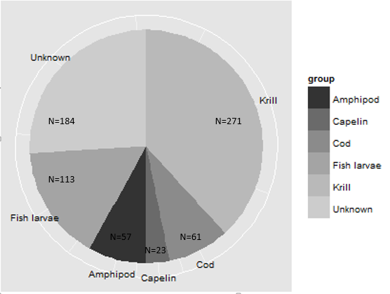
Not all prey types could be categorized in terms of precise species, but were at least assigned to fish, Northern krill (Meganyctiphanes norvegica) or Arctic amphipod (Themisto libellula). Since most younger fish specimens were relatively transparent and therefore difficult to assign to a specific species, they were placed in a combined group of “fish larvae”, composed of capelin (Mallotus villosus), herring (Clupea harengus) and sand lance (Ammodytes marinus). Cod juveniles (Gadus morhua) however, contain more pigment and were therefore easier to distinguish as a species. In addition, older capelin specimens were also fed to Arctic tern chicks and could be recognized due to their silverish appearance. Prey that could not be placed in either one group was categorized as unknown and would therewith still contribute to feeding rate analyses. This was a relatively large group of little over 25% of the total amount of delivered prey (Fig. 10).

Figure 10. An overview of all prey types and their contribution to the total amount of prey observed.
Total number of prey is N=709

Apart from species identification, prey length was estimated as well. Prey size could be estimated by comparison with the bill length of the tern carrying the prey item (Stienen et al., 2015; Robertson et al., 2014; Oswald et al., 2012; Dies and Dies, 2005; Monaghan et al., 1992; Uttley, 1992; Barrett and Furness, 1990; Safina et al., 1990; Hopkins and Wiley, 1972).
Each food provisioning was listed and time intervals in between food deliveries were recorded. When intervals exceeded 1 hour and there was reason to believe this could be caused by either the presence of an Arctic fox or stress caused by tourists approaching the nest, data gathering was continued elsewhere at a different nest site.

Parenting behavior

Parental care was quantified by gathering data on nest defense, time spent brooding chicks, and distance of the parents to their chicks. However, as mentioned previously, only brooding was taken into account as a parental care factor for this study. The amount of time that was spent by either one of the parents brooding their chicks was recorded, and a distinction was made between warming only 1 or both chicks when 2 chicks were present. With clutch sizes of 2 chicks, the duration of brooding was averaged for both chicks. With chick age, brooding was noted to decrease significantly, and chicks older than 8 days were only being brooded in one specific case (Fig. 11, Appendix Table 3A).
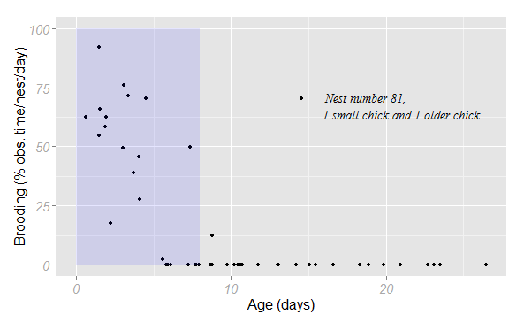
Figure 11. Time spent by at least one parent tern brooding their chick(s), indicated for each day since hatching of the egg(s). Brooding time is presented as the percentage of total observation time for each nest and age. The percentage of time spent brooding is practically zero for chicks older than 8 days. The first 8 days have been used for regression analysis in an LM and are therefore marked.

Data preparation

Several factors were simplified or reorganized prior to analysis, in particular the environmental factors. Since temperature was a relatively constant factor, and there were no observations during excessively warm or cold days, this predictor variable was withheld from analysis. Only wind speed and precipitation were used. Days with precipitation were low in number and the amount of precipitation limited. Hence, this factor was transformed into a dummy variable with the number 0 for the absence, and 1 for the presence of rain on any specific day. Wind speed however, was used as a continuous factor in meters per second, due to its considerable variation over the days.
The variable “tide” was divided into 4 categorical factors (Fig. 12). A set-up with the development of the stages in hours has been used by Frick and Becker, but would have complicated the statistical analysis due to its sinusoidal fluctuations (Fig. 12). A more common method is the division of the tides in four sections (Schwemmer et al., 2009), which provides a more detailed overview.
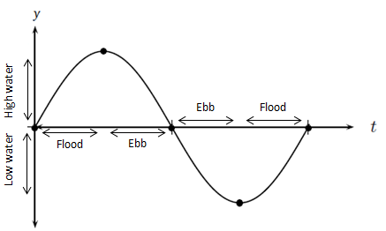
As for the dietary data, 3 existing variables were reorganized and a new one was deduced from a combination of the obtained data in this study, and data found in literature. The variable prey species was reduced to only 3 groups; “crustaceans” as a fusion of krill and amphipods, “fish” composed of cod, capelin and other species, and “fish larvae” which was composed of the smaller transparent specimens. The deliveries of these prey to chicks were counted and therewith, this factor would qualify as a count variable. However, since the total number of prey deliveries showed considerable variation over the days and nests, the variable
Flhwww
Ebbhw
Ebblw
Fllw
Figure 12. Indication of the tidal stages as used in this study.

Table 2. Overview of the estimated caloric content of fish and crustacean species observed in this study. The length range and associated caloric values are indicated as found in literature from several Arctic as well as temperate regions. The caloric value range is especially large for the fish specimen due to their larger length range. Caloric values are indicated per whole specimen as observed in this study and not per length unit.
Prey | Length range (mm) | Caloric value range (kj) | Area
Krill (Thysanoessa inermis) | 20-30 | 0.3-1.3 | Northeast Atlantic ^{[17]}, West Svalbard^{[24] [18]}, East coast Canada^{[20] [25]}
Amphipod (themisto libellula) | 10-20 | 0.19-0.21 | Svalbard ^{[14] [18] [21] [23] [24]}
Capelin | 30-100 | 2.42-18.13 | Newfoundland^{[19]}, Svalbard^{[12] [18] [15] [24]}, Northeast Atlantic^{[17]}
cod (arctic) | 20-80 | 0.5-24.2 | Northeast Atlantic^{[17]}, Svalbard ^{[12] [18] [24]}, Norway/ northeast Arctic ^{[22]}, Beaufort Sea/Hudson Bay^{[16]}
fish larvae | 20-100 | 0.43-2.17 | Svalbard ^{[23]}, South-Western France ^{[13]}

was transformed into proportions instead of frequencies. Thus, each group of prey was presented as a percentage of the total amount of recognizable prey for that day, nest, wind speed, or any other factor. Since we were working with proportions however, a minimum number of 9 prey provisionings was taken into account for each subgroup used in the analyses.
The provisioning rate was indicated as the number of prey per chick and per hour. At the start of each nest observation, the first delivery was registered only for prey type but not for feeding rate, due to missing information on required foraging time for this first item. In addition to the variables “prey type” and “feeding rate”, a new variable, “caloric intake”, could be assembled with the available information on delivered prey in this study, and the caloric content of these prey as stated in the literature (table 2). Several articles stated the length and corresponding dry weight and wet weight of the prey observed in this study and the caloric content in kJ per g dry weight and/or wet weight. For the fish specimen an indication was also given of the length and caloric content for each month of the year. Estimates used in this study may differ from their actual energetic contents however, since the values given in literature were often based on studies during different time periods and on different locations than Svalbard.

The only behavioral factor, brooding, was used as a percentage of the total observation time for that nest during that specific day. Chick age and the number of chicks were also registered on a daily basis in order to relate behavioral and also dietary variables to nest characteristics. Number of chicks was either 1 or 2, since nests with more than 2 chicks are rare and were not observed during this study. Chick age as opposed to chick number, was used as a continuous variable ranging from 0-27 days.

Statistics
The effects of several environmental factors and nest characteristics on the time parenting terns spend brooding their chicks, were tested using a Linear Mixed Model (LM). In this model, as in all other models used in this study, both “Day number” and “Nest number” were included as random factors to correct for differences between nests and individual days (Zuur et al., 2009; Crawley, 2007). The model was only applied to the first 8 days after hatch, since the duration of brooding of chicks older than 8 days was practically zero and thus, these values would affect the reliability of the model.
To analyze whether environmental factors and nest characteristics had an effect on the provisioning of chicks with specific prey types, a Generalized Linear Mixed-Effects Model (GLMER) was used as a binomial model for proportions (Zuur et al., 2009; Crawley, 2007). A separate analysis with this model was conducted for each of the three prey groups; crustaceans, fish, and fish larvae. Furthermore, a minimum number of 9 prey was taken into account for each subgroup.
Provisioning rate was tested using a Linear Mixed-Effects Model (LMER) with log-transformed dependent variables (y + 1). Similar to the model for caloric intake, data were only used from nests that were observed for a minimum of 30 minutes.
Finally, the caloric intake of Arctic tern chicks was analyzed using a Generalized Additive Model (GAM) (Zuur et al., 2009).
Models were tested for normality, overdispersion and other statistical anomalies according to protocol (Zuur et al., 2009; Crawley, 2007) Furthermore, the elimination of non-significant terms was conducted according to a level of significance of P=0.05.

Results
Prey type
The most important prey type for Arctic tern chicks on Ny-Ålesund was crustaceans (51.6 % of known prey), with krill being fed most frequently. The second largest group that made up a significant part of their diet was fish larvae (21.5% of known prey, Fig. 10 M&M).
The proportion crustaceans as part of the whole identified diet was significantly larger with higher wind speeds (Table 3, Fig. 13). Also, older chicks from larger nests received a significantly larger proportion of crustaceans than younger single chicks (Table 3). However, chick age and the number of chicks per nest as factors by themselves did not have a significant impact on the proportion of crustaceans (Table 3).

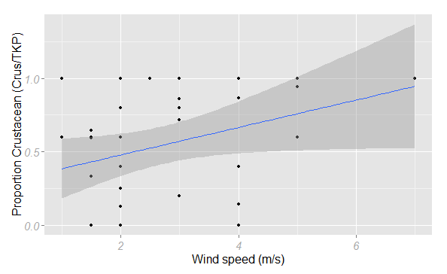
Table 3. Final MAM model for dependent variable “crustacean” as proportion of the “Total Known Prey” (TKP). Results were obtained with a Binomial model for Proportions (LMER) with both random factors “Nest number” and “Day number” included, and rejected terms are presented with values prior to removal from model.
Figure 13. Development of the proportion of crustaceans as part of the “Total Known Prey” (TKP) fed to Arctic tern chicks over increasing wind speeds up to 7 m/s. The proportion of crustaceans significantly increases with increasing wind speeds. A 95% confidence interval has been added to the regression line.
Variable | Estimate | Std. Error | Z | DF | P
(Intercept) | - 2.49 | 1.53 | - 1.63 |  | 0.10
Wind | 0.67 | 0.33 | 2.09 | 1 | 0.04*
NestAg | - 0.06 | 0.19 | - 0.32 | 1 | 0.75
Nrchicks2 | - 0.22 | 1.35 | - 0.17 | 1 | 0.87
Nrchicks2:NestAg | 0.46 | 0.21 | 2.15 | 1 | 0.002**
Rejected terms
Tide | - | - | - | 3 | 0.28
Precip1 | - 2.41 | 1.71 | - 1.41 | 1 | 0.12
Fish as a prey species showed a significant negative correlation with both wind speed and chick age. As opposed to the group of crustaceans, the proportion of fish in the chick diet significantly decreases with increasing wind speed (Table 4, Fig. 14). With age, a negative correlation towards a reduced proportion of fish for older chicks could be observed (Table 4, Fig. 15, 17).

Table 4. Final model for dependent variable “fish” as proportion of the “Total Known Prey” (TKP). Results were obtained with a Binomial Model for Proportions (LMER) with both random factors “Nest number” and “Day number” included, and rejected terms are presented with values prior to removal from model.
Variable | Estimate | Std. Error | Z | DF | P
(Intercept) | 0.61 | 0.81 | 0.76 |  | 0.45
Wind | - 0.64 | 0.26 | - 2.47 | 1 | 0.01*
NestAg | - 0.11 | 0.05 | - 2.22 | 1 | 0.03*
Rejected terms
Nrchicks2 | 0.01 | 0.77 | 0.02 | 1 | 0.99
Precip1 | 0.26 | 1.25 | 0.21 | 1 | 0.84
Tide | - | - | - | 3 | 0.23

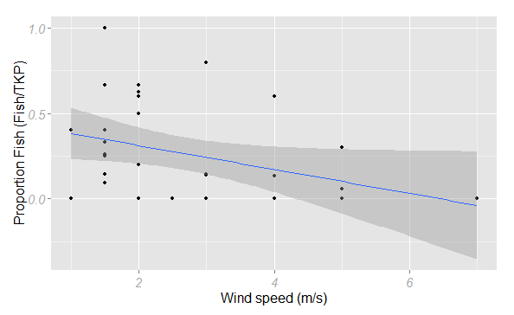

Figure 14. Development of the proportion of fish as part of the “Total Known Prey” (TKP) fed to Arctic tern chicks over increasing wind speeds up to 7 m/s. The proportion of fish significantly decreases with increasing wind speeds. A 95% confidence interval has been added to the regression line.

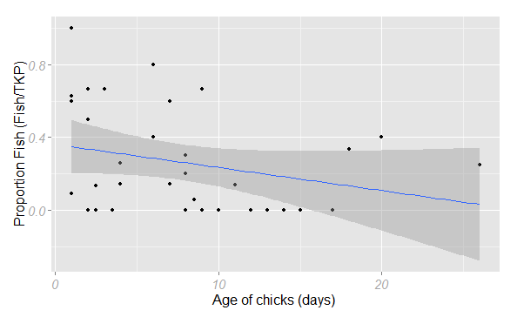
Figure 15. Development of the proportion of fish as part of the “Total Known Prey” (TKP) fed to Arctic tern chicks over increasing chick age up to 26 days old. The proportion of fish significantly decreases with increasing chick age. A 95% confidence interval has been added to the regression line.
136 58 130 105 53 12

Figure 16. Contribution of each prey type to the total number of recognizable prey provisionings (in %) for 6 age groups. Groups are set at days of 4. Total number of known prey is depicted at the base of each bar.

The amount of fish larvae in the diet of Arctic tern chicks was dependent on a variety of both environmental and nest-related factors. As opposed to crustaceans whose proportion was significantly higher during the retreating tidal stages, fish larvae appeared as a significant larger proportion in the diet of the chicks during flood tides (Fig. 17 & 18, Table 5). Furthermore, both the age of the chicks and the amount of chicks per nest affected their diet with regard to the amount of fish larvae they received (Table 5). Chick age had a minor, hardly significant positive effect on the amount of fish larvae Arctic tern chicks received (Table 5). More chicks per nest however, resulted in a strong reduction in fish larvae being delivered to either of the chicks (Fig. 19, Table 5).
Table 5. Final model for dependent variable “Fish larvae” as proportion of the total known prey. Results were obtained with a Binomial Model for Proportions with both random factors “Nest number” and “Day number” included (binomial mixed model) and rejected terms are presented with values prior to removal from model.
Variable | Estimate | Std. Error | Z | DF | P
(Intercept) | - 1.08 | 1.63 | - 0.66 |  | 0.51
Flhw-Ebbhw | - 7.03 | - 1.67 | - 4.21 | 1 | < 0.001***
Flhw-Ebblw | - 4.56 | 1.38 | - 3.31 | 1 | 0.005**
Ebblw-Ebbhw | - 2.47 | 1.05 | - 2.35 | 1 | 0.08
Fllw-Flhw | 4.31 | 1.74 | 2.47 | 1 | 0.06
Fllw-Ebbhw | - 2.73 | 1.54 | - 1.77 | 1 | 0.27
Fllw-Ebblw | - 0.25 | 1.17 | - 0.22 | 1 | 0.997
NestAg | 0.14 | 0.07 | 1.98 | 1 | 0.048*
Nrchicks2 | 6.28 | 1.95 | 2.23 | 1 | 0.001**
NestAg:Nrchicks2 | - 1.08 | 0.23 | - 4.78 | 1 | < 0.001***
Rejected terms
Precip1 | 3.38 | 1.66 | 2.03 | 1 | 0.35
Wind | - 1.37 | 0.45 | - 3.04 | 1 | 0.49
27 53 53 34 36 110 38 27 25 28 53 41
Figure 17. Contribution of each prey type to the total number of recognizable prey provisionings (in %) for each tidal hour. Low water is set as a zero point from which the tidal hours before or after LW are determined. Total number of known prey is depicted at the base of each bar.

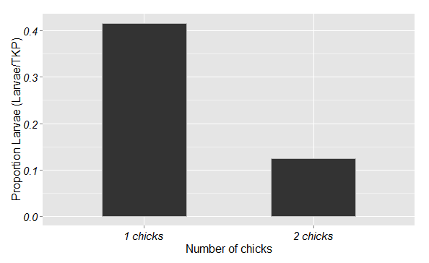
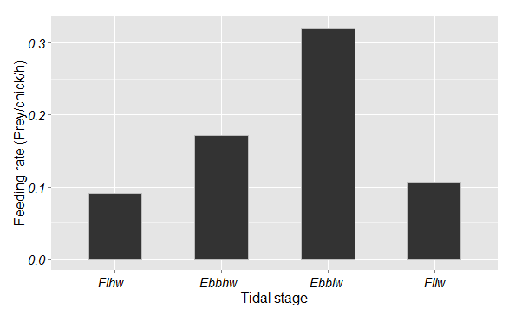
Figure 18. Overview of the proportion of fish larvae as part of the “Total Known Prey” (TKP) fed to Arctic tern chicks over 4 tidal stages. The proportion larvae is significantly lower during Flhw compared to Ebbhw and compared to Ebblw. N=157, N=140, N=207, and N=82.

Proportion Fish larvae (larvae/TKP)
Figure 19. Overview of the proportion of fish larvae per chick as part of the total amount of recognizable prey provisionings (TKP) for nests with only 1 chick (N=102) and nests with 2 chicks (N=486). The larger nests receive considerable less fish larvae than the nests with only 1 chick.
*
*

Provisioning rate
The rate at which Arctic tern chicks were supplied with prey was highest during high wind speeds and when crustaceans were delivered. Prey such as krill and amphipods were provided at a significantly higher rate than larger prey like fish and fish larvae (Fig. 21). Furthermore, during the low water stage of flood, prey provisionings were least frequent in comparison to the high water stage of flood (Appendix Table 5A & 5B). More chicks per nest also resulted in more frequent prey deliveries per chick (Fig. 20).
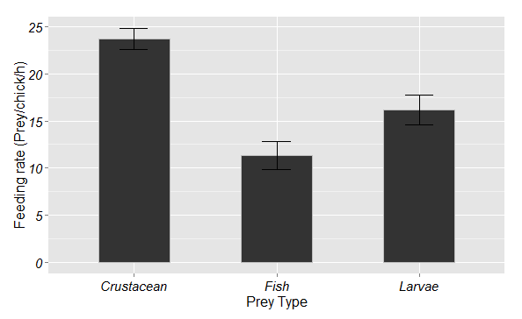
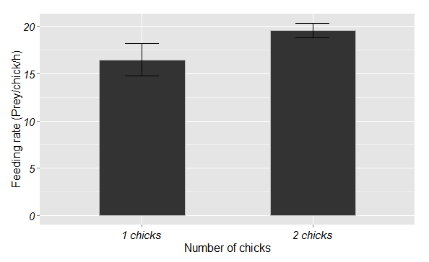
Figure 21. The average feeding rate per chick in “number of prey per hour” for 3 different prey groups. Crustaceans (N= 268) are delivered with a much higher frequency than fish (N=72) and fish larvae (N=90). Error bars show the standard error of the mean.
*
*
Figure 20. The average feeding rate per chick in “number of prey per hour” for 2 clutch sizes. With a larger clutch size, the feeding rate also increases significantly. Error bars show standard error of the mean. N=102 and N=486.
*

Changes in environmental conditions also induced significant alterations in provisioning rate. With increasing wind speed, the rate of prey provisionings increased gradually as well with around 13 prey/chick/h for a wind speed of 0.5 m/s up to 32 prey/chick/h for a wind speed of 7 m/s (Fig. 22). In addition, tidal fluctuations had a significant effect on provisioning rate with a lower provisioning rate during the rising phase with high water (Flhw) compared to the rising phase during low water (Fllw). The other tidal stages did not differ significantly either compared to each other or to both the flood stages (Fig. 23).

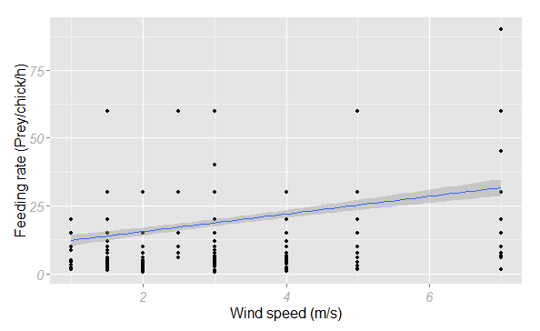
Figure 22. The feeding rate per chick per hour over increasing wind speeds up to 7 m/s. With increasing wind speeds, feeding rate increases as well. A 95% confidence interval has been added to the regression line.
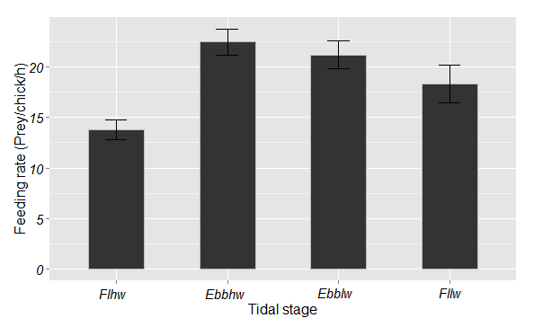
Figure 23. Overview of the feeding rate per chick per hour for each of the 4 indicated tidal stages. The feeding rate is significantly lower during Flhw compared to Fllw. Error bars show the standard error of the mean. N=157, N=140, N=207, and N=82.
*

Caloric intake
The caloric intake of Arctic tern chicks in Ny-Ålesund, based on estimated energetic values of prey species, decreased significantly with chick age. In particular during the first week, Arctic tern chicks received significantly more calories per chick and time unit than chicks older than 1 week (Fig. 24). As for the environmental impact on caloric intake, the presence of precipitation significantly reduced the intake (Fig. 25). Wind and tide however, showed no correlation with caloric intake when tested without interaction of other factors (Appendix Table 4A & 4B). Although wind speed in interaction with the tidal stages indicated a significant correlation with each distinct stage, with caloric intake being significantly higher during the retreating tidal phases and higher wind speeds as opposed to lower intake during the flood tidal phases in combination with high wind speeds. In addition, during higher wind speeds, older chicks received considerably more calories than younger chicks (Appendix Table 4A & 4B).

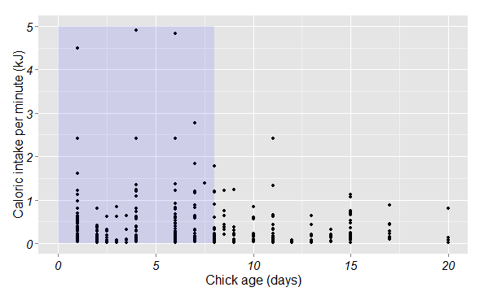
Figure 24. The caloric intake (kJ) per chick and time unit over the age of the Arctic tern chicks. The first 8 days have been highlighted due to a visibly larger caloric intake in this section.
Caloric intake per chick/min (kJ)
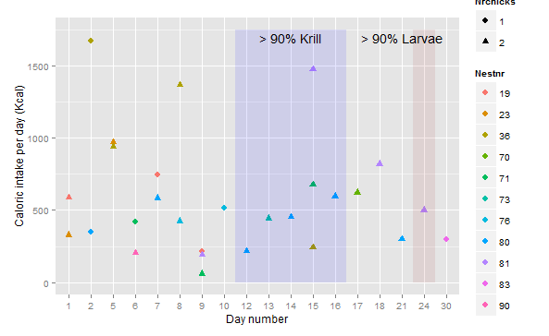
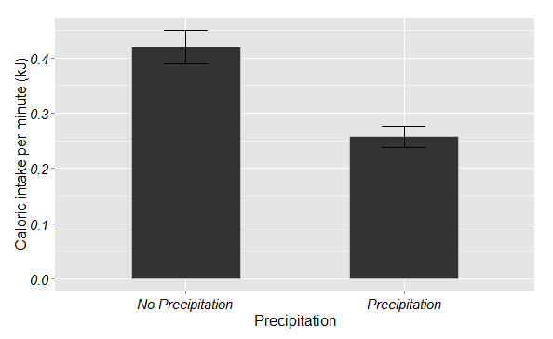
Figure 26. The total caloric intake (kJ) per day and per chick for each nest and observation day. Days have been numbered from the first day of observation until the last, day 30. Not all nests are equally represented since some nests were predated after only a few days and others only hatched later on in the season.
Caloric intake per day and chick (kJ)
Observation day number
*
Figure 25. The average caloric intake (kJ) per chick and time unit during days without precipitation (n=437) versus days with precipitation (n=151). Error bars show standard error of the mean.
Caloric intake per chick/min (kJ)

During the observation period, some days or even a series of days were marked by frequent deliveries of specific prey items. On day 12-16 of the observation period more than 90% of the prey provisionings were krill. The caloric intake seems to be slightly lower on these days as well. Similarly, on day 24 most prey items were fish larvae. Overall, a decrease in total caloric intake was registered after one week, when smaller prey such as krill and fish larvae started to make up for a larger part of the chick diet (Fig. 26, day 12-16 & day 24).
Discussion
The aim of this study was to investigate the diet of Arctic tern chicks in the high Arctic, with specific emphasis on variation in parental food provisioning in relation to changes in a number of environmental factors.
When reviewing their overall diet in Ny-Ålesund, the high percentage of custaceans in comparison to the other delivered recognizable prey groups is striking (Table 8). Crustaceans being their primary prey source when the recognized prey are taken into account, may indicate either the importance of this prey group for Arctic tern chicks in the high Arctic or simply a specifically high abundance of these prey in the area. Previous research on both adult Arctic terns as chicks and in both northern as more temperate regions already discussed their specific preference for smaller prey specimen like crustaceans (Burton and Thurston, 1959; Frick and Becker, 1995; Hall et al., 2012; Hopkins and Wiley, 1972; Lemmetyinen, 1976; Monaghan et al., 1992; Robertson et al., 2014). However, the contribution of this prey group to the diet of both adult terns and chicks in these areas still remains significantly smaller than that of Arctic tern chicks in the high Arctic (Table 8). Whether this is due to a larger preference for this group in the high Arctic or whether it is simply a consequence of a higher abundance of crustaceans there, remains unclear. When tidal fluctuations uncover large planes of mudflats, as is the case in the Waddensea region, a high number of crustaceans become available which then results in a temporal larger proportion of this prey group in the tern diet (Frick and Becker, 1995). No such process occurs in the high Arctic however, and the lack of a correlation between the proportion of crustaceans in the tern chick diet and the tidal stages here might suggest a higher dependence of this prey group on stratification as opposed to physical changes in the water level (Weslawski et al., 1991; Weslawski and Legezynska, 1998; Zajaczkowski and Legezynska, 2001). In particular since Arctic terns primarily forage along glacier edges in this region, where the outflow of freshwater creates a local increase in crustacean abundance in the top water layer due to “osmotic shock” (Weslawski and Legezynska, 1998; Weydmann et al., 2013; Zajaczkowski and Legezynska, 2001; Otterlei et al, 1999; Carscadden et al., 2001).
With a lower caloric content of smaller crustacean prey items as opposed to fish however, the provisioning rate would have to be intensified to maintain the required energy level for the chicks (Oswald et al., 2012; Stienen et al., 2015; Robertson et al., 2014). This hypothesis was confirmed in this study when Arctic terns delivered crustaceans with a much higher provisioning rate than fish items or fish larvae. In particular during days with high wind speeds when the main prey item was krill.

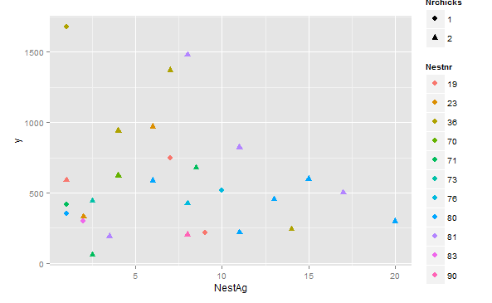
Table 8. Overview of the contribution of the 3 main prey groups to the diet of both arctic terns as other tern species in Svalbard versus more temperate regions. Percentages are given for each group, but do not add up to 100% at least for Svalbard since the group of “unknown” species was left out.
Figure 27. The caloric intake per chick per day over increasing age and for each nest and number of chicks.
Chick age (days)
Caloric intake/chick/day (kJ)
 | CHICKS |  | ADULTS |  | PREY GROUP
AREA (YEAR) | ARCTIC TERN  CHICK | OTHER TERN CHICK | ARCTIC TERN | OTHER TERN | CRUS.  (%) | FISH  (%) | FISH LARVAE  (%)
Svalbard | X |  |  |  | 46.26 | 11.9 | 15.94
Gulf of Maine (‘90-’97) | X |  |  |  | 33.9 | 64.1 | -
Gulf of Maine (‘90-’97) |  | X |  |  | 1.4 | 96.5 | -
South Finland (‘68-’70) |  |  | X |  | 6.3 | 69.1 | -
Nova Scotia (‘99-’05) |  |  | X |  | 3.5 | 75.6 | -
Nova Scotia (‘99-’05) |  |  |  | X | 1.1 | 76.9 | -
New York  (‘84-’87) |  |  |  | X | 3.3 | 94.3 | -
New York  (‘84-’87) |  |  |  | X° | 0 | 100 | -
South Finland (‘68-’70) |  |  |  | X | 1 | 86.3 | -
Higher wind speeds increase turbidity in the top water layer, which would likely cause fish to retreat to slightly larger depths (Taylor, 1983; Haney and Stone, 1988; Schwemmer et al., 2009). Therewith, crustaceans might be relatively more available for foraging Arctic terns during these conditions than fish. Moreover, an increase in freshwater input and glacial ablation in the bay due to these wind conditions, would enhance crustacean abundance in the top water layer (Weslawski et al., 1992; Mehlum and Gabrielsen, 1993; Weydmann et al., 2013; Weslawki and Legezynska, 1998). Conversely, the shift in diet composition for tern chicks during heavy wind conditions, might also be attributed to a severe change in foraging conditions. Unfavorable flight conditions are likely to limit opportunities for both obtaining prey as the foraging area, which could result in more intense foraging close to the nests affecting prey diversity (Taylor, 1983; Rock et al., 2007; Robinson et al., 2002). Hence, a combination of reduced foraging range as well as a change in abundance of crustaceans in the top water layer during windy days are considered to be the cause of this significant shift in Arctic tern chick diet.
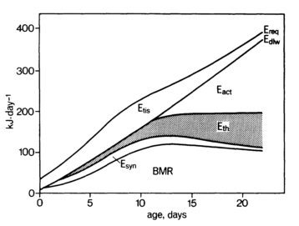
Despite the Arctic tern’s less varied diet composition in the Arctic in comparison to their more southern congeners, the overall caloric intake of their chicks seemed to be sufficiently high (Fig. 27). When considering the Arctic tern chick energy requirements with increasing age according to Klaassen et al in their article on the growth and energetics of Arctic tern chicks (Fig.28, Klaassen et al., 1989a), the Ny-Ålesund chicks receive far above average calories. However, there is likely to be a significant discrepancy there, since only the caloric supply to the chicks was taken into account in the current study, whereas Klaassen and his colleagues studied the actual caloric intake in terms of energy being allocated to basal metabolism, biosynthesis, thermoregulation, activity, and tissue deposition (Klaassen et al., 1989a). Since prey digestion is not 100% efficient, the actual utilized percentage of the prey would be significantly lower for each prey than indicated in the graph (Fig. 27). Moreover, the carapax of the main prey group in this study would decrease their energy density compared to softer prey such as fish items (Weslawski et al., 1994; Weslawski et al., 1991). However, since the majority of the chicks were supplied with prey with a total caloric content much higher than the required amount of calories, the final caloric intake might have been sufficient despite some loss due to digestive inefficiency, in particular of the crustaceans. After the first 10 days, their actual caloric intake may have reached insufficient levels, since the supplied calories were approximately equal to the required calories (Fig. 27). Taken into account that the Arctic tern chicks received significantly less larger fish items at a later age, the energy density of the smaller prey they received was presumably also smaller (Weslawski et al., 1994; Mårtensson et al., 1996; Weslawski et al., 1991; Uttley, 1992). It is uncertain why the caloric supply to the chicks dropped to such a low level after the first 10 days, but since it couldn’t be connected to harsh weather conditions, it may be more likely that certain larger and more nutritious prey species became less abundant for the Arctic terns at the end of the breeding season. This theory is even more plausible when the regular timing of the breeding season is taken into account. Usually, Arctic terns rear chicks between half June/early July (Egevang et al., 2010). The terns that were observed for this study, reared young chicks still at the end of July and the start of August. It is unsure whether this was due to later arrival of Arctic terns or whether these nests were replacement clutches for failed attempts earlier in the season or nest predation. This could have potentially caused a trophic mismatch for the Arctic terns. In addition, this would also explain the higher amount of larger fish being fed to younger chicks and vice versa for older chicks, who received proportionally more smaller prey items. Results from other studies indicated a reversed order with prey size gradually increasing with age (Rock et al., 2007; Safina et al., 1990).
Figure 28. Total energy requirements (E_{req}) of Arctic tern chicks in Ny-Ålesund, Svalbard. Source: Klaassen et al., 1989a
As expected, caloric supply was not only dependent on the age of the chicks, but also on the environmental conditions in Ny-Ålesund. In contrast to the age of the chicks, inclement weather did have the anticipated effect on the caloric supply to Arctic tern chicks. In particular the presence of precipitation heavily affected this supply in a negative way. The significant drop in delivered calories by almost 50% during rainy days, can be attributed to 2 factors. Firstly, deteriorated flight conditions would affect the foraging success of adults due to impaired visibility of prey at the water surface (Robinson et al., 2002; Dunn, 1975). This depressive effect on foraging success however, is more detrimental during days with stronger wind than during days with precipitation (Dunn, 1975). Hence, the other factor that should be taken into account here, and which would explain the bulk of the reduction in provisioned calories. During rainy days, tern chicks are faced with a severe risk of hypothermia of specifically the younger, but also the older chicks when exposed. This means that either more time can be invested in brooding the chicks and preventing exposure, at the cost of a significantly reduced caloric supply, or more effort can be allocated to foraging in conditions in which the prey supply is unlikely to compensate for the extra energy requirements. Since one of the adult terns can still go out foraging, but the other one should maintain brooding, the caloric intake would naturally be reduced with approximately 50% (Dunn, 1975). The absence of a significant reduction in caloric supply to older chicks with elevated wind speeds, can be attributed to the thermostability of these chicks (Klaasen et al., 1989a; Devlin, 2006). Arctic tern chicks become thermostable after little over a week, which reduces the necessity of parental brooding. Consequently, parents can allocate more time to foraging and prey provisioning as opposed to nest attendance. Younger, thermolabile chicks however, need more intensive brooding during windier days, leaving less time for foraging (Burton and Thurston, 1959; Klaasen et al., 1989a; Robinson et al., 2002; Anderson et al., 2007).

Conclusion

The outcome of this study emphasizes the importance of crustaceans as a prey group for Arctic terns in the high Arctic. Furthermore, it sheds a light on the impact that environmental fluctuations can have on the diet and caloric supply of surface feeding birds such as the Arctic tern in this region.
Overall, the most evident results of this study concern the diet composition of the tern chicks which was dominated by small prey being krill and amphipods, in particular during windy days. Predominantly wind speed and the presence of precipitation had a significant impact on the diet composition, provisioning rate, and caloric supply of tern chicks. Unlike expected, and unlike in the more temperate regions, the effect of the tides on the Arctic tern chicks’ diet was of minor importance in the high Arctic. However, tidal fluctuations in the Arctic did result in a higher proportion of fish larvae during ebb tides and an increased provisioning rate during the same tides, which is both inconsistent with previous research by Frick and Becker.
Furthermore, the provisioning of chicks with larger prey items coincided with reduced provisioning rates as hypothesized, whereas smaller prey were generally fed with smaller intervals. An anticipated increase in crustaceans as part of the chick diet during low water, was not detected however, although they were the main prey type during elevated wind speeds.
Then finally, and most importantly, the caloric supply to tern chicks during this breeding season seemed sufficient enough in the first 10 days to ensure a caloric intake that would meet the energetic requirements. However, after these 10 days, it may have been highly likely that the severe drop in supplied calories, in combination with a high predation pressure, may have been responsible for the low survival rate of Arctic tern chicks this season.
In a vulnerable and dynamic environment where surface feeding seabirds such as the Arctic tern have to plan both the timing and location of their chick rearing very carefully, reaching a better understanding of those factors that determine their diet is a highly complicated task. Since the diet of Arctic tern chicks in this study was determined through observations of prey deliveries at the nest, crucial information on the marine availability of prey was missing. Therefore, it was impossible to determine whether alternating diet compositions in connection to wind speeds and precipitation, could be attributed to either a change in prey availability, limited foraging opportunities and range, or a combination of the two.
Even more critical was the missing information on the exact caloric intake of the tern chicks based on specific prey types. This stresses the need for combined research at the nest sites itself, at foraging grounds, and in the lab to get a better overview of the actual impact of the factors involved in this study.

Improvements and future research

The summer of 2014 was a relatively bad breeding season for the Arctic terns on Ny-Ålesund, with a high number of both eggs and chicks that were predated. As a result, there may have been some bias in the data that were gathered during fieldwork. Due to predation, there was a strong fluctuation in the number of nests that were available for observations and thus, some nests were studied with a much higher intensity than others. This may have affected the reliability of the results, especially since there was a large difference between the number of nests with one, and nests with two chicks. Furthermore, since mostly young chicks were predated, the composition of age groups was skewed and chicks of 10 days or older had a higher representation. A larger sample size with a more equal distribution of hatch dates and clutch sizes would have provided a more reliable dataset.
Also, the determination of delivered prey species from a distance and by observations through a telescope may not have been accurate enough. Prey were mostly identifiable up to at least family level and size was estimated based on bill length of the supplying tern, but this may have been a potential source of error. Recording deliveries by observation is a commonly used method (Safina et al., 1990; Anderson et al., 2005; Uttley 1992; Oswald et al., 2012; Robinson and Hamer 2000; Hall et al., 2012; Stienen et al., 2015). However, more precise methods have been used in dietary studies and involved the retrieval of delivered prey items after which they could be measured and their calorific content determined (Harter et al., 2013). This would provide a more detailed insight in the composition and energetic content of the Arctic tern chick diet. In particular for studies in which the actual caloric intake is essential, such a method would be crucial to determine whether the energetic requirements of the chicks have been met. Adversely, retrieving prey items that have already been delivered to a chick is likely to induce stress and to have a short-term effect on feeding behavior. A better and less invasive approach that should be implemented in combination with prey-studies at the nest sites, entails sampling of fish and plankton in the top water layer of both infrequently as frequently visited foraging sites. This may provide a general overview of their diet preferences and availability of potential prey. Moreover, determining length and calorific content of known prey species from these samples would be more reliable than the estimates used in this study.
When considering the potential nutritious value of the prey items delivered in this study, the decrease in supply of larger fish items towards the end of the breeding season was remarkable. Normally, this would have been reversed with larger fish being delivered to older chicks in order to ensure an increase in caloric intake. A possible explanation for this mismatch is that the peak in most advantageous prey was already earlier in the season, which is why the majority of the Arctic terns also arrived earlier. In fact, with climate change taken into account, a tendency towards earlier breeding seasons is expected as a response to earlier spring plankton blooms (Wanless et al., 2009; Verhulst and Nilsson, 2008). In order to determine whether the Arctic tern will be able to adapt to these changing conditions, more research on their diet is essential both in their Antarctic wintering areas as their Arctic breeding regions.
Another consequence of the heavy impact of climate change in the Arctic would be a larger volume of freshwater input due to glacial ablation and changing precipitation levels (Weslawski et al., 2000; Zajaczkowski and Legezynska, 2001). As of now, the effect that limited amounts of freshwater outflow have on the temporal and local availability of zooplankton is known to be advantageous to certain surface feeding birds (Mehlum and Gabrielsen, 1993). However, apart from the osmotic shock experienced by zooplankton when exposed to low salinity levels, high levels of zooplankton mortality are also common, reducing their availability in the top water layer (Weslawksi and Legeynska, 1998; Zajaczkowski and Legezynska, 2001; Weslawski et al., 2000). This emphasizes the need for more information about the possible local depletion of Arctic tern foraging grounds in the vicinity of glacier edges.
Ultimately, more research on the behavior and diet composition of Arctic marine birds is essential, not only for the conservation of their populations, but also to assess the current and future condition of the Arctic marine environment. Monitoring of seabirds can be a way to obtain an index of the distribution, numbers, and spatial and temporal variability of their prey stocks as well as the impact of increasing anthropogenic influences in the Arctic (Monaghan, 1996; McKnight et al., 2014; Vigfusdottir et al., 2013).

Acknowledgements
I want to thank my supervisors Maarten Loonen and Christiaan Both for their support and guidance during this project. Everyone else affiliated with the Arctic Centre, and present during my work there also receive my gratitude for their help, and of course for offering me a great time at this multidisciplinary centre. One of my colleagues and friend, Margje de Jong, deserves extra gratitude from me for her unremitting support and availability for questions, both during my work at the Arctic Centre as in the field in Ny-Ålesund. Furthermore, the people who supplied me with the necessary information on the tern nests in Ny-Ålesund, and who also helped me out during my fieldwork there; Malenthe Teunis, Janwillem Loonen, and several others, deserve a thank you. Finally, I would like to thank all the people present in Ny-Ålesund during my fieldwork there. In addition to Ny-Ålesund being an amazing location to do fieldwork and explore the high North, the researchers and staff there made my stay an unforgettable experience.

References
^{[54]}Anderson, S. K., Roby, D. D., Lyons, D. E., & Collis, K. (2007). Relationship of Caspian tern foraging ecology to nesting success in the Columbia River estuary, Oregon, USA. Estuarine, Coastal and Shelf Science, 73(3-4), 447–456.
Anderson, S. K., Roby, D. D., Lyons, D. E., & Collis, K. (2005). Factors Affecting Chick Provisioning by Caspian Terns Nesting in the Columbia River Estuary. Waterbirds, 28(1), 95–105.
Ashpole, J., Burfield, I., Ieronymidou, C., Pople, R., Tarzia, M., Wheatley, H., & Wright, L. (2015). Birdlife International: Detailed regional assessment and species account from the European Red List of Birds.
^{[7]}Barrett, R. T., & Furness, R. W. (1990). The prey and diving depths of seabirds on Hornoy, North Norway after a decrease in the Barents Sea capelin stocks. Ornis Scandinavia, 21(3), 179–186.
Boecker, M. (1976). Bonner Zoologische Beiträge.
Bonanomi, S., Pellissier, L., Therkildsen, N. O., Hedeholm, R. B., Retzel, A., Meldrup, D., … Nielsen, E. E. (2015). Archived DNA reveals fisheries and climate induced collapse of a major fishery. Scientific Reports, 5, 1–8.
^{[12]}Brekke, B., & Gabrielsen, G. W. (1994). Assimilation efficiency of adult Kittiwakes and Brünnich’s Guillemots fed Capelin and Arctic Cod. Polar Biology, 14(4), 279–284.
^{[13]}Bureau Du Colombier, S., Bolliet, V., Lambert, P., & Bardonnet, a. (2007). Energy and migratory behavior in glass eels (Anguilla anguilla). Physiology and Behavior, 92(4), 684–690.
^{[26]}Burton, P. J. K., & Thurston, M. H. (1959). Observations on Arctic Terns in Spitsbergen. British Birds, LII, 149–161.
^{[10]}Burtt, E. H. (1974). Success of Two Feeding Methods of the Black-Legged Kittiwake. The Auk, 91(4), 827–829.
Carscadden, J. E., Frank, K. T., & Leggett, W. C. (2001). Ecosystem changes and the effects on capelin (Mallotus villosus), a major forage species. Can. J. Fish. Aquat. Sci., 58(1), 73–85.
Crawley, M. J. (2007). The R Book, Chichester, England; Hoboken, NJ: Wiley.
^{[14]}Dale, K., Falk-Petersen, S., Hop, H., & Fevolden, S. E. (2006). Population dynamics and body composition of the Arctic hyperiid amphipod Themisto libellula in Svalbard fjords. Polar Biology, 29(12), 1063–1070.
Denlinger, L. M. (2006). Alaska Seabird Information Series.
^{[47]}Devlin, C. (2006). Birds crossing borders: a population study of arctic terns (Sterna paradisaea).
Dies, J. I., & Dies, B. (2005). Kleptoparasitism and Host Responses in a Sandwich Tern Colony of Eastern Spain. Waterbirds, 28(2), 167–171.
^{[37]}Dunn, E. K. (1975). The Role of Environmental Factors in the Growth of Tern Chicks. Journal of Animal Ecology, 44(3), 743–754.
^{[29]}Egevang, C., & Frederiksen, M. (2011). Fluctuating Breeding of Arctic Terns ( Sterna paradisaea ) in Arctic and High-Arctic Colonies in Greenland. Waterbirds, 34(1), 107–111.
^{[31]}Egevang, C., Kampp, K., & Boertmann, D. (2004). The Breeding Association of Red Phalaropes with Arctic Terns: Response to a Redistribution of Terns in a Major Greenland Colony. Waterbirds: The International Journal of Waterbird Biology, 27(4), 406–410.
^{[32]}Egevang, C., Stenhouse, I. J., Phillips, R. a, Petersen, A., Fox, J. W., & Silk, J. R. D. (2010). Tracking of Arctic terns Sterna paradisaea reveals longest animal migration. Proceedings of the National Academy of Sciences of the United States of America, 107(5), 2078–81.
Fijn, R. C., Hiemstra, D., Phillips, R. a, & Winden, J. Van Der. (2013). Arctic Terns Sterna paradisaea from the Netherlands Migrate Record Distances Across Three Oceans to Wilkes Land, East Antarctica. Ardea, 101(1), 3–12.
Frank, K., & Leggett, W. (1986). Effect of prey abundance and size on the growth and survival of larval fish: an experimental study employing large volume enclosures . Marine Ecology Progress Series, 34, 11–22.
^{[46]}Frick, S., & Becker, P. H. (1995). Unterschiedliche Ernährungsstrategien von FluB- und Küstenseeschwalbe (S. hirundo und S. paradisaea) im Wattenmeer. J. Für Ornithologie, 136(1), 47–63.
^{[15]}Gabrielsen, G. W., Mehlum, F., & Nagy, K. A. (1987). Daily energy expenditure and energy utilization of free-ranging black-legged kittiwakes. Condor, 89(1), 126–132.
^{[8]}Garthe, S., Benvenuti, S., & Montevecchi, W. a. (2000). Pursuit plunging by northern gannets (Sula bassana) feeding on capelin (Mallotus villosus). Proceedings. Biological Sciences / The Royal Society, 267(1454), 1717–1722.
^{[55]}Gudmundsson, G. A., Alerstam, T., & Larsson, B. (1992). Radar observations of northbound migration of the Arctic tern, Sterna paradisaea, at the Antarctic Peninsula. Antarctic Science, 4(02), 163–170.
^{[48]}Hall, C. S., Kress, S. W., Griffin, C. R., & Stephen, W. (2012). Composition , Spatial and Temporal Variation of Common and Arctic Tern Chick Diets in the Gulf of Maine. Waterbirds, 23(3), 430–439.
^{[11]}Hamer, K. C., Phillips, R. A., Wanless, S., Harris, M. P., & Wood, A. G. (2000). Foraging ranges, diets and feeding locations of gannets Morus bassanus in the North Sea: Evidence from satellite telemetry. Marine Ecology Progress Series, 200, 257–264.
^{[6]}Haney, J. C., & Stone, A. E. (1988). Seabird foraging tactics and water clarity: are plunge divers really in the clear? Marine Ecology Progress Series, 49(1-2), 1–9.
^{[16]}Harter, B. B., Elliott, K. H., Divoky, G. J., & Davoren, G. K. (2013). Arctic cod (Boreogadus saida) as prey: Fish length-energetics relationships in the Beaufort sea and Hudson Bay. Arctic, 66(2), 191–196.
^{[9]}Hobson, K. a, & Welch, H. E. (1992). Observations of Foraging Northern Fulmars (Fulmarus-Glacialis) in the Canadian High Arctic. Arctic, 45(2), 150–153.
Hopkins, C. D., & Wiley, R. H. (1972). Food Parastism and Competation in Two Terns. The Auk, 89(3), 583–594.
^{[33]}Isaksen, K., & Bakken, V. (1995). Seabird populations in the Northern Barents Sea.
^{[27]}Klaassen, M., Bech, C., Masman, D., & Slagsvold, G. (1989). Growth and Energetics of Arctic Tern Chicks ( Sterna paradisaea ). The Auk, 106(2), 240–248.
^{[28]}Klaassen, M., Bech, C., & Slagsvold, G. (1989). Basal Metabolic Rate and Thermal Conductance in Arctic Tern Chicks and the Effect of Heat Increment of Feeding on Thermoregulatory Expenses. ARDEA, 77(2), 193–200.
Lemmetyinen, R. (1976). Feeding Segregation in the Arctic and Common Terns in Southern Finland. The Auk, 93(3), 636–640.
^{[34]}Lilliendahl, K., & Solmundsson, J. (1997). An estimate of summer food consumption of six seabird species in Iceland. ICES Journal of Marine Science, 54(4), 624–630.
Loeb, V., Siegel, V., Holm-Hansen, O., Hewitt, R., Fraser, W., Trivelpiece, W., & Trivelpiece, S. (1997). Effects of sea-ice extent and krill or salp dominance on the Antarctic food web. Letters to Nature, 387, 879–900.
Madsen, J., Tombre, I., & Eide, N. E. (2009). Effects of disturbance on geese in Svalbard: Implications for regulating increasing tourism. Polar Research, 28(3), 376–389.
^{[17]}Mårtensson, P. E., Lager Gotaas, A. R., Nordøy, E. S., & Blix, A. S. (1996). Seasonal changes in energy density of prey of northeast atlantic seals and whales. Marine Mammal Science, 12(4), 635–640.
McKnight, A., Allyn, A. J., Duffy, D. C., & Irons, D. B. (2013). “Stepping stone” pattern in Pacific Arctic tern migration reveals the importance of upwelling areas. Marine Ecology Progress Series, 491, 253–264. http://doi.org/10.3354/meps10469
^{[18]}Mehlum, F., & Gabrielsen, G. W. (1993). The diet of high-arctic seabirds in coastal and ice-covered, pelagic areas near the Svalbard archipelago. Polar Research, 12(1), 1–20. http://doi.org/10.3402/polar.v12i1.6698
^{[38]}Monaghan, P. (1996). Relevance of the behaviour of seabirds to the conservation of marine environments. Oikos, 77(2), 227–237. http://doi.org/10.2307/3546061
^{[39]}Monaghan, P., Uttley, J. D., & Burns, M. D. (1992). Effects of Changes in Food Availability on Reproductive Effort in Arctic Terns Sterna paradisea. ARDEA, 80(1), 71–81.
Montevecchi, W. A., & Myers, R. A. (1995). Prey harvests of seabirds reflect pelagic fish and squid abundance on multiple spatial and temporal scales. Marine Ecology Progress Series, 117(1-3), 1–10.
^{[19]}Montevecchi, W. A., & Piatt, J. (1984). Composition and energy contents of mature inshore spawning capelin (mallotus villosus): implications for seabird predators. Comparative Biochemistry and Physiology Part A: Physiology.
^{[20]}Nicol, S., & Endo, Y. (1999). Krill fisheries: Development, management and ecosystem implications. Aquatic Living Resources, 12(2), 105–120.
^{[21]}Noyon, M., Narcy, F., Gasparini, S., & Mayzaud, P. (2011). Growth and lipid class composition of the Arctic pelagic amphipod Themisto libellula. Marine Biology, 158(4), 883–892.
^{[53]}Oswald, S., Arnold, J., Hatch, J., & Nisbet, I. (2012). Piracy at the Nest: Factors Driving Kleptoparasitic behaviour of Common Tern Chicks. Acta Ornithologica, 47(1), 95–100.
^{[22]}Otterlei, E., Nyhammer, G., Folkvord, A., & Stefansson, S. O. (1999). Temperature-and size-dependent growth of larval and early juvenile Atlantic cod (Gadus morhua): a comparative study of Norwegian coastal cod and northeast Arctic cod. Canadian Journal of Fisheries and Aquatic Sciences, 56(11), 2099–2111.
^{[1]}Pearson, T. H. (1968). The Feeding Biology of Sea-Bird Species Breeding on the Farne Islands, Northumberland. The Journal of Animal Ecology, 37(3), 521–552.
Pedersen, T., & Fossheim, M. (2008). Diet of 0-group stages of capelin (Mallotus villosus), herring (Clupea harengus) and cod (Gadus morhua) during spring and summer in the Barents Sea. Marine Biology, 153(6), 1037–1046.
^{[2]}Robertson, G. S., Bolton, M., Grecian, W. J., Wilson, L. J., Davies, W., & Monaghan, P. (2014). Resource partitioning in three congeneric sympatrically breeding seabirds: Foraging areas and prey utilization. The Auk, 131(3), 434–446.
^{[39]}Robinson, J. A., & Hamer, K. C. (2000). Brood size and food provisioning in Common Terns Sterna hirundo and Arcitc Terns S. paradisaea: consequences for chick growth. Ardea, 88(1), 51–60.
^{[40]}Robinson, J. A., Hamer, K. C., & Chivers, L. S. (2001). Contrasting Brood Sizes in Common and Arctic Terns: The Roles of Food Provisioning Rates and Parental Brooding. The Condor, 103(1), 108–117.
^{[41]}Robinson, J. A., Hamer, K. C., & Chivers, L. S. (2002). Developmental plasticity in Arctic Terns Sterna paradisaea and Common Terns S . hirundo in response to a period of extremely bad weather. IBIS, 144(2), 344–346.
^{[49]}Rock, J. C., Leonard, M. L., & Boyne, A. W. (2007). Do Co-Nesting Arctic and Common Terns Partition Foraging Habitat and Chick Diets? Waterbirds, 30(4), 579–587.
Safina, C., Wagner, R., Witting, D. A., & Smith, K. J. (1990). Prey Delivered to Roseate and Common Tern Chicks ; Composition and Temporal Variability. Journal of Field Ornithology, 61(3), 331–338.
^{[44]}Schwemmer, P., Adler, S., Guse, N., Markones, N., & Garthe, S. (2009). Influence of water flow velocity, water depth and colony distance on distribution and foraging patterns of terns in the Wadden Sea. Fisheries Oceanography, 18(3), 161–172.
Steiger, S. S., Valcu, M., Spoelstra, K., Helm, B., Wikelski, M., & Kempenaers, B. (2013). When the sun never sets: diverse activity rhythms under continuous daylight in free-living arctic-breeding birds. Proceedings. Biological Sciences / The Royal Society, 280(1764), 1–10.
^{[50]}Stephensen, S. W., Zwiefelhofer, D. C., & Howard, R. J. (2002). Seabird Colony Survey of South and East Kodiak Island, Alaska, June 2001.
^{[45]}Stienen, E. W. M., Brenninkmeijer, A., & Courtens, W. (2015). Intra-specific plasticity in parental investment in a long-lived single-prey loader. Journal of Ornithology, 156(3), 699–710.
Suddaby, D., & Ratcliffe, N. (1997). The Effects of Fluctuating Food Availability on Breeding Arctic Terns ( Sterna paradisaea ). The Auk, 114(3), 524–530.
^{[42]}Taylor, I. R. (1983). Effect of Wind on the Foraging Behaviour of Common and Sandwich Terns. Ornis Scandinavica, 14(2), 90–96.
Uttley, J. D. (1992). Food supply and allocation of parental effort in arctic terms Sterna paradisaea. ARDEA, 80(1), 83–91.
Verhulst, S., & Nilsson, J. -a. (2008). The timing of birds’ breeding seasons: a review of experiments that manipulated timing of breeding. Philosophical Transactions of the Royal Society B: Biological Sciences, 363(1490), 399–410.
^{[35]}Vigfusdottir, F., Gunnarsson, T. G., & Gill, J. A. (2013). Annual and between-colony variation in productivity of Arctic Terns in West Iceland. Bird Study, 60(3), 289–297.
Vikingsson, G. A., Pike, D. G., Valdimarsson, H., Schleimer, A., Gunnlaugsson, T., Silva, T., … Hammond, P. S. (2015). Distribution, abundance, and feeding ecology of baleen whales in Icelandic waters: have recent environmental changes had an effect? Frontiers in Ecology and Evolution, 3(February), 1–18.

^{[43]}Wanless, S., Frederiksen, M., Walton, J., & Harris, M. P. (2009). Long-term changes in breeding phenology at two seabird colonies in the western North Sea. IBIS, 151(2), 274–285.
^{[23]}Weslawski, J. M., Jankowski, A., Kwasneiewski, S., Swerpel, S., & Ryg, M. (1991). Summer hydrology and zooplankton in two Svalbard fjords. Polish Polar Research, 12(3), 445–460.
Weslawski, J. M., & Legezyńska, J. (1998). Glaciers caused zooplankton mortality? Journal of Plankton Research, 20(7), 1233–1240.
Wȩsławski, J. M., Pedersen, G., Petersen, S. F., & Poraziński, K. (2000). Entrapment of macroplankton in an Arctic fjord basin, Kongsfjorden, Svalbard. Oceanologia, 42(1), 57–69.
^{[24]}Weslawski, J. M., Ryg, M., Smith, T. G., & Oritsland, N. A. (1994). Diet of ringed seals (Phoca hispida) in a fjord of west Svalbard. Arctic, 47(2), 109–114.
Weydmann, A., Soreide, J. E., Kwasniewski, S., Leu, E., Falk-Petersen, S., & Berge, J. (2013). Ice-related seasonality in zooplankton community composition in a high Arctic fjord. Journal of Plankton Research, 35(4), 831–842.
^{[51]}Whittam, R. M., & Leonard, M. L. (2000). Characteristics of Predators and Offspring Influence Nest Defense by Arctic and Common Terns. The Condor, 102(2), 301–306.
^{[52]}Wiggins, D. A., & Morris, R. D. (1987). Parental care of the Common Tern Sterna hirundo. IBIS, 129(4), 533–540.
^{[25]}Wilding, A. T. (2007). Krill as a source of aquafeeds (unpublished 2nd draft).
Zajaczkowski, M. J., & Legezyńska, J. (2001). Estimation of zooplankton mortality caused by an Arctic glacier outflow. Oceanologia, 43(3), 341–351.
Zamon, J. E. (2002). Tidal changes in copepod abundance and maintenance of a summer Coscinodiscus bloom in the southern San Juan Channel, San Juan Islands, USA. Marine Ecology Progress Series, 226, 193–210.
Zamon, J. E. (2003). Mixed species aggregations feeding upon herring and sandlance schools in a nearshore archipelago depend on flooding tidal currents. Marine Ecology Progress Series, 261(1), 243–255.
Zuur, A. F. (2009). Mixed Effects Models and Extensions in Ecology with R, Statistics for Biology and Health, United Kingdom, Newburgh.
Appendix
Table 1A. Clarification on the statistical terms and interactions used in tables in the results section. All factors are described and two examples of interactions are given below.
Statistical term | Definition | # classes | Interpretation
Age | Age of chicks in nest | Continuous factor | Age in days from hatch, until 28 days old.
AgeClass | Age of chicks in nest | 2 | Age in days from hatch, first class (1) chicks < 1 week, second class (2) chicks > 1 week.
EbbFl | Tidal stages ebb and flood | 2 | Tides consisting of 2 classes being; ebb, measured as the hrs between hw and lw, and flood, measured as the hrs between lw and hw.
Feedingrate | Provisioning to chicks | Continuous | Rate of prey deliveries to chicks; number of prey per chick per hour.
hwlw | Tidal stages high water and low water | 2 | Tides consisting of 2 classes being; hw measured as the hrs between halfway hw and halfway lw and lw, measured from halfway lw to halfway hw (Fig. 9 M&M section).
Nrchicks | Number of chicks in the nest | 2 | Nests observed for this study consisted of either 1 or 2 chicks.
Precip | Presence of precipitation | 2 | Presence (1) or absence (0) of precipitation.
Predation | Presence of predation | 2 | Presence (1) or absence (0) of predation on either eggs during previous nest attempts, or chicks from previous or current nest attempts.
PreyTyp | Type of fed prey | 3 | Prey type fed to chicks, consisting of 3 classes being: crustaceans, fish or fish larvae.
Wind | Average wind speed | Continuous | Average wind speed during observation hours; meters per second.
Interactions
Age:Nrchicks1 | Interaction between two factors | Variable | An interaction is depicted with a colon between two factors. The statistical values in the tables are applicable to the class denoted with a number, in this case nests with 1 chick. The group of nests with 2 chicks is used as reference point.
Wind:hwlwlw | “ | “ | Interaction between wind speed and tidal stages hw and lw, with statistical values for class lw in comparison to reference class hw. Therefore lw is indicated as an extra addition to the factor “hwlw”.
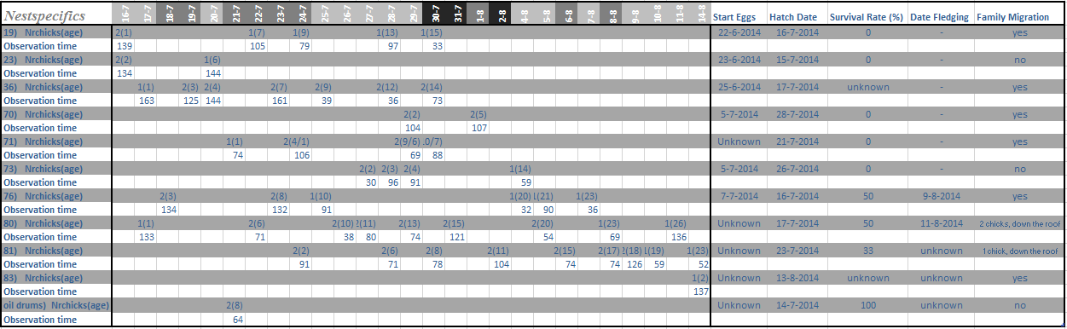
Table 2A. Details of the observed nests in this study. Nest numbers are depicted in the left column and the dates in the top row. Dates have been marked with 1 out of 3 colors indicating the weather situation at that day, and ranging from good weather (lightest color) to bad weather with higher wind speeds (darkest color). Observation time is given in minutes.

Table 3A. Final model for dependent variable “Brooding” up to the age of 8 days. Results were obtained with a Linear Mixed Model (lme) and rejected terms are presented with values prior to removal from model. Nest number is included as a random factor.
Variable | Estimate | Std. Error | T | DF | P
(Intercept) | 58.92 | 10.12 | 5.82 | 10 | < 0.001
Age | -9.84 | 1.18 | - 8.34 | 10 | < 0.001**
Wind | 5.99 | 2.90 | 2.06 | 10 | 0.07
Rejected terms
Age:Chick1 | - 0.85 | 3.44 | - 0.25 | 7 | 0.81
Temp | 0.04 | 2.25 | 0.02 | 8 | 0.98
Chick1 | - 7.49 | 6.79 | - 1.10 | 9 | 0.30

Table 4A. Final model for dependent variable “caloric intake”. Results were obtained with a Generalized Linear Mixed Model (GLMER) using a GAMMA distribution. Rejected terms are presented with values prior to removal from model and both Day number as Nest number were used as random factors.
Variable | Estimate | Std. Error | t | DF | P(LRT)
(Intercept) | 0.65 | 0.79 | 0.83 |  | 0.41
NestAg | - 0.11 | 0.04 | - 2.65 | 1 | 0.005**
Precip1 | - 0.77 | 0.29 | - 2.69 | 1 | 0.009**
Tide | - | - | - | 3 | 0.08
Wind | - 0.64 | 0.24 | - 2.69 | 1 | 1.00
Wind:NestAg | 0.04 | 0.01 | 2.92 | 1 | 0.002**
Rejected terms
Nrchicks2 | - 0.14 | 0.21 | - 0.66 | 1 | 0.49

Table 4B. Significant interactions between the factor wind and the separate tidal stages, retrieved with a “PostHoc Tukey test”. The Tukey Test was performed on the final model (GLMER) for caloric intake with a GAMMA distribution.
Variable | Estimate | Std. Error | t | DF | P(LRT)
Wind:Ebbhw | 0.49 | 0.08 | 5.76 | 1 | < 0.001***
Wind:Ebblw | 0.04 | 0.01 | 4.02 | 1 | < 0.001***
Wind:Flhw | - 0.13 | 0.03 | - 3.90 | 1 | < 0.001***
Wind:Fllw | - 0.08 | 0.04 | - 2.24 | 1 | 0.03*

Table 5A. Final model for dependent variable “provisioning rate”. Results were obtained with a log-transformed Linear Mixed Model (LMER) and rejected terms are presented with values prior to removal from model. Both random factors “Nest number” and “Day number” were included in the model. Prey and tidal groups were compared after the initial LMER model was used with a “PostHoc Tukey test” of which the results are shown in the next table.
Variable | Estimate | Std. Error | t | DF | P(LRT)
(Intercept) | 1.46 | 0.20 | 7.11
Wind | - 0.20 | 0.07 | - 2.92 | 1 | 0.007**
Nrchicks | - 0.18 | 0.08 | - 2.21 | 1 | 0.03*
Rejected terms
Wind:Tide | - | - | - | 3 | 0.45
NestAg | - 0.01 | 0.01 | - 0.71 | 1 | 0.34
Wind:Precip1 | - 0.04 | 0.06 | - 0.66 | 1 | 0.23
NestAg:Nrchicks2 | - 0.05 | 0.03 | - 1.82 | 1 | 0.11
Precip1 | 0.20 | 0.24 | 0.84 | 1 | 0.06

Table 5B. Significant and non-significant interactions between the separate prey groups and tidal phases. These results were retrieved with a “PostHoc Tukey test”. The Tukey Test was performed on the final model (log-transformed LMER) for the dependent variable provisioning rate.
Variable | Estimate | Std. Error | t | DF | P(LRT)
Fish-Crustacean | - 0.16 | 0.04 | - 3.62 | 1 | 0.002**
Larvae-Crustacean | - 0.23 | 0.05 | - 4.60 | 1 | < 0.001***
Larvae-Fish | - 0.07 | 0.06 | - 1.20 | 1 | 0.62
Fllw-Flhw | 0.18 | 0.05 | 3.34 | 1 | 0.004**
Fllw-Ebbhw | 0.21 | 0.08 | 2.54 | 1 | 0.05
Flhw-Ebblw | - 0.11 | 0.05 | - 2.33 | 1 | 0.09
Fllw-Ebblw | 0.07 | 0.05 | 1.31 | 1 | 0.55
Flhw-Ebbhw | 0.03 | 0.07 | 0.45 | 1 | 0.97
Ebblw-Ebbhw | 0.14 | 0.07 | 1.98 | 1 | 0.19

