CONFIDENTIAL

Abstract

Packaging developers try reducing polyolefin use by material reduction, exploring biobased materials, using recycled or waste materials and replacing part of the material by fillers. Fillers can be fibers from wood waste, plants or paper or particles from minerals like calcium carbonate. This report investigates the possibility of replacing an HDPE laminate tube with a laminate tube made of a calcium carbonate filled polyolefin.

It is found that such a FPO laminate tube is a feasible option for cosmetic packaging. Possible issues might include oil barrier, scratch and wear resistance and oxygen barrier. Furthermore, UV- and thermal stability might call for additives like HALS in order to slow down degradation. The FPO material is more sustainable. However, a quantitive comparison like a LCA will have to show the actual fossil fuel and CO2 reductions that are made.

21 September 2017

Author L.M. Hoff

E-mail lottemhoff@gmail.com

Filled Polyolefin in Packaging

Calcium carbonate as a filler in tube manufacturing – A cheap and sustainable option?

Rijksuniversiteit Groningen

University supervisor: Prof. dr. F. Picchioni

E-mail: F.Picchioni@rug.nl

Beiersdorf AG

Supervisor: I. Alshut

E-mail: Ines.Alshut@beiersdorf.com

Table of Contents

1. Introduction 3

2. Methodology 3

3. Filler Materials 4

3.1. Wood 4

3.2. Paper 4

3.3. Plant fibers 5

3.4. Mineral powders 5

4. Quality function deployment 7

4.1. Product requirements 7

4.2. Processing requirements 8

4.2.1. Production process 8

4.2.2. Conclusion 10

4.3. House of Quality 12

5. Material Development 13

5.1. Processing requirements 13

5.2. Product requirements 14

5.2.1. Color 14

5.2.2. Appearance/Tactile Consumer Experience 14

5.2.3. Mechanical Properties 15

5.2.4. Compatibility 17

5.2.5. Degradation 21

6. Sustainability 23

6.1. Atom Economy 23

6.2. Feedstock 23

6.3. Carbon footprint 24

6.4. Recycling 24

7. Conclusion and Recommendations 25

7.1. Recommendations 25

7.1.1. Life cycle analysis 25

7.1.2. Further testing 25

7.1.3. More materials 26

Bibliography 27

Appendix 29

# Introduction

The use of fossil fuel based materials is currently inevitable in the cosmetic packaging industry. The aspiration of a more sustainable future as well as cost considerations have driven companies towards the reduction of polyolefin use. There are different approaches for reaching these goals: the packaging design itself (weight reduction), the use of recyclable material, the development of bio-based materials (e.g. polyethylene based on bioethanol, polylactic acid based on lactic acid,…), replacing part of the material with another substance called a filler, etc.

This report considers the possibility of using a filler in a polyolefin (PO) used as a packaging material. More specifically, an existing cosmetic packaging (flexible tube) will undergo a raw material change in order to reduce the use of fossil fuel, carbon footprint and material cost. The aim is to give an indication towards the feasibility of such a packaging material for Beiersdorf’s cosmetic products. Is it feasible? Is there a sustainable advantage? Is there an economic advantage?

A filled PO (FPO) has different properties than a neat PO. These properties depend on filler material and filler content in the FPO. In order to find the best filler material as well as optimum filler content, we first need to look at the common requirements the tube might have. First, the consumer’s needs have to be met. The consumer expects a tube which is as good as or better than the current packaging. The tube has to still be recognizable and of good quality which is especially important for a big brand like Nivea or Eucerin. Second, there are requirements that are related to compatibility with the packaging content. Important issues can be solvent resistance and barrier properties of the packaging material. Last but not least, requirements based on available processes and equipment need to be considered. It would be most convenient to produce the tube in the existing production process without any major changes or investments.

# Methodology

First, possible filler materials are addressed briefly and a choice of filler material is made. Next, specifically the use of calcium carbonate (CaCO3) as a filler in tube production is considered. A quality function deployment is performed in order to find all the requirements of the tube material based on customer needs, compatibility with the packaging content and processability of the material. The influence of filler particles on each requirement is investigated. A comparison of FPO tube with current tube is made in order to find the feasibility of actual production of such a tube. In order to find if the resulting FPO tube actually is more sustainable, the tube and its material are investigated on the topics of atom economy, feedstock, carbon footprint and recycling.

# Filler Materials

There are various filler materials that can be used in order to reduce fossil fuel based material usage. They range from waste materials over plant fibers to minerals.

First of all, the difference between nanoparticles and filler needs to be pointed out. Nanoparticles are often made of the same material as bulk filler powders or fibers. However, particle sizes of nanoparticles range from 1nm to 500nm while fillers sizes are between 10 µm and 1cm [1]. Particles of such a small size have a very different impact when mixed into a polymer matrix than the bigger particles. They are often used to increase very specific properties like oxygen or water barriers. Although an argument can be made that increasing the barrier or mechanical properties of a material might allow for thinner tubes and thus decrease the material usage, these types of particles are left out of the scope of this research.

When considering the materials, one should remember that they should:

* be compatible with the polymer matrix.
* be thermally stable at the processing temperature (extrusion, sealing,…)
* be sustainable (bio-based or waste)
* not be (too) visible in the resulting plastic part

## Wood

Wood fibers or flour can be gained as waste product from mills and wood manufacturing plants. Wood can be used in POs like high density polyethylene (HDPE) and polypropylene (PP) with the aid of dispersing agents [2, 1]. Wood fillers have shown to improve mechanical properties and can compare to those of construction materials like aluminum and glass-fiber composites. However, volatiles form during processing because the wood is thermally unstable above 200°C [3, 4]. This causes discoloration and with insufficient control, the composite loses its strength [4]. These types of fibers are advantageous over inorganic fillers because of their lower density and low friction in processing equipment [2]. Examples of wood fibers in packaging materials can be seen in Figure 2.

## Paper

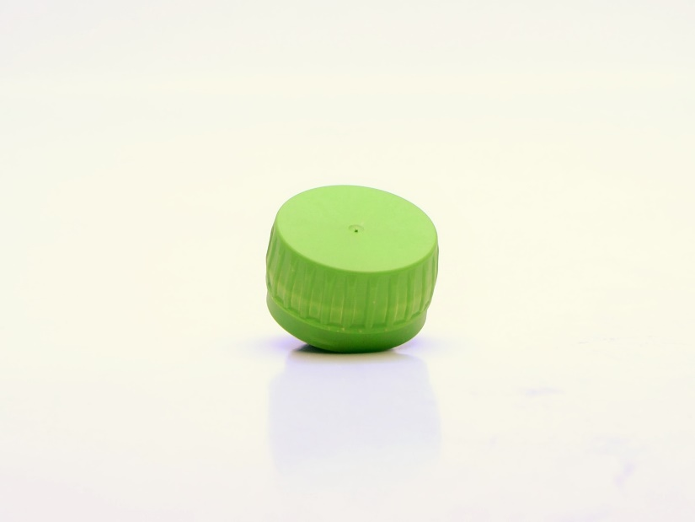Paper waste can be gained from paper mills or out of recycling streams. They are made up of cellulose fibers. These can be completely combusted without producing harmful gases or solid residues. This is advantageous towards waste management. However, they also require dispersing agents with polar groups because of their incompatibility with hydrophobic polymer melts. Furthermore, these fibers cause a negative effect on tensile strength and are, just like wood, not thermally stable at higher processing temperatures which can cause discoloration or bad mechanical strength [2].

Figure 1 - Injection molded cap made of paper pulp filled polyolefin (provided by StoraEnso)

StoraEnso is a company producing biomass based packaging. A big part of their innovative ideas is using recycled paper as filler in PO to produce packaging material (see Figure 1).

## Plant fibers

Different plant and tree fibers can be used in FPOs. These include hemp, kenaf, jute, flax, and many more. These natural fiber composites (NFCs) have better mechanical properties, lower weight, and lower cost, good thermal and acoustic insulating properties compared to other composites. However, they are often incompatible with the polymer matrix and have a tendency to form aggregates. Furthermore, NFCs often show poor stability due to moisture absorption. These issues can be resolved by additives like coupling agents, compatibilizers or by chemical or plasma treatment of the fibers [5, 4, 6, 7].

Below some examples of injection molded caps out of FPOs are shown. They were provided by Cosmetic Packaging Factory Pollena S.A. As you can see, the fibers in the NFC are very visible in the finished product. This type of look might be interesting for cosmetic packaging which should bring across a natural and sustainable image, e.g. the cosmetics by Rituals. This is an image that Nivea does not have and thus these types fall through.

Spruce

Rice Hull

Bamboo

Pine

Coconut

Talcum

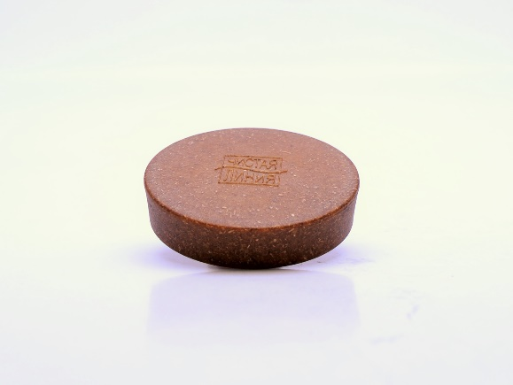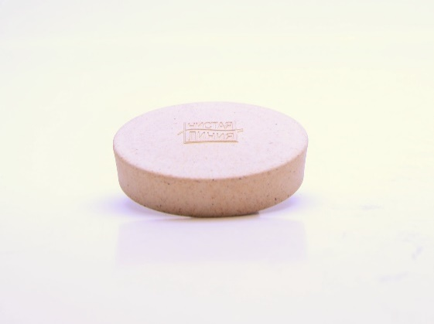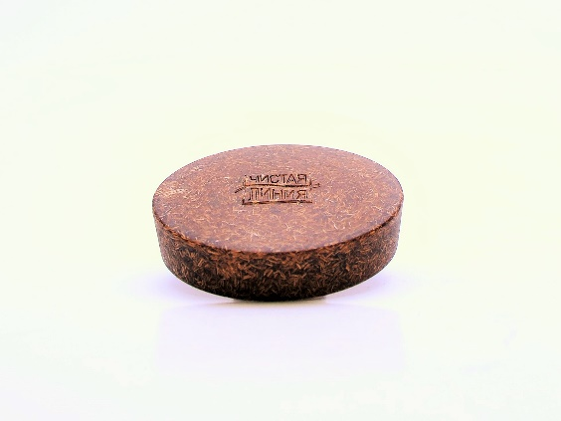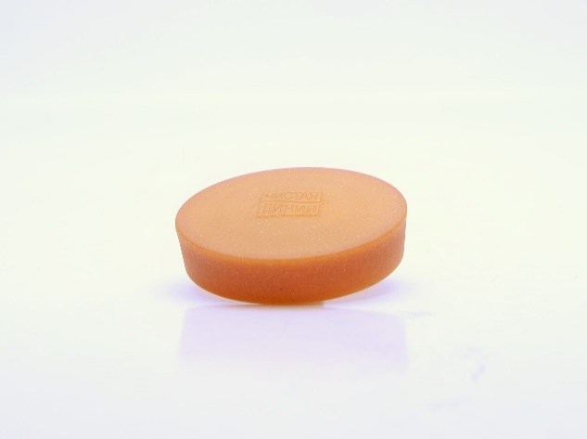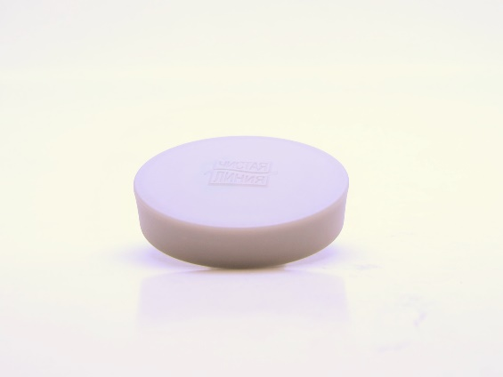

Figure 2 - Examples of injection molded caps made out of FPOs (provided by Pollena)

## Mineral powders

Mineral fillers like talcum do not have that look about them, as you can see in Figure 2. They are usually very small particles which, at good dispersion, only give cause to a different color and are otherwise not visible.

Mineral fillers can be anything from talc, mica and calcium carbonate (CaCO3) to gypsum and waste construction material. These materials all increase the crystallinity of the PO due to their own crystallinity and according to literature also because they provide more nucleation points [8, 9, 10, 11]. It depends on the surface treatment of the particles, how the mechanical properties are influenced. Particle-matrix interaction becomes better with better dispersion and adhesion between mineral and PO. Thermal stability of these mineral fillers is very good and CaCO3 is a relatively soft mineral which is why abrasiveness and processing has not found to be a problem [12].

These minerals originate from different deposits or wastes. CaCO3 is usually mined from limestone deposits. These are quite abundant and can be found on any continent. While talcum is rarer than CaCO3, it can also be counted as an abundant ‘natural’ feedstock (see section 6.2). Gypsum could be gained from a waste incineration plant. Gypsum is the waste product when removing SOx gases from the flue gases (see reaction scheme below). Limestone, i.e. CaCO3 and Ca(OH)2, is sprinkled over the flue gas. The limestone reacts to form calcium sulfite (CaSO3) which in turn can oxidize in the presence of water to form gypsum, i.e. CaSO4**.**2(H2O).

Scheme 1 - Simplified reaction scheme in a SOx scrubber for fuel gas from a waste incineration plant

Research to using stabilized fly ashes or the cement resulting from its treatment is being done, e.g. [13]. However, potentially hazardous substances can leach out and the composition of the fly gases

It was chosen early on, to concentrate the research on a mineral filled PO because of its superior look and processability. When comparing the different possible fillers, talcum seemed to have worse solvent resistance (as will be mentioned later), as did mica. Since suppliers claim good experience with chalk (CaCO3) as a filler material, the chalk filled tube is investigated further. However, for future reference gypsum should also be considered as it is a waste product. If gypsum could be used in the packaging, the incineration of the packaging as waste would reproduce at least part of the material used in it.

# Quality function deployment

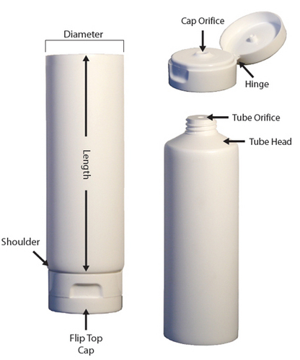In this chapter, requirements on the material are worked out. We need to differentiate between requirements we have on the finished product, ‘What is important for the consumer?’, and requirements that are related to the processing of the tube, ‘What is important for the production process?’

## Product requirements

The finished product is here defined as a cream filled tube that can be bought in the drug store. However, the requirements we are looking for will not relate to the dimensional design of the packaging but just to the material function itself.

In first instance, the tube should be as similar to the current packaging as possible. The consumer should still recognize it as a Nivea product. Thus, the appearance is very important which relates to color and pigment stability but also scratch and wear resistance. The identity white and blue should be possible and should remain in good condition during transport, on the shelf or during consumer use. Furthermore, the tactile experience should be as good as or better than the current tube, i.e. it should not feel too rubbery but rather have a smooth, paper-like feel. The tactile experience is related to surface properties of the material.

Figure - Schematic view of a tube for cosmetic packaging (indiamart.com)

The tube should be able to withstand the pressure during filling and/or pressure due to stacking of products during storage. The mechanical properties should be as good as or better than the current tube. These properties include, the burst pressure of the tube, the tensile stress of the material, the elastic modulus of the material. Furthermore, the cap should not break when the packaging is dropped from about 1.20 m. The tube should be flexible enough that the consumer feels he can squeeze out all the product, i.e. residual emptying should be similar to the current tube. Furthermore, the tube should get back into its original shape and no permanent deformation should occur, i.e. no or only little wrinkling of the tube should occur.

Another important issue is the packaging content. The cream should remain in the packaging and not leak out or evaporate through the packaging. No material additives and such should migrate into the packaging content. The material should have good solvent resistance, i.e. the material should not swell up due to the packaging content. The packaging should not let through any substances that could harm the packaging content, e.g. oxygen, hydrogen, water vapour, light.

The shelf-life of the product in the closed packaging should be longer than 3 years. Nivea usually has no expiry dates, thus the packaging or packaging content should not degrade within that time. It is promised to the consumer that the ‘period after opening’ is at least 12 months. Degradation could be caused by (UV-)light, heat or chemical reaction.

## Processing requirements

The tube should be produced in the existing manufacturing process. Furthermore, optimally energy requirements and production speed remain the same or are improved compared to the current process.

### Production process

First of all, the production process of a laminate tube needs to be addressed. The supply chain of the FPO tube is not a direct one. The neat PO pellets as well as CaCO3 powder are bought as a raw material. These are compounded at site 1 and shipped to the tube production site (site 2).

The tube manufacturer then extrudes this compound into laminate feedstock which is printed, heat-formed and sealed on the sides to form a cylinder tube. The shoulder and cap of the tube can also be made out of FPO but the material requirements are different. The FPO might have a lower filler content than the one used for the laminate tube. The shoulder and cap are both injection molded.

At site 3, the shoulder is compression molded to the laminate tube, the cap is screwed on. The tube is now filled with cosmetic product from the top and subsequently sealed.

#### Compounding

The FPO is produced at the compound supplier site by melt mixing the PO with the filler particles in a modular co-rotating twin screw extruder. As you can see in Table 1, the surface energy of PP/PE is much lower than pure CaCO3 particles and interaction between the two phases needs to be improved. Common CaCO3 fillers are treated with a compatibilizing additive (like stearic acid) in order to reduce interfacial tension between polymer and filler. Surface energy of the filler particles should be equivalent to that of the PO (see Table 1). This will ensure better filler-matrix interaction and improves mechanical properties. Furthermore, the particles are more easily dispersed throughout the matrix and agglomeration is avoided.

Table 1 - Surface energy values of fillers and plastics [14]

|  |  |
| --- | --- |
| Material | Surface energy (mJ/m2) |
| Diamond | 10000 |
| Mica | 240-500 |
| Glass | 1200 |
| Titanium dioxide | 650 |
| Kaolin | 500-600 |
| CaCO3 | 65-70 |
| Stearate coated CaCO3 | 25-30 |
| Talc | 65-70 |
| Polymers | 15-60 |
| Polypropylene/Polyethylene | 29-36 |

In order to create a good dispersion, the PO is first melted in the first extruder section after which the filler is added at two different points along the screw, as shown in Figure 4. After melt mixing, the compound is pelletized, dried and filled into bigbags in order to ship it to the laminate production site (site 2).

The extra compounding step increases the production cost slightly, increasing material cost by about 10% depending on volume of the tube, according to suppliers.

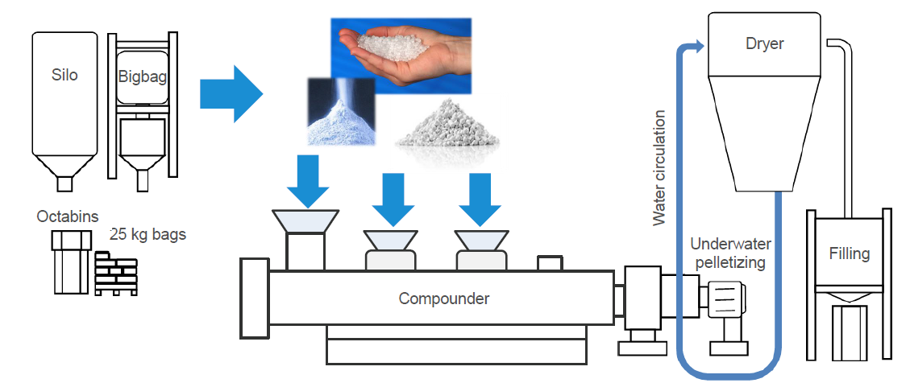

Figure 4 - Compounding process ©RKW Group

#### Laminate tube

Laminate tubes are made by first creating a laminate feed stock. This is created by sheet extrusion of PO and foil. For this process, the compound is heated to its melting temperature in an extruder. The resulting foil needs to be pulled out of the extruder at a certain speed in order to create the desired thickness and material properties. The extrusion speed and cooling speed is determined by the thermal properties of the material. The faster melting and cooling can occur, the faster the speed of the laminate production. The films are laminated together to a structure of PO-foil-PO. Currently the tube is made of a 350µm laminate which contains a 25µm ethylene-vinyl alcohol (EVOH) layer. This layer is needed to ensure the products shelf-life.

EVOH is a highly crystalline random copolymer of ethylene and vinyl alcohol groups. The layer provides very good barriers towards oxygen, carbon dioxide, and organoleptics (aromas, fragrances, etc.). Solvent and vapor resistance against low polarity materials, like oils [15].

The laminate feed stock is subsequently printed. Usually, this is done by offset-printing or sometimes flexography. After application of each ink or lacquer it is cured by short intense exposure to UV-light. Sometimes the tubes are also decorated by hot foil stamping in order to get good metallic effects.

Next, the tubes are formed by feeding the laminate feed stock through forming rolls. These turn the tube and form it into a cylinder. The sides of the material are seamed together by heat generated by high frequency. At the cutting station, the tubes are cut to the correct tube height [16].

#### Shoulder and Cap

The dispenser and shoulder form the head of the tube. These are produced separately by injection molding. The preformed head is fed down vibrator shoots and fused to the top of the tube by heat generated by high frequency.

The cap is also injection molded separately. At the capping station, the cap is applied and torqued to the desired torqueing requirements. The tube is subsequently packed in a carton and transported to the filling site [17].

#### Filling and Sealing

At the filling site, the tubes are aligned automatically by an optical sensor. The tube is then filled with cream at a certain speed and pressure. Immediately afterwards, the top of the tube (at the top seam) is heated and sealed by applying pressure. Subsequently, the top seam is cut off to leave a clean finish.

### Conclusion

The aim is to keep the same production process of a tube made of a new material: FPO. From this short description of the production process, most requirements can be found:

Generally, energy requirements should be kept as low as possible and preferably be lower than for the current material. Production speed should remain the same or be increased. These are generally related to the melting temperature, thermal conductivity, and viscosity of the material. Abrasion of the process equipment, like extruder screws, should not be too high. The filler particles should not be too hard.

For extrusion and sealing, melting temperature and thermal stability are determining. Existing extruders should be able to operate at operate at the required temperatures while no or little material degradation occurs. Furthermore, the melt viscosity and melt expansion determine the laminate production. Higher viscosity or melt expansion might result in different and/or uneven laminate thickness.

For printing or hot foil stamping of the tube to be possible, the surface of the tube should not be too smooth. Adhesion of ink, lacquer and adhesives is generally better with rougher microsurfaces.

## House of Quality

Obviously, product and processing requirements will be related to the same engineering characteristics. A summary of the most important requirements can be found in the House of Quality, see figure below.



Figure 5 - House of Quality for a flexible tube as packaging for cosmetic products.

# Material Development

Now, the engineering characteristics and requirements are known. In this chapter, literature values and supplier experiences are reported for the most important requirements.

## Processing requirements

Suppliers describe the FPO with CaCO3 particles as easily processable in current production lines. Table 2 describes physical properties which are relevant to changes in processing conditions.

Table 2 - Physical Properties of PO and filler

|  |  |  |  |
| --- | --- | --- | --- |
|  | CaCO3 | PE/PP | Source |
| Thermal Conductivity [W/m.K] | 3-6 | 0.3-0.5 | [18, 19] |
| Specific Heat [kJ/kg.K] | 0.9 | 1.8-2.4 | [10, 20] |
| Density [kg/m3] | 2-3 | 0,7-1 | [19, 21] |
| Expansion during melting [%] | - | 20% | [21] |
| Melt Viscosity | Lower in FPO than in neat PO | | [20] |

Thermal conductivity of the compound is increased significantly while the specific heat is decreased compared to the neat PO. Faster melting and cooling is thus possible, resulting in a higher production rate. E.g. faster cycles for injection molding are possible. This difference is not at least due to the crystalline structure of the compound. This in turn indicates that there will be a change in expansion ratio during melting. This ratio is not as important for injection molding processes as it is for blow molding or extrusion. For blow molding, changes in the mold design might be necessary as changes in wall thickness distribution are expected. Issues have been reported by manufacturers of blow-molded products, like shampoo bottles. Manufacturers of laminate feedstock have however not reported any problems.

The lower specific heat already indicates that the melting temperature and thus operating temperature will be much lower. Consequently, energy requirement of the process will be reduced. However, an extra compounding step is required. Suppliers claim that energy requirement is not raised significantly. However, a total energy balance has not been calculated. A definite conclusion cannot be drawn.

A disadvantage might be the weight increase of the FPO tube due to the much higher density of the filler. This issue needs to be addressed mostly in terms of sustainability. Does the weight increase cause more CO2 emission due to more transport fuel?

The filler particles might be abrasive to the equipment. Suppliers claim that abrasion has not been a problem so far. In fact, some even claim that it helps with keeping extruders clean and prevent fouling.

Adhesion of ink/coating on the FPO is much better than with neat PO. This is attributed to the rougher micro-surface (see Figure 7) [20].

## Product requirements

### Color

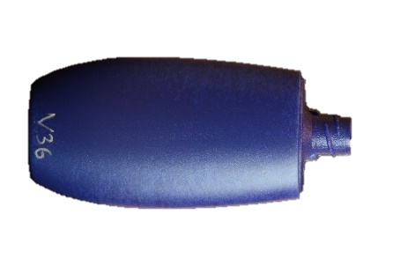Depending on the brand, the color of the products packaging is very important. It is the first thing the customer sees. Nivea, for example, has a very distinctive blue and white image whereas the Eucerin brand is recognizable by its very clear white.

CaCO3 powder, as used by most suppliers, has an off-white to yellow color. When compounded with PE, the resulting batch is cream colored. Suppliers claim that with extra white pigments, like TiO2, a good whiteness can still be achieved. Furthermore, the amount of white pigments needed to create a white color is supposedly much lower than with neat PO.

Tests with a dark blue pigment in the master batch of extrusion blown bottles showed that the dark pigment was not always able to completely cover the CaCO3 particles (see Figure 6).

Figure 6 - Example of an extrusion blown bottle with dark blue pigment and CaCO3 filler

Actual problems with Nivea or Eucerin tube colors can only be evaluated by experimenting. However, it can be concluded that transparent tubes will not be possible when using FPO as a material.

### Appearance/Tactile Consumer Experience

Tubes made out of FPO generally have a rougher surface than unfilled tubes (see Figure 7). This results in a soft, paper-like touch and has a positive consumer response.

Furthermore, the rough micro-surface results in better adhesion properties of the tube. However, scratch resistance of printed designs has been found to be insufficient compared to current tubes. This might be due to the brittleness of the tube itself (see section 5.2.3.2) or the adhesive bonds themselves are too stiff and brittle.

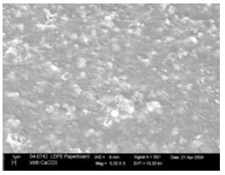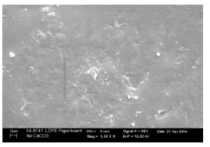

Figure 7 - Rough microsurface of extruded blown film

### Mechanical Properties

Suppliers of FPO laminate tubes recommend a content of 60wt% in the laminate and 20-30wt% in the shoulder and cap. These are values resulting from experiments related to different mechanical properties. In order to better understand the suppliers choices, some literature is consulted.

#### Stiffness

Although a stiffer material might have a higher quality feel, another important customer need is residual emptying of the tube. A stiffer material seems to have worse residual emptying than more flexible and elastic materials. Stiffness should thus not be too high.

The addition of CaCO3 particles to PE as well as PP results in higher stiffness which is due to a higher crystallinity of the compound. This change in morphology can have different causes.

First, the small particles can be considered as multiple nucleation points for crystallization. It is known that depending on the amount of nucleation points, a certain part of PE will remain crystalline. The addition of small particles delivers these nucleation points. Depending on processing conditions (temperature, pressure, fluid velocity,…), a larger part of the compound will thus become crystalline.

Second, the particles themselves are crystalline thus increasing the crystalline part in the compound. This effect is however dependent on the interaction between CaCO3 particles and polymer matrix. As mentioned earlier, the filler-polymer interaction is improved by the surface treatment of the filler particles with stearate.

Third, particles that are well-dispersed promote percolation of the polymer chains around the particles, inducing a change in morphology.

The Young’s Modulus shows the increase in stiffness resulting from the increase in crystallinity (see figures below [8]).

Figure 8 - Young's Modulus of HDPE filled with up to 30 vol% ground lime stone treated with stearate (CC1), precipitated CaCO3 treated with stearate (CC2), and untreated ground limestone (CC3) [6]

Literature suggests that, at good dispersion of the filler particles in the polymer matrix, shore d values will increase while tensile strength will decrease with filler content [10, 22].

Figure 9 - Yield stress of HDPE filled with up to 30 vol% ground lime stone treated with stearate (CC1), precipitated CaCO3 treated with stearate (CC2), and untreated ground limestone (CC3) [6]

Other data found in literature suggest that at lower filler loading (below 20 wt%), the tensile strength is increased with filler content. This is most likely due to good filler-polymer interaction. It would thus be easier for external stresses to be transferred to the filler particles, creating a more elastic response of the material [18]. However, the filler content should be as high as possible in order to produce a more sustainable packaging and certainly above 20 wt%. Thus, for this application it can be concluded that elasticity decreases and stiffness increases with filler content because of higher crystallinity.

Furthermore, the tube is more easily foldable. This will most likely appeal to the customer as it suggests better residual emptying. However, the material reacts much less elastic which means that permanent deformation, like a creased tube, is a high risk. This is a problem which was observed with multiple samples provided by various suppliers (see Figure 10).

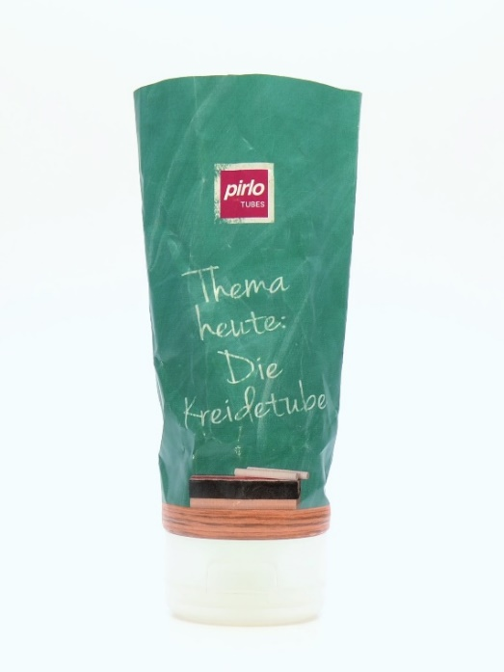

#### Brittleness

The higher stiffness implies that the material is more brittle and will most likely burst more easily. An important factor for tubes because they need to withstand certain squeezing pressures during customer use but most importantly during transport. Tubes quality is tested for the inner pressure they can withstand (called the burst pressure). Suppliers claim that burst pressure has not proven to be problematic and might even be improved. This remains to be confirmed.

Bartczak et al. have concluded that debonding of the particles from the matrix occurs near the yield point in tensile testing. They conclude that the surface treatment with calcium stearate does not improve adhesion between particles and polymer matrix but only helps with good dispersal of the particles [8].

Figure 10 - Tube made of chalk filled PP.

#### Impact Resistance

Impact resistance of the cap is another issue. Obviously, the processing history (e.g. flow orientation during injection molding) will influence the fracture mechanics of the cap. Bartczak et al. report differences in toughness at different areas of an injection molded bar (HDPE filled with CaCO3). They attribute this to different microstructural orientations produced by the flow during the injection molding process.

In literature, the impact resistance is found to be increased significantly with filler content up until a certain point [8, 14, 23, 18, 24]. This point will depend on particle-matrix interaction and dispersal of the particles. At higher filler content, big filler particles may act as stress concentration points or points of discontinuity promoting crack initiation and propagation [18]. Thus, the impact resistance will be higher with smaller particle size, better dispersion and beneficial surface treatment (like stearate). The cap material will have to be investigated further and is out of the scope of this research.

#### Particle Size

This chapter has revealed quite often how important good dispersion and particle size are. Different suppliers offer different particle sizes and different particle size distributions. A smaller particle size offers better particle-matrix interaction [25]. However, this often comes with wide particle size distribution which might make a good dispersion in the polymer melt difficult. Supplier experience and expertise will have to be the guide for correct mineral powder selection.

### Compatibility

#### Solvent resistance

The hydrophobic coating of CaCO3 particles with stearate reduces or even diminishes water absorption. However, suppliers report problems with oily products and claim that swelling of the plastic during storage testing increases with FPO filler content. The hydrophobic nature of the entire polymer as well as filler phase, promotes migration of hydrophobic substances to migrate out of the content formulation into the packaging [14, 20]. This migratory effect might also be explained by the more crystalline structure of the filled polymer matrix compared to the neat polymer. The oil particles can be easily trapped inside the structure as shown in Figure 11.

Furthermore, a smelling test (see Appendix for explanation) with extrusion blown bottles made out of CaCO3 filled PP was performed. The results can be seen in the figures below. Different filler materials, including talc, limestone, and chalk were tested. Chalk (CaCO3) performed best, however a difference in smell was still detected. The cosmetic product reportedly started getting a plastic-like smell after storing at room temperature and even more significantly at 40°C, suggesting migration of packaging material into the cosmetic product. Furthermore, oily products like lotions seemed to perform better than products like shower gels and antiperspirants.

Figure 11 - Entrapment of oil particles in structured FPO

Figure 12 - Smelling tests with extrusion blown bottles out of FPO filled with Chalk, lime stone, talcum. Tests done at room temperature (RT) and 40°C.

Figure 13 - Smelling tests with extrusion blown bottles out of FPO filled with Omyalene (treated CaCO3). Tests done at room temperature (RT) and 40°C.

#### pH resistance

CaCO3 reacts with acidic medium according to:

$CaCO_{3}\left(s\right)+2H^{+}\left(aq\right)→{Ca}^{2+}\left(aq\right)+H_{2}O\left(l\right)+{CO}_{2}\left(g\right)$

Care needs to be taken when combining low pH formulation with CaCO3 filled material. The material will degrade rapidly when in contact with that kind of medium [14]. As most cosmetic products considered are of alkaline nature, this issue will most likely not be occurring. Only a few specific creams are slightly acidic (pH 5). It should, however, be considered during product design and when doing storage tests.

#### Migration into packaging content

It will be depending on the nature of the packaging content if migration of the filler or other additives in the packaging material is a problem. Although suppliers do report general issues with oily (hydrophobic) products, products containing essential oils or alcohol, they will not disclose the exact composition of the corresponding FPOs. It is impossible to predict any problems with existing formulations. Storage, leakage, and smelling tests will need to confirm the compatibility of the packaging with its intended content.

As discussed earlier, a smelling test was performed with extrusion blown bottles with different formulations as packaging content. It can be seen that chalk performs better than talcum and limestone. Furthermore, the FPO performance becomes worse with increasing filler content. These tests do not deliver enough information to draw a definite conclusion. However, it indicates that migration of oils into the FPO packaging material might be a problem.

#### Barrier properties

It is important to protect the packaging content from outside influences as well as prevent the product (or its components) from evaporating through the packaging. Currently, the EVOH layer in the laminate tube acts as an oil barrier. This layer is most likely still needed in the FPO laminate tube, as discussed in the previous section.

The shelf-life of the content should be as good as or better than it is with the current packaging. Oxidative degradation or solvent evaporation can cause the active component, e.g. Vitamin C or hyaluronic acid, to become inactive, the emulsion to separate into phases, the smell to become rank, … There are several outside influences that can cause problems.

##### Light

A barrier against light might be necessary because it might accelerate oxidative degradation processes (as described later in section 5.2.5) within the packaging content or cause pigment degradation.

Due to the refractive nature of the white CaCO3 particles, the light barrier is increased significantly. The light is reflected by the particles and cannot penetrate the packaging.

##### Gas barrier

Due to the higher crystallinity of the FPO, the gas can penetrate the packaging much less easily [20].

Hydrogen, water vapor as well as carbon dioxide show a decrease in permeation rate by up to 25% compared to neat PO tubes. This figure is claimed by suppliers, as you can see in Figure 14 literature confirms the general effect of increasing gas barrier.

Figure 14 - Water vapor, CO2 and O2 barrier in HDPE and LLDPE films with 0 and 25wt% CaCO3 filler content [7]

Oxygen permeation rate, although slightly decreased, is still found to be a problem for oxygen sensitive content, e.g. Vitamin C or hyaluronic acid.

### Degradation

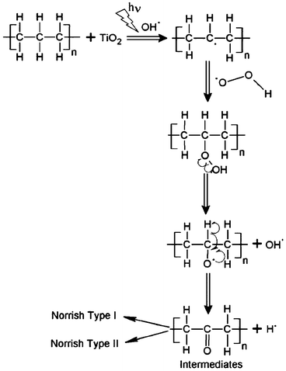Degradation of the material can occur due to ultraviolet radiation inducing chain scission in the polymer backbone or thermal radiation during processing inducing oxidized species or unsaturations. The material might become brittle due to accelerated crystallization or it might break down and dissolve in the packaging content.

#### UV-degradation

When plastics are exposed to UV radiation they often deteriorate rapidly. UV energy is absorbed by carbonyl bonds, peroxides, C-C double bonds or other functional groups that absorb within the UV range (10-400 nm, naturally occurring on earth surface from the sun: 300-400nm) [26, 27, 19]. Bond excitation above their stable energy level causes the scission of bonds. Free radicals are formed which in turn will start free-radical chain reaction, and this way start the degradation mechanism.

Scheme - UV-degradation mechanism

In the presence of atmospheric oxygen an oxidative chain reaction will occur. Degradation products like carbonyl, double C-C, hydroxyl and peroxide groups can also absorb UV radiation and thus accelerate the degradation process [8].

UV degradation of PE or PP will depend on their processing history. Differences in crystallinity will influence the likelihood of degradation. For instance, in HDPE the amorphous phase is more favorable for degradation reactions. The amorphous phase is photo-oxidized forming carbonyl groups. These groups then start cross-linking reaction, making the amorphous phase crystalline. In case of PP gelation will occur just like with PE, as oxygen containing groups form and start cross-linking [10, 28]. The concentration of functional groups (which absorb UV-light) is affected by thermo-mechanical degradation during processing. For instance, during extrusion carbonyl groups can form [27, 29].

Suppliers claim that UV degradation is accelerated by the presence of filler CaCO3. Literature suggests that it is not the filler itself but the compatibilizer (e.g. stearate) that catalyzes chain scission. Whatever the cause, acceleration of UV degradation in PE/PP due to the presence of CaCO3 filler is reported.

However, as mentioned in section 5.2.4.4.1, the particles also help prevent penetration of the light into the polymer matrix. Depending on the filler content, first only the surface is affected by degradation reactions. Next, the formed carbonyls/free radicals may start cross-linking, increasing the crystallinity. The increased crystallinity helps prevent UV-light from penetrating the polymer bulk even more. However, the free radicals or carbonyl groups can also initiate degradation throughout the entire polymer bulk and these reactions are accelerated by (impurities in) the CaCO3 filler making it easier for degradation to spread throughout the entire volume. The purity of the filler will determine the catalytic influence it has on the degradation process. Some impurities might help speed up degradation while others will slow it down. More specific information was not found in the scope of this research. If filler content were high enough that most UV light is reflected, the degradation reactions might be terminated before degradation really gets into the bulk [27, 26].

The filler content needs to be tuned such that reflection of UV-light is high enough that the acceleration of chain scission is not the dominant process. Since the material is already exposed to UV-light during curing of the printed inks and lacquers (see section 4.2.1.2), the UV-light has most likely already penetrated the material. The positive effect of the reflective particles would then probably be negligible over the catalytic effects. If this is not possible, (additional) UV stabilizers will need to be added. These are usually hindered amines light stabilizers (HALS) [12].

#### Thermal degradation

For tube manufacturing the degradation of the polymer during extrusion and thermal sealing processes is most important. Singlet oxygen can form from oxygen which is occluded into the material due to processing temperature effects. This singlet oxygen rapidly reacts to form unsaturations and oxidized species. These functional groups cause a decrease in the composites stability.

Thermal degradation is a complex chemical as well as physical process. It is usually measured by thermal gravimetric analysis (TGA) which detects a weight loss percentage based on the initial weight of the sample. Based on weight loss peaks at specific temperatures, kinetics of the thermal degradation process (e.g. activation energy of the degradation reactions) can be determined [30].

It is known that activation energy for thermal degradation is lower for PP than for PE [30]. Furthermore, recycled POs have lower thermal stability than their unrecycled counterparts [9]. Literature suggests that thermal stability is increased by the addition of CaCO3 [23, 9]. However, it will depend on additives like compatibilizers or stabilizers if this effect is observed in practical applications. So far, suppliers have not mentioned any additional problems compared to unfilled PP/PE.

# Sustainability

The aim of using an FPO as a packaging material is to reduce the use of fossil fuel based material and hopefully also reduce CO2 emissions due to production. This chapter briefly addresses the sustainability of the FPO material compared to neat PO.

## Atom Economy

Under the principle of atom economy, a mineral filler is a sustainable option because nearly all of its raw material atoms are used in the final product. However, additives like compatibilizers are not considered in this assessment. Since only a small amount of these additives are needed, they will most likely not have a significant impact.

Another argument is to be made that the filler and the additives, like compatibilizers, actually increase sustainability. They increase mechanical properties of the PO resulting in the possibility of thinner tube walls and thus the use of less material. They might even be able to eliminate (part of) the EVOH layer.

## Feedstock

Mineral fillers are often classified as natural fillers but are not gained from a biologically renewable feedstock, like plant fibers or wood flour. The minerals need to be mined and milled which arguably requires more energy than producing/recycling plant fibers or wood flour. However, they are abundant and not depleting as urgently as fossil fuels which are required for the production of POs and have better atom economy than POs, as mentioned earlier [31].

The CaCO3, needed for FPOs, is usually gained from marble mining sites like the ones in the Massa-Carrara province of Italy. This type of calcite is very crystalline and hard compared to e.g. calcite produced by sedimentation of dead shell organisms in oceans. Due to continental movement about 200 Mio. years ago, high pressure was put on these sediments resulting in more crystallization of the limestone.

When mining this marble, producing large pieces is the primary goal. This marble is quite valuable and can be used for artistic statues or special architectural features. The less expensive ‘waste’ product are all the small fragments. These are the raw material for many products like chalk, building material and can also be used in FPOs. It is important to note that this material should be low in iron due to its oxidative nature which is unwanted in plastic material.

An argument is made by suppliers that less calcite is mined then is produced in the ocean by sedimentation of dead organisms. This way, they claim to be environmentally sustainable. This needs to be seen critically. However, the most important question is: Is this calcite a more sustainable feedstock than fossil fuel? Currently, the answer is: Yes.

## Carbon footprint

Suppliers claim that the carbon footprint is reduced. Different suppliers disagree on how much it is actually reduced. They claim values ranging from 30-55% less CO2 emission for the production of an FPO tube compared to a conventional PO tube.

These values of equivalent CO2-reduction mostly incorporate the material use. Furthermore, less energy is needed for the tube production process due to the lower specific heat and higher thermal conductivity (see Table 2). Whereas another production step is needed for the compounding of the FPO. This lower process energy requirement might thus not make a big dent in the carbon footprint.

## Recycling

While recycling of an FPO with mineral filler is possible due to the good thermal stability of the filler, these materials are currently considered to disturb the PE recycling process. They are to be classified as mixed plastics (just like the current laminate tube containing the EVOH layer). They are sorted out of the recycling stream based on their density and/or later by a near-infrared scanner based on their absorption spectrum. The waste can in the end only be managed by incineration.

If enough of this material were brought into circulation, a mass flow of about 3000-5000 ton/year (suggested by some suppliers), a separate recycling stream could be created. Suppliers expect that this could be realized quite soon. Many foils for plastic bags and food packaging already use an FPO with about 10-15% of CaCO3. This material stream is estimated to be about 5000ton/yr in Europe. If this class of FPOs could be combined with FPOs of higher filler content (50-60%), the required annual mass flow should be reached within the foreseeable future.

Another issue to consider is the faster degradation under UV light. After each life cycle a little bit more of the material is degraded. Prospectively, the FPO can undergo a lower amount of cycles than neat PO.

# Conclusion and Recommendations

A tube made of CaCO3 particles filled polyolefin for cosmetic packaging is feasible. Suppliers recommend a 60wt% filler content in the laminate tube and about 20-30wt% filler content in the cap. Other mineral fillers like talcum are also a possibility.

The FPO tube can be easily produced in the current production process. Due to lower specific heat and higher thermal conductivity, energy requirements are lowered and production speed is increased.

The barrier properties of the FPO tube are improved compared to the current tube. However, the oxygen sensitive or oily content might still be a problem. An EVOH barrier layer in the laminate would solve that problem. Furthermore, degradation of the material due to UV exposure is prospectively sped up by the addition of calcium carbonate. This can be resolved by adding stabilizers like HALS. However, recyclability is limited due to faster degradation during each cycle. The appearance of the tube seems positive and maybe even better than the current one. However, scratch and wear resistance might be insufficient. Furthermore, the stiffness of the material results in good residual emptying while causing permanent deformation of the tube (wrinkling).

The aim is to create a more sustainable packaging. Currently, the FPO material is not recyclable. This is only due to the annual production. At about 5000 ton/year of this FPO, recycling sites could be built and recycling becomes economic. It seems that this material has a more sustainable, biologically renewable feedstock. However, a complete life cycle analysis should show how much energy and CO2 the milling and transport of the mineral costs.

## Recommendations

### Life cycle analysis

In order to address the topic of sustainability more deeply a full life cycle analysis should be done of a specific tube and cap made of FPO and the current material. It might also be interesting to compare these with and without EVOH layer in order to see if this layer has a big influence. Unfortunately, such an analysis is not within the scope of this research.

### Further testing

UV and thermal degradation have up until now only been addressed either theoretically or in experiments in unprocessed compounds. The packaging content might have an influence on thermal stability during storage test. Thus FPO tubes with different contents should be tested in storage tests for thermal stability. This will at the same time test compatibility of the FPO material with different cosmetics.

UV degradation should be observed with a printed tube (cured by UV-light) and an unprinted one. Testing can be done in an ageing chamber or by leaving the tube in the window under sunlight.

There is little known about burst pressure of this type of tube. Burst pressure should be tested. It might also be significant to test the burst pressure at different times during the storage test. This way any degradation of the material can be detected.

### More materials

It would be interesting to test gypsum as a possible filler material. Gypsum seems advantageous to use because it is a waste product from waste incineration plan. Specifically this type of gypsum should be investigated for application in FPOs. It seems that its water solubility could be problematic. Gypsum powder might also not be dispersing well in the polymer matrix. Surface treatment with fatty acids might solve both of those problems.

Furthermore, it would be interesting to test filler materials with recycled POs. The UV and thermal stability might be decreased even further. However, an even more sustainable packaging material might be created.

# Bibliography

|  |  |
| --- | --- |
| [1] | M. Hetzer und D. D. Kee, „Wood/polymer/nanoclay composites, environmentally friendly sustainable technology: A review,“ *Chemical Engineering Research and Design,* Bd. 86, pp. 1083-1093, 2008. |
| [2] | I. Baroulaki, J. Mergos, G. Pappa, P. Tarantili, D. Economides, K. Magoulas und C. Dervos, „Performance of polyolefin composites containing recycled paper fibers,“ *Polymers For Advanced Technologies,* Bd. 17, pp. 954-966, November 2006. |
| [3] | R. Woodhams, G. Thomas und D. Rodgers, „Wood fibers as reinforcing fillers for polyolefins,“ *Polymer Engineering and Science,* Bd. 24, pp. 1166-1171, October 1984. |
| [4] | M. Farsi, „Thermoplastic Matrix Reinforced with Natural Fibers: A Study on Interfacial Behavior,“ in *Some Critical Issues for Injection Molding*, D. J. Wang, Hrsg., InTech, 2012. |
| [5] | S. D. Wanjale und J. P. Jog, „Polyolefin-Based Natural Fiber Composites,“ in *Cellulose Fibers: Bio-and Nano-Polymer Composites*, Berlin, Heidelberg, Springer-Verlag, 2011, pp. 377-398. |
| [6] | S. M. Mirmehdi, F. Zeinaly und F. Dabbagh, „Date palm wood flour as filler of linear low-density polyethylene,“ *Composities: Part B,* Bd. 56, pp. 137-141, 2014. |
| [7] | J. O. Agunsoye, T. S. Isaac und S. O. Samuel, „Study of Mechanical Behaviour of Coconut Shell Reinforced Polymer Matrix Composite,“ *Journal of Minerals and Materials Characerization and Engineering,* Bd. 11, pp. 774-779, 2012. |
| [8] | Z. Bartczak, A. Argon, R. Cohen und M. Weinberg, „Toughness mechanism in semi-crystalline polymer blends: II. High-density polyethylene toughened with calcium carbonate filler particles,“ *Polymer,* pp. 2347-2365, 1999. |
| [9] | J. González, C. Albano, M. Ichazo, M. Hernández und R. Sciamanna, „Analysis of thermogravimetric data of blends of polyolefins with calcium carbonate treated with Lica 12,“ *Polymer Degradation and Stability,* pp. 211-224, January 2001. |
| [10] | K. Sirin, M. Balcan und F. Dogan, „The Influence of Filler Component on Mechanical Properties and Thermal Analysis of PP-LDPE/DAP Ternary Composites,“ in *IntechOpen*, Turkey, 2012. |
| [11] | R. Zazenski, W. H. Ashton, D. Briggs, M. Chudkowski, J. W. Kelse, L. MacEachern, E. F. McCarthy, M. A. Nordhauser, M. T. Roddy, N. M. Teetsel, A. B. Wells und S. D. Gettings, „Talc: Occurrence, Characterization, and Consumer Applications,“ *Regulatory Toxicology and Pharmacology,* Bd. 21, pp. 218-229, 1995. |
| [12] | G. Wypych, Handbook of fillers, Toronto: ChemTec Publishing, 2016. |
| [13] | N. Rodella, M. Pasquali, A. Zacco, F. Bilo, L. Borgese, N. Bontempi, G. Tomasoni, L. Depero und E. Bontempi, „Beyond waste: new sustainable fillers from fly ashes stabilization, obtained by low cost raw materials,“ *Heliyon,* Bd. 2, Nr. 9, 2016. |
| [14] | R. N. Rothon, Particulate filled Polymer Composites, 2 Hrsg., Shawbury UK: Rapra Technology Limited, 2003. |
| [15] | T. Cooper, „Developments in plastic materials and recycling systems for packaging food, beverages and other fast-moving consumer goods,“ in *Trends in packaging of food, beverages and other FMCG*, Woodhead Publishing Limited, 2013, pp. 58-91. |
| [16] | Pirlo GmBH &C Co. KG, „Pirlo - Metall- und Kunststoffverpackungen,“ [Online]. Available: www.pirlo.com. [Zugriff am August 2017]. |
| [17] | T. T. Council, „How Laminate Tubes are made,“ 2017. [Online]. Available: http://www.tube.org. [Zugriff am August 2017]. |
| [18] | S. O. Adeosun, W. A. A. Mohammed Awwalu Usman und M. A. Bodude, „Physico-Mechanical Responses of Polypropylene-CaCO3 Composite,“ *Journal of Minerals and Materials Characterization and Engineering,* Bd. 1, pp. 145-152, 2013. |
| [19] | C. Vasile, „Chapter 4 - Additives,“ in *Practical Guide to Polyethylenes*, Shrewsbury, UK, Rapra Technology Press, 2005, pp. 89-93. |
| [20] | M. Roussel, A. Guy, L. Shaw und a. J. Cara, „The Use of Calcium Carbonate in Polyolefins Offers Significant Improvement in Productivity,“ in *PLACE Conference*, Proctor, VT, 2005. |
| [21] | „engineeringtoolbox.com,“ [Online]. Available: http://www.engineeringtoolbox.com/. [Zugriff am August 2017]. |
| [22] | J. Adams, C. Paynter and S. Ritchie, "Mineralogical Society," [Online]. Available: http://www.minersoc.org/files/mfl-Adams-poly.pdf. [Accessed July 2017]. |
| [23] | H. Essabir, M. O. Bensalah, D. Rodrigue, R. Bouhfid und A. e. k. Qaiss, „A comparison between bio- and mineral calcium carbonate on the properties of polypropylene composites,“ *Construction and Building Materials,* pp. 549-555, 5 January 2017. |
| [24] | Jun-Zhou, X.-H. Du und Yan-Chen, „Study on the Preparation and Properties of CaCO3/Polypropylene Composite Materials,“ in *International Forum on Energy, Environment Science and Materials*, China, 2015. |
| [25] | K. Piekarska, E. Piorkowska und J. Bojda, „The influence of matrix crystallinity, filler grain size and modification on properties of PLA/calcium carbonate composites,“ *Polymer Testing,* Bd. 62, pp. 203-209, 2017. |
| [26] | R. Deanin, S. Orroth, R. Eliasen und T. Greer, „Mechanism of Ultraviolet Degradation and Stabilization in Plastics,“ *Polymer Engineering and Science,* Bd. 4, pp. 228-234, July 1970. |
| [27] | A. Valadez-Gonzalez, J. Cervantes-Uca und L. Velevab, „Mineral filler influence on the photo-oxidation of high density polyethylene: I. Accelerated UV chamber exposure test,“ *Polymer Degradation and Stability,* pp. 253-260, February 1999. |
| [28] | S.-S. Wu, Q.-P. Ran und J. Shen, „Effect of Light Intensity on Ultraviolet Irradiated Polypropylene and its Compatibilization with CaCO3,“ *Journal of Thermoplastic Composite Materials,* Bd. 23, pp. 149-159, 2010. |
| [29] | M. C. S. C. L.A. Pinheiro, „The role of chain scission and chain branching in high density polyethylene during thermo-mechanical degradation,“ *Polymer Degradation and Stability,* pp. 445-453, 31 May 2004. |
| [30] | A. Aboulkas, K. E. harfi und A. E. Bouadili, „Thermal degradation behaviors of polyethylene and plypropylene. Part I: Pyrolysis kinetics and mechanisms,“ *Energy Conversion and Management,* pp. 1363-1369, 20 January 2010. |
| [31] | M. Tolinski, „Choosing Additives and Reinforcements for Sustainability,“ *Reinforced Plastics,* Bd. 61, pp. 58-60, 2017. |

# Appendix

**Smelling test:** Bottles filled with different cosmetic products were stored at room temperature as well as 40°C. Furthermore cut pieces of the material were placed in cosmetic product and stored in the same way. After 6 months the change in smell of the product is rated.

**Storage test:** Packaging with or without content is stored at 40°C and ambient humidity for at least 6 months. Every month, samples are taken out and investigated for migration of packaging content, for any warping of the packaging, changes in colour & smell of the packaging as well as content, changes in surface and stability of the packaging, leakage, …

**Leakage test:** A (unsealed) packaging filled with its intended content is closed. It is placed with its closure downwards in a vacuum chamber at 600mbar and 40°C. After 3 minutes, the packaging is taken out and investigated for any leakage of the packaging content.