Synthesis &

Structure Determination of

Nickel Formazanate complexes

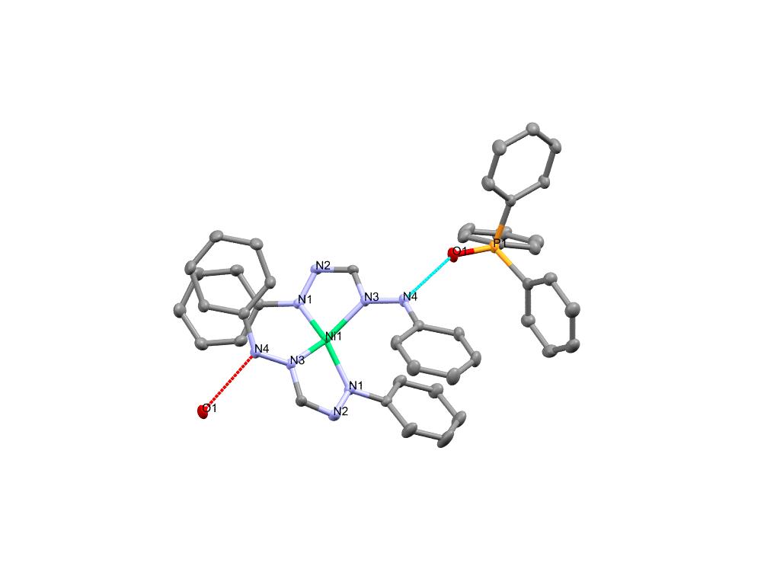

Masters Research Project (WMEC13006, 30EC)

Master Educatie en Communicatie in de Wiskunde en Natuurwetenschappen

Renske de Vries

R.A.de.Vries.3@student.rug.nl

S:2496534

Supervisor: prof. dr. E. Otten

26-05-2018

Contents

1 Summary 2

2 Introduction 3

2.1 Goal 6

3 Results and discussion 7

3.1 Synthesis of the diphenyl formazanate nickel complex (complex 1) 7

3.2 Synthesis of two-electron reduced complex 3 7

3.3 Synthesis and structure determination of complex 4 9

3.4 Counter ions 12

4 Conclusions 17

5 Acknowledgements 19

6 Experimental procedure 19

7 Bibliography 22

8 Supporting information 24

8.1 NMR 24

8.2 Infrared spectroscopy 31

# Summary

A reproducible synthetic route was established for the two-electron reduced bis(formazanate) nickel complex (complex **3**). A reaction with water resulted in complex **5**, the identity of which is investigated here but not conclusively elucidated. Characterization of **5** by cyclic voltammetry was done, but showed no chemical reversibility upon scanning into the negative or positive directions.

The reaction of complex **3** with PPNCl resulted in complex **9**. Complex **9** shows similarities in the chemical shift of the ligand in the 1H-NMR spectrum with complex **5**. It thus seems that both PPNCl and H2O react with **3** to form a similar species, but its identity remains unknown.The reaction of complex **1** with reducing agent, PPh4Cl and water resulted in a bis(formazanate) nickel complex with two protonated ligands (complex **8**). A reaction sequence is proposed in which the PPh4+ cation was reduced during a two-electron cleavage to PPh3O in the presence of water. Complex **8** shows interesting redox chemistry; multiple quasi-reversible peaks were obtained from cyclic voltammetry. Unfortunately, no hydrogen evolution reaction was visible after electrochemical catalysis in the presence of acetic acid.

# Introduction

Fossil fuels will run out but the global energy demand is growing (*1*). Replacing these fossil fuels with renewable energy is becoming more and more important. Solar power is an example of a renewable energy source and is already applied in current society. However solar power is associated with high costs and the applications have some drawbacks (*2*). One of the drawbacks is its intermittent availability, which requires larg-scalestorage, for example in batteries which are are expensive and have low energy density.

Another way to store energy is by water electrolysis, a highly efficient method with a high energy density in hydrogen storage by the use of high-pressure cylinders (*3*). The devices used for the electrolysis need efficient catalysts for the hydrogen evolution reaction (abbr. HER). The splitting of water involves the half-reaction 2H+ + 2e- 🡪 H2 at the cathode (a two-electron reaction), while the anodic half-reaction is 2 H2O 🡪 4H+ + 4e- + O2. After absorption of the proton on the catalytic site of the catalysts, the hydrogen gas gets desorbed (see figure 1). Besides, the catalysts should be able to release the energy through hydrogen oxidation reactions (abbr. HOR) (*4*). The catalyst providing these reactions are nowadays mainly based on scarce and expensive metals (*5*).



HER and HOR are examples of reactions that need catalysts that can facilitate two electron redox processes. Traditionally, heterogeneous metal catalysts based on noble metals, such as platinum, were used. Platinum can facilitate the two electron redox changes needed for the reaction. To replace the noble metal platinum with non-noble and more earth abundant metals, the interest in molecular homogeneous complexes was raised.

*Figure 1: Hydrogen evolution reaction (schematic representation)*

The first generation of homogeneous catalysts consists typical of a complex with a non-noble metal center surrounded by ligand(s). These catalysts use cheap and earth abundant metals (*6*). During HER the metal is reduced first, followed by protonation of the metal. This gives a metal-hydride intermediate. Reaction with another proton will yield hydrogen (*7*).

Recent studies show another option to mimic the role of noble metals, which are catalysts with non-innocent ligands (*8*). The (chemically) non-innocent ligands of the catalysts can be useful in bond making and breaking reactions. Besides, ligands play an important role to tune the selectivity and reactivity of the catalyst, using electronic and steric interactions.

Metals used for the metal center of this catalysts are for example nickel, molybdenum, cobalt and iron (*12*). These transitions metals show great interest in this field, since they are cheap, earth-abundant and some can accommodate multiple oxidation states.

Three different types of reactions using non-innocent ligands are possible (*4*). In the first type (see figure 2) the ligands acts as a ligand e- reservoir and the reaction occurs at the metal center, forming metal hydride intermediates (*9*). Nevertheless, there is an increasing interest in the other HER routes: ligand acting as the redox active center and the metal acting as e- reservoir with the reaction occurring at the ligand (*10*)(*11*).



Grapperhaus et al. showed that instead of the metal hydride intermediates also ligand based processes can result in HER and HOR (*11*). One example is complex ReL3 (see figure 3) which can be used as an electrocatalyst in HER/HOR and which uses a ligand centered mechanism. However, rhenium is one of the rarest metals on earth. Since rhenium was not used as a center of the reaction, the question of replacing it with a more earth abundant metal was aroused.

*Figure 2 f.t.t.b.: Ligand e- reservoir, metal centered reaction; Ligand redox active center; Metal e- reservoir, ligand centered reaction*



Literature shows increasing interest in nickel catalysts, a cheap and earth abundant metal. Since complex ReL3 (mentioned above) showed promising results, the combination of this ligand with nickel was investigated (see figure 4). Changing the ligand in this case was done to see if ligand based HER/HOR could be obtained.

*Figure 3: Catalyst (ReL3) used for HER/HOR*



*Figure 4: Nickel catalyst with same ligand as ReL3*

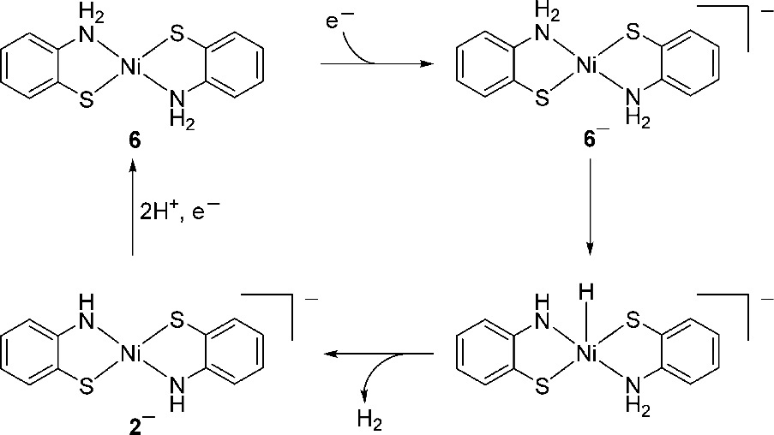The geometry of these complexes are closer to the planar bis-chelate nickel catalysts (see figure 5) mentioned by Eisenberg et al. (*6*). Eisenberg and coworkers showed that hydrogen production was possible with this catalysts (figure 4) via the traditional metal-hydride pathway (*13*).

*Figure 5: Nickel catalyst with metal-hydride HER pathway*

The pathway Grapperhaus et al. found for hydrogen production was similar (metal-hydride intermediate) to the prior results Eisenberg et al. found(*13*).



To get more insight in ligand based (electro-)chemistry, the electronic properties of various nickel complexes were studied. An example to illustrate this are dipyrrinato nickel (II) complexes by Zhu et al. (see figure 6). The first oxidation and the first reduction in these complexes are most likely to occur in the ligand instead of the nickel ion (*14*). This conclusion was drawn from DFT calculations, since both the LUMO and HOMO are mostly localized in the ligands.

*Figure 6: Dipyrrinato nickel (II) complex*

Another ligand with a redox non-innocent nature is the formazanate ligand. Otten et al. reported the redox chemistry of bis(formazanate) zinc complexes (see figure 7), which showed that all the redox processes are ligand based (*15*). The redox processes were reported to be quasi-reversible using cyclic voltammetry experiments. Since zinc (II) has an electronic configuration of d10, it is nearly redox inactive. Nickel (II), however, has an electronic configuration of d8 and could therefore be active in redox reactions. Recent (unpublished) work replaces the zinc metal for a nickel center, with no or different substituents on the R position.

*Figure 7: Bis(formazanate) zinc complex*

In the Otten group several bis(formazanate) nickel complexes were synthesized and their (electro-)chemical properties were studied. These complexes could be chemically reduced and their one- and two-electron reduced forms were isolated and characterized (respectively complex **2** and **3** shown in figure 8). Previous work showed that the sodium atom is involved in geometry change of the chelate ligand from six-membered to five-membered upon reduction. Electrochemical experiments were done and calculation showed that the first reduction generates most likely a ligand-base radical.



*Figure 8: Bis(formazanate) nickel complexes: complex* ***1*** *(left),* ***2*** *(middle) and* ***3*** *(right)*

## Goal

Upon reproduction of the two-electron reduced complex **3** some inconclusive results came out. In one attempt to form complex **3** it seemed that a different product was formed (complex **4**). No evidence of complex **3** was found in that 1H-NMR, but the spectrum appeared to show another bis(formazanate) nickel complex. It is necessary to find out the experimental conditions in which complex **3** can be reproduced. Besides that, it is important to identify what complex **4** looks like in order to identify the alleged second synthetic route.

The geometry of complex **1** changes when it gets reduced. Since it seems that the sodium counter ion plays a role in this, it can be interesting to replace it by another counter cation. A weaker binding counter cation gives the chance to explore the geometry changes of the complex.

The final interesting topic in this research, is getting more insight in protonation of the complex. If the nickel complex can be protonated, the possibilities in obtaining hydrogen evolution reactions can be explored.

# Results and discussion

## Synthesis of the diphenyl formazanate nickel complex (complex 1)

Previous (unpublished) research provided an one pot synthesis for the formation of the diphenyl formazanate nickel complex. The reaction to form the formazanate ligand with phenylhydrazine and trimethyl orthoformate was catalyzed by a few drops of perchloric acid. Other strong acids (HCl, H2SO4) were tested but did not result in the desired reaction. The yield of formation of the complex was 12% after addition of nickel perchlorate. Due to safety concerns regarding perchlorates, we decided to investigate whether it is possible to replace Ni(ClO4)2 and HClO4 by other, less oxidizing, reagents. Adding a catalytic amount of the strong acidic HBF4 solution gave the expected intermediate. Nickel perchlorate was substituted by nickel (II) acetate tetrahydrate and gave the expected product, complex **1** (see figure 9).



*Figure 9: Synthesis of complex* ***1***

Since there is made use of an aqueous acidic solution, the trimethyl formate may be hydrolyzed to methyl formate and methanol *(18)*. This results of course in derogation of the yield. The final yield after two steps was 33% (based on phenylhydrazine), which is an average to good yield in metalcomplex synthesis with formazanate ligands.

## Synthesis of two-electron reduced complex 3

Since our goal is to determine the experimental conditions in which complex **3** can be reproduced, the synthetic route must be investigated. It is known that by treating the nickel complex **1** with 1.1 equivalent of Na/Hg 2.447wt% the one-electron reduced complex **2** could be obtained. This was shown in previous (unpublished) research in 67% yield. The result was a five membered chelate ring in tetrahedral orientation (dihedral angle of 83°) (see figure 10).



*Figure 10: Synthesis of complex* ***2***

Subsequently the two-electron reduced complex **3** was synthesized by addition of 2.1 equivalent of Na/Hg to complex **1**(see figure 11) in previous work. The geometry of the chelate rings changed from six-membered to five-membered upon reduction, probably to reduce steric hindrance of the phenyl groups and due to the interaction with the sodium(THF) counterion. The five membered chelate rings were obtained after slow diffusion of the mixture from hexane into THF solution. However, in one experimental attempt a different product (complex **4**) was obtained, despite the fact that the same experimental conditions were used.

Structure?

NiL22-



*Figure 11: Synthesis of complex* ***3***

To start the investigation towards the synthesis of complex **3** the reaction was done as previous attempts but the reaction mixture was not filtered. Presence of oxygen or water in the mixture from the filter during previous filtrations, could be causing oxidation or degradation of the product. No evidence of water and oxygen was found, since no degradation product was obtained. Making sure the filter was dried in the oven and cycled with nitrogen/vacuum properly before usage, this would no longer be a possible cause of degradation of the product.

The second attempt to synthesize complex **3** resulted in a 1H-NMR spectrum with broad peaks (see figure 12), this could be a sign of a paramagnetic species present. The intermediate for the formation of complex **3** is the paramagnetic complex **2**(see figure 13). To check whether traces of complex **2** were the reason for peak broadening, 0.25 equivalent of Na/Hg was added additional to the mixture. This resulted in a 1H-NMR spectrum similar to the two-electron reduced nickel complex **3** shown in previous research. This indicates that there must be some impurities reacting with Na/Hg. The reaction was therefore done again with 2.2 and 2.5 equivalent of Na/Hg, where 2.5 equivalent of Na/Hg shows the best results.



*Figure 12: 1H-NMR of complex* ***3****(top) and the second attempt (bottom)*



*Figure 13: Synthesis of complex* ***3****with intermediate complex* ***2***

The changes in experimental conditions compared to previous research are the addition of more Na/Hg 2.447wt% (2.5 equiv.) and making sure no water or air is present in the reaction mixture. By these adjustments the reaction has proven to be reproducible. Reaction was done up to 1 mmol scale in 31% yield.

## Synthesis and structure determination of complex 4

The 1H-NMR spectrum (see figure 14, bottom) of the product obtained when attempting to repeat the synthesis of **3** is different than that of complex **3**. This observation suggests that another product may be formed using a very similar procedure (complex **4**). The first product, complex **3**, could be characterized by x-ray crystallography. This was not possible for complex **4**. To figure out the structure of complex **4** comparing both spectra might be useful.

The spectrum of the reaction mixture of complex **4** does not show free ligand, free metal, free phenylhydrazine or other unwanted side products. This indicates that all ligands are bound to the metal nickel center and a single product is formed (no mixture of various products)

Comparing both phenyl (Ph) groups will give insight about the structure of both complexes **3** and **4**. The 1H-NMR shows that the para protons from both phenyl groups are different. The meta and ortho protons in one phenyl group are equivalent (show respectively one triplet and doublet). The meta and ortho protons from the different phenyl groups differ in their chemical shift. This conclusion can be drawn by taking a COSY-NMR and comparing meta, ortho and para protons.

The proton from the formazanate backbone gives a single peak in the spectrum, which indicates that both ligands are identical. The differences in spectra are thus the chemical shifts of the peaks and that complex **4** shows meta, para and the backbone protons on a very narrow part of the spectrum. This suggests that the ligands are bound in a different way to the metal center.

**



*Figure 14: 1H-NMR of complex* ***3****(top) and complex* ***4*** *(bottom)*

To get more information on the identity of **4**  it is important to investigate possible side reactions in the 2-electron reduction of **1**. Another research from the Otten group shows the reaction with a boron complex and water *(19)*. It shows the protonation of the backbone of the formazanate ligand (see figure 15). The double reduced boron complex was able to react with water, where the single reduced product remained unaffected. NMR data is not conclusive about the site of electrophile attachment.



*Figure 15: Reaction of H2O with double reduced boron complex*

Therefore a reaction of complex **3** with water was done. Surprisingly, the peaks obtained in the 1H-NMR are at the same chemical shift as complex **4** (see figure 16).



Starting material **1**

This concludes that our double reduced complex **3** undergoes a reaction with water, forming complex **5**. Complexes **4** and **5** are identical (visual: homogeneous and color) since they have identical chemical shifts and shape of the peaks in 1H-NMR.

*Figure 16: Complex* ***4*** *(top) and complex* ***5*** *(bottom)*

Complex **3** reacts with water and protonation of the complex is most likely occurring. Unfortunately the product did not show an x-ray diffraction pattern, so this method was excluded for structure determination.

The alleged N-H peak, however, is not visible in the 1H-NMR. Since the para, meta and backbone hydrogens are overlapping, the N-H proton could be in this collection of peaks (see figure 16). Attempts to collect a 15N-NMR spectrum were unsuccessful and labeling the complex with a deuterium isotope (using D2O) and analysis by 2H NMR spectroscopy gave also no conclusive data.

Another method to discover a N-H bond is infrared spectroscopy (IR). The isotope effect in vibrational spectroscopy between H and D can calculated and must be visible from IR.

Isotope effect:

From the IR data no clear N-H or N-D peak could be observed, leaving the structure to be unknown so far (see figure 17).

N-H fingerprint region

*Figure 17: IR of complex* ***5***

The redox activity of complex **5** was investigated by cyclic voltammetry (CV). The first few cycles show (quasi-)reversible redox activity, but after a few cycles the redox activity drops. This indicates that complex **5** is electrochemical reversible, but chemically not reversible. In contrast with complex **3**, which is both electrochemical and chemically reversible.

Summarizing, the complex **5** has two identical ligands with unsymmetrical phenyl rings. The phenyl rings itself are symmetrical, clarified due to the presence of two inequivalent para phenyl signals.

No evidence was found for the protonation of complex **5**. However, if complex **5** is protonated, two reasonable structures are possible (see figure 15). In section 3.4.4.1 the discussion about the structure continues because the structure of nickel complexes with different counterions gives us new information to compare with complex **5**.

*Figure 15: Possible structures of protonated complex*

## Counter ions



It was shown that the sodium cation was coordinated to the nitrogen atoms in reduced complexes of the formazanate backbone (see figure 18). Since the starting material consisted of a six membered ring, the role of the sodium cation in the conversion to a five-membered chelate ring was investigated. In previous (unpublished) research the sodium cation was replaced by a tetrabutylammonium cation in the single reduced complex **2**. This cation has no direct interaction with the anionic Ni complex, which resulted in two six membered chelate rings (see complex **8**, figure 19). Therefore the interest towards the role of the counter ion was aroused. Different counter ions were tested in order to see the role of the counter ion in the preference for either five- or six-membered ring chelates. The counter ions used in this research are lipophilic cations. The cations used are permanently, positively, charged.

*Figure 18: Complex* ***2****(left) and complex* ***3*** *(right)*

*Figure 19: complex* ***6***

### Attempted synthesis of complex 6: two-electron reduced complex with tetraethylammonium bromide (TEAB)

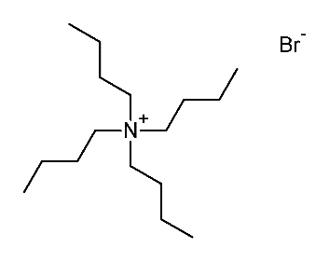

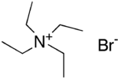Previous research was done with addition of tetrabutylammonium bromide (TBAB)(see figure 19 and 20) to complex **2**in which the sodium cation would precipitate out as NaBr salt. The crystal structure was of poor quality, but the solution suggests that indeed the complex has six-membered ligand chelates when the cation is not bound. To obtain better structural data, TBAB was changed for TEAB (see figure 18) so see if the smaller ion TEAB would result in better crystals. Addition of TEAB to both complex **2** and **3** did not result in a chemical reaction, since in both cases starting material was recovered.

*Figure 20: TBAB (left) and TEAB (right)*

### Synthesis of complex 7: one-electron reduced complex with tetraphenylphosphonium chloride (PPh4Br)

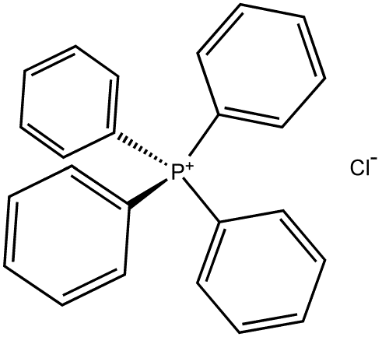

Another salt which is often used as counter ion is PPh4Br, because the PPh4+ ion (see figure 21) often crystallizes easily. Complex **1** was stirred in the presence of 1.1 equivalent Na/Hg and 1.1 equivalent PPh4Br. This resulted in complex **7**, brown block crystals (stacked together). Complex **7** was formed over the weekend after slow diffusion at -30°C of hexane into a THF solution.

*Figure 21: PPh4+*

#### EPR Characterization

Compound **7** gave broad peaks in 1H-NMR, which is typical for paramagnetic compounds. To get more information about the structure an EPR spectrum was recorded. The spectrum gave one broad signal (g-value 2.16) in THF at room temperature (see figure 22). This g-value is equal to complex **2** from previous research.

The same measurement was done at solid state (77 K), and shows anisotropic signals (g-values: gx-value=2.3 gy-value=2.1 gz-value=2.05) (see figure 22). The g-values of complex **2** in solid state were determined in previous research; gx ≈ 2.3, gy ≈ 2.1 and gz ≈ 2.05. Since the g-values of complex **2** and **7** are almost identical, the PPh4+ ion does not influence the electronic configuration of the one-electron reduced complex **2**.

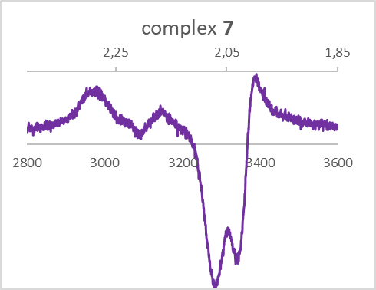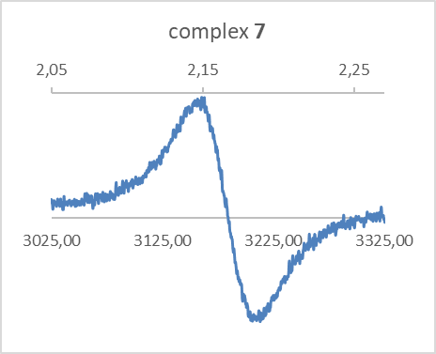

### Synthesis of complex 8: two-electron reduced complex with tetraphenylphosphonium chloride (PPh4Br)



Complex **1** was stirred in the presence of 2.5 equivalent Na/Hg and 2.1 equivalent PPh4Cl (see figure 21 and 23). Black block crystals were formed (complex **8**) over the weekend after slow diffusion at -30°C in hexane from THF.

The structure of **8** (based on NMR and X-ray crystallography, see below) is different than expected, since the PPh4+ ion changed to PPh3O and two protons are attached to the ligands. From literature it is known that PPh4+ can be reduced during a two-electron cleavage to triphenylphosphine oxide in the presence of water (*16*). During this reduction a phenyl ring is split off. To see if our double reduced complex can facilitate this an 1H-NMR of complex **3** and PPh4Cl was taken. Here it was immediately a benzene peak visible at 7.30 ppm (see figure 24), confirming the hypothesis(*17*). This concludes that water is responsible for the protons attached to the ligand and the formation of PPh3O from PPh4+.

*Figure 23: Reaction scheme of formation of complex* ***8***



*Figure 24: 1H-NMR of complex* ***3****and* ***PPh4Cl***

#### NMR Characterization

The compound is EPR silent and could be characterized with NMR. The 1H-NMR showed a peak at 9.42 ppm (see figure 8.1.5 in SI) which did not show any correlation with other peaks in COSY NMR and no coupling with a carbon atom in the HSQC NMR (see figure 25).



*Figure 25: HSQC (left) and COSY (right) of complex* ***8***

This suggested that the hydrogen was attached to another nuclei than carbon.

13C-NMR shows 9 different peaks from the complex (and peaks from PPh3O), so the phenyl groups of the ligand are not symmetric.

#### X-ray christallography

The structure was determined with X-ray crystallography (see figure 26) and showed two five membered chelate rings, with a proton attached to the fourth nitrogen outside the ring.

The bond lengths of the five-membered chelate ring in complex **8** can be found in table 1.

|  |  |  |
| --- | --- | --- |
| Selected bond lengths in Å | NiL22H  [PPh3O] | NiL22- |
| Ni(1)-N(1) | 1.880 | 1.918(2) |
| Ni(1)-N(3) | 1.899 | 1.899(2) |
| N(1)-N(2) | 1.332(2) | 1.358(3) |
| N(3)-N(4) | 1.374(2) | 1.358(3) |



*Figure 26: structure of complex* ***8*** *from x-ray christallography*

*Table 1: bond lengths of complex* ***8*** *from x-ray christallography*

#### Cyclic Voltammetry

The redox properties of complex **8** were investigated with CV experiments in THF solution with [Bu4N][PF6] electrolyte. Upon scanning towards the reductive potential three quasi-reversivle redox processes were visible at -1.38 V, -2.07 V and -3.19 V (see figure 27). An irreversible oxidation peak was visible at 0.14 V and an irreversible reduction peak at -2.71 V. (see figure 27)

*Figure 27: CV of* *a 2.5 mM solution of**complex* ***8***  *in THF (0.1 M [Bu4N][PF6]) recorded at 0.1 V/s*

To the mixture with complex **8** was added (in following order) 1.4 mM, 2.8 mM and 3.5mM CH3COOH to see if HER activities are present. CH3COOH is used as proton source, but no H2 production could be observed by electro catalysis (see figure 28).

*Figure 28: CV of* *a 2.5 mM solution of**complex* ***8*** *in THF (0.1 M [Bu4N][PF6]) recorded at 0.1 V/s with added CH3COOH*

#### Infrared (IR) spectra

The IR of complex **8** (see figure 9.2.1 in SI) shows aromatic C=C stretches from the phenyl rings between 1400-1600 cm-1 and C-H stretches between 2950-3100cm-1. The secondary N-H stretch can be found between 3150-3250 cm-1.

### Synthesis of complex 9: two-electron reduced complex with bis(triphenylphosphine)iminium chloride (PPNCl)

Another ion which is often used to crystallize inorganic salts is the counter cation PPN+, which is not expected to suffer from reductive cleavage reactions. Complex **1** was stirred in the presence of 2.5 equivalent Na/Hg and 2.0 equivalent PPNCl. The color changed from blue to brown, solid brown product was obtained (complex **9**, not crystalline). The 1H-NMR showed that the ortho, meta and para protons from the phenyl are inequivalent (see figure 9.1.10 in SI), but only one C-H peak (see figure 29) from the formazanate backbone. From the 13C-NMR 9 different signals are obtained, indicating that the ligands bound to the nickel center are symmetrical but the phenyl rings in the ligands are inequivalent. The structure will be discussed in the next section 3.4.4.1.



*Figure 29: 1H-NMR of complex* ***9****arrow indicating single C-H peak from backbone*

#### Discussion of structure complex 4/5 by comparison with complex 8 and 9.

Since we now know the structure of complex **8** we can use this knowledge to gain more insight in the structure of complex **5** After mixing complex **5**with PPh3O overnight at room temperature and at 60 °C over the weekend, the two starting materials were recovered and no complex **8** was formed (see figure 28). It is thus unlikely that **5** contains five-memberd chelate ligands that are protonated at the terminal N-atoms. So if the complex is protonated, it is most probably in a six-membered fashion.



*Figure 28: Reaction between complex* ***5*** *and* ***PPh3O***

The final comparison to figure out the structure of complex **5** was done to complex **9**. Figure 29 shows that the protons from the phenyl groups of complex **5** and **9** are at similar chemical shift in the 1H-NMR. Since the reaction to form complex **9** did not contain water, a protonation of the backbone is unlikely. A new and sealed bottle of PPNCl was used, therefore the existence of water can be excluded. Since there was no evidence found for complex **5** to be protonated, water could have a different role in these reactions.

This points towards the role of the sodium ion again. Since THF is still present in the NMR spectra, the presence of the sodium ion is not unlikely (THF coordinated towards sodium). Water and PPN+ might interact with the sodium ion, to confirm this hypothesis, further research is needed.



*Figure 29: 1H-NMR of complex* ***9****(top) and complex* ***5*** *(bottom)*

# Conclusions

The aim of this research was to get more insight in the synthesis of the two-electron reduced nickel complex and to know more about the role of the sodium counter ion. The role of the sodium counter ion in among others the geometry changes of the one- and two-electron reduced complexes was unclear.

The experimental conditions where complex **3** can be reproducible synthesized are found. Addition of excess reducing agent (2.5 equiv. Na/Hg 2.447 wt%) was needed, most likely because there were impurities present reacting with the reducing agent. Complex **4** and **5** are shown to be the same species and are formed due to a reaction of complex **3** with water. The structure of complex **4/5** is still unknown, but the downfield shift of the CH resonance of the ligand backbone upon going from **3** to **4**/**5** suggests that the ligand backbone in **4**/**5** is less electron-rich, consistent with protonation. However, despite various attempts it was not possible yet to prove the presence of an NH group in the product. Complex **9** shows in 1H-NMR the proton peaks of the phenyl rings at the same chemical shift as complex **4/5**, which argues against a NH group (unless adventitious water was present in this reaction mixture) Further research on complex **9** could give more insight in the structure of the complex and cyclic voltammetry needs to be done to gather insight in the (electro)chemical redox activity.

The structure of complex **8** was unexpected, since a side reaction with PPh4Cl resulted in PPh3O. Complex **8** was formed due to a reaction with complex **1**, reducing agent, PPh4Cl and water. Resulting in a bis(formazanate) nickel complex with two protonated ligands. The formed PPh3O was coordinated towards the two protons by a hydrogen bridge.

Complex **8** shows interesting redox activity: three quasi-reversible redox peaks, one oxidation peak and one reduction peak are visible. Calculations towards the HOMO/LUMO needs to be done to determine the origin of these redox activities (e.g. ligand and/or metal based). A (electro)chemical reaction with acetic acid did not show hydrogen evolution.

For further research the protonation of the ligands of bis(formazanate) nickel complexes is an interesting field of research. The major challenge is to get hydrogen evolution after protonation of the complex. Hydrogen evolution reaction by the use of homogeneous electrocatalysts is an interesting field of research with an increasing publicity *(6)(11)(13)*.

# Acknowledgements

First of all, I would like to thank prof. dr. Edwin Otten for letting me do research at his group. You gave me the space to grow both on an academic level and personal level. You taught me that asking for advice is something good, even tho I still find this hard sometimes. Secondly, I would like to thank prof. dr. Wesley Browne for being my second assessor and the discussions we had about my research (on Sundays).

This report would not have been possible without the rest of the Otten group. Francesca, Ranajit, BeiBei, Onno, Denise, Jelte and Folkert thank you for your advice and answering all my questions. You are all amazing people and I will never forget how much fun we had! I wish all of you the best in your academic careers.

Last but not least, Oetze and Johannes, two people who cannot be missed at the Inorganic department. Thank you for being in and around the labs, I enjoyed the many talks we had.

# Experimental procedure

**Synthesis of complex 1 [Ni(PhNNC(H)NNPh)2]**

The synthesis of NiL2 is a one pot, two step synthesis.

Synthesis of diphenyl formazan (L2H)

To a flask 2.0 g (18.5 mmol) phenylhydrazine and 1.0 g (9.40 mmol) trimethyl orthoformate were added. Acetonitrile (25 mL) was used as a solvent, which gives a yellow solution. Two drops of HBF4 were used to catalyze the condensation reaction. The solution was refluxed overnight, where it changed from yellow to a dark red solution. The mixture was allowed to cool to room temperature. The product was not isolated, but immediately used for the synthesis of NiL2.

To the mixture of L2H, 1.17 g Ni(OAc)2. 4 H2O (4.7 mmol) was added. The mixture was refluxed overnight, where is changed from dark red to a brown solution. The suspension with green solids was filtered and washed with cold EtOH and hexane. Recrystallization from toluene was used to purify the product. Slow diffusion from THF into hexane was used as an additional purification step. A green solid was obtained in 33% yield.

1H NMR (400 MHz, THF-d8) δ 8.98 (s, 1H), 7.56 (dd, J = 7.7, 1.7 Hz, 4H), 7.03 (dd, J = 8.4, 6.7 Hz, 4H), 6.96 (dd, J = 8.2, 6.2 Hz, 2H).

**Synthesis of complex 2 [Na(THF)4][Ni(PhNNC(H)NNPh)2]-**

To a green suspension of 50 mg (0.099 mmol) NiL2 in 7 mL THF, 99 mg (0.11 mmol) Na/Hg (2.447 wt%) was added. After stirring for 6h the solution turned black-grey and the insoluble were removed. Slow diffusion of hexane into THF was done at -30°C over the weekend to obtain crystals. The supernatant was purple and black block/sharp crystals were formed in **50.5%** yield (40.8 mg, 0.0050 mmol). The solvent was removed and subsequently an EPR was performed (solvent: THF).

**Synthesis of complex 3 [Na(THF)3]2[Ni(PhNNC(H)NNPh)2]2-**

****To a green suspension of 100 mg (0.20 mmol) NiL2 in 5 mL THF, 482 mg (0.51 mmol,) Na/Hg (2.447 wt%) was added. After stirring over the weekend the solution turned blue and the insoluble were removed by filtration. Slow diffusion of hexane into THF was done at -30°C to obtain crystals. A purple solution was obtained and solids were formed in **31%** yield (52.5 mg, 0.062 mmol). Crystals from the supernatant (left in freezer) are formed. Color is black with a gold/red shine.

1H NMR (400 MHz, THF-*d*8) δ 8.70 (d, *J* = 8.0 Hz, 1H), 8.29 (d, *J* = 7.9 Hz, 1H), 7.19 (t, *J* = 7.0 Hz, 1H), 6.89 (t, *J* = 7.6 Hz, 1H), 6.61 (t, *J* = 7.2 Hz, 1H), 6.45 (t, *J* = 7.6 Hz, 1H), 6.23 (s, 0H).

**Synthesis of complex 7 [PPh3O][Ni(PhNNC(H)NNPh)2]-**

To a green suspension of 50mg (0.099 mmol) NiL2 in 5 mL THF, 99 mg (0.11 mmol) Na/Hg (2.447 wt%) and 84 mg PPh4Br (0.20 mmol) were added. After stirring overnight the solution turned black-grey and the insoluble were removed. Slow diffusion of hexane into THF was done at -30°C over the weekend to obtain crystals. The supernatant was green and solids were formed in **67%** yield (55.9 mg, 0.066 mmol) rounded and sticked to each other. The solvent was removed and subsequently an EPR was performed (solvent: THF).

**Synthesis of complex 8 [PPh3O]2[Ni(PhNNC(H)NN(H)Ph)2]**



To a green suspension of 50 mg (0.099 mmol) NiL2 in 5 mL THF, 195 mg (0.11 mmol) Na/Hg (2.447 wt%) and 81 mg (0.22 mmol) PPh4Cl were added. After stirring overnight the solution turned brown-purple and the insoluble were removed by filtration. Slow diffusion of hexane into THF was done at -30°C to obtain crystals. Crystals were formed (small blocks) and the supernatant was collected and put back into the freezer. Overnight, more crystals were formed from this supernatant in block shapes and bigger than the previous batch. Crystals are dark brown with a golden shine in **93%** yield (0.0987 g, 0.928 mmol)

X-ray spectroscopy was done to determine unit cell and structure from both crystals. Structure from X-ray shows: [O=PPh3]2[Ni(PhN(H)NC(H)NNPh)2]

1H NMR (400 MHz, THF-*d*8) δ 9.42 (s, 1H), 8.53 (d, *J* = 7.6 Hz, 2H), 7.72 – 7.61 (m, 2H), 7.50 (s, 1H), 7.45 (s, 1H), 7.31 (t, *J* = 7.4 Hz, 1H), 7.01 (t, *J* = 7.8 Hz, 2H), 6.94 (t, *J* = 7.8 Hz, 2H), 6.84 (t, *J* = 7.1 Hz, 1H).

13C NMR (101 MHz, THF-*d*8) δ 153.61 , 139.04 , 138.02 , 136.32 (d, *J* = 9.5 Hz), 135.82 , 134.49 , 133.25 , 132.64 (d, *J* = 11.8 Hz), 128.12 , 126.44 , 123.39 , 117.32.

31P NMR (162 MHz, THF-*d*8) δ 74.99 , 25.12 .

**Synthesis of complex 5**

To a green suspension of 60 mg (0.119 mmol) NiL2 in 5 mL THF, 290 mg (0.16 mmol) Na/Hg (2.447 wt%) was added. After stirring for 2h, 4.28 mg H2O (0.22 mmol) was added. A purple mixture was obtained after stirring overnight. The insoluble were removed by filtration. Slow diffusion of hexane into THF was done at -30°C to obtain crystals. Crystals were grown into each other, shaped irregular and not x-ray active. Crystals are black-brown with a shine in 20**%** yield (0.0987 g, 0.928 mmol)

1H NMR (400 MHz, THF-*d*8) δ 8.08 (d, *J* = 7.7 Hz, 1H), 7.72 (d, *J* = 7.5 Hz, 1H), 6.92 – 6.73 (m, 3H).

13C NMR (126 MHz, thf) δ 150.46, 129.53, 129.34, 122.16, 120.75, 118.11, 114.50, 67.38, 25.31.

**Synthesis of complex 9 [PPN]2[Ni(PhNNC(H)NN(H)Ph)2]2-**

To a green suspension of 60 mg (0.119 mmol) NiL2 in 5 mL THF, 290 mg (0.16 mmol) Na/Hg (2.447 wt%) and 136 mg (0.238 mmol) PPNCl were added. After stirring overnight the solution turned brown and the insoluble were removed by filtration. Slow diffusion of hexane into THF was done at -30°C to gain from the purple-brown mixture a dark brown solid.

1H NMR (400 MHz, THF-*d*8) δ 8.08 (d, *J* = 7.9 Hz, 1H), 7.69 (d, *J* = 7.0 Hz, 1H), 7.60 (d, *J* = 7.2 Hz, 1H), 7.54 (dd, *J* = 13.1, 7.4 Hz, 3H), 7.46 – 7.39 (m, 3H), 6.78 (d, *J* = 6.4 Hz, 1H), 6.74 (t, *J* = 7.7 Hz, 1H), 6.68 (s, 0H), 6.64 (t, *J* = 7.1 Hz, 1H).

13C NMR (101 MHz, THF-*d*8) δ 162.76 , 154.25 , 138.14 , 137.25 – 136.47 (m), 136.32 (d, *J* = 9.7 Hz), 135.96 (d, *J* = 2.7 Hz), 134.13 – 133.77 (m), 132.80 (d, *J* = 4.3 Hz), 132.66 , 132.52 , 132.30 , 131.23 , 125.67 , 123.47 , 121.50 , 118.21 .

# Bibliography

1. British Petroleum, BP Statistical Review of World Energy 2017. *Br. Pet.*, 1–52 (2017).

2. S. Reichelstein, M. Yorston, The prospects for cost competitive solar PV power. *Energy Policy*. **55**, 117–127 (2013).

3. J. Ivy, Summary of Electrolytic Hydrogen Production Milestone Completion Report. *Small*, 27 (2004).

4. A. Z. Haddad, S. P. Cronin, M. S. Mashuta, R. M. Buchanan, C. A. Grapperhaus, Metal-Assisted Ligand-Centered Electrocatalytic Hydrogen Evolution upon Reduction of a Bis(thiosemicarbazonato)Cu(II) Complex. *Inorg. Chem.* **56**, 11254–11265 (2017).

5. O. T. Holton, J. W. Stevenson, The Role of Platinum in Proton Exchange Membrane Fuel Cells Evaluation of platinum’s unique properties for use in both the anode and cathode of a proton exchange membrane fuel cell. *@BULLETPlatinum Met. Rev*. **57**, 259–271 (2013).

6. R. Jain, M. S. Mashuta, R. M. Buchanan, C. A. Grapperhaus, Electrocatalytic Hydrogen Evolution and Hydrogen Oxidation with a Ni(PS) 2 Complex. *Eur. J. Inorg. Chem.* **2017**, 3714–3719 (2017).

7. Z.-Y. Wu *et al.*, Enhancing the reactivity of nickel( <scp>ii</scp> ) in hydrogen evolution reactions (HERs) by β-hydrogenation of porphyrinoid ligands. *Chem. Sci.* **8**, 5953–5961 (2017).

8. P. J. Chirik, K. Wieghardt, Radical ligands confer nobility on base-metal catalysts. *Science (80-. ).* **327**, 794–795 (2010).

9. S. Wiese, U. J. Kilgore, D. L. Dubois, R. M. Bullock, ) 2 ](BF 4 ) 2 as an Electrocatalyst for H 2 Production. *J. Am. Chem. Soc.* **2**, 777–785 (2012).

10. E. J. Thompson, L. A. Berben, Electrocatalytic Hydrogen Production by an Aluminum(III) Complex: Ligand-Based Proton and Electron Transfer. *Angew. Chemie - Int. Ed.* **54**, 11642–11646 (2015).

11. A. Z. Haddad *et al.*, Proposed Ligand-Centered Electrocatalytic Hydrogen Evolution and Hydrogen Oxidation at a Noninnocent Mononuclear Metal–Thiolate. *J. Am. Chem. Soc.* **137**, 9238–9241 (2015).

12. J. R. McKone, S. C. Marinescu, B. S. Brunschwig, J. R. Winkler, H. B. Gray, Earth-abundant hydrogen evolution electrocatalysts. *Chem. Sci.* **5**, 865–878 (2014).

13. A. Das, Z. Han, W. W. Brennessel, P. L. Holland, R. Eisenberg, Nickel complexes for robust light-driven and electrocatalytic hydrogen production from water. *ACS Catal.* **5**, 1397–1406 (2015).

14. Z. Xue, Y. Dong, J. Ma, Y. wang, W. Zhu, Synthesis, characterization and electrochemistry of dipyrrinato nickel(II) complexes with different aromatic rings to meso-position. *Polyhedron*. **127**, 287–292 (2017).

15. M. C. Chang *et al.*, The formazanate ligand as an electron reservoir: Bis(formazanate) zinc complexes isolated in three redox states. *Angew. Chemie - Int. Ed.* (2014), doi:10.1002/anie.201309948.

16. J. M. Saveant, S. K. Binh, Electrochemical Reduction of Phosphonium Cations in Media of Low Proton Availability. *J. Org. Chem.* **42**, 1242–1248 (1977).

17. H. E. Gottlieb, V. Kotlyar, A. Nudelman, NMR Chemical Shifts of Common Laboratory Solvents as Trace Impurities In the course of the routine use of NMR as an aid for organic chemistry , a day-to-day problem is the identifica- tion of signals deriving from common contaminants literature , but the. *J. Org. Chem.* **62**, 7512–7515 (1997).

18. J. Clayden, N. Greeves, S. Warren, Organic Chemistry (second edition) [book section] Oxford University Press, 248 (2012)

19. R. Mondol, E. Otten, Reactivity of Two-Electron-Reduced Boron Formazanate Compounds with Electrophiles: Facile N–H/N–C Bond Homolysis Due to the Formation of Stable Ligand Radicals. *Inorganic Chemistry*. ASAP (2018)

# Supporting information

## NMR

### 1H-NMR complex 1





### COSY-NMR complex 1





### 1H-NMR complex 3





### COSY-NMR complex 3





### 1H-NMR complex 8





### 13C-NMR complex 8





### 31P-NMR complex 8





### COSY-NMR complex 8





### HSQC-NMR complex 8





### 1H-NMR complex 4 (data from previous research)



### 13C-NMR complex 4 (data from previous research)



### 1H-NMR complex 9



### 13C-NMR complex 9



### COSY-NMR complex 9



### HSQC-NMR complex 9



## Infrared spectroscopy

### IR of complex 8

### IR of complex 5

### IR of complex 5 with deuterium