

**Relaxation time of Spontaneous Otoacoustic emission suppressions**

**Sophie Rozemarijn Hinterding**

S2465027

Dept. of Biomedical Engineering

University of Groningen

the Netherlands

period 5-2-2018 until 29-6-2018

Supervisor: dhr. ir. A. Maat – dept. of Audiology

University Medical Center Groningen (UMCG)

Mentor: Dhr. M.J.W. Greuter. UMCG, dept. of Radiology

Table of contents

1 Abstract 3

2 Introduction 4

3 Method 6

3.1 Measurement setup 6

3.2 Measurement protocol 6

3.3 Analysis 7

4 Results 8

4.1 Overview whole research 8

4.2 Measurements 9

5 Discussion and conclusion 12

6 Literature 14

7 Appendix 15

7.1 STC measurement plan of action 15

7.2 Checklist during measurements 16

# Abstract

In some human ears a phenomenon called Spontaneous OtoAcoustic Emissions, further denoted as SOAEs, can be detected as variations in pressure level in the external auditory canal. The SOAE offers a method to assess the frequency tuning selectivity which is one of the key functional properties of the inner ear and has been a fundamental question in hearing research. The method to assess the frequency tuning while using the SOAE is to suppress these emissions. By presenting an external tone into the ear the emissions will be reduced in amplitude, i.e. suppressed. This result can be displayed in a Suppression Tuning Curve, a V-shaped peak which shows the main area of suppression. The aim of this study is to find out more about the SOAE suppressions, mainly to investigate the time dependence of the emission suppression and its side lobe. The final goal is to obtain the time it takes, the relaxation time, for an emission and its side lobe to disappear due to the external tone, and the amount of time after it appears again while the tone is not presented any longer.

# Introduction

The hearing mechanism is one of the main five senses of the human body. Here, the sound waves are transduced in the inner ear (Figure 1) and the frequency components of sound are coded in neural responses sent to the brainstem and brain. Each individual nerve fiber carries the information from a specific range of frequencies, which means that the auditory nerve is tonotopically organized.1

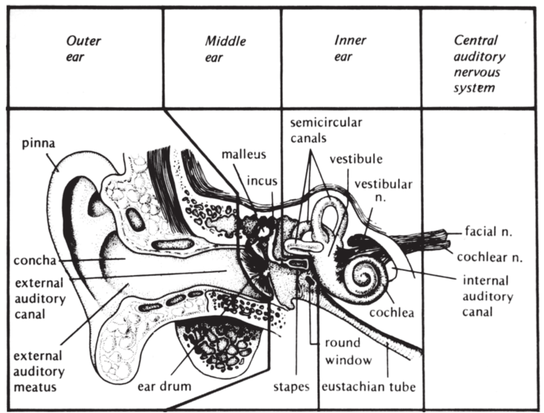

Figure 1 The anatomy of the Auditory system (Adapted from Hearing loss 1)

Aside from the ability to receive sound, the hearing organ can also actively emit sound without external stimulation. These so-called Spontaneous OtoAcoustic Emissions (further denoted as SOAEs) can be detected by measuring the variations in pressure level in the external auditory canal.2 These low-level sounds were discovered by Kemp in 19783 and can typically be detected between 1000 and 5000 Hz.4 The SOAEs can be identified from normal-hearing ears but are not present in all humans. Nevertheless, the research in this field has shown that appearance of SOAEs seems to be higher in females than in males, that they are more frequently apparent in right ears than left ears and that the number of SOAE per ear is higher in children than in adults.5,6

Up to now, the SOAEs have been of lesser interest than other OAEs because the emissions are not existent in all ears. Although they might be more meaningful than previously thought, their presence seems to have an effect on Evoked OAEs (EOAEs). In presence of SOAE the EOAE has a higher level than an ear without SOAEs. Therefore, the presence of SOAEs might be an indicator of normal hearing since they are correlated with better hearing thresholds.7 In addition, SOAE offers a method to assess the frequency tuning selectivity which is one of the key functional properties of the inner ear and has been a fundamental question in hearing research.8

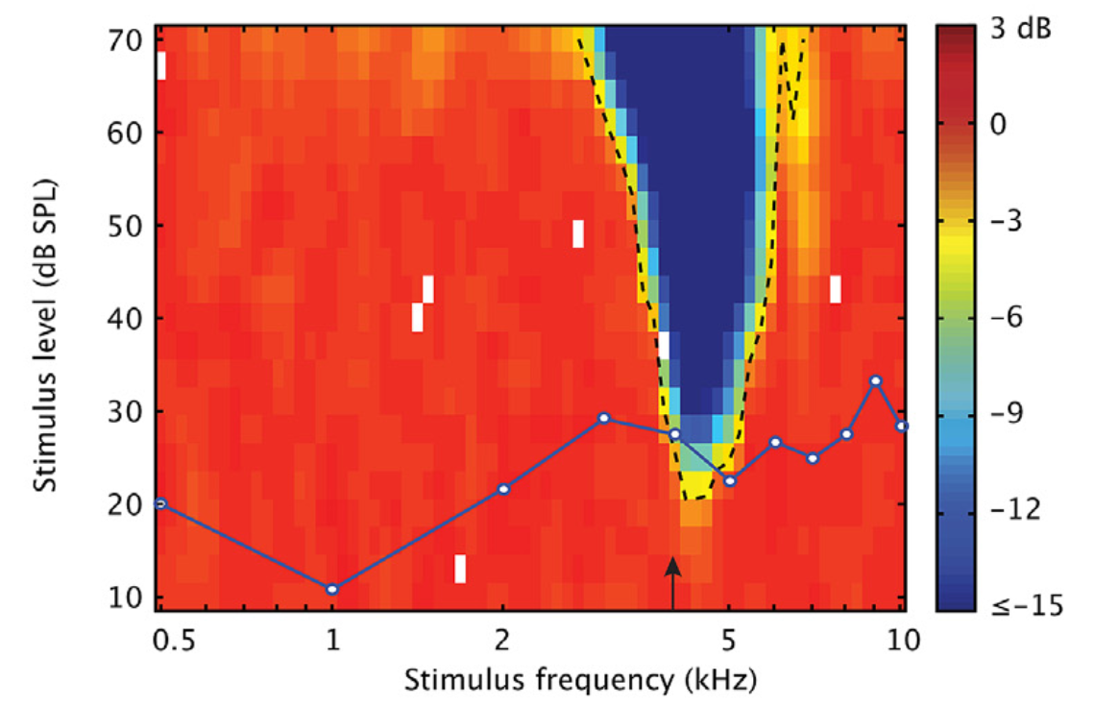The method to assess the frequency tuning while using SOAE is to suppress these emissions. By presenting an external tone into the ear the emissions will be reduced in amplitude, i.e. suppressed.9 The characteristics of the tone are person-dependent and the suppression is coherent to the emission frequency, this can be displayed in a Suppression Tuning Curve (STC) (Figure 2). Here, the relation between amplitude and frequency of the suppressor tone can be seen. The V-shaped peak shows the main area of suppression and is just above the SOAE frequency, which is indicated by the black arrow.8 Approximately, half of the SOAEs displayed narrow side lobes of suppression at high-frequency flanks of the STC; they occur at spectral distances of 0,5 -1 octave above the SOAE frequency.8,9

Figure 2 Example of Suppresion Tuning Curve (adapted from Manley et al8)

In order to find out more about SOAE suppressions we will conduct a study in which the time dependence of the amplitude is also taken into account. Meaning, the time it takes, the relaxation time, for an emission to disappear due to the external tone, and the amount of time after it appears again while the tone is not presented any longer. The relaxation time of the emissions have not been elaborately discussed in literature, nevertheless Schloth and Zwicker10 did describe the suppression pattern of the SOAE and its time course. In this study, these time courses of the suppression are anticipated to be found as well in the same order. If these patterns are found, it is likely that the way of measuring is correct and can be used for further research on the properties of SOAEs.

# Method

## Measurement setup

For this study 5 males and 4 females were included, all of which were fully awake and displayed normal hearing in the period of testing. The setup used is based on the method of Manley et al.7 Each subject was measured individually in a silent room in which they lay down on a chair with a high sensitivity microphone in the ear canal. This ER10B microphone from Etymotic Research was inserted in the ear canal with disposable, size dependent tip. The microphone’s signal was preamplified with 40 dB during all of the measurements. Subsequently, the signal was filtered with a SR560 low-noise amplifier as a high-pass filter with a cutoff at 300Hz, 12 dB/oct and the other settings at low noise and gain = 1. Outside the silent room, a SR640 low-pass filter filtered the signal set at a 15 kHz and an input gain variable at 20 dB. A higher input gain variable caused the system to overload. Both high-pass and low-pass filters are by Stanford Research Systems. Connected to the in-ear inserted microphone was an earphone (Etymotic ER2) which could present the auditory stimuli. The earphone and the microphone are both connected through audio ports to a 24-bit MOTU 624 AD/DA converter. This converter recorded the digital signals and generated the auditory stimuli. Finally, the converter was controlled by custom made Matlab scripts (R2016b, MathWorks Inc).

## Measurement protocol

Every once a month the entire setup is calibrated with use of KEMAR to make sure the auditory stimuli presented and recorded are in the same order.

In order to perform a suppression measurement, the subject had to have SOAEs. Therefore, the first test was a SOAE screening in which the peaks, levels and according frequencies could be detected. In case of no detectable SOAEs, they were excluded from further research. Also, the subjects with detectable SOAEs but which barely arose the noise floor were also excluded. To begin with, both ears were screened for 120 seconds each with the high-sensitivity microphone from which an emission spectrum was computed. Each spectrum was evaluated and used to determine which ear could be used for measurements, dependent on level and frequency of the emissions.

Before the actual STC measurement could take place, the in-ear sound levels needed to be calibrated. This was done with gain = 0 in both the high-pass and low-pass filters. Then, the STC map was computed by randomly presenting tones of different tone levels and different tone frequencies. The tone levels were all in the range of 10 – 70 dB SPL in 3 dB steps and tone frequency range was adjusted to incorporate the frequency of the SOAE. The duration of each tone was 1.2 s with a period of 0.4ms in between. During the measurement the subjects could follow their progress on a computer screen. Every 2 minutes, there was a 10 second break allowing the subject to re-adjust their position or swallow.

With the STC map a few level-frequency combinations were chosen which lied close to the frequency of the tip. With these combinations a relaxation time measurement was performed by presenting the same tone 100 times in the ear. Each tone had the same duration of 200ms and was always preceded and succeeded by 100ms of silence. In addition, a level-frequency combination was chosen in the side lobe of suppression which can occur at 0,5 -1 octaves above the SOAE frequency. Also, with these combinations a relaxation time measurement was performed by presenting the same tone 100 times.

A checklist for this protocol has been created and can be found in the appendix.

## Analysis

The relaxation time measurement, which is done for several level-frequency combinations, was saved and then further analyzed with help of custom made Matlab scripts (R2016b, MathWorks Inc). Each level-frequency combination was measured for 100 repetitions of 0.4 seconds; in total a file of 40 seconds duration was created. Individually, each repetition consisted of presentation of a tone for 0.2 seconds and in total 0.2 seconds rest in between (0.1 seconds silence before and after the tone was presented).

In Matlab, one by one the repetitions were zero padded, Fourier transformed and multiplied with a Butterworth filter with a different preset bandwidth and as a center frequency the frequency of the emission was used. The signal was now in the frequency domain and needed to be converted back to the time domain. Therefore, the inverse Fourier transform used was followed by a Hilbert transform. The Hilbert transform creates the smooth curve outlining the extremes of the signal, thereby taking the envelope of the signal. This outline visualizes the time dependence of the amplitude of the SOAE. A graph was plotted with each of the 100 envelopes displayed as coloured lines and the average as a black line.

# Results

## Overview whole research

In the following table (Table 1) an overview of the results is given. Unfortunately, none of the three subjects with SOAEs had a clearly visible side lobe present at the first STC measurement therefore the suppression relaxation times between the main lobe and the side lobe have not been measured.

|  |  |  |  |  |  |  |
| --- | --- | --- | --- | --- | --- | --- |
| Subject | Gender | Ear | fSOAE (Hz) | Auditory stimulus  (Hz, dB) | | Remarks |
| SOAE1 | M | AD/AS | No SOAEs | x | x | x |
| SOAE2 | M | AD/AS | No SOAEs | x | x | x |
| SOAE3 | M | AD/AS | No SOAEs | x | x | x |
| SOAE4 | F | AD | 1353 | 1388 | 34 | One really high emission in right ear, left ear had none. |
| SOAE5 | F | AS | 3171 | x | x | From previous experiment it was known which ear had SOAE. |
| SOAE6 | M | AD/AS | No SOAEs | x | x | x |
| SOAE7 | F | AD | 967, 1073, 1118 | x | x | Emissions might be too small to suppress. |
| SOAE8 | M | AD/AS | No SOAEs | x | x | x |
| SOAE9 | F | AD/AS | No SOAEs | x | x | x |

Table 1 Overview of data from all subjects who participated in the experiments. M = male, F = female, AD = Auris Dextra, AS = Auris Sinistra, fSOAE = frequency Spontaneous OtoAcoustic Emission

## Measurements

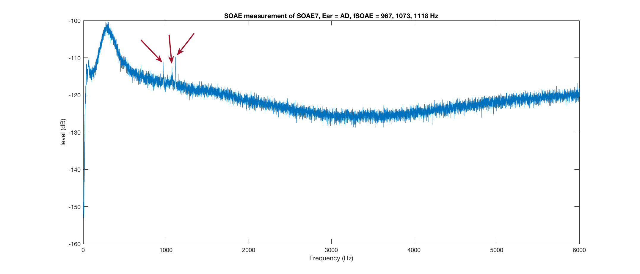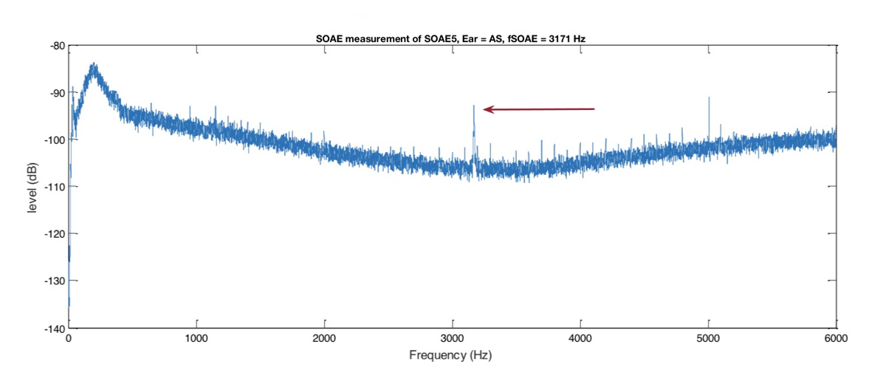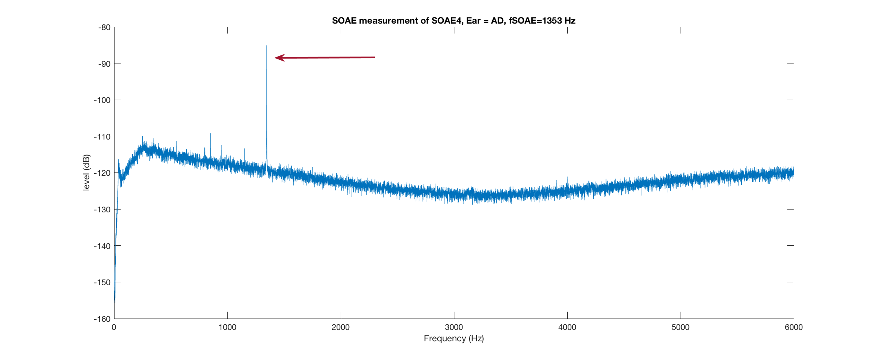The first measurement was the SOAE measurement which all of the 9 subjects experienced. The result was used to see if the subject had SOAEs. Therefore, only for subjects with emissions this result is displayed below.

Figure 4 SOAE Spectrum SOAE5, Ear = A3, fSOAE = 3171 Hz

Figure 3 SOAE Spectrum SOAE4, Ear = AD, fSOAE = 1353 Hz

Figure 5 SOAE Spectrum SOAE7, Ear = AD, fSOAE = 967, 1073, 1118 Hz

Secondly, the subjects with SOAEs underwent the Suppression Tuning Curve (STC) measurement. For each of the SOAE frequencies an STC map was made.

|  |  |
| --- | --- |
| A. STC Map SOAE4,  Ear = AD, fSOAE = 1353 Hz | B. A. STC Map SOAE5,  Ear = AS, fSOAE = 3171 Hz |

|  |  |  |
| --- | --- | --- |
| D. STC Map SOAE7,  Ear = AD, fSOAE = 967 Hz | E. STC Map SOAE7,  Ear = AD, fSOAE = 1073 Hz | F. STC Map SOAE7,  Ear = AD, fSOAE = 1118 Hz |

Figure 6 Suppression tuning Curves, 6A, 6B and 6D-F for 3 different subjects

Finally, only subject SOAE4 was presented with a relaxation time measurement where a stimulus was played 100 times at 1388 Hz at 34 dB. This level-frequency combination was chosen from the STC map. Unfortunately, the frequency was too close to the frequency of the SOAE, 1353 Hz, therefore suppression can only be seen when the analysis filter is really small. If the analysis filter is too big, the stimulus and the SOAE are both covered by the analysis filter. Below the results of the relaxation time measurement with an increasing analysis filter.

|  |  |
| --- | --- |
|  |  |
| A. 10 Hz Analysis filter | B. 20 Hz Analysis filter |
|  |  |
| C. 30 Hz Analysis filter | D. 40 Hz Analysis filter |
|  |  |
| E. 50 Hz Analysis filter | F. 60 Hz Analysis filter |
|  |  |
| G. 70 Hz Analysis filter | H. 80 Hz Analysis filter |
|  |  |
| I. 90 Hz Analysis filter | J. 100 Hz Analysis filter |

Figure 7 Relaxation time measurements each multiplied with a different analysis filter

# Discussion and conclusion

The findings of this study are not sufficient to form a definitive conclusion. The aim of this study was to find out more about the SOAE suppressions, mainly to investigate the time dependence of the emission suppression and its side lobe. The final goal was to obtain the time it takes for an emission and its side lobe to disappear due to the external tone, and the amount of time after it appears again while the tone is not presented any longer. Although these relaxation times are rarely discussed in the literature, Schloth and Zwicker did describe the time course of suppression of the emission in 198310. Here, a mean delay time of τmean delay = 13 ms was found. A specific time for the onset and recovery of the emission were not given in the article so the τmean delay would already be difficult to compare to our study.

Nevertheless, in our study the actual times of the onset and recovery from both the emission and side lobe have not been calculated. In this study the main focus was set on finding a subject with a SOAE which rose far above the noise floor and with a side lobe present in the STC map. Due to searching for a subcategory in a subcategory, a subject with visible SOAE and side lobe, the number of suitable subjects narrows down. In our study, we were not able to find a subject with visible SOAE and side lobe. Since SOAEs are not present in all humans, finding such a specific subject requires a lot of measurements and even more subjects. In the set amount of time, this appeared to be unrealistic. Therefore, only the relaxation time measurement of SOAE4 was performed. SOAE4 did not have a side lobe either so this was not meant to be the main subject of our study. However, due to technical difficulties SOAE4 is the only subject where the final relaxation time measurement could be performed. Unfortunately, the frequency chosen for this measurement was too close to the fSOAE causing the suppression can only be witnessed when the analysis filter is really small (Figure 7C, 7D) The result is too unreliable to use for further analysis to calculate the onset and recovery times.

For further measurements it is important to use multiple level-frequency combinations per subject especially choosing a frequency stimulus which lies near the fSOAE using very low-level tones for the main area of suppresion.8 It might also be useful to use some level-frequency combinations not near to the fSOAE to set as a baseline measurement. At the moment this is the most sensitive method to measure the tuning selectivity of the human cochlea. Manley and van Dijk8 observed that the most sensitive frequencies of suppression sidelobes are related to the center frequency of the STC and were on average 0,5 octave and 1 octave above the frequency of the tip. Therefore, it is recommended to use these numbers when testing a subject with a visible side lobe in the STC map. The assumption is made by Manley and van Dijk that these side lobes support the theorem of SOAEs being standing waves on the basilar membrane.

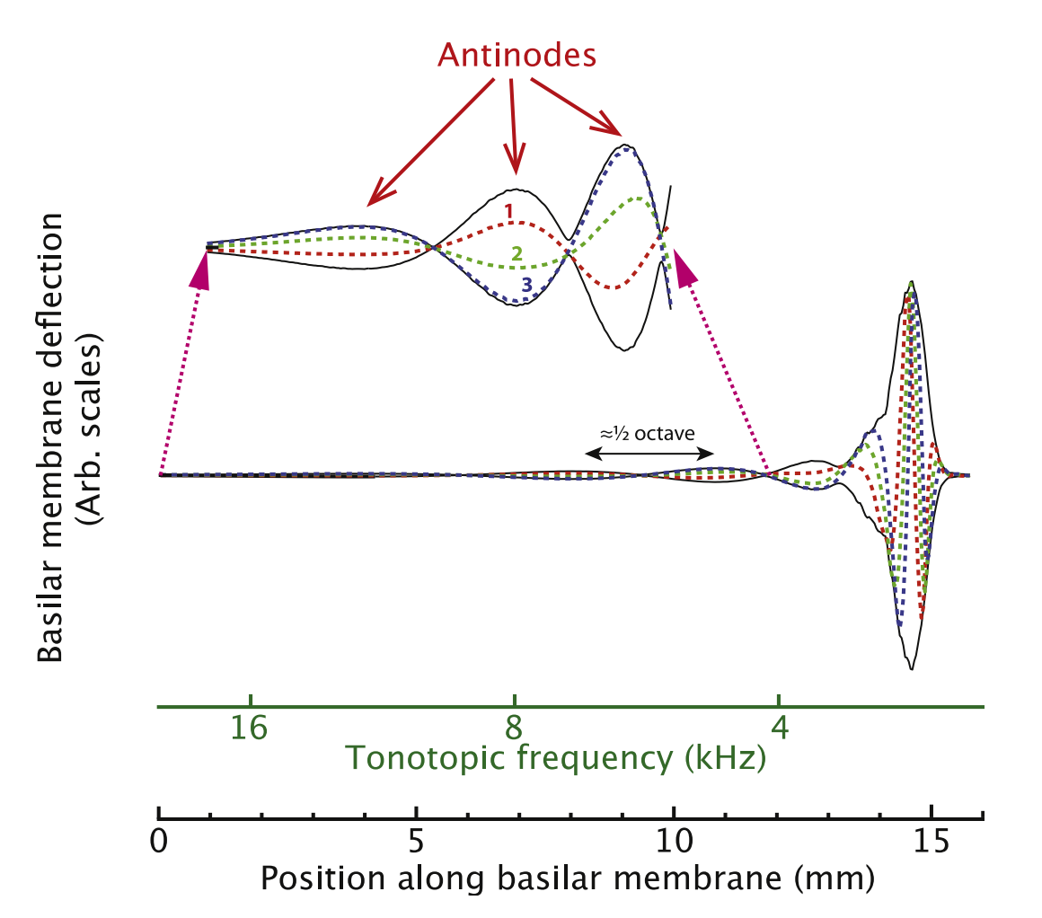

Figure 8 Basilar membrane motion due to an SOE peak (Adapted from Manley and Van Dijk (2016)8)

Not only does the SOAE peak correspond to a cochlear travelling wave at the tonotopic location of the emission frequency it also creates a standing wave on the basilar membrane, basal to SOAE frequency (Figure 8). As mentioned earlier, the antinodes of this standing wave appear at approximately 0.5 and 1 octave above the fSOAE. To investigate this even further, an external tone could be presented at a frequency 0.5 or 1 octave above the SOAE frequency which in theory should suppress the SOAE.8

The aim of this study was to investigate the time dependence of the emission suppression and its side lobe. Since, we were not able to find a subject with a side lobe, the goal of the study was not reached. We expected to find a different relaxation time for the emission and its side lobe to further support the theory that an external tone could neutralize the standing wave and hence the emission signal. Next to this, another focus of the study was to improve and further clarify the protocol used. This goal has been accomplished and is added in the appendix and as an attachment to this thesis.

# Literature

1. Dobie R, Van Hemel S. Hearing Loss: Determining Eligibility for Social Security Benefits. In: *National Academy of Sciences*. ; 2005:42-68.

2. Fruth F, Jülicher F, Lindner B. An active oscillator model describes the statistics of spontaneous otoacoustic emissions. *Biophys J*. 2014;107(4):815-824. doi:10.1016/j.bpj.2014.06.047.

3. Kemp DT. Stimulated acoustic emissions from within the human auditory system. *J Acoust Soc Am*. 1978;64(5):1386-1391. doi:10.1121/1.382104.

4. Ozturan O, Oysu C. Influence of spontaneous otoacoustic emissions on distortion product otoacoustic emission amplitudes. *Hear Res*. 1999;127(1-2):129-136. doi:10.1016/S0378-5955(98)00184-1.

5. Kuroda T. Clinical investigation on spontaneous otoacoustic emission (SOAE) in 447 ears. *Auris Nasus Larynx*. 2007;34(1):29-38. doi:10.1016/j.anl.2006.09.023.

6. Lamprecht-Dinnesen A, Pohl M, Hartmann S, et al. Effects of age, gender and ear side on SOAE parameters in infancy and childhood. *Audiol Neuro-Otology*. 1998;3(6):386-401. doi:10.1159/000013808.

7. Jedrzejczak WW, Kochanek K, Pilka E, Skarzynski H. Spontaneous otoacoustic emissions in schoolchildren. *Int J Pediatr Otorhinolaryngol*. 2016;89:67-71. doi:10.1016/j.ijporl.2016.07.034.

8. Manley GA, van Dijk P. Frequency selectivity of the human cochlea: Suppression tuning of spontaneous otoacoustic emissions. *Hear Res*. 2016;336:53-62. doi:10.1016/j.heares.2016.04.004.

9. Epp B, Manley GA, van Dijk P. Mechanics of Hearing Preliminary Manuscripts Suppression Tuning Curves in a Transmission Line Model of. 2017:1-5.

10. Schloth E, Zwicker E. Mechanical and acoustical influences on spontaneous oto-acoustic emissions. *Hear Res*. 1983;11(3):285-293. doi:10.1016/0378-5955(83)90063-1.

# Appendix

## STC measurement plan of action

An STC measurement can be done by following this certain plan of action. This plan consists of a few steps and is based on the method of Manley et al8. The scripts are organized by the following order:

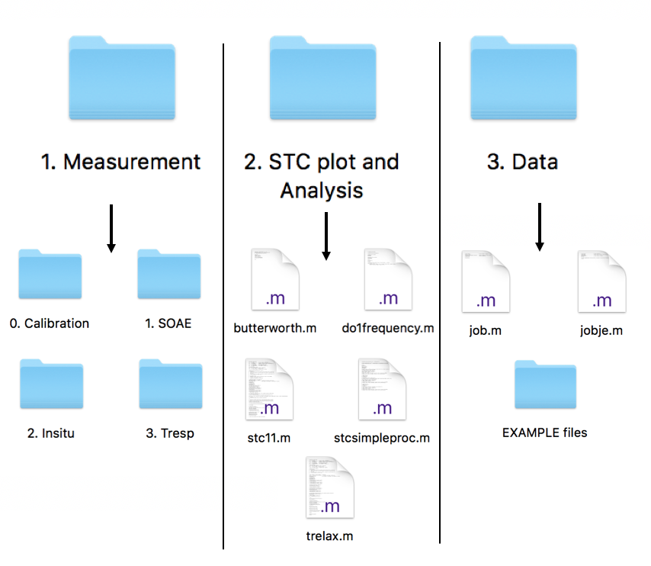

Figure 9 Schematic overview of the files and scripts needed for this experiment

In general, the experiment consists of three main steps: 1. Measurement, 2. Producing the STC plot and Analysis, 3. Collection of final data. These are also the number of main folders which can be seen above in Figure 9. When starting the experiment for the first time, the entire setup needs to be calibrated every once a month using 0. Calibration. And in every subject the experiment starts with an a SOAE measurement (1. SOAE), then the in-situ calibration (2. Insitu) and finally the STC measurement (3. Tresp). With the results from the previous a STC plot needs to be produced using the folders 2. STC plot and Analysis and 3. Data.

The setup is used with the ER-10B+ Low NoiseTM DPOAE Microphone from Etymotic Research with disposable tips. The high-pass filter has the following settings: high-pass filter cutoffs (Hz) = 300, 12 dB/oct, Gain mode = Low Noise, Gain = 1. The power was supplied by batteries during the experiments. For running the measurement scripts, Matlab is used.

Before measuring a subject make sure that:

* The input gain in the Low-pass filter is set to 20 dB
* The input gain in the High-pass filter is set to 40 dB
* Every device (MOTU, Microphone, Low-pass and High-pass filter, Computer) is switched ON
* The Audio ports are plugged in correct
* The Oscilloscope can detect the auditory stimuli and the signal from microphone

## Checklist during measurements

|  |  |
| --- | --- |
|  |  |
| 1. | **SOAE Measurement** |
|  | Make sure the Low-pass filter is set at 20 dB and the one of the High-pass filter set on 40 dB |
|  | Subject is on the lounge chair in silent room with the microphone in ear (AD or AS) |
|  | Measure if Subject has SOAE (AD and AS) with soae.m by running for (insert number) seconds |
|  | Write down the frequency of the SOAE which can be seen from the plot (if any) and save the plot |
| 2. | **Insitu Calibration** |
|  | In case of SOAE or previous knowledge of SOAE, continue and make sure that both gains are set to 0 dB |
|  | Now insitu.m is in your path and the ‘Calibration in KEMAR’ lines are commented (line 44-47) and make sure line 190 is uncommented. Run insitu.m and produce a calibration.mat file |
|  | Write down the name of the calibration.mat file which is in the form of ‘yymmdd-hhmmss.mat’ |
| 3. | **The STC Measurement** |
|  | Set the input gain of the Low-pass filter back to 20 dB and the one of the High-pass filter back to 40 dB |
|  | maketone.m should be in your path |
|  | Open the initcalibration.m script (in folder 0. Calibration) and insert the name of the calibration.mat file you just made which is still saved on your desktop |
|  | In tresp.m make sure the right interface is uncommented |
|  | Run tresp.m which calls the calibration file with initcalibration |
|  | Write down the name of the tresp.mat file which is in the form of ‘yymmdd-hhmmss.mat’ |
|  | Write down the f1low and f1high and the step size |
| 4. | **Producing an STC Plot** |
|  | Create a folder with the soae.m calibration.mat and tresp.m snd files and graphs in 3. Data |
|  | Create a new script called job.m and make sure do1frequency is in your path (in folder 2. STC plot and Analysis)  subject='SOAE..'; % Insert number of subject  ear='AS or AD';  filename='yymmdd-hhmmss.tresp.snd'; %Insert filename of tresp snd file  fcenter=3171; % Insert fSOAE here  artlevel=.03;    do1frequency; |
|  | Run job.m and save the STC plot (left figure shows the v-shaped peak) |
| 5. | **Performing the Relaxation time measurement** |
|  | Choose a level-frequency combination from the STC plot and make sure in tresp.m the right interface is uncommented. Now a suppression relaxation is performed. |
|  | %% Suppression relaxation  f1low=....; % Adjust to chosen frequency  f1high=....; % Adjust to chosen frequency  l1low=....; % Adjust to chosen level  l1high=....; % Adjust to chosen level  l1step=5;  fratio=2^(1/4);  nrep=100;  nperoct=16; % steps per octave  tonelength=0.2; % length of individual stimuli, including rise and fall (s)  rise=0.01; % rise and fall time (s)  silence1=0.1; % silent interval before a stimulus starts (s)  silence2=0.1; % silent interval after a stimulus ended (s) |
|  | Write down the name of the tresp.mat file which is in the form of ‘yymmdd-hhmmss.mat’ and saved in the correct folder in 3. Data |
| 6. | **Producing Relaxation Time Analysis** |
|  | The previous made tresp.mat file is analyzed with a new script called jobje.m and make sure trelax.m is in your path  fcenter=....; % Insert fSOAE here  fwidth1=100; % Enter width of analysis filter here in Hz  artlevel=0.1;  subject='SOAE..'; % Insert number of subject  ear='AD or AS';    filename='yymmdd-hhmmss.tresp.snd';%Insert filename of tresp snd file nrep=100 1 frequency-level  trelax; |
|  | Run jobje.m and save the graphs |