**The effect of gut microbiota on host fitness of animals released from captivity**

Taylor Smith  
S3586499  
University of Groningen

**Table of Contents**

I. Abstract ………………………………………………………………………………………………………………………………… 2  
II. Introduction ..………………………………………………………………………………………………………………………. 2  
III. Captivity disrupts the animal gut microbiota ………………………………………………………………………. 5  
IV. Diet alters host gut microbiota in captivity …………………………………………………………………………. 8  
V. Gut microbiota drives host behavior with social implications and higher mortality risk …….. 10  
VI. The gut microbiota’s role in captive animal health …………………………………………………………… 12  
VII. The gut microbiota’s influence on host development ..……………………………………………………. 13  
VIII. Discussion ..…………………………………………………………………………………………………………………….. 13  
IX. Future Directions and Conclusion……………………………………………………………………………………… 16  
X. References…………………………………………………………………………………………………………………………. 17

**I. Abstract**

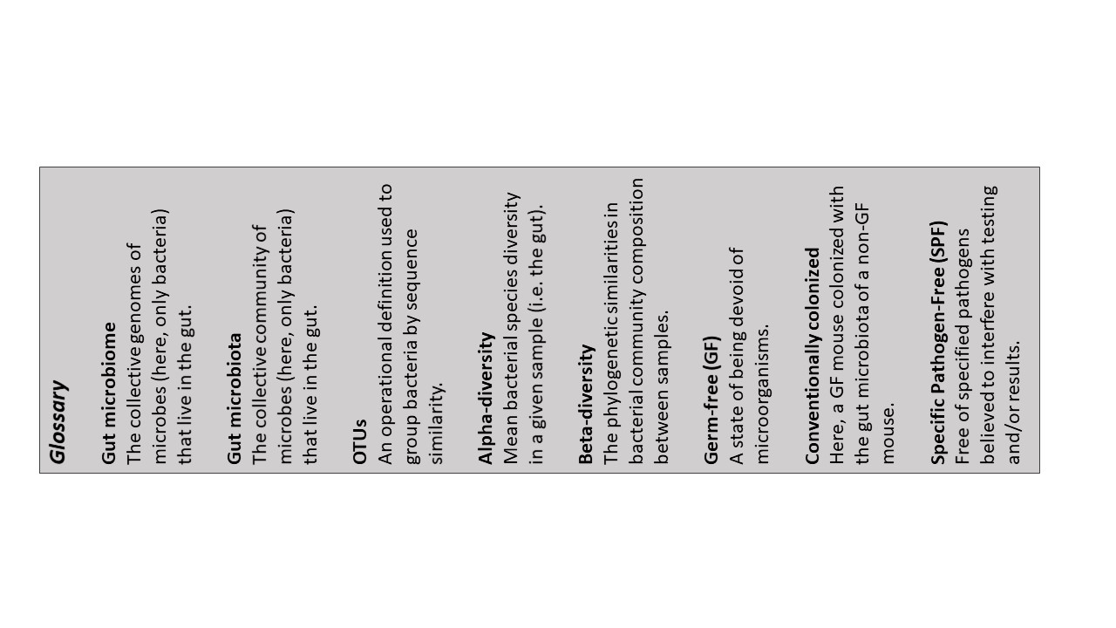 It is estimated that only 33% of the animals in reintroduction programs survive upon their release into the wild, highlighting a major area of concern among captive-breeding and reintroduction conservation programs. A potential method for improving survival rates involves the maintenance of the gut microbiota, as it has been found to directly and/or indirectly regulate various physiological and behavioral traits of the host. Due to the current trends of biodiversity loss and the statistical lack of success in reintroduction programs, an understanding of how the gut microbiota influences fitness is vital. In this review I assessed the composition of the gut microbiota among various species in captivity compared to their wild conspecifics. I also reviewed the influence of the gut microbiota on diet, behavior, health, and development. In most species, alpha-diversity of the gut microbiota was lower in captive animals. Beta diversities also differed between captive and wild animals in most species. This indicates that captivity does indeed alter the gut microbiome. This may partially explain the often-inferior health of captive animals. In addition, a change in the gut microbiota may result in altered behavior, as the gut microbiome is associated with behaviors such as anxiety and social interaction. A change in gut microbiota may thus have a significant effect on the fitness of individuals. Determining the extent of these effects and designing a method to mitigate them may improve the success of conservation programs.

**II. Introduction**

We are estimated to currently be experiencing the first ever anthropogenic-induced mass extinction (Naeem et al. 2009; Edie et al. 2018), resulting in much warranted concern over biodiversity loss. Over the past four decades a continuous trend of biodiversity loss has been observed, and it is expected to continue to decline (Butchart et al. 2010). As a result, nearly half of our current species will be extinct within the next 100 years (Singh et al. 2017). The International Union for Conservation of Nature (IUCN) provides the most accurate and up-to-date information on species that are threatened by extinction. Out of 93,577 surveyed species, the IUCN lists 26,197 species (28%) as “endangered,” with over 160,000 more species still left to evaluate. Out of these endangered species, approximately 5,483 of them are “critically endangered,” requiring immediate action for their preservation (Universidad de Sevilla. Departamento de Biología Vegetal y Ecología et al. 2018). WWF (World Wildlife Fund) and ZSL (Zoological Society of London) have also compiled a database from a variety of reputable sources (e.g., journals, government reports, etc.) to create the Living Planet Database. From this database the Living Planet Index was calculated as a means to measure global biodiversity. The results are used to inform policymakers and to measure success in biodiversity restoration goals. This index also indicates clear negative trends in global biodiversity (Fig. 1)(McRae et al. 2016).

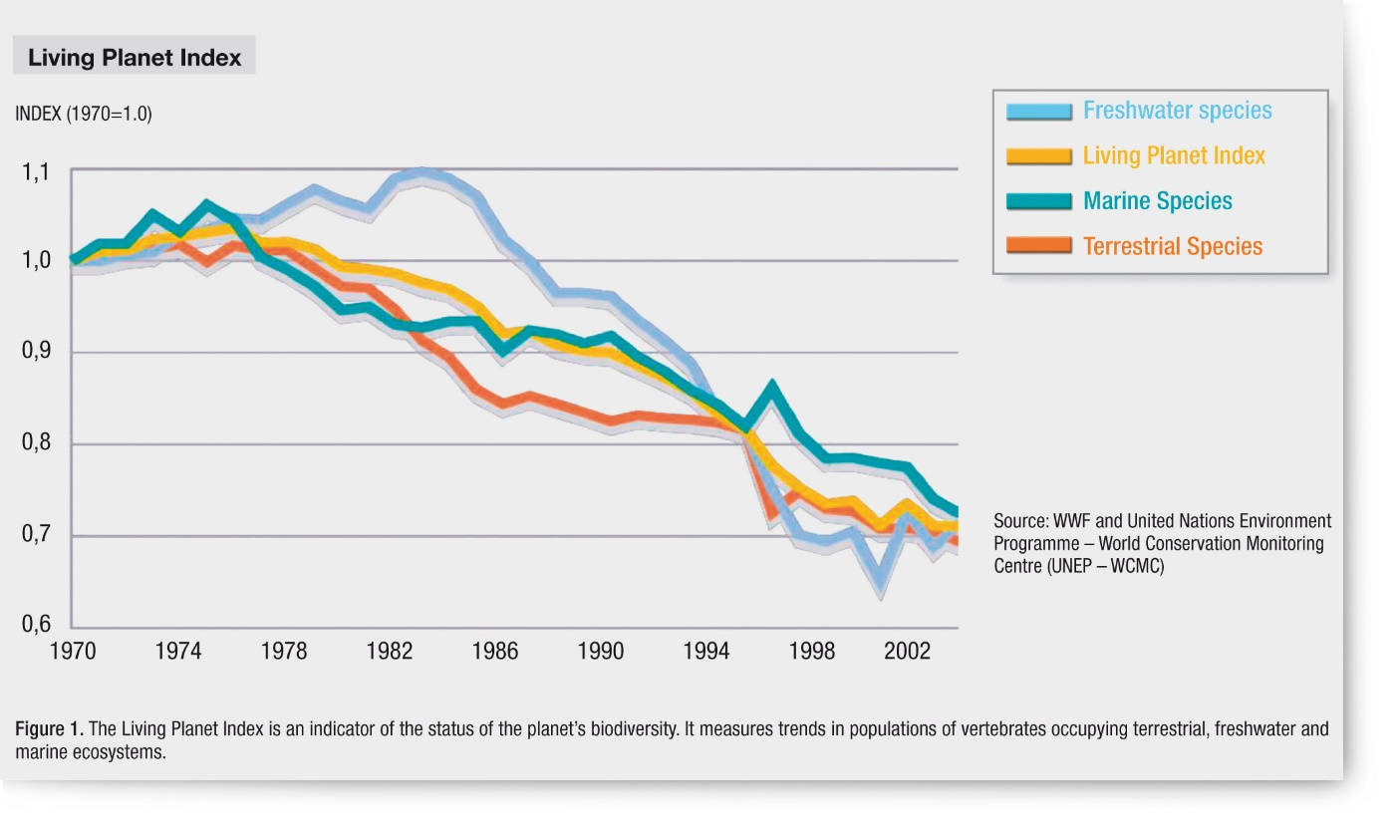 **Figure 1. Living Planet Index**This graph indicates the Living Planet Index – an accepted indicator of biodiversity – over the years. A steep decline is seen in all groups of species considered.

Biodiversity has strong influences on the functionality and stability of all ecosystems, and therefore is vital to maintain (Edie et al. 2018). The implementation of successful species conservation programs, such as habitat restoration or captive breeding with the goal of reintroduction, is necessary for the reestablishment and preservation of endangered populations and their associated ecosystems. However, there are some doubts concerning the success of these conservation programs due to survival rates of the reintroduced individuals as it is estimated that only 33% of the animals in these programs survive upon their release into wild habitats (Jule et al. 2008). Jule et al. gave four criteria that must be met for a conservation program to be considered successful, all of which view the success of the population as a whole, and consider the program to be successful when the population is self-sustaining and reproducing.

The current definition of success does not look at the success of the individual, and therefore a reintroduction project can be determined successful even with high mortality rates of released individuals. Assessing only on the population level and not on the individual level is problematic, as a population may stay stable or increase irregardless of the presence, or lack thereof, of the reintroduced individuals. If a released individual dies before achieving reproduction, it ultimately was not successful, even if the population trend does not reflect this. Alternatively, a released individual might emigrate to another population and achieve reproductive success there. By not contributing to the focal population its success may be overlooked, regardless of the benefits its reproductive success provides for the species as a whole. Grimm et al. discuss the merits of individual-based modelling in the scope of population ecology and argue its superiority due to factors like these (Grimm and Railsback 2004). With this understanding, it may be beneficial to (re)structure conservation programs to the advantage of the health and fitness of the individual, particularly where captive-breeding is concerned.

This study focuses on factors that may improve captive-breeding and reintroduction programs. Concerning carnivores, translocated, wild-born individuals are 53% more likely to survive than their captive-born counterparts upon their release into the wild. (Jule et al. 2008). Hindrances like starvation, unsuccessful predator/competitor avoidance, and disease all affected the captive-born populations more significantly. Therefore, either ensuring the ultimate fitness of individuals in captivity before their release into the wild is critical, or exploring translocation as a superior species conservation method is essential.

Survival rates among captive-bred or translocated animals reintroduced into the wild are higher when their general health is superior (Acevedo-Whitehouse and Duffus 2009). Currently, most captive-breeding programs are concerned with retaining genetic diversity (i.e. avoiding inbreeding), (Williams and Hoffman 2009), maintaining health (preventative treatments, i.e. antibiotics), (Deem et al. 2008), food acquisition (i.e. hunting, scavenging, etc.), and their behavior where human interaction and breeding is concerned (i.e. losing their fear of humans, and having inappropriate social behavior that leads to the inability to find a mate), (Price and Soorae 2003; Fraser 2008). However, it is arguable that these current practices and focuses are simply not sufficient, since there remains poor success in these reintroductions. Alternatively, it is plausible that there exist other factors that influence an individual’s fitness upon reintroduction that have not been properly evaluated within the context of captive-breeding and reintroduction programs.

One such undervalued factor that has been overlooked until recently is the gut microbiome. The gut microbiome is now known to be responsible for regulating a multitude of physiological functions within the body, such as metabolism, development, and immune health, as well as behavior (Mayer et al. 2015a; Macke et al. 2017). Until recently, many of these functions were considered to be solely regulated by host genetics or environment. The discovery of the importance of the role of the gut microbiome to the host is now bringing understanding that the proper maintenance of the gut microbiome is necessary for many physiological functions. It is important to evaluate this research under the discipline of ecology and determine any applications that can lead to the improved fitness of individuals in captive-breeding and reintroduction programs.

The aim of this paper is to determine if the gut microbiota plays a role in animal fitness in the transition from captivity to their release into the wild. For this, I will first evaluate the differences in composition and diversity of the gut microbiota between hosts in captivity and hosts in the wild. Next, the role of the gut microbiota in diet and metabolism, behavior, and immune system functionality of the animal host will be investigated. I expect that gut microbiota will differ between captive and wild individuals, and that this will have a negative impact on the other three factors, resulting in a general trend of reduced fitness of animals in captivity and upon their release.

Determining if the gut microbiota plays a role in animal fitness, and if so the manners in which it does, can lead to future research and procedures that may improve the success rates of conservation programs and species reestablishment.

**III. Captivity disrupts the animal gut microbiota**

Animals in captivity experience significant lifestyle changes compared to their wild conspecifics. Increased contact with humans, anthropogenic environments, and unnatural (anthropogenic) stimuli lead to many behavioral and physiological changes, most notably due to change in diet and feeding, medical intervention (i.e. antibiotics, known gut microbiota disruptors), altered social communities, and lack of predation. The gut microbiota is one such physiological aspect that may be influenced by captivity. Diet is known to be a strong influencer of gut microbiota composition, and consequently the gut microbiota is susceptible to diet modification (Ley et al. 2008). The behavioral and physiological changes experienced by animals in captivity are also likely to influence the gut microbiome. Together with antibiotics, these factors are likely the cause of any differences found in the gut microbiota between the captive and wild animals.

Most studies have shown there indeed exists a difference in the gut microbiota composition between animals in captivity and those in the wild; however, the manner in which the gut microbiome differed was found to be species-specific (Jule et al., 2008, Table 1). Alpha diversity measurements (i.e. richness - the number of different operational taxonomic units [OTUs] present - and the Shannon index - abundance and evenness of the species present) were in most species lower in captive than their wild counterparts, particularly in canids, primates, and equids (Clayton et al., 2016; Jule et al., 2008). For example, the alpha diversity of the gut microbiome in two captive primates, the red-shanked doucs (*Pygathrix nemaeus*) and mantled howling monkeys (*Alouatta palliata*), decreased when brought into captivity. Interestingly, individuals housed in an intermediate, “semi-captive” primate sanctuary demonstrated alpha diversities in between that of the captive and wild primates. This indicates the importance of the environment on the gut microbiota diversity, suggesting that it is favorable to create the most wild-like habitat for individuals in captive-breeding programs.

**Table 1. An overview of diversity of the gut microbiota between captive and wild individuals of different species.**



Analysis of the gut microbiota of individuals in captivity and individuals in the wild for various orders were performed within numerous studies. Alpha- and beta-diversities are the most common scope used to determine significant variance between the two groups. Species were classified by their diet type, OTUs present, and their gut microbiome’s diversity. The symbols can be read as follows: H = herbivore, O = omnivore, C = carnivore, I = insectivore. A subscript of “g” or “s” indicates a dietary generalist or specialists, respectively.   
 +/- indicates the increase or decrease of alpha diversity, and 0 indicates no change in alpha diversity.  
y/n indicates whether there was a difference in beta diversity: y = difference, n = no difference.  
P indicates the presence of human OTUs.   
N/A means that the information was not measured or stated.

* While the red crowned crane showed an increase of OTUs and diversity within captivity, some of these were related to possible (and known) pathogens of the species (*Clostridium sp.).*

Beta-diversity measures, which are used to compare microbial community compositions, also differ between captive and wild animals in almost all investigated species (Jule et al. 2008; Clayton et al. 2016; Xie et al. 2016). The measured shift in beta-diversities indicates that despite being similar in alpha-diversity, captive and wild animals may have a difference in microbial community composition. In addition, offspring born in captivity, may differ in gut microbial community composition from their wild-caught captive parents as indicated by the study on red-crowned cranes (*Grus japonensis*), (Xie et al. 2016). Note that this does not imply that gut microbiomes from animals born in captivity differ more from that of their wild counterparts than the gut microbiomes of their parents.

Concerning the four species in which alpha-diversity was similar between captive and wild individuals, there is no clear explanation as to why they presented with no change in alpha-diversity. The Giant Anteater (*Myrmecophaga tridactyla)* and aardvark (*Orycteropus afer*) are both insectivores, a diet type that is difficult to replicate within captivity. Captive individuals in U.S. zoos are fed a diet consisting largely of cat food, while other countries (i.e. Germany) provide them with a diet consisting of meat, fruit, and vegetables. Since they are dietary specialists, many zoos have begun hiring specialized animal nutritionists to assist in designing a healthy diet plan for them while in captivity. As such, these species may benefit from the extra attention their diet receives, and therefore possibly be eating relatively similarly to their wild conspecifics. Springboks (*Antidorcas marsupialis*) and wildebeests (*Connochaetes sp*.) were the only herbivores without reduced alpha-diversities. Their habitat ranges overlap, and they share similar preferences for food resources (shrubs, grasses, and succulents). Certain zoos and/or conservation organizations allow these species to graze in enclosed fields during summer months, resulting in the consumption of a more natural diet type.

Differences in alpha- and beta-diversities may arise both due to a loss of certain OTUs, but also due to acquisition of OTUs not present in wild individuals. For instance, the red-shanked doucs and mantled howler monkeys both lost certain OTUs when in captivity, but also obtained OTUs from human-associated gut bacterial genera *Bacteroides* and *Prevotella* (Fig. 2b, Clayton et al. 2016). All these changes may result into a disbalance, or dysbiosis, between host and its gut microbiome, which may lead to a higher susceptibility for pathogens and diseases (Maslowski and Mackay 2011). Incidentally, five captive doucs died during the study, which was hypothesized to be caused by gastrointestinal-related diseases (Clayton et al. 2016). The gut microbiome of these animals showed a trend of diverging even further from their conspecifics in the wild than the surviving captive individuals; however, due to the very small sample size significant conclusions could not be drawn (Clayton et al. 2016). Likewise, reintroduction and captive breeding programs for the red-crowned crane suffered from low survival rates both in captivity and upon reintroduction (Xie et al. 2016). Bacterial infections were frequently found to be the cause of their mortality, despite those being held in captivity having access to proper medical treatment (i.e. antibiotics). Even though captive individuals had the highest alpha-diversity, they did not perform well both in captivity and upon their release into the wild. Moreover, this increased alpha-diversity may also be due to the invasion of new bacteria species, including pathogens. It is important to realize that higher alpha-diversity is not an 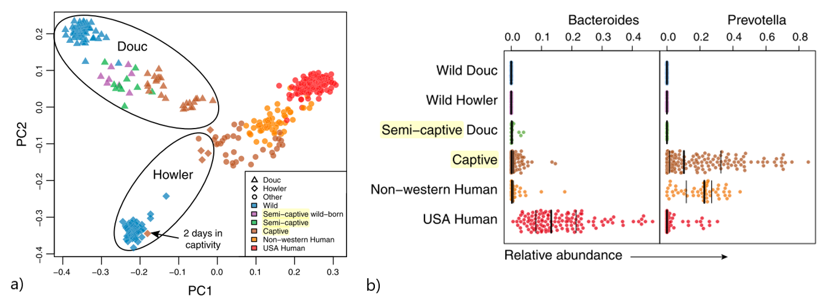indication of superiority or general fitness.  
  
**Figure 2. The gut microbiome of captive primates converges towards that of a Westernized diet.**a) Principal coordinates plot of unweighted UniFrac distances that show the convergence of the gut microbiome of wild, intermediate, and captive primates (doucs, howlers, and other) towards that of humans (i.e., non-western and USA human).  
b) A bee swarm plot (using the arc-sine square root relative abundance) of *Bacteroides* and *Prevotella*. These two bacterial genera were chosen as a measure of likeness to compare primate gut microbiota to human gut microbiota, as *Bacteroides* and *Prevotella* are the dominant genera in the human gut microbiome. Minimal similarity to human abundance of the genera was seen in wild doucs and howlers, with a sudden shift to high abundance of the genera when the primates were in captivity.   
Source: Clayton et al., 2016

In general, it is thought that the main drivers of gut microbiota alteration within captivity are diet and antibiotic treatments. However, other anthropogenic influences certainly play a role in the composition of the gut microbiota, which in turn can alter host fitness.

**IV. Diet alters host gut microbiota in captivity**

The effects of diet on the gut microbiota and the concurrent effects of the gut microbiota on host metabolism have been well-accepted at this point in time (Proctor et al. 2017). Changes in diet can have a direct effect on gut microbiota composition, which in turn influences the metabolic capacity and health of the host (Nelson et al. 2013). Diet is a bidirectional effect, as diet influences gut microbiota composition, and the gut microbiota influences in turn diet (i.e., digestion capabilities), as well as behavior, which may also influence an individual’s diet. Animals in captivity tend to experience a high deviation in diet compared to the natural diet of their species in the wild (Clayton et al. 2016). Herbivores are particularly susceptible to diet changes within captivity, as their specialized digestive system is adapted to process tough fibrous plant matter, and as a result is more complex than the digestive system of carnivores (Kohl et al. 2014). Omnivores, meanwhile, are the most generalist when it comes to diet, allowing for more variety in diet both in captivity and in the wild. However, the diet types that are likely most susceptible to captivity-induced alteration of the gut microbiota are diet specialists (Kohl et al. 2014). As such, diet type may determine a species’ susceptibility to diet change, particularly when in captivity. The dietary specialist of the woodrat *Neotoma stephensi* responded differently in captivity than its dietary generalist counterpart, the *Neotoma albigula*. Both species experienced reduced gut microbiome diversity when in captivity, but the dietary specialist *N. stephensi* exhibited greater diversity loss. A loss of 64% shared OTUs was seen between wild and captive *N. stephensi*, and a loss of 51% shared OTUs was seen between wild and captive *N. albigula*, indicating a vulnerability of dietary specialists when raised or brought into captivity (Kohl et al. 2014). This has implications for current conservation programs, i.e. the endangered Black-footed ferret (*Mustela nigripes*), a carnivorous dietary specialist with only 206 adults found in the wild (Brickner et al. 2014; Belant et al. 2018).

Particularly in herbivorous and omnivorous diets, inefficient supplemental fiber can prove to be a large driver of gut microbiota alteration. The lower gut microbiota diversity in captive herbivorous red-shanked doucs and mantled howling monkey (Clayton et al. 2016) may be associated with the decreased plant variety and dietary fiber in their diets. The effects of diet on captive animal gut microbiomes can be somewhat mitigated with the restoration of the animal’s natural diet as indicated by the partly restoration of the gut microbiome diversity when red-shanked doucs and mantled howling monkeys were housed in an intermediate “semi-captive” primate habitat, and fed a diet that more closely resembled that of the wild doucs and howlers. This is likely due the dietary fiber levels being more similar between semi-captive and wild individuals, stressing that maintaining the natural diet of animals in captivity seems important for their overall health. The gut microbiota of captive doucs and howlers tended to diverge towards that of Westernized humans, as evident by the presence of *Bacteroides* and *Prevotella*, the dominant genera in the human gut microbiome (Fig. 2). The “Westernized diet” is known to have low-fiber content, which is suggested to be responsible for certain diseases, i.e. diabetes and obesity (Clayton et al. 2016; Proctor et al. 2017). The five captive primates that died during the study of Clayton et al. died from gastrointestinal-related diseases, implying a possible correlation between health and Westernized diet.

Additionally, it is important to consider the effects of captivity on species capable of diet-induced phenotypic flexibility. Food availability due to factors like seasonality and migration determines this flexibility in such organisms – a skill considered beneficial to some in the wild. American robins (*Turdus migratorius*) and European starlings (*Sturnus vulgaris*) are two such species capable of dietary switching. When their diet type is switched (i.e. between fruit and insects), inefficiency in processing is observed on the first day of this diet switch. However, within 2 – 3 days later diet-specific efficiency levels were achieved. (Levey and Karasov 1989). Similarly, red knots (*Calidris canutus*) also exhibit phenotypic flexibility in their digestive capabilities. They were found to undergo rapid adjustment of their gizzard size when their diet was switched from a hard food type (i.e. blue mussels, *Mytilus edulis*) to a soft food type (trout pellets in captivity, or tundra arthropods in the wild), or vice versa (Dekinga et al. 2001). Possessing a targeted digestive system for the available food type is necessary for balancing energy costs, and therefore influences host fitness.

These dietary switchers exhibit changes in morphology (i.e. a change in gut morphology), metabolism (i.e., a change in the gut enzymes), and therefore also a change in the habitat (the gut) for the bacteria located within the host. This switch leads to a lag in reaching optimal digestive capabilities during the process of switching diet types. Animals in captivity typically do not experience diet switches, as they are provided with *ad libitum* food. However, upon their release into the wild they may be unable to find the food that their digestive system is currently adjusted for. As such, these individuals may immediately be forced to undergo a dietary switch upon their release, which can take up to a week to fully realize. During this time their gut is maladjusted to the available food type, resulting in an inefficiency in processing (manual and chemical digestion, nutrient absorption, etc.) their food, which may lead to illness, a decrease in body mass, and/or death. To avoid this, dietary switchers should be primed for the diet most readily available in the habitat and climate that the individual will be released in.

**V. Gut microbiota drives host behavior with social implications and higher mortality risk**

Recent studies have indicated that the gut microbiome affects host behavior (Heijtz et al. 2011; Bendtsen et al. 2012; Desbonnet et al. 2014; Clayton et al. 2016; Macke et al. 2017). Currently, most of the studies have evaluated this claim on laboratory rodents, and have found that behavior such as anxiety, risk-taking, and social interactions are partially affected by the gut microbiome.

Germ-free mice (*Mus musculus*, Swiss Webster) are found to be less social than conventionally-colonized mice, indicating the role of the gut microbiota in normal social behavior. Desbonnet et al. (2014) exposed mice to a three-chambered sociability test and found that germ-free mice displayed abnormal social behavior, i.e. spending less time in chambers housing other mice, less time investigating novel mice, and increased self-grooming. Recolonizing 21-day old germ-free mice with conventional bacteria restored social behavior back to normal expected displays, except with social investigation. This indicates that certain behaviors, such as social investigation, are established via the gut microbiota during the pre-weaning period, implying that development with the proper gut microbiota is critical for social behavior (Desbonnet et al. 2014). This has implications for captive-breeding programs. If species-specific bacteria are necessary for development of proper social behavior and are absent in the maternal host or in the captive habitat, then offspring may then not receive these species in their gut microbiome, thereby losing any social and behavioral benefits provided by the (properly) functioning gut microbiota.

Anxiety is another behavior found to be partially affected by the gut microbiome (Heijtz et al. 2011; Neufeld et al. 2011; Bendtsen et al. 2012; Hoban et al. 2018). Studies have indicated that germ-free mice may become more fearless, as shown by their time spent in exploratory activity and in open spaces. Heijtz et al. (2011) found that germ-free mice were more prone to explore the center of a novel, open-field box, traveled further distances within the box, and showed more rearing activity - a form of exploratory behavior - than specific pathogen free mice. In a light-dark box test, germ-free mice spent significantly more time in the light part of the box when compared to specific pathogen free mice, and spent more time in the open arms of the elevated plus maze (a four-chambered box consisting of a perpendicular intersection that is an accepted method to test for anxiety in lab mice and rats), both of which can be labelled as riskier behavior. Fear, or anxiety, contributes to the behaviors seen of animals in the wild, i.e. predator avoidance, and lack of fear can result in premature death of an individual.

Further tests indicate that timing of exposure to bacterial species is relevant to adult behavior. The conventionally-reared young of germ-free mice were colonized at the age of 8 – 10 weeks with microbiota obtained from the gut of unmated specific pathogen free mice and were exposed to the same testing by Heijtz et al., 2011. They were found to exhibit behavior similar to that of the specific pathogen free mice, suggesting that the process of microbial colonization indirectly affects motor control and anxiety behavior via neuronal circuits. Interestingly, while the conventionalized offspring displayed normal behavior, the germ-free adult mice that had been recolonized for the purpose of breeding these offspring did not return to their normal behavioral state (Heijtz et al. 2011).

This implies that the gut microbiota plays a role in regulating behavior, and that exposure to the proper bacteria during a crucial developmental stage may be necessary for the proper social and anxiety behavior to be developed. This seems very relevant for captive breeding programs, as offspring hatched in isolation, or removed promptly from their mother’s care, may fail to be colonized by these vital bacteria, and therefore may fail to develop the proper social or personal behavior needed to survive in the wild. Abnormal social behavior may result in reduced fitness, as the individual may experience difficulties with acquiring a mate or being accepted into a social group, thereby decreasing their chances of survival. For example, individual wolves benefit from belonging to a pack due to increased protection and easier food acquisition (McGlynn 2010). Intriguingly, the effects of this are bidirectional – the gut microbiota drives the host to engage in normal social interactions, and in turn the host is able to share and receive other beneficial bacteria from being in close proximity to the others (Song et al. 2013; Tung et al. 2015). The act of belonging to a social group and its consequent sharing of bacteria may also lead to an improved immune system (Takahashi et al. 2018), indicating that proper socialization may be crucial for host fitness.

**VI. The gut microbiota’s role in captive animal health**

In addition to being linked to animal behavior, the gut microbiome is known to affect the health of its host by its impact on the immune system (Maslowski and Mackay 2011; Rosshart et al. 2017). Studies observing the success of reintroduction and captive-breeding programs often report reduced health and fitness of the individuals both when in captivity and when released into the wild (Snyder et al. 1996; Fraser 2008). Indeed, Rosshart et al. (2017) presented detailed findings that indicated that the gut microbiota could alter host fitness and disease resistance. A wild population of mice (*Mus musculus domesticus*) with high genetic similarity to laboratory mice was selected to determine if the sterilized environment of the lab led to altered, ‘unnatural’ gut microbiomes, and if this could determine host fitness and disease resistance. A gut microbiota transplant was immediately performed from the wild mice to pregnant (14 days into pregnancy) germ-free laboratory mice in order to eliminate confounding factors, while also testing for vertical transfer of the microbiome. Analysis found that the wild mouse microbiome varied significantly from the laboratory mouse microbiome, and that the wild gut microbiota promotes host fitness and reduced inflammatory response when tested against the influenza virus and colorectal tumorigenesis (Rosshart et al. 2017). The implications of this study among captive-breeding and reintroduction programs are relatively straightforward. Many of these conservation programs falter or fail from diseased-related premature death of the animals, either when still in captivity or upon their release into the wild, such as seen with the red-crowned cranes (Xie et al. 2016). Since disease is one of the most common causes of red-crowned crane mortality in these programs, it is plausible that its fitness in captivity and upon reintroduction may be improved by proper gut microbiota management.

Hyper-inflammation is another physiological, immune factor found to be regulated by the gut microbiome, as shown in captive house sparrows (*Passer domesticus*), indicating the overall regulation of the immune system by the gut microbiota. More research should be considered, particularly with critically-endangered keystone species, to discover particular immune pathways and bacterial species involved with this process, as regulation of the gut microbiota in captivity may be able to assist in fitness and longevity both in captivity and upon releasement into the wild (Martin et al. 2011).

The importance of both maternal and environmental transference of the gut microbiota has been further realized. Failure to colonize during early development can lead to abnormal immune system functioning (Heijtz et al. 2011; Maslowski and Mackay 2011; Sommer and Bäckhed 2013; Macke et al. 2017). The gut microbiota has co-evolved with its wild host (population), with traits for disease resistance and immune support being selected for under the pressures found in the natural environment (Shapira 2016). Animals bred into captivity may find themselves lacking some of these benefits, therefore exhibiting an insufficient immune response and potentially being more susceptible to diseases. Animals brought into captivity from the wild may also find their gut microbiota shifting during their time in captivity, or being altered by the administration of antibiotics. This in turn could make them less fit – a trait that could be transferred to their offspring, or could affect them if they are returned to their natural habitat. Careful consideration should be taken when considering the organization of a captive breeding program or reintroduction program, and further research is needed to gain more insight in how the gut microbiota affects animal health, and how it can be maintained to promote higher host fitness.

**VII. The gut microbiota’s influence on host development**

The gut microbiota has been found to directly- or indirectly-facilitate various physiological and behavioral functions within the host. In addition to altering these functions in adults, the gut microbiota is also known to regulate development of the host. This includes influence on organ development, host metabolism, immune system establishment, etc. (Sommer and Bäckhed 2013; Macke et al. 2017). As such, proper maternal and sibling exposure is important for the colonization of these vital bacterial species (i.e. via birth, nursing/feeding, nest/environment, etc.). Individuals that did not receive this exposure have been found to display altered behavior and physiological functioning (i.e. germ-free mice, Heijtz et al. 2011). Individuals born into captivity and/or abandoned by their mother may potentially not receive these beneficial bacteria, and therefore probiotic administration should be considered.

**VIII. Discussion**

This review supports the expectation that the gut microbiota differs between captive animals and wild conspecifics, and that general trends of fitness-reducing traits were found among animals in captivity. The alpha- and beta-diversities of the gut microbiota were found to differ between animals in captivity and their wild counterparts, implicating that captivity does indeed alter the gut microbiome due to anthropogenic influences (Clayton et al. 2016; McKenzie et al. 2017; Metcalf et al. 2017). While deviance from the norm does not inherently imply inferiority, here the general trend seen in captive animals of altered gut microbiotas and reduced fitness would indicate that in this instance the two are correlated. Literature further supports this notion, as there is a significant failure to thrive of captive animals, both during their captivity and upon their reintroduction into their natural habitats (Fraser 2008; Jule et al. 2008).

The differences in gut microbiota diversity and community composition are likely to have an impact on host behavior and immune function, as the gut microbiota is vital to proper development and maintenance of behavior and immune health (Archie and Tung 2015; Philip et al. 2015; Johnson and Foster 2018). Behavior is crucial to the fitness of a host, as it can be responsible for acceptance into a social group, which may improve the individual’s chances of the acquisition of food, protection from predators, and therefore ultimately mating. The effect of the gut microbiome on behavior is bidirectional: the gut microbiota is found to partially drive certain behavior, including social tendencies (e.g. anxiety, novel social investigation), and increased social contact is thought to facilitate the transmission of beneficial bacterial species that can then enter the gut microbiome (Archie and Tung 2015). Good immune health improves survival, and therefore fitness. Health is found to be superior in wild populations compared to captive populations due to the anthropogenic alteration that captive populations experience. Additionally, the gut microbiome is also vital for the proper development of host metabolism and organ development (Sommer & Bäckhed 2013).

In turn, the major factors influencing gut microbiota in captivity appear to be diet and human interaction (i.e. human-built environments/compounds, “Westernized diet,” antibiotics and other medical treatment, direct human contact, etc.). Diet, a bidirectional factor, can be adjusted to increase the similarity between captive and wild gut microbiota, as seen with the primates held in the primate sanctuary and fed an intermediate diet (Clayton et al. 2016). In this manner human interaction may be decreased, but overall it is quite difficult to negate.

A way in which human influence might easily be reduced is the administration of antibiotics. Some organizations may be prone to routine administration in order to prevent disease, while others are likely to turn to antibiotics at early signs of illness. Antibiotics should always be used when the individual’s life is at risk, but hesitation should be employed otherwise. Routine administration of antibiotics in particular is devastating to the gut microbiota, and ideally should not be practiced (Mayer et al. 2015b; Xie et al. 2016). In the absence of the effects of antibiotics, the individual will be able to maintain a gut microbiome that is more similar to its wild conspecifics, thereby receiving the benefits of a healthy gut microbiota.

Maintaining and monitoring the gut microbiota composition of animals in captivity is important, as being ill-adapted to a diet in captivity or upon release into the wild can lead to malnutrition, starvation, or just general lowered fitness.

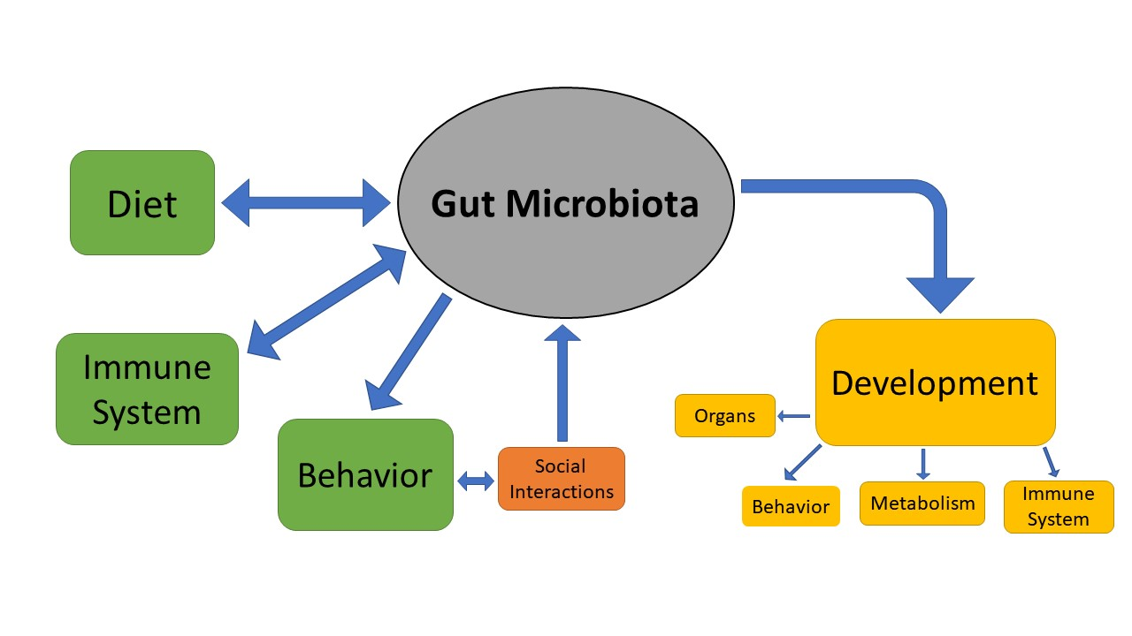

**Figure 3. An overview of the influence of the gut microbiota on host traits**The directional influences of the gut microbiota on fitness-associated traits of an individual.  
The gut microbiota has a bidirectional relationship with diet and the immune system. It influences behavior, and behavior directs social interactions. Social interactions facilitate the transmission of gut microbiome species. Development is affected by the gut microbiota, which is responsible for organ development (i.e. the brain), behavior, metabolism, and immune system development.

The gut microbiota is shown to influence the various traits (Fig. 3), that have significant influence on the fitness of an individual. Adjusting the environment and diet of captive individuals, and thereby their gut microbiota, is expected to improve their fitness, both when in captivity and upon reintroduction. An alternative or additional avenue may be the routine administration of wild-specific probiotics to captive individuals, but more research is required to determine the effects of probiotic administration upon health and fitness, as well as other methods relating to the gut microbiota that may be implemented (i.e. returning to a more natural diet) to improve the fitness and survival rates of those in captivity and reintroduced into the wild.

The aim of this paper was to determine if the gut microbiota played a role in animal fitness in the transition from captivity to their release into the wild. It was determined that there is a trend between altered alpha- and beta-diversity and captivity. The gut microbiota was found to have bidirectional effects with diet, and diet was determined to play a role in maintaining health of the host. Behavior was found to be altered as a by-product of gut microbiota mechanisms, and the immune system was found to influenced by the gut microbiota as well. Additionally, all of these factors were found to be influenced by the gut microbiota during the developmental phase of the host’s life.

**IX. Future Directions and Conclusion**

With the rapid declination of biodiversity (Butchart et al. 2010), conservation programs for the reestablishment of endangered species must become prioritized. In particular, reintroduction and captive-breeding programs should continue to be focused on in addition to habitat restoration and protection; however, the recent realization of the importance of the gut microbiota on host fitness needs to fully adapted under the scope of these programs. This review found that while gut microbiota diversity was impacted by captivity, those effects were species-specific. Assuming limited funding, research should be developed around the species of highest concern first (IUCN categories “extinct in the wild,” “critically endangered,” and “endangered,” respectively) in order to determine how the gut microbiota and the host’s fitness are impacted by captivity. The results can dictate the direction of further research and of future captive-breeding management. It is likely that these captive species will benefit from the administration of species-specific probiotics alongside the consumption of the most natural-type diet possible (Mayer et al. 2015; Clayton et al. 2016). To test this, research can be done on captive individuals within different species. Individuals in reintroduction programs should be fed various sensible diets, and their fitness should be tracked upon release (i.e. via monitoring health, behavior, acquisition of food, reproduction, assimilation to social groups, lifespan, etc.) in order to determine if a preferential diet emerges. The same can be performed with probiotic administration (coupled with decreased [unless necessary] antibiotic administration). If funding and resources are too limited for this proposal, then performing these same dietary, health, and behavioral tests *in situ* (e.g., zoos) is also beneficial. Any knowledge gained within the scope of this field that may increase the survival rate of reintroduced individuals in the wild can in some extent be applied to conservation programs globally.

**X. References**

Acevedo-Whitehouse K. and A.L.J. Duffus. 2009. Effects of environmental change on wildlife health. Philos Trans R Soc Lond B Biol Sci 364:3429–38.

Archie E.A. and J. Tung. 2015. Social behavior and the microbiome. Curr Opin Behav Sci 6:28–34.

Belant J., D. Biggins, D. Garelle, R.G. Griebel, and J.P. Hughes. 2018. Mustela nigripes. The IUCN Red List of Threatened Species. International Union for Conservation of Nature - IUCN.

Bendtsen K.M.B., L. Krych, D.B. Sørensen, W. Pang, D.S. Nielsen, K. Josefsen, L.H. Hansen, et al. 2012. Gut microbiota composition is correlated to grid floor induced stress and behavior in the BALB/c mouse. PLoS One 7:e46231.

Brickner K.M., M.B. Grenier, A.E. Crosier, and J.N. Pauli. 2014. Foraging plasticity in a highly specialized carnivore, the endangered black-footed ferret. Biol Conserv 169:1–5.

Butchart S.H.M., M. Walpole, B. Collen, A. van Strien, J.P.W. Scharlemann, R.E.A. Almond, J.E.M. Baillie, et al. 2010a. Global biodiversity: indicators of recent declines. Science 328:1164–8.

Clayton J.B., P. Vangay, H. Huang, T. Ward, B.M. Hillmann, G.A. Al-Ghalith, D.A. Travis, et al. 2016. Captivity humanizes the primate microbiome. Proc Natl Acad Sci U S A 113:10376–81.

Deem S.L., W.B. Karesh, and W. Weisman. 2008. Putting Theory into Practice: Wildlife Health in Conservation. Conserv Biol 15:1224–1233.

Dekinga A., M.W. Dietz, A. Koolhaas, and T. Piersma. 2001. Time course and reversibility of changes in the gizzards of red knots alternately eating hard and soft food. J Exp Biol 204.

Desbonnet L., G. Clarke, F. Shanahan, T.G. Dinan, and J.F. Cryan. 2014. Microbiota is essential for social development in the mouse. Mol Psychiatry 19:146–148.

Edie S.M., S. Huang, K.S. Collins, K. Roy, and D. Jablonski. 2018. Loss of Biodiversity Dimensions through Shifting Climates and Ancient Mass Extinctions. Integr Comp Biol.

Fraser D.J. 2008. How well can captive breeding programs conserve biodiversity? A review of salmonids. Evol Appl 1:535–86.

Grimm V. and S.F. Railsback. 2004. *Individual-based Modeling and Ecology*.

Heijtz D.R., S. Wang, F. Anuar, Y. Qian, B. Björkholm, A. Samuelsson, M.L. Hibberd, et al. 2011. Normal gut microbiota modulates brain development and behavior. Proc Natl Acad Sci U S A 108:3047–52.

Hoban A.E., R.M. Stilling, G. Moloney, F. Shanahan, T.G. Dinan, G. Clarke, and J.F. Cryan. 2018. The microbiome regulates amygdala-dependent fear recall. Mol Psychiatry 23:1134–1144.

Johnson K.V.-A. and K.R. Foster. 2018. Why does the microbiome affect behaviour? Nat Rev Microbiol 16:647–655.

Jule K.R., L.A. Leaver, and S.E.G. Lea. 2008. The effects of captive experience on reintroduction survival in carnivores: A review and analysis. Biol Conserv 141:355–363.

Kohl K.D., M.M. Skopec, and M.D. Dearing. 2014. Captivity results in disparate loss of gut microbial diversity in closely related hosts 2.

Levey D.J. and W.H. Karasov. 1989. Digestive responses of temperate birds switched to fruit or insect diets. Auk.

Ley R.E., M. Hamady, C. Lozupone, P.J. Turnbaugh, R.R. Ramey, J.S. Bircher, M.L. Schlegel, et al. 2008. Evolution of Mammals and Their Gut Microbes. Science 320:1647–1651.

Macke E., A. Tasiemski, F. Massol, M. Callens, and E. Decaestecker. 2017. Life history and eco-evolutionary dynamics in light of the gut microbiota. Oikos 126:508–531.

Martin L.B., L. Kidd, A.L. Liebl, and C.A.C. Coon. 2011. Captivity induces hyper-inflammation in the house sparrow (Passer domesticus). J Exp Biol 214:2579–2585.

Maslowski K.M. and C.R. Mackay. 2011. Diet, gut microbiota and immune responses. Nat Immunol 12:5–9.

Mayer E.A., K. Tillisch, and A. Gupta. 2015a. Gut/brain axis and the microbiota. J Clin Invest 125:926–38.

McGlynn T.P. 2010. How Does Social Behavior Evolve? Nat Educ.

McKenzie V.J., S.J. Song, F. Delsuc, T.L. Prest, A.M. Oliverio, T.M. Korpita, A. Alexiev, et al. 2017. The Effects of Captivity on the Mammalian Gut Microbiome. Integr Comp Biol 57:690–704.

McRae L., R. Freeman, and V. Marconi. 2016. Living Planet Report 2016: Risk and resilience in a new era. WWF International.

Metcalf J.L., S.J. Song, J.T. Morton, S. Weiss, A. Seguin-Orlando, F. Joly, C. Feh, et al. 2017. Evaluating the impact of domestication and captivity on the horse gut microbiome. Sci Rep 7:15497.

Naeem S., D.E. Bunker, A. Hector, M. Loreau, and C. Perrings. 2009. Biodiversity, Ecosystem Functioning, and Human Wellbeing. Oxford University Press.

Nelson T.M., T.L. Rogers, A.R. Carlini, and M. V. Brown. 2013. Diet and phylogeny shape the gut microbiota of Antarctic seals: a comparison of wild and captive animals. Environ Microbiol 15:1132–1145.

Neufeld K.-A.M., N. Kang, J. Bienenstock, and J.A. Foster. 2011. Effects of intestinal microbiota on anxiety-like behavior. Commun Integr Biol 4:492–494.

Philip V., J. Lu, H.J. Galipeau, E.F. Verdu, K.D. McCoy, P. Langella, A.J. Macpherson, et al. 2015. The role of immune system maturation in gut-microbiota-brain axis communication. Brain Behav Immun 49:e36–e37.

Price M.R.S. and P.S. Soorae. 2003. Reintroductions: whence and whither? Int Zoo Yearb 38:61–75.

Proctor C., P. Thiennimitr, N. Chattipakorn, and S.C. Chattipakorn. 2017. Diet, gut microbiota and cognition. Metab Brain Dis 32:1–17.

Rosshart S.P., B.G. Vassallo, D. Angeletti, D.S. Hutchinson, A.P. Morgan, K. Takeda, H.D. Hickman, et al. 2017. Wild Mouse Gut Microbiota Promotes Host Fitness and Improves Disease Resistance. Cell 171:1015–1028.e13.

Shapira M. 2016. Gut Microbiotas and Host Evolution: Scaling Up Symbiosis. Trends Ecol Evol 31:539–549.

Singh P.K., R.S. Chauhan, and P. Singh. 2017. Biodiversity and Its Conservation. Pp. 315–340 in Princ Appl Environ Biotechnol a Sustain Futur. Springer Singapore, Singapore.

Snyder N.F.R., S.R. Derrickson, S.R. Beissinger, J.W. Wiley, T.B. Smith, W.D. Toone, and B. Miller. 1996. Limitations of Captive Breeding in Endangered Species Recovery. Conserv Biol 10:338–348.

Sommer F. and F. Bäckhed. 2013. The gut microbiota-Masters of host development and physiology. Artic Nat Rev Microbiol.

Song S.J., C. Lauber, E.K. Costello, C.A. Lozupone, G. Humphrey, D. Berg-Lyons, J.G. Caporaso, et al. 2013. Cohabiting family members share microbiota with one another and with their dogs. Elife 2:e00458.

Takahashi A., M.E. Flanigan, B.S. McEwen, and S.J. Russo. 2018. Aggression, Social Stress, and the Immune System in Humans and Animal Models. Front Behav Neurosci 12:56.

Tung J., L.B. Barreiro, M.B. Burns, J.-C. Grenier, J. Lynch, L.E. Grieneisen, J. Altmann, et al. 2015. Social networks predict gut microbiome composition in wild baboons. Elife 4.

Universidad de Sevilla. Departamento de Biología Vegetal y Ecología, C.M. Romero Zarco, A. Carapeto, C. Pinto Cruz, P.G. García Murillo, S. Ríos Ruiz, and P. Fraga i Arquimbau. 2018. Juncus fernandez-carvajaliae. The IUCN Red List of Threatened Species 2018. International Union for Conservation of Nature - IUCN.

Williams S.E. and E.A. Hoffman. 2009. Minimizing genetic adaptation in captive breeding programs: A review. Biol Conserv 142:2388–2400.

Xie Y., P. Xia, H. Wang, H. Yu, J.P. Giesy, Y. Zhang, M.A. Mora, et al. 2016. Effects of captivity and artificial breeding on microbiota in feces of the red-crowned crane (Grus japonensis). Sci Rep 6:33350.