Author: Romy Schaake
5-1-2015
Researchgroup and supervisor: Behavioural Physiology, Jocelien Olivier

Is there one critical period for stress during pregnancy?
A literature update
Source: http://post.jagran.com/search/prenatal-anaemia

Abstract

Emotional state and behavior of the mother may affect the child she is carrying. Nowadays, a major risk factor is stress, high levels of stress are experienced by more than a quarter of the pregnant woman during pregnancy. The main goal of this report was to investigate whether there is a specific critical period for stress during pregnancy. To answer this question, findings of existing literature have been summarized. The focus was on behavioral- and biochemical effects, in specific time periods in the gestation of rodents. This report showed that prenatal stress, mostly performed during the last week of gestation, can cause multiple changes in anxiety-and depression-like behavior, HPA axis activity, sleep wake cycle and in several neurotransmitter systems.
Changes in various systems are also observed after postnatal stress, mostly performed from PND 2-14 (this timescale may vary). This may lead to alterations in anxiety-and depression-like behavior, sleep disturbances, HPA axis activity, NPY level, NGF expression and to changes in neurotransmitter systems. Taken together prenatal and postnatal stress can both cause behavioral and biochemical changes in rodents. However, it should be noted that there possibly are effects of the mother which influence the results of these stress experiments. Prenatal stress may have an effect on the maternal behavior of the dam and postnatal stress may influence the amount of maternal care.
When investigating the period of stress exposure, this report showed that there is not only one specific period in pregnancy where the fetus is vulnerable to stress. Every system in the brain has its own specific period of maximum development, therefore there is a specific period in brain development where a system is more vulnerable. This varies between the systems and depends on the specific development of the system itself.
Table of contents
Abstract 1
Introduction 3
Prenatal maternal stress 5
Prenatal maternal stress – the experimental models 5
Behavioral findings 6
Biochemical findings 8
Postnatal stress 12
Postnatal stress – the experimental models 12
Behavioral findings 13
Biochemical findings 14
Effects of maternal behavior 18
Postnatal stress - Maternal separation 19
Conclusion and discussion 20
References 22

Introduction

A growing body of scientific literature of epidemiological and animal studies suggests that besides genetic factors, environmental events acting prenatally on the developing fetus are important determinants for disorders later in life (Huizink et al, 2004). Due to the fact that these disorders are often long-lasting even until adulthood, this phenomenon has been denoted as ‘fetal programming’ (Merlot et al, 2008).
Emotional state and behavior of the mother may affect the child she is carrying, this idea was already common in early historic times. In 1862 in a report about the possible causes of mental deficiencies they spoke about maternal impression (Ferreira, 1965). Maternal impression is the belief that a powerful mental or physical factor, influencing the mother may have its effects on the child she is carrying. This led to further research about multiple influences which could affect the unborn child.
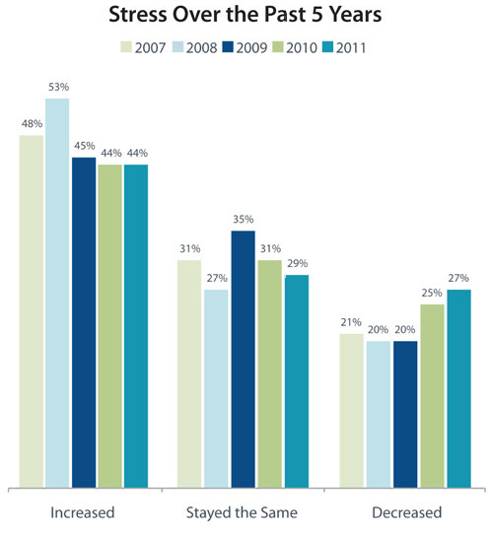
Thus, maternal adversity affects the developing child and one of the most investigated factors related to this adversity is stress. Stress plays a major role in current society. Common causes of stress involve money, work, the (socio)economic status or a relationship (The American Psychological Association). The age group experiencing the highest level of stress is the group aged from 18 to 33 years. The American Psychological Association investigated whether the stress level of people in America has increased, decreased or stayed about the same over the years 2007 till 2011. As shown in figure 1, most of the people experienced more stress than the year before. In addition, 53% of the Americans reported personal health problems caused by stress.
Figure 1. Stress level in daily life. When asked the question: thinking about the past 5 years, would you say the level of stress in your life has increased, decreased or has it stayed about the same over time?
Source: The American Psychological Association

In the group aged 20-33 year people experience the highest levels of stress (New health guide, 2014). This is the age group were most woman get pregnant, so stress during pregnancy is a common phenomenon. When experiencing stress (physical, psychological or environmental) the regular stress response of the body is activated. At first, the hypothalamus produces corticotrophin releasing hormone (CRH). This stimulates the production and release of the adrenocorticotropic
hormone (ACTH) from the anterior pituitary. ACTH can enter the blood circulation which leads to the release of glucocorticoids (corticosterone in rodents, cortisol in primates) from the adrenal cortex (figure 2). As a result of the increased glucocorticoid levels, the hypothalamus responds by reducing CRH levels in the hypothalamus, a so called negative feedback system. Together, these interactions are called the hypothalamic-pituitary-adrenal (HPA) axis.
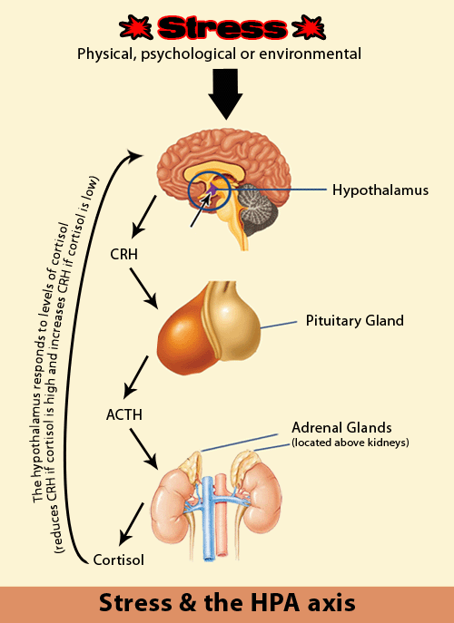

Figure 2. The specific interactions of the stress response, via the hypothalamic-pituitary-adrenal (HPA) axis. Source: http://total-body-psychology.com.au/stress-response-hpa-axis/

The bureau of Vital records and health statics revealed that more than a quarter of the pregnant woman experience high levels of stress during pregnancy. This leads to changes in the mother but also to several changes in the unborn child. Research indicated that prenatal stress in humans is a significant risk factor for adverse birth outcomes, such as low birth weight and prematurity ( March of dimes, 2010).
In addition, prenatal stress and stress during early childhood may also lead to the development of human psychopathologies later in life. For example, prenatal stress may be a potential risk factor for the development of depression, schizophrenia or anxiety disorders (Huizink et al, 2004).
Prenatal stress in humans can cause long-term changes in the offspring. Although several studies have tried to elucidate the underlying mechanisms, they remain elusive. To answer important questions about the effects and underlying mechanisms of stress during pregnancy and early childhood animal models are of great value. As such, effects of prenatal stress have been investigated in several animal models. The developing rat brain closely resembles that of the human, especially in the early embryonic stages (Bayer et al, 1993). For example, various brain regions (such as parts of the hypothalamus, the hippocampus, and amygdala) of rats are developed in the last part of the second week (days 12 and 13) and in the last week of gestation (days 14-21). Similar structures are developed in the first trimester of human pregnancy (weeks 4-14). But there is an important difference in fetal brain development during pregnancy between rodents and humans. There are neuronal systems that are present at birth in the human (such as the dentate granule cells of the hippocampus) while in rodents they continue to develop for several days or weeks after birth (Clancy et al, 2001). To investigate the effects of stress during the latest stages of human fetal development several postnatal stress paradigms have been developed, a.o. maternal separation, in rodents. Results of such experiments can possibly be translated to the human situation where stress during late stage of pregnancy and early childhood has taken place.
In this essay an overview is given about the effects of prenatal and postnatal stress in die offspring of rodents. The aim of this report is to define the most critical period during pregnancy in which stress affects the offspring the most. The main focus of this report is on behavioral-and biochemical findings.

Prenatal maternal stress

Prenatal stress (PS), either physical or emotional, experienced by a mother during pregnancy, may have significant consequences for the developing fetus (Huizink et al, 2004). Stress during pregnancy may result in lasting biochemical changes and has lasting effects on the infant’s behavior (Pechtel et al, 2011). In humans, prenatal stress has been associated with the development of various cognitive and affective disorders, such as anxiety and depression (Weinstock, 2001; Huizink et al, 2004; Mulder et al, 2002). Prenatal maternal stress is also used in animal experimentation to investigate the various effects on the offspring, and underlying mechanisms. In this part of the report, the model of prenatal stress will be further explained, as well as the results of prenatal stress experiments on rodents, divided in behavioral findings and biochemical findings.

Prenatal maternal stress – the experimental models
The main principle of this experimental model is the exposure of an expectant mother to distress. There are three main mechanisms which may be involved in transducing stress from the mother to the fetus (Huizink et al, 2004). The first is the trans-placental transport of maternal stress hormones to the fetus. Maternal stress is associated with increased secretion of corticosterone (the main glucocorticoid hormone in rodents) in the dam. Corticosterone is able to cross the placental and blood-brain barriers. Direct evidence is provided by Barbazanges et al (1996) who compared offspring of prenatally stressed mothers with offspring of prenatally stressed mothers with blocked corticosterone secretion. The offspring of the intact animals showed prolonged stress-induced secretion of corticosterone and a decrease in hippocampal type I corticosteroid receptors. These results were not present in the offspring of the mothers without corticosterone secretion. The second mechanism for transduction is the maternal stress-induced release of placental hormones that enter the fetal circulation. Maternal stress may stimulate the production of CRH and related stress hormones by placental cells. But this mechanism has been found only in primates.
The third mechanism of transduction is the maternal stress-induced effects on the blood flow to the placenta. Maternal stress may reduce utero-placental blood flow because cortisol and catecholamines are known to affect vessel tone. Therefore stress in the pregnant mother can reduce blood flow through the placenta via the activation of the sympathetic nervous system (Huizink et al, 2004).
When performing prenatal maternal stress experiments, the dams are exposed to a stressor mostly during the last week of pregnancy. But the timeframe of the exposure varies between studies. Moreover, several types of stressors are used. For example, Yang et al. (2006) used daily 10 food shocks (1 s, 0.8 mA, 2–3 min intershock intervals) in a Skinner box to evoke behavioral stress. However, the most commonly used stressor is restraint stress. Using this type of stressor, pregnant females are placed individually in a plastic transparent restrainer fitted closely to body size. In most protocols this stressor is used 3 times a day for 45-minutes but this also varies between studies. Restraint sessions are usually performed in a lighted environment. Restraint stress is often used because it has an indirect influence on the fetus via a direct stress on the mother. The restraint stress procedure was already described by Ward and Weisz in 1984 (Ward and Weisz, 1984).
The offspring of distressed mothers is mostly weaned at postnatal day (PND) 21. In every study the inclusion criteria of the offspring needs to be determined. For example, some studies only use male offspring, others use both female and male offspring. Moreover, to minimalize the effects of litter, experimenters only use litters with comparable numbers of females and males. The offspring can be tested for various parameters at specific defined ages. Most experiments are performed at the age of 12 weeks.

Behavioral findings
Results from animal studies have shown that the behavior of the adult offspring can be altered by prenatal maternal stress. Several studies showed that prenatal maternal stress has an effect on anxiety-like behavior of the offspring. As shown in figure 3, offspring of prenatally stressed rats spent significantly less time on the open arms of the elevated plus-maze test (Pellow et al, 1985). In this experiment the dams were submitted to a restraint stress during the last week of pregnancy (Vallee et al, 1997). They also used a group of early handled rats as a second control group. In this group, the neonatal rats experienced a separation from their mother for a brief period of time (15 minutes). As seen in figure 3 this has a positive influence on their score on the elevated plus maze. They spent significantly more time on the open arms compared to the control and PS rats.

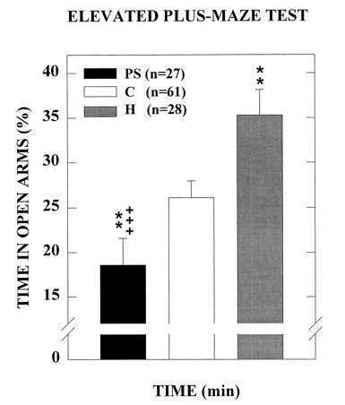
Figure 3
Results of the elevated plus-maze test. Percentage of time spent on the open arms measured in the elevated plus-maze over the 10 minutes test. Prenatally stressed rats had a lower percentage spent on the open arms compared to the control group (Vallee et al, 1997).
In the study of Vallee et al (1997) all experiments were performed with prenatally stressed male rats. Van den Hove et al (2013) had the same kind of results using the elevated plus maze on prenatally stressed rats. They also used restraint stress, which was performed daily during the last week of pregnancy (gestation day 14-21). This resulted in a significantly lower amount of time spent on the open arms when testing male adult rats. But when testing female rats this led to no difference between the prenatally stressed group and the control group. This research group also tested the anxiety-like behavior in the home cage emergence (HCE) test. This resulted in a significant difference between the male PS-and control group. The male PS group had a significantly higher escape latency time; a higher escape latency time stands for more anxiety-like behavior (Van den Hove et al, 2013). This pattern is also seen between the female groups (PS and control) but does not reach statistical significance.

As mentioned before, prenatal stress in humans has been associated with the development of disorders as depression. Depression-like behavior can also be tested in animals; signs of behavioral despair or anhedonia have been described in rodents.
Basta-Kaim et al (2014) used a two-bottled sucrose preference test (D’Aquila et al, 1997) to assess the anhedonic behavior in rats. The dams were subjected to daily restraint stress from the 14th day of pregnancy until the delivery. They showed that prenatally stressed offspring have a significant lower sucrose preference (figure 4). Low sucrose preference is a putative indicator of anhedonia in rodents. Anhedonia is the inability to experience pleasure from activities usually found enjoyable (such as sucrose for rodents).
Van den Hove et al(2013) performed the sucrose preference test in the offspring exposed to prenatal stress (restraint stress, gestation day 14-21). They did not find any significant difference between the PS and the control group in either sex.

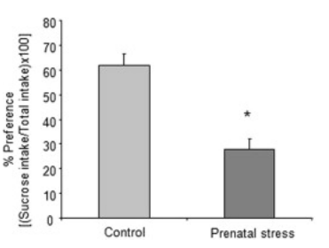

Figure 4
The effect of prenatal stress on the sucrose intake of rats. Results are expressed as % of preference ([sucrose intake/total intake) x 100]) (Basta-Kaim et al, 2014)

Prenatally stressed rats are also tested on their behavioral despair. One of these depression tests is the forced swim test (Porsolt et al, 1977), this test is being used to test behavioral despair in rodents. When testing the immobility and strong mobility of prenatally stressed rats (restraint stress, gestation day 14-21) no significant difference in immobility is seen between PS and control group in either sex (Van den hove, 2013). In contrast, research of Morley-Fletcher et al (2013) who used PS (restraint stress, gestation day 14-21) rats and performed the same forced swim test, significantly higher immobility time was seen (figure 5). Related to this, the duration of swimming behavior of the PS rats was decreased. Climbing behavior was not affected (Morley-Fletcher et al, 2013).
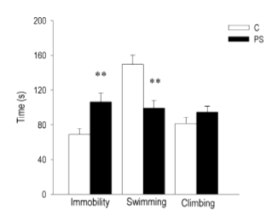
Frye et al (2003) studied the differences between the results of male and female rats on a forced swim test. Prenatally stressed (restraint stress, prenatal day 18) female rats struggled more and spent significantly more time immobile, compared to prenatally stressed male rats.

Figure 5
The effects of prenatal stress in the forced swim test. Testing the immobility, swimming and climbing behavior. (Fletcher et al, 2013)

A strong marker of human depression is an altered sleep-wake cycle. Prenatal restraint stress during the last week of the pregnancy resulted in changes in both the structure and the continuity of sleep in the adult offspring (van Reeth et al, 1999). Prenatally stressed rats showed a significant increase in total time spent in REM sleep, during both the light and dark phases. The increase in time spent in REM sleep was due to an increase in the number of REM, this is also seen in depressed human patients. In addition, prenatally stressed rats showed an increase in total light slow wave sleep time that was restricted to the dark phase (van Reeth et al, 1999).

Biochemical findings
Researchers discovered multiple behavioral changes after performing prenatal maternal stress, as discussed above. This led to the research into the mechanisms leading to these behavioural changes. Prenatal maternal stress leads to several biochemical changes in the brain of the offspring.
The hypothalamic–pituitary–adrenal (HPA) axis has been shown to be affected by prenatal restraint stress. Research of Weinstock et al (1998) have shown higher levels of circulating glucocorticoids under baseline conditions in adult rodents that were exposed to stress in utero. In this study dams were exposed to noise and light stress, three times per week on an unpredictable basis throughout gestation. But also the stress response of the parentally stressed rats is changed as seen in the secretion of corticosterone and ACTH between prenatally stressed rats of 4 months old (restraint stress, last week of gestation) and control rats (Maccari et al, 2003). Both graphs in figure 6 represent the time-course of secretion at different times following a 30 minute restraint stress on the prenatally stressed adult offspring group (PNRS) and the control group. Prenatally stressed rats show a tendency to have a prolonged ACTH secretion after stress. In line with this, the secretion of corticosterone after stress is significantly increased at T75 and T120 minutes in prenatally stressed rats. This increase in corticoterone secretion after stress is seen in several other studies (Barbazanges et al, 1996; Takahashi et al, 1988).
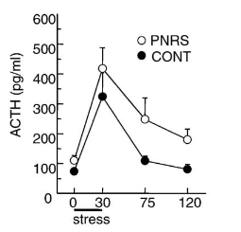

Figure 6. On the left the ACTH secretion of the parentally restraint stressed group (PNRS) and the control group after a stressor. On the right the corticosterone secretion in controle and PNRS animals. (Maccari et al, 2003).

Thus, elevated levels of maternal glucocorticoids during development lead to the observed effects on the offspring’s HPA axis. One of the mechanisms behind this may be the fact that high glucocorticoid levels during development alter de HPA axis development by down regulation of hippocampal corticosteroid receptors of the fetus. The corticosteroid receptors are fully expressed during the last week of gestation (Meaney et al, 1988), so when performing the prenatal maternal stress procedure those receptors are already expressed and will be affected by the stress. Research of Maccari et al (2003) investigated the expression of the hippocampal type I corticosteroid receptor. They showed that, at 90 days, the PNRS (restraint stress, last week of gestation) group had a significant decrease in type I corticosteroid receptor expression in the hippocampus, compared to control. These data confirm that high glucocorticoid levels, experienced during development of the fetus, alter the HPA axis by down regulation of hippocampal type I corticosteroid receptors.

Other effects of prenatal stress on the development of the fetal brain is investigated. For example, Insulin-like growth factor-1 (IGF-1) andd its binding proteins. IGF-1 plays a role in neurogenesis (Llorens-Martin et al, 2009) and gliogenesis (Russo et al, 2005), myelination and synaptic formation. Previous research has shown that IGF-1 binding proteins participate in embryogenesis and brain development. Basta-Kaim and colleagues (2014) performed prenatal restraint stress during day 14 till the end of the gestation. Prenatally stressed adult male rats showed a significant decrease in the IGF-1 protein concentration in the hippocampus (Hp) and in the frontal cortex (FCx) compared to the unstressed controls. Moreover, alterations in IGF-1 binding protein family (IGFBP) were found. Significant decreased IGFBP-2 concentration and significant increased IGFBP-4 concentration in the Hp and PCx of adult PS males were found (see figure 7). The alterations found in the IGF-1 binding protein network may be responsible for the decrease in IGF-1 concentration in the Hp and PCx. IGFBP-2 regulates IGFs’ degradation and prolongs its half-life, the decrease in IGFBP-2 may shorten IGF-2s’ half-life and stimulates its degradation leading to an IGF-1 down regulation (Russo et al, 2005). Basta-kaim speculated in his research about the fact that hormones as glucocorticoids may be capable of regulating IGFBP-2 brain expression. Therefore the elevated level of glucocorticoids seen in prenatally stressed rats may be one of the causes of the disturbance in the IGFBP-2 level which is seen. Figure 7 also shows an increase in IGFBP-4 concentration in both brain areas. IGFBP-4 regulates growth and development of tissues by negatively regulating IGF-1 signaling. This regulation is required for normal balance between IGFBP-4 and IGF-1 in the brain and is essential for normal brain growth and development (Russo et al, 2005). Therefore it may be hypothesized that the elevated IGFBP-4 concentrations after prenatal stress in part explain the decrease of IGF-1.
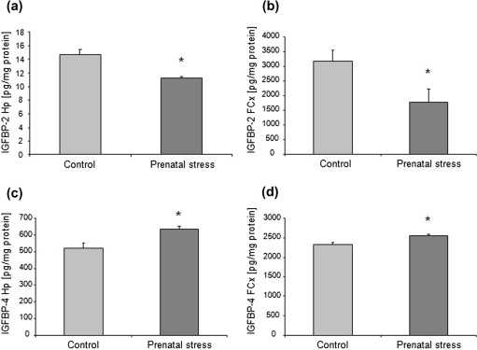

Figure 7.
The effect of prenatal stress on the level of IGFBP-2 (figure ?a-b), there is a significant decrease in IGFBP-2 in the hippocampus (Hp) and frontal cortex (FCx). And the effects of prenatal stress on the level of IGBP-4 (figure ?c-d), there is a significant increase in IGFBP-4 in the HP and FCx (Basta-Kaim et al, 2014)

Several studies have been done to investigate the effects of prenatal stress on the brains’ neurotransmitter systems.
There is a close relationship between the regulation of the HPA axis and serotonin (5-HT). 5-HT is also an important factor in early brain development; it plays a role in synapse formation and maintenance (Hayashi et al, 1998). Peters (1986) performed a prenatal stress experiment to investigate its effects on 5-HT levels in the fetal brain. Dams were stressed by treatment of one daily removal of the cage to another laboratory where they received a single saline injection (0.1 ml SC). This was done from day 4 of gestation until birth of the litter. This resulted in a significant increase of tryptophan in plasma, and therefore the amount of tryptophan available in the fetal brain of prenatally stressed rats compared to control. Tryptophan is the precursor to 5-HT, indicating that the levels of 5-HT were also elevated in the fetal brain. These changes are associated with the decrease in 5-HT receptors in the brain of adult prenatally stressed rats (Peters, 1986). Because it is known that serotonin plays a role in neuronal development (Hayashi et al, 1998) during the perinatal period, the stress-induces increase in 5-HT in the fetal brain may be one of the mechanisms by which prenatal stress can cause behavioral changes.

Huizink et al (2004) mentioned that maternal stress during gestation leads to a change in cerebral lateralization of dopaminergic activity and this increases the risk for depression and anxiety in the offspring. Exposure to restraint prenatal stress during the last week of gestation leads to a decrease in Dopamine-3 (D3) receptors in the core and shell of the nucleus accumbens (Henry et al, 1995). Research of Mcnamara et al (2002) suggested that a decrease in D3 receptor activity may account for the dysregulation in dopamine-mediated behaviors such as the increase in depression-like behaviors.

Stress leads in normal situation to an increase of acetylcholine in the hippocampus (Imperato et al, 1991). Adult prenatally stressed (restraint stress, gestation day 14-21) rats had a higher increase in hippocampal acetylcholine as a response on a mild stress (saline injections) compared to controls.
And in males during the first hour after injection, the CRF-induced increase in hippocampal acetylcholine release was larger in prenatally stressed rats compared to controls. In females this effect was seen during the third hour after the saline injection. These results indicate that prenatal stress has long-term effects on the development of the cholinergic systems (Day et al, 1998).

Altogether, the studies described indicate that prenatal maternal stress has an effect on fetal brain development, resulting in for example alterations in HPA axis activity, insulin-like growth factor and several neurotransmitter systems. Because of the alterations during fetal brain development several behavioral changes are seen. All the prenatal stress experiments and results described in this report are summarized in table 1.
Prenatal stress experiments do not cover the entire human fetal brain development. When trying to mimic the latest stages of human fetal development and early childhood, postnatal stress experiments in rodents are more appropriate, therefore experiments with postnatal test will be described in the next section.

Prenatal stress
Time period | Stressor | Protocol | Results
Last week of pregnancy | Restraint stress | 3 x 45 minutes restraint stress | ↑ anxiety-like behaviour ^{53,55}
14th day of gestation till delivery. | Restraint stress | 3 x 45 minutes restraint stress | Anhedonia signs^{3,55}  (⁵⁵, did not find significant results)
Gestation day 14-21 | Restraint stress | 3 x 45 minutes restraint stress | ↑ behavioral despair ³⁶  (⁵⁵, did not find significant results. ¹³, ♀ more behavioral despair compared to ♂)
Last week of pregnancy | Restraint stress | 3 x 45 minutes restraint stress | Disruption of sleep-wake cycle⁵⁴
Throughout gestation | Noise & light stress | 3 times weekly on a unpredictable basis | ↓ Basal levels circulating glucocorticoids⁵⁷
Gestation day 14-21 | Restraint stress | 3 x 45 minutes restraint stress | ↑ HPA axis activity as response on stress^{28,2,47}
Gestation day 14-21 | Restraint stress | 3 x 45 minutes restraint stress | ↓ Type I hippocampal corticosteroid receptor²⁸
Gestation day 14-21 | Restraint stress | 3 x 45 minutes restraint stress | ↓ IGF-1 protein concentration. And alterations in IGFBP³
Gestation day 4-21 | Cage removal and saline injections. | Once a day | ↑ Tryptophan in plasma/ ↑ 5-HT⁴¹
Gestation day 14-21 | Restraint stress | 3 x 45 minutes restraint stress | ↓ D3 receptor in nucleus Accumbens ¹⁶
Gestation day 14-21 | Restraint stress | 3 x 45 minutes restraint stress | ↑ increase in hippocampal acetylcholine (as response to stress)¹¹
Table 1. Summary results of prenatal stress experiments. All the experiments are performed in rats.

Postnatal stress

Adverse childhood experience in humans is considered to be of the major risk factors for the development of psychopathology (Tata, 2012). In humans early life stress such as childhood abuse, neglect and loss of a family member may also be a major risk factor for developing disorders as depression later in life (Heim et al, 2012). Research into the effects and underlying mechanisms of early life stress is important. Human brain development during the last trimester is comparable to brain development of rodents during the first weeks after birth (Bayer et al, 1993). In rodents, during the postnatal period, the rat brain is still developing. Including dendritic development, neurogenesis and apoptosis of the hippocampal granule cells which is at the maximum at postnatal days 5 to 7. Synaptogenesis is at the maximum at postnatal days 4-11 and ends at postnatal day 21, where in humans it ends at the age of 4 years. The HPA axis is also undergoing development during the postnatal period (Huot et al, 2000). Together, this indicates that postnatal stress in rodents may lead to changes in the development and can cause long-lasting biochemical and behavioral alterations.
In this paragraph the model of postnatal stress will be furtherly explained, as well as the results of postnatal stress experiments in rodents. The results are divided in behavioral findings and biochemical findings. In this report the focus is on rodent data. Results of postnatal stress experiments in rodents could possibly be translated into the effects of stress during the last trimester of the pregnancy or/and stress during early childhood.

Postnatal stress – the experimental models
There are two common paradigms of postnatal stress in rodents. The first one is maternal separation (MS), were the pups are separated from their mother for a short period of time. This period can differ between experiments. There are experiments which use 1 hour per session, 3 to 6 hours per session (Huot et al, 2002) and there are even cases of one single 24-hour separation. This separation is done during the first 1-3 weeks after birth, but also this timeframe may differ between experiments. The second model for postnatal stress is the early deprivation (ED). This model refers to the separation of pups from their mother and littermates, meaning they are being socially isolated. During MS the pups are not being socially isolated because they are separated from the dam with the whole litter instead of being totally socially isolated during ED. The period of separation is comparable to those used in MS (McCormick et al, 1998).
Because pups are completely depended on their mother during the first three weeks, experiments as MS and ED are considered to be extremely stressful. Evidence for this is given by Daniels et al (2009), who showed that MS pups have a significant higher plasma levels of corticosterone compared to control pups, measured on postnatal day 21 (figure 8). Early deprivation also resulted in an elevation of corticosterone levels in their plasma on postnatal day 21(McCormick et al, 1998).

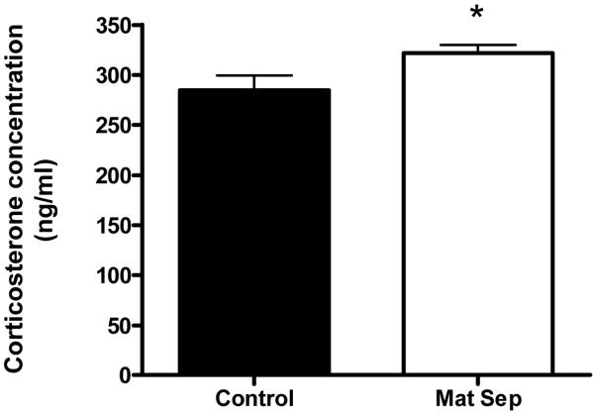
Figure 8. Corticosterone concentration of control and maternal separation group, measured on postnatal day 21. (McCormick et al, 1998)

Behavioral findings
On the behavioral level, several studies have been performed to investigate the effects of postnatal stress on anxiety levels in rodents. Daniels et al (2004) performed a maternal separation experiments on rats. The MS protocol was performed for 3 hours daily from PND 2-14, and on PND 60 anxiety on the elevated plus maze was tested (Pellow et al, 1985). A significant difference between maternal separated and control rats with respect to the number of entries to the two arms was found. Maternally separated rats entered the open arm and the closed arm significantly less than controls (figure 9). In this study they did not test whether the groups differed in activity on the elevated plus maze. They did investigate the amount of freezing behavior during the test, which was similar in both groups.
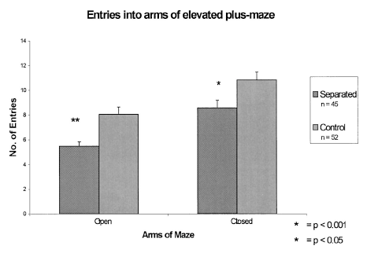
Figure 9. The differences in the number of entries into the open and closed arms between maternally separated and control animals.
In line with this, Salzberg et al (2007) showed that maternal separation leads to changes in anxiety-like behavior. They separated rats daily from postnatal days 2-14 for 180 minutes, as a control they used an early handling group. The early handled rats were separated from their mothers for daily sessions of 15 minutes. The rats were tested on the elevated plus maze when they were 7 weeks old. Both male and female maternally stressed rats showed a reduction of time spent on the open arms compared to the early handled group.
Interestingly, not all studies are in line with the previous results. Hulshof et al (2011) did not find effects on anxiety when rats were maternally separated from PND1-14 for 3 hours a day as they found no differences in time spent on the open arms of the elevated plus maze between the MS and control group.

In humans early life stress is considered to be a major risk factor for developing depression (Huizink et al, 2004). To investigate this in rodents, depression tests are performed after the exposure to postnatal stress.
Lee et al (2007) performed a forced swim test on postnatal days 62-64. They showed that control rats gradually increased their immobility during the sessions of the test (figure 10). This is the typical pattern of learned helplessness, which is a useful response. But there was a significant increase in immobility during the first swim test in the maternal separated rats (postnatal days 2-14, sessions of 3 hours). Although the forced swim test was designed to screen antidepressants, the increased immobility might indicate an increase in depression-like behavior due to maternal separation.

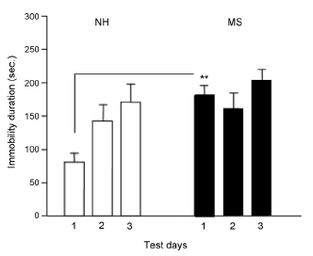
Figure 10. Forced swim test assessed over three test days (postnatal days 62-64). Differences between the maternal separation (MS) group and the control/non-handled (NH) group. (Lee et al, 2007)
In addition to the forced swim test, anhedonia has also been tested after postnatal stress. In rodents, the sucrose preference test is being used to test anhedonia. When rats were daily separated from PND-2-21, for 3 hours a day(Aisa et al, 2007) an interaction was found between rearing condition (control or MS) and sucrose intake. Although all animals showed a preference for sucrose, MS rats consumed significantly less sucrose water compared to the control group.

Prenatal stress in humans may lead to sleep disturbances, for example prenatal stress increased the time of REM sleep, similar to patterns observed in depressive patients. Maternal separation (3 hours a day) from postnatal days 2 to 14 leads also affects sleep in male rats. Maternal separation lead to an increase of baseline REM sleep levels in male rats compared to control (Tiba et al, 2004). When performing maternal separation in female rats no effect on baseline REM sleep was found (Tiba et al, 2008). However, MS in females did cause a significant stress-induced (cold-water stress) REM sleep rebound during the nighttime period. Together these results show that both males and females are affected by MS as seen with sleep disturbances. Tang et al (2005) suggested that an increase in REM and sleep in general, after exposure to stress, may play a role in the process to recover from stress. These increases in REM sleep may reflect adaptive processes in rodents as they cope with environmental challenges. If this hypothesis is valid, maternally separated female rats are more able to use REM/sleep in general as a recovery mechanism from stress. Or female maternally separated rats need more sleep to recover from the same stress as control rats (Tiba et al, 2008).

Biochemical findings
During maternal separation there is an increase in plasma corticosterone and ACTH levels of rats (Daniels et al, 2009). This can be seen as evidence for the fact that maternal separation is a strong stressor for neonatal rats. During adulthood, prenatally stressed rats show an increased HPA axis response after being exposed to a stressor (Daniels et al, 2009). In response to an acute stressor, MS (180 minutes, PND 2-21) rats showed an increase in plasma corticosterone and ACTH levels compared to control (figure 11) (Aisa et al, 2007).
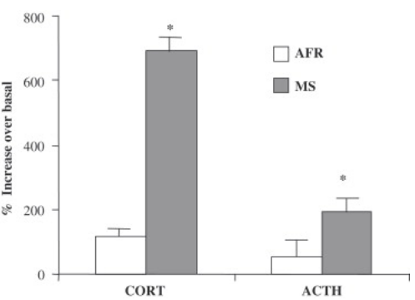

Figure 11. HPA axis activity, measured by corticosterone and ACTH levels in bloodplasma. Effects of maternal separation (MS) and control (AFR) on HPA activity after an acute stressor (15 minute swim stress). The increase is measured over basal levels of stress (Aisa et al, 2007).
In the same study the distribution of glucocorticoid receptor protein was also studied. MS rats have a lower hippocampal glucocorticoid receptor density compared to control (Aisa et al, 2007). These results are in line with the so called glucocorticoid cascade hypothesis (Sapolsky et al, 1986). The hippocampus plays, via the high density in glucocorticoid receptors, a major role in the negative regulation of the HPA axis. The hypothesis suggests that the elevated level of corticosterone leads to hippocampal neuronal loss and therefore glucocorticoid receptor loss. The loss of glucocorticoid receptors causes a decrease in negative regulation of the HPA axis, which leads to a further increase in glucocorticoid levels. Therefore, the hyper activation of the HPA axis after a stressor may attribute to the impaired glucocorticoid-mediated negative feedback, which is normally mediated by hippocampal glucocorticoid receptors (Aisa et al, 2007).
However, some contradictory results were found on HPA axis activity after MS. Van Oers et al (1998) performed a 24 hour separation from PND-3 to 4, and exposed the rats to a mild stressor on PND 20 (saline injection). In response on this stressor MS rats showed an increase blood plasma in ACTH secretion. However, when shifting the separation to PND 11 to 12, a decrease in ACTH response was observed. Therefore they concluded that the timing and period of maternal separation may have a differential impact on HPA axis activity as a response to stress.

Because a dysregulation of 5-HT is implicated in various psychiatric disorders, such as depression and anxiety, the 5-HT system has also been studied after MS. When rats were exposed to maternal separation for 3 hours daily from postnatal day 1 to 14 this resulted in a significant decrease in 5-HT concentration in the hippocampus of MS rats compared to control rats. It is known that 5-HT release in the hippocampus is involved in the regulation of the HPA-axis. As mentioned before, the hippocampus has a negative feedback on the HPA axis activity. Exposure to an increase in 5-HT can elevate the mRNA levels of the glucocorticoid receptor in hippocampal neurons. So the decrease of 5-HT seen in MS, may cause a lack of negative regulation on the HPA axis activity and thereby result in the hyper activation of this system after MS (Lee et al, 2007).
Most of the 5-HT neurons are localized in the raphe nuclei. In the same study of Lee et al (2007) a decrease in serotonin reuptake transporter (5-HTT) in the raphe nucleus of MS rats was shown. This transporter is responsible for the reuptake of 5-HT from the synaptic cleft after release, and as a result, this reuptake will inhibit the 5-HT release. The level of 5-HTT can therefore be altered by the 5-HT level, as a feedback loop. Thus, decreased levels of 5-HTT may be influenced by a decrease in hippocampal 5-HT levels. And it has been shown in studies using photon emission computed tomography (SPECT) that humans suffering from depression have a decreased binding of 5-HTT in the raphe nuclei. For that reason the decrease in 5-HTT seen in the raphe nucleus of MS rats may (partly) cause the depression-like behavior also seen in rats after maternal separation.

As mentioned before, maternal separation may lead to depressive-like behavior. It is suggested that neuropeptide Y (NPY) acts with high potency on a common core mechanism of emotionality and behavioral stress responses (Heilig M, 2004). NPY is decreased in plasma and CFS of patients with depression. And also in genetic animal models for depression these decreases in hippocampal NPY expression are being found (Heilig M, 2004). Maternal separation of 6 hours a day from postnatal days 2 to 6 and from postnatal days 9 to 13, leads to changes in NPY expression in different brain regions. In the hypothalamus there was a significant increase in NPY in both sexes. On the other hand, in the dorsal hippocampus there was a significant decrease in NPY in both sexes. And in the prefrontal cortex only female MS rats showed a significant decrease in NPY. The decrease in hippocampal concentrations of NPY are in line with the same alterations of NPY concentrations in genetic models for depression (FSL rat). Thus, maternal separation has an influence on the NPY concentrations, with region specific alterations which may be involved in the development of the depressive-like behavior after MS (Jimenez-vasques et al, 2001).

Neurotrophic factors, such as nerve growth factor (NGF), play a fundamental role in brain development by acting on proliferation, survival and neurochemical differentiation of neurons in the peripheral and central nervous system (Cirulli et al, 2000). To investigate whether this system is altered by MS, Cirulli et al (2000) performed an experiment using a 1 and 3 hour separation on postnatal day 9 or 16. On postnatal day 9, rats with 1 and 3 hour separation showed a significant increase in NGF expression in the dentate gyrus and hypothalamus compared to controls. On postnatal day 16, 3 hour separation influenced the NGF expression significantly in the hypothalamus and dentate gyrus (figure 12). Even in the frontal cortex an effect of the 3 hour treatment was shown, but this was not a significant effect. The same effects are seen with the one hour separation, but they were not as strong (figure 12).
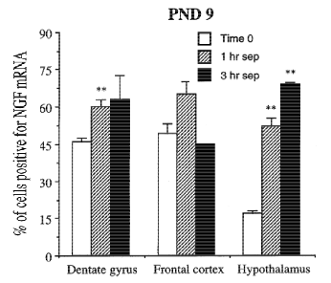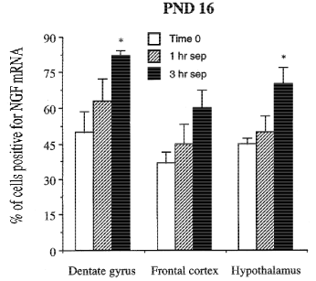
Figure 12. Comparison between the results of 1 and 3 hour MS and control between postnatal day 9 and 16. Measured in three brain regions; dentate gyrus, frontal cortex and hypothalamus. (Cirulli et al, 2000).

Several studies have found that maternal separation resulted in alterations in glutamate release of adult rats. Daily 3 hours of maternal separation from postnatal day 11 to 14 led to a selective decrease in glutamate release in the ventral hippocampus. This brain region is known for its function in memories related to stress and emotions (Marrocco et al, 2012). Thus, MS had effects on glutamate release, however it failed to affect the inhibitory neurotransmission system (GABA) in the same brain region. Because of this, there is an imbalance between excitatory and inhibitory neurotransmission in the ventral hippocampus. This imbalance might contribute to the anxiety/depressive-like behavior of rats due to MS. To examine whether the relationship between the reduced glutamate release and anxiety-like behavior is causal, Marrocco et al (2012), performed a study in which glutamate release was pharmacologically stimulated. This enhancement of glutamate release in the ventral hippocampus reversed the anxiety-like behaviors normally seen in MS rats. It is unknown how MS causes the dysfunction in glutamate release in this specific brain area. More studies are necessary to investigate whether the hyperactivity of the HPA-axis might play a role in this (Marrocco et al, 2012).

Postnatal stress also causes long-lasting changes during development of the fetus/neonatal rat. There are changes in anxiety and depression-like behavior and in the sleep cycle of rats after maternal separation. On the biochemical level, several alterations were found; changes in HPA axis activity as response to a stressor, 5-HT levels, neuropeptide Y and nerve growth factor. All the postnatal stress experiments and their results are summarized in table 2.

Postnatal stress
Time period | Model (maternal separation=MS; Early deprivation=ED) | Protocol | Results
Postnatal days 2 to day 14 | MS | Sessions of 3 hours a day | ↑ Anxiety-like behavior^{8,44}
Postnatal days 1-14 | MS | Sessions of 3 hours a day | No difference in anxiety ¹⁸
Postnatal days 2-14 | MS | Sessions of 3 hours a day | ↑ Depression-like behavior (behavioural despair) ²⁴
Postnatal days 2-21 | MS | Sessions of 3 hours a day | ↑ Depression-like behavior (anhedonia) ¹
Postnatal days 2-14 | MS | Sessions of 3 hours a day | Sleep disturbances ^{50,51}
Postnatal days 1-14 | MS | Sessions of 3 hours a day | ↓ hippocampal 5-HT & ↓ 5-HTT in raphe nucleus ²⁴
Postnatal days 2-21 | MS | Sessions of 3 hours a day | ↑ Corticosterone and ACTH levels as response to stressor & ↓ hippocampal glucocorticoid receptor ¹
Postnatal days 3-4 | MS | 24-hours | ↑ACTH as response to stressor⁵⁶
Postnatal days 11-12 | MS | 24-hours | ↓ ACTH as response to stressor⁵⁶
postnatal days 2 to 6 and from postnatal days 9 to 13 | MS | Sessions of 6 hours a day | ↓ NPY in hippocampus and hypothalamus ²²
Postnatal day 9 or 16 | MS | Session of 1 or 3 hours | Changes in expression of NGF⁶
Postnatal day 11-14 | MS | Sessions of 3 hours a day | ↓ glutamate release ³¹
Table 2. Summary results of postnatal stress experiments. All the experiments are performed in rats.

Effects of maternal behavior

Cirulli et al (2000) speculated about the fact that the results of maternal separation experiments may not be due to the separation procedure per se, but rather to specific changes in, or lack of, maternal behavior. In the next section the effects of maternal behavior on the results of pre-and postnatal stress experiments will be discussed.
Prenatal stress
In prenatal stress experiments, dams are exposed to prenatal stressed for a defined period of time. After giving birth the pups stay with their mother and are weaned around the 21st day after birth. The pups are then left undisturbed mostly until the age of 4 months. After this age the behavioral and/or biochemical tests are performed.
However, when using this protocol the pups do not only experience prenatal stress but also experience suckling from a previous stressed mother. So it is possible that stress during pregnancy could have altered the hormonal balance of the dam and thereby it may have its effects on lactation and maternal care (Maccari et al, 2003). This may have a big effect on the outcomes of the experiments. Long-lasting effects in the mother are found after a period of restraint stress. For example, prenatal stressed mothers showed an increase in anxiety-like behavior during the lactating period indicating that the effects are lasting for the mother (Maccari et al, 2003).
The influence on maternal behavior and/or lactation is supported by cross-fostering experiments. In such experiments, PS rats are fostered by control mothers (non-stressed dams), to prevent the influence on the pup of having a previous stressed mother. By performing cross-fostering experiments, Cabrera et al (1999) showed that fostering of PS rats to control mothers prevented the long-lasting effects on body weight, motor activity and emotionality.
In line with this, Maccari et al (2003) showed that PS rats with stressed mothers displayed higher plasma corticosterone levels than those of control rats after 120 minutes of novelty exposure. But when PS rats were fostered by control dams, their corticosterone levels were at the same levels as control rats after 120 minutes (figure 13).
These results suggest that probably the combination of prenatal stress and suckling from a previously stressed mother may induce long-lasting changes in for example emotional regulation or HPA axis activity (Cabrera et al, 1999).
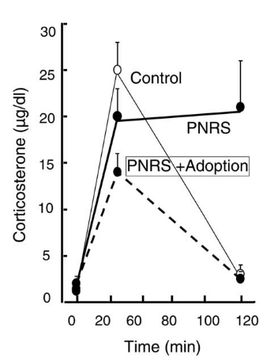
Figure 13. Corticosterone levels of control rats (adult rats 4-7 months), prenatally stressed rats with stressed mothers and prenatally stressed rats with non-stressed mothers. As a response on novelty expose from 0 to 120 minutes. (Cabrera et al, 1999)

Postnatal stress - Maternal separation
Being separated from their mother during the first weeks after birth causes a stress response in neonatal rats (Daniels et al, 2009). This stress response is believed to cause several changes in for example neurotransmitter systems and anxiety-like behavior (Daniels et al, 2009). But another potential factor which may contribute to these effects of maternal separation is the amount of maternal care. Especially the maternal licking and grooming towards the pup, following separation. In a normal situation there is a variation in the amount of maternal care, both within the litter and among dams. After separation there is an increase in maternal care for the pup, this increase may function as a buffer against the enhanced HPA axis reactivity, because an increase in maternal care is associated with a decrease of corticosterone response to stress in adult rats ( Liu et al, 1997). Tata (2012) speculated that the corticosterone response of MS rats when exposed to stress as adults may be mediated by the amount of maternal care received during the postnatal period.
In line with this is the fact that the positive effects of postnatal early handling may be mediated by effects of maternal care. Sapolsky (1997) showed that the amount of maternal care almost doubled after an early handling procedure. These maternal behaviors were associated with reduced plasma ACTH and corticosterone responses to restraint stress in adult offspring.
These results suggest that the behavioral and biochemical changes seen after maternal separation could be caused by the amount of maternal care and not specifically the separation itself.

Conclusion and discussion
Emotional state and behavior of the mother may affect the child she is carrying. Nowadays there are lots of factors which can alter the emotional state of the mother, and have influence on the fetus. One of the factors which is a major part of current society is stress. The bureau of Vital records and health statics revealed that more than a quarter of the pregnant woman experience high levels of stress during pregnancy. Known is that prenatal stress is a risk factor for adverse birth outcomes, such a low birth weight and prematurity (March of dimes, 2010). The main goal of this report was to investigate whether there is a specific critical period for stress during pregnancy. To answer this question, findings of existing literature have been summarized. The focus was on behavioral- and biochemical effects, in specific time periods in the gestation of rodents. This report showed that prenatal stress, mostly performed during the last week of gestation, can cause multiple changes in anxiety-and depression-like behavior, HPA axis activity, sleep wake cycle and in several neurotransmitter systems (table 1). Changes in various systems are also observed after postnatal stress, mostly performed from PND 2-14 (this timescale may vary). This may lead to alterations in anxiety-and depression-like behavior, sleep disturbances, HPA axis activity, NPY level, NGF expression and to changes in neurotransmitter systems (table 2).
Taken together prenatal and postnatal stress can both cause behavioral and biochemical changes in rodents. There is not only one specific period in pregnancy where the fetus is vulnerable to stress. It also depends on the parameters that are accessed, because every system in the brain has its own specific period of maximum development, for example the dendritic development, neurogenesis and apoptosis of the hippocampal granule cells is at his maximum at postnatal days 5 to 7 (Huot et al, 2000). This means there is a specific period in brain development where a system is more vulnerable to stress, depending on their specific development. However, as the brain is plastic, stress during the entire pregnancy may have an effect in different brain regions. During pregnancy the fetus is partly protected against elevated maternal stress levels by a placental enzyme called hydroxystroid dehydrogenase type 2 (11β-HSD2), which converts cortisol to the inactive cortisone. At the end of the pregnancy the activity of this enzyme decreases so that the organs, such as lungs and central nervous system, of the fetus can mature (Ma et al, 2003). Welberg et al (2005) showed that an acute stressor will lead to an increase in 11β-HSD2, to protect the fetus. But chronic stress (restraint stress) does not affect the 11β-HSD2 levels, therefore the fetus is not protected against the restraint stress. This study also showed that the capacity to adapt placental 11β-HSD2 activity in response to an acute stressor was greatly reduced by previous exposure to chronic stress (Welberg et al, 2005). Therefore, the 11β-HSD2 protection system may be not efficient when exposed to chronic stress during the pregnancy.

It should be noted that there are inconsistencies among reports. There are differences regarding gender, reports and timescale of stress procedure. Conflicting results were found in several reports when investigating the same behavior. They may be due to the time period at which the stress is applied, but even when this time period is similar differences were present. The differences in results of males and females are also notable. Some studies found a greater effect of PS or MS on males, others on females or both. This may be partly due to differences in the procedures across studies (for example nature and duration of stressor or stress challenges later in life). However, research of Weinstock (2007) suggests that genders may differ in the sensitivity of developing brain areas to stress hormones. Another important factor is the effect of maternal care. Prenatal stress may have its influence on the mother during lactation period, such as changes in maternal behavior and/or lactation. These changes may play a role in the effects seen after the prenatally stressed offspring (Maccari et al, 2003). Sapolsky (1997) showed that the amount of maternal care almost doubled after an early handling procedure. In line with this, when performing cross-fostering experiments, Cabrera et al (1999) showed that fostering of PS rats to control mothers prevented the long-lasting effects of body weight, motor activity and emotionality. Therefore the effects seen in MS rats may also partly be due to the changes in maternal behavior

It is hard to translate these results directly to humans because there are differences in brain development. A recommendation for future research is to change the type of stressors being used in animal studies. They could try to designs prenatal stress studies with stressors that may be encountered in human pregnancy. Stressors like daily hassles or social stress may provide more relevant and comparable results for human studies. Another recommendation for future research is to investigate the role of coping of the mother and its effects of prenatal stress in the offspring. Genetic studies are more and more used to shed light on the genetic contribution to individual sensitivity of infants for exposure to prenatal stress, in future research this may play a bigger role.

References
- Aisa B, Tordera R, Lasheras B, Del Rio J, Ramirez M.J. 2007. Cognitive impairment associated to HPA axis hyperactivity after maternal separation in rats. Psychoneuroendocrinology. 32(3):256-66.
- Barbazanges A, Piazza P.V, Le Moal M, Maccari S. 1996. Maternal glucocorticoid secretion mediates long-term effects of prenatal stress. The journal of neuroscience. 16(12): 3943-3949
- Basta-Kaim A, Szczesny E, Glombik K, Slusarczyk J, Trojan E, Tomaszewski K.A, Budziszewska B, Kubera M, Lason W. 2014. Prenatal stress leads to changes in IGF-1 binding proteins network in the hippocampus and frantal cortex of adult male rat. Neuroscience. Aug 22; 274;59-68.
- Bayer S.A, Altman J, Russo R.J, Zhang X. 1993. Timetables of neurogenesis in the human brain based on experimentally determined patterns in the rat. Neurotoxicology. 14(1): 83-1440
- Cabrera R.J, Rodríguez-Echandía E.L, Jatuff A.S, Fóscolo M. 1999. Effects of prenatal exposure to a mild chronic variable stress on body weight, preweaning mortality and rat behavior. Braz J Med Biol Res. 32(10):1229-37.
- Cirulli F, Alleva E, Antonelli A, Aloe L. 2000. NGF expression in the developing rat brain: effects of maternal separation. Brain Res Dev Brain Res. 123(2):129-34.
- Clancy B, Darlington R.B, Finlay B.L. 2001. Translating developmental time across mammalian species. Neuroscience. 105:7-17.
- Daniels W.M, Pietersen C.Y, Carstens M.E, Stein D.J. 2004. Maternal separation in rats leads to anxiety-like behavior and a blunted ACTH response and altered neurotransmitter levels in resonse to a subsequent stressor. Metabolic brain disease. 19(1-2):3-14.
- Daniels W.M, Fairbairn L.R, van Tilburg G, McEvoy C.R, Zigmond M.J, Russel V.A, Stein D.J. 2009. Maternal separation alters nerve growth factor and corticosterone levels but not the DNA methylation status of the exon 1(7) glucocorticoid receptor promotor region. Metab Brain Dis. 24(4): 615-27.
- D’Aquila P.S, Newton J, Willner P. 1997. Diurnal variation in the effect of chronic mild stress on sucrose intake and preference.Physiol. Behav. 62: 421–426.
- Day J.C, Koehl M, Deroche V, Le Moal M, Maccari S. 1998. Prenatal stress enhances stress- and corticotropin-releasing factor-induced stimulation op hippocampal acetylcholine release in adult rats. Journal of Nueroscience. 18(5): 1885-92.
- Ferreira A.J. 1965. Emotional factors in prenatal environment. A review. J Nerv Ment Dis. 141(1): 108-18.
- Frye C.A, Wawrzycki J.A. 2003. Effect of prenatal stress and gonadal hormone condition on depressive behaviors of female and male rats. Hormones and behavior. 44:319-326.
- Hayashi A, Nagaoka M, Yamada K, Ichitani Y, Miake Y, Okado N. 1998. Maternal stress induces synaptic loss and developmental disabilities of offspring. International Journal of Developmental Neuroscience. 16: 209–216.
- Heilig M. 2004. The NPY system in stress, anxiety and depression. Neuropeptides. 38(4): 213-24.
- Henry C, Guegant G, Cador M, Arnauld E, Arsaut J, Le Moal M, Demotes Mainard J. 1995. Prenatal stress in rats facilitates amphetamine-induced sensitization and induces long-lasting changes in dopamine receptors in the nucleus accumbens. Brain Research. 685:179–186.
- Huizink A.C, Mulder E.J, Buitelaar J.K. 2004. Prenatal stress and risk for psychopathology: speciﬁc effects or induction of general susceptibility? Psychol. Bull. 130, 115–142.
- Hulshof H.J, Novati A, Sgoifo A, Luiten P.G, den Boer J.A, Meerlo P. 2011. Maternal separation decreases adult hippocampal cell proliferation and impairs cognitive performance but has little effect on stress sensitivity and anxiety in adult Wistar rats. Behav Brain Res. 216(2):552-60.
- Huot R, Ladd C.O, Plotsky P.M. 2000. Maternal deprivation, in Encyclopedia of stress. New York, academic Press. P699-707.
- Huot R.L, Plotsky P.M, Lenox R.H, McNamara R.K. 2002. Neonatal maternal separation reduces hippocampal mossy fiber density in adult Long Evans rats. Brain Research. 950(1-2): 52-63.
- Imperato A, Puglisi-Allegra S, Casolini P, Angelucci L. 1991. Changes in brain dopamine and acetylcholine release during and following stress are independent of the pituitary-adrenocortical axis. Brain Res. 538(1):111-7.
- Jimenez-vasques P.A, Mathe A.A, Thomas J.D, Riley E.P, Ehlers C.L. 2001. Early maternal separation alters neuropeptide Y concentrations in selected brain regions in adult rats. Brain Res Dev Brain Res. 131(1-2):149-52.
- Lambas-senas L, Mnie-Filali O, Certin V, Faure C, Lemoine L, Zimmer L, Haddjeri N. 2009. Functional correlates for 5-HT(1A) receptors in maternally deprived rats displaying anxiety and depression-like behaviors. Prog Neuropsychopharmacol Biol Psychiatry. 33(2): 262-8.
- Lee J.H, Kim H.J, Kim J.G, Ryu V, Kim B.T, Kang D.W, Jahng J.W. 2007. Depressive behaviors and decreased expression of serotonin reuptake transporter in rats that experienced neonatal maternal separation.
- Liu D, Diorio J, Tannenbaum B, Caldji C, Francis D, Freedman A, Sharma S, Pearson D, Plotsky P.M, Meaney M.J. 1997. Maternal care, hippocampal glucocorticoid receptors, and hypothalamic-pituitary-adrenal responses to stress. Science. 277:1659-1662.
- Llorens-Martin M, Torres-Aleman I, Trejo J.L. 2009. Mechanisms mediating brain plasticity: IGF1 and adult hippocampal neurogenesis. Neuroscientist. 15(2):134-48.
- Ma X.H, Wu W.X, Nathanielsz P.W. 2003. Gestation-related and betamethasone-induced changes in 11beta-hydroxysteroid dehydrogenase types 1 and 2 in the baboon placenta. Am J Obstet. Gynecol. 188: 13-21.
- Maccari S, Darnaudery M, Morley-Fletcher S, Zuena A.R, Cinque C, Van Reeth O. 2003. Prenatal stress and long-term consequences: implications of glucocorticoid hormones. Neuroscience and Biobehavioral Reviews. 27; 119–127
- Malison R.T, Price L.H, Berman R, van Dyck C.H, Pelton G.H, Carpenter L, Sanacora G, Owens M.J, Nemeroff C.B, Rajeevan N, Baldwin R.M, Seibyl J.P, Innis R.B, Charney D.S. 1998. Reduced brain serotonin transporter availability in major depression as measured by [123I]-2 beta-carbomethoxy-3 beta-(4-iodophenyl)tropane and single photon emission computed tomography. Biol Psychiatry. 44(11):1090-8.
- March of Dimes, Stress and Prematurity: Quick References and Fact Sheets, 2010. Available on 21-12-2014, source: http://www.marchofdimes.com.
- Marrocco J, Mairesse J, Ngomba R.T, Silletti V, Van Camp G, Bouwalerh H, Summa M, Pittaluga A, Nicoletti F, Maccari S, Morley-Fletcher S. 2012. Anxiety-like behavior or prenatally stressed rats is associated with a selective reduction of glutamate release in the ventral hippocampus. J Neurosci. 32(48):17143-54.
- McCormick C.M. Kehoe P, Kovacs S. 1998. Corticosterone release in response to repeated, short episode of neonatal isolation: evidence of sensitization. International Journal of Developmental Neuroscience. 16(3-4): 175-185.
- McNamara F.N, Clifford J.J, Tighe O, Kinsella A, Drago J, Fuchs S. 2002. Phenotypic, ethologically based resolution of spontaneous and D2-like vs D1-like agonist-induced behavioural topography in mice with congenic D3 dopamine receptor “knockout.” Synapse. 46: 19–31.
- Meaney M.J, Viau V, Aitken D.H, Bhatnagar S. 1988. Stress-induced occupancy of translocation of hippocampal glucocorticoid receptors. Brain Res. 445:198-203.
- Merlot E, Couret D, Otten W. 2008. Prenatal stress, fetal imprinting and immunity. Brain, behavior and immunity. 22(1): 42-51.
- Morley-Fletcher S, Darnaudery M, Koehl M, Casolini P, Van Reeth O, Maccari S. 2003. Prenatal stress in rats predicts immobility behavior in the forced swim test. Effects of a chronic treatment with tianeptine. Brain Research. 989; 246-251.
- Mulder E.J, Robles de Medina P.G, Huizink A.C, Van den Bergh B.R, Buitelaar J.K, Visser G.H. 2002. Prenatal maternal stress: Effectson pregnancy and the (unborn) child. Early Hum Dev 70(1/2):3–14.
- New health guide. When is a woman most fertile? 2014. Avaliable on 21-12-2014, source http://www.newhealthguide.org/When-Is-A-Woman-Most-Fertile.html
- Pechtel P, Pizagalli D.A. 2011. Effects of early life stress on cognitive and affective function: an integrated review of human literature. Psychopharmacology. 214:55-70.
- Pellow S, Chopin P, File S.E, Briley M. 1985. Validation of open: closed arm entries in an elevated plus-maze as a measure of anxiety in the rat. Journal of Neuroscience Methods. 14(3): 149-167.
- Peters D. A. 1986. Prenatal stress: Effect on development of rat brain serotonergic neurons. Pharmacology, Biochemistry and Behavior. 24:1377–1382.
- Porsolt R.D, Le Pichon M, Jalfre M. 1977. Depression: A new animal model sensitive to antidepressant treatments. Nature. 266: 730-732.
- Russo V.C, Gluckman P.D, Feldman E.L, Werther G.A. 2005. The insulin-like growth factor system and its pleiotropic functions in the brain. Endocr Rev. 26(7):916-43.
- Salzberg M, Kumar G, Supit L, Jones N.C, Morris M.J, Rees S, O’Brien T.J. 2007. Early postnatal stress confers enduring vulnerability to limbic epileptogenesis. Epilepsia. 48(11):2079-85.
- Sapolsky R.M, Krey L.C, McEwen B.S. 1986. The neuroendocrinology of stress and aging: the glucocorticoid cascade hypothesis. Endocr Rev. 7(3):284-301.
- Sapolsky R.M. 1997. The importance of a well-groomed child. Science. 277:1620–1621.
- Takahashi L.K, Kalin N.H, Barksdale C.M, Van den burgt J.A, Brownfield M.S. 1988. Stressor controllability during pregnancy influences pituitary-adrenal hormone concentrations and analgesic responsiveness in offspring.Physiology & Behavior. 42 (4): 323-329.
- Tang X, Yang L, Sanford L.D. 2008. Rat strain differences in freezing and sleep alterations associated with contextual fair. Sleep. 28(10): 1235-44.
- Tata D.A. 2012. Maternal separation as model of early stress: effects on aspects of emotional behavior and neuroendocrine function. Hellenic Journal of Psychology. 9: 84-101.
- Tiba P.A, Tufik S, SUchecki D. 2004. Effects of maternal separation on baseline sleep and cold stress-induced sleep rebound in adult wistar rats. Sleep. 27(6):1146-53.
- Tiba P.A, Tufik S, Suchecki D. 2008. Long lasting alteration in REM sleep of female rats submitted to long maternal separation. Physiology & behavior. 93: 444-452.
- Ward I.L, Weisz J. 1984. Differential effects of maternal stress on circulating levels of corticosterone, progesterone, and testosterone in male and female rat fetuses and their mothers. Endocrinology 114:1635–1644.
- Vallee M, Mayo W, Dellu F, Le Moal M, Simon H, Maccari S. 1997. Prenatal stress induces high anxiety and postnatal handling induces low anxiety in adult offspring: correlation with stress-induced corticosterone secretion. Journal of Neuroscience. Apr 1;17(7):2626-36.
- Van Reeth O, Dugovic C, Koehl M, Weibel L, Maccari S. 1999. Hormonal and behavioral effects of prenatal stress: focus on circadian rhythms and sleep. Journal of sleep-wake research. 39-50.
- Van den hove D.L, Kenis G, Brass A, Opstelten R, Rutten B.P.F, Bruschettini M, Blanco C.E, Lesch K.P, Steinbusch H.W, Prickaerts J. 2013. Vulnerability versus resilience to prenatal stress in male and female rats; Implications from gene expression proﬁles in the hippocampus and frontal cortex. European Neuropsychopharmacology . 23, 1226–1246
- Van Oers H.J. de Kloet E.R, Levine S. 1998. Early vs. late maternal deprivation differentially alters the endocrine and hypothalamic responses to stress.Brain Res Dev Brain Res. 111(2): 245-52.
- Weinstock M, Poltyrev T, Schorer-Apelbaum D, Men D, McCarty R. 1998. Effect of prenatal stress on plasma corticosterone and catecholamines in response to footshock in rats. Pysiol Behav. 64(4):439-44.
- Weinstock M. 2001. Alterations induced by gestational stress in brain morphology and behaviour of the offspring. Prog. Neurobiol. 65, 427–451.
- Weinstock M. 2007. Gender differences in the effects of prenatal stress on brain development and behaviour. Neurochem Res. 32(10):1730-40.
- Welberg L.A.M, Thrivikraman K.V, Plotsky P.M. 2005. Chronic maternal stress inhibits the capacity to up-regulate placental 11β-hydroxysteroid dehydrogenase type 2 activity. J Endocrinol. 186: 7-12.
- Yang J, Han H, Cao J, Li L, Xu L. 2006. Prenatal stress modiﬁes hippocampal synaptic plasticity and spatial learning in young rat offspring. Hippocampus 16: 431-436

