Date: 10-04-2017

Supervisor: Sylvia Notenboom
Inge A.M. de Graaf

Department: Department of Pharmacokinetics, Toxicology and Targeting
BSEP inhibited induced cholestasis and its rescue mechanisms
Which efflux transporters take over the function of the inhibited Bile Salt Export Pump (BSEP/ABCB11)? does this rescue mechanism prevent from intrahepatic cholestasis?

Lotte van LeeuwenS | S2750805 | Pre-master Medical Pharmaceutical Sciences

2017

Abstract

Cholestasis is a complicated, often drug-induced disease that can be triggered by inhibition of the Bile Salt Export Pump (BSEP) transporter. Often used drugs like birth control pills are due to their estrogen rich compounds the instigator in this problem. The present literature study is focused on drug-induced cholestasis caused by inhibition of BSEP. Possible rescue mechanisms, in this case other efflux transporters, will be evaluated on their ability to prevent drug-induced cholestasis. BSEP is the biggest transporter of amidated bile acids and stimulates bile acid dependent bile flow. When BSEP is inhibited, the amidated bile acid transport is shut down. The transport can be taken over by MRP2 or BCRP on the canalicular membrane, or by MRP1, MRP3, MRP4 or OSTα/β on the sinusoidal membrane. For the decrease in hepatotoxicity, MRP4 or OSTα/β seems to be a good option. Both have an amidated substrate specificity and are upregulated in case of cholestasis. This however will result in a movement of the toxic environment from the hepatocyte to elsewhere in the body. Concluding that these two transporters despite their lowering of the toxic state in the liver, can not restore the bile flow and can therefore not prevent from intrahepatic cholestasis. To maintain a proper bile flow, the BCRP transporter on the canalicular membrane is important. The BCRP transporter has transport activity for both the amidated- and conjugated- form of bile acids. BCRP is the only option for the transport of amidated bile acids into the bile ducts to restore bile flow. Due to its low distribution of this transporter in the liver it is not able to completely take over BSEP function. For the same reason, BCRP is not able to prevent from intrahepatic cholestasis. However, if in the future 17β-estradiol induced BCRP overexpression in the hepatocyte shows to be effective, this could be part of a a rescue mechanism for intrahepatic cholestasis. Besides the bile acid transporters there are also other factors of interest, named molecular interactions. These molecular interactions can induce cholestasis, and therefore should too be treated against.

List of abbreviations

ABC transporter: ATP binding cassette transporter
AhR: aryl hydrocarbon receptor
AhRE: aryl hydrocarbon response element
ARE: antioxidant – responsive element
BCRP: breast cancer resistance protein
BSEP: bile salt export pump
E₂17βG: estradiol
ERE: estrogen response element
FXR: farnesoid X receptor
GR: glucocorticoid receptor
GSH: glutathione
HBAB: hepatic bile acid-binding protein
HRE: hypoxia response element
Keap1: actin-kelch-like-ECH-associated protein 1
Lrh-1: liver receptor homolog-1
mEH: microsomal epoxide hydrolase
NFκβ: active nuclear factor κβ subunit response element
Nrf2: NF-E2-related factor
NTCP: Na⁺-taurocholate co-transporting polypeptide
PRE: progesterone response element
PPARγ: peroxisome proliferator-activated receptor gamma
PXR: pregnane x receptor
SHP: small heterodimer partner
TJP2: tight junction protein 2
XRE: xenobiotic responsive element
Index
Abstract 2
List of abbreviations 3
Introduction 5
Uptake transporters in general 8
Intracellular bile salt transport 10
Efflux transporters in general 11
Bile acid specific efflux transporters 12
Basolateral transporters 12
MRP1/ABCC1: 12
MRP3/ABCC3: 12
MRP4/ ABCC4: 12
OST α/β / SLC 51A/51B: 13
Canalicular transporters 14
MRP2/ABCC2: 14
BCRP / ABCG2: 15
Collaboration in and between efflux transporters 16
Conclusion / Discussion: 17
References 20

Introduction

Cholestasis is a complicated disease and is often triggered by the inhibition of BSEP. Drugs like birth control pills or other estrogen rich compounds have an adverse side effect of inhibiting BSEP. To get a better insight in how to prevent this adverse side effect or how to diminish the hepatotoxic state, more information must be found out about the mechanisms of the other bile acid efflux transporters in the liver.

Bile acid handling is located in the liver. The liver is an important organ for the uptake of nutrients and has two blood supply routes. The portal vein from the spleen, pancreas and intestines, which provides 75% of the blood volume. This portal blood is rich in nutrients but poor in oxygen. The other route is the hepatic artery, which comes directly from the heart and is oxygen rich, but poor in nutrients. In the liver, the blood of these two veins will mix and when the nutrients are taken up, the blood flows back to the heart through the inferior vena cava. (Holland, 2012)
Bile is the secretory product of the liver and is stored in the gallbladder. During digestion, bile is released from the gallbladder into the small intestine. Due to the amphiphilic character of the bile acids, they can absorb lipids and lipid soluble vitamins. Bile acids are secreted into the intestine, where they are effectively reabsorbed and reused via the enterohepatic circulation. This is a continuous process (Chiang, 2013). The bile acids are reabsorbed by the Na⁺ Bile Salt Cotransporter, this occurs mainly in the ileum. The bile acids are actively transported out of the ileal mucosal cells into the portal blood. They are then taken up by hepatocytes via an isoform of the co-transporter (P. a Dawson, Lan, & Rao, 2009). Production of bile takes place inside the hepatic lobule, and is composed of bile acids, cholesterol, phospholipids, bilirubin, proteins, inorganic ions, glutathione and water (Anwer, 2014). The liver lobule is formed in the shape of a hexagon. In the middle of the lobule lies the central vein, which collects the oxygen- and nutrient poor blood. On the outside of the lobule lies the portal vein, the hepatic vein and the bile duct. The blood flows from the outside of the lobule to the central vein. On the contrary, the bile flows from the inside of the hexagon to the bile ducts on the outside. The different parts of the bile are derived from sinusoidal blood and move via intracellular transport in direction of the efflux transporters to get secreted into the bile ducts. Secretion from the hepatocyte to the bile duct is the rate limiting step in bile formation. Bile acids can be grouped in primary and secondary bile acids. Primary bile acids are synthesized out of cholesterol in the liver, these are cholic acid and chenodeoxycholic acid. Secondary bile acids are made in the intestines by dehydroxylation and are deoxycholic acid, ursocholic acid, ursodeoxycholic acid and lithocholic acid (Anwer, 2014). The most abundant bile acids in human bile are the primary bile acids chenodeoxycholic acid (40%), cholic acid (40%) and secondary bile acids deoxycholic acid (20%) and a trace amount of lithocholic acid (Chiang, 2013).

The different types of bile acids are produced in the liver and can or can not be amidated. Amidated bile acids are bound to taurine or glycine in a ratio of 1:3 (Byrne et al., 2017). The fact that the bile acids are bound makes them stronger acids, which means that they will be less permeable to cell membranes. The amidation is also responsible for a decrease in toxicity (Jones, Alpini, & Francis, 2015). The decrease in hydrophobicity is associated with the decrease in toxicity (Monte et al., 2009). The hydrophobicity of the bile acids, is dependent on the number, position and orientation of the hydroxyl groups. Besides this, the amidation at the C-24 position is important. The hydrophobicity results in an impaired reactivity of the bile acid reactive groups. The amidated and more hydrophilic bile acids are usually not toxic, unless their concentration approaches their critical micellar concentration. Chenodeoxycholic acid and deoxycholic acid have lower critical micellar concentrations then cholic acid. For this reason, they are at any given concentration more toxic (table 1) (Perez & Britz, 2009). Amidated bile acids can be deamidated by bacterial enzymes in the liver (Anwer, 2014).
Table 1: Minimum and maximum values of micellar concentrations in water at 37°C (in mmol/l) for the sodium salts of major bile acids (Monte et al., 2009).
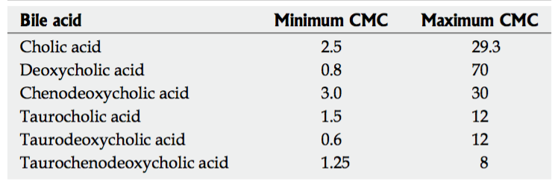

Another type of bile acids are the conjugated bile acids. These are sulfated or glucuronidated and are more important under cholestatic conditions. The glucuronidated bile acids can be exported over the sinusoidal membrane into the blood to go to the kidneys to be excreted. Because of the glucuronide group, the product is easier excreted. Glucuronidated bile acids are present in the liver and the small intestinal mucosa. The glucuronide activity in the liver shows to be twice as high as in the kidney and about two to three times that observed in the small intestinal mucosa. Glucuronide has a high affinity for lithocholic acid (Matern, Matern, Farthmann, & Gerok, 1984). The sulfated conjugates are also able to eliminate bile acids which are then excreted by the kidneys and feces (T. Li & Apte, 2015). The conjugates are under normal physiological circumstances secreted into the bile. However, bile acids with glucuronide- or sulfide- group are not reabsorbed by the ileal transport system and are discarded from the body in the feces (P. A. Dawson & Karpen, 2014). In cholestatic circumstances, when the liver can not cope with the amount of bile acids, the kidney helps with discarding the bile acids.

When there is an impaired bile flow the body suffers from cholestasis. This impaired bile flow leads to increased bile acid concentrations in the liver and the systemic circulation. The low bile flow also leads to shortage of bile in the duodenum. The cause for this stop in bile flow can be divided in two groups; hepatocellular cholestasis (the hepatocytes do not have a sufficient bile flow) or obstructive cholestasis. The latter, obstructive cholestasis is caused by a blockade in the bile tract, e.g. by bile stones or a tumor. In this paper the main focus will lay on the hepatocellular cholestasis. For example due to the imbalance in synthesis or between uptake and efflux of bile acids. Intrahepatic cholestasis can be hormone induced via estrogen. Causes are pregnancy, birth control (drug induced) or anabolic steroids (drug induced). A different kind of hepatocellular cholestasis is neonatal hepatitis. Several bile production mechanisms in newborns are not fully developed yet. This causes an overall decrease in bile. The overall decrease in combination with the still developing liver, which is more susceptive for injury, can lead to a reduction in bile synthesis and bile flow (Osmosis, 2015) (Adams, 2007)(Adams, 2007). Additional forms of intrahepatic cholestasis include primary biliary cirrhosis, a disease which breaks down the bile ducts (Yang & Duan, 2016), and septicaemia, an infection of the blood (Adams, 2007).

In hepatocellular cholestasis is, as just mentioned, the inhibition of the Bile Salt Export Pump (BSEP) very important. For this reason, the present study is focused on Bile Salt Export Pump (BSEP) inhibited cholestasis. Which other hepatocellular transporters take over its function and does this rescue mechanism prevents from intrahepatic cholestasis? Uptake transporters NTCP, OATP1B1, OATP1B3 and OATP1A2 will be evaluated. And the efflux transporters MRP1, MRP2, MRP3, MRP4, OST α/β and BCRP are discussed (Figure 1).

Estrogen, for example, inhibits bile acid secretion by inhibiting the bile salt export pump (BSEP), so the bile acids can not leave the hepatocyte and go into the bile canaliculi. When the bile acids can not leave the cell, it produces a signal for the hepatocyte, to let it know it should inhibit the production of bile acids and should also inhibit bile secretion. Through the inhibition of bile secretion, the total amount of bile acids will accumulate even further. The same happens to another component of the bile, bilirubin. When the high concentrations of bile acids can not leave the cell through BSEP, they find another way, through the blood. Jaundice is caused by a high amount of glucuronidated bilirubin and gives the yellow skin color (Bassari & Koea, 2015) (Köck & Brouwer, 2012). Jaundice is often triggered by inhibited MRP2 or MRP3 (Keppler, 2014). Clinical markers for cholestasis are pale stool, while microbes in the small intestine can not break the bilirubin down to urobilinogen. (Sticova & Jirsa, 2013) During cholestasis there is a lot of bilirubin in the blood. When the blood passes the kidneys, the bilirubin gets filtered out. For this reason, the urine gets darker, also called bilirubinuria. Other clinical markers of cholestasis are the enzymes ALP, 5-NT, ALT, AST and GGT (figure 2). These enzymes are found in increased amounts in the blood when hepatocytes suffer from damage or stress (Osmosis, 2015) (Giannini, Testa, & Savarino, 2005).

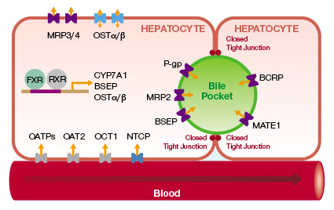
Figure 1: The uptake and efflux transporters of the hepatocyte. (Qualist Transporter Solutions, LLC)

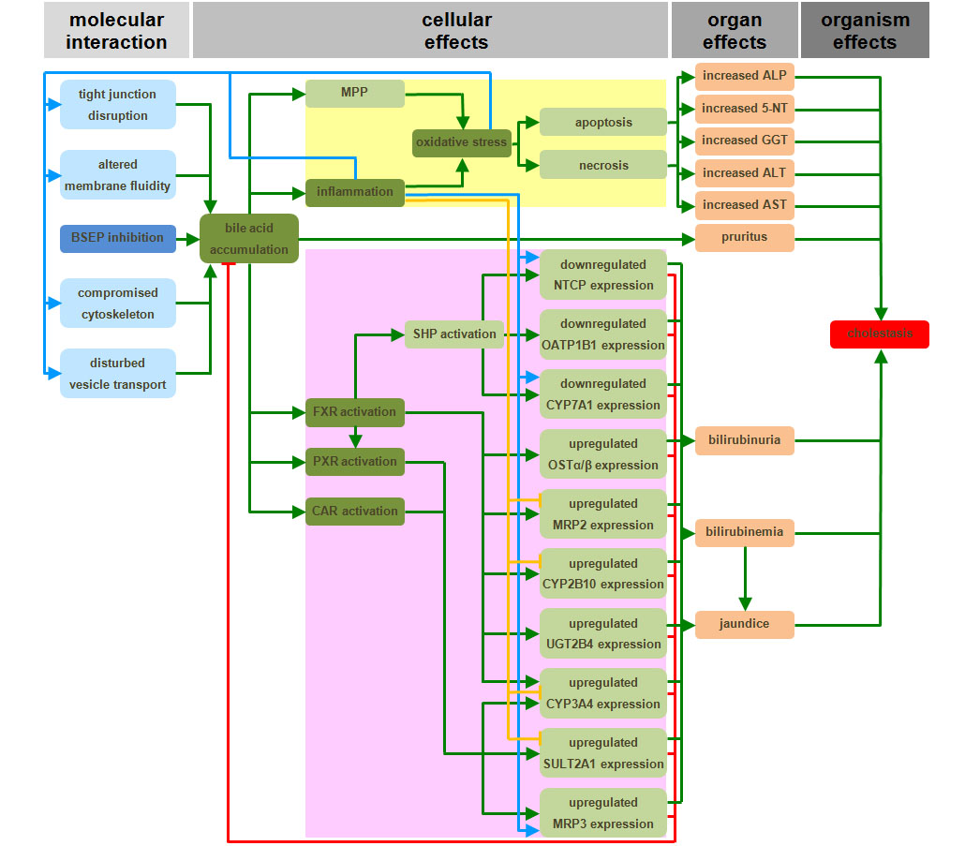
Figure 2: OAP: Cholestatic Liver Injury induced by Inhibition of the Bile Salt Export Pump. (Vinken et al., 2013)

Uptake transporters in general

The gathering of bile acids through uptake transporters mainly occurs from the sinusoidal blood into the periportal hepatocyte. Thus, the concentration gradient is high in the periportal zone and low in the perivenous zone of the hepatocyte. When the cell suffers from cholestasis, this concentration gradient is inverted. Due to the cholestatic condition, all the bile acids accumulate in the perivenous zone of the hepatocyte. This is because they can not leave the hepatocyte through the BSEP efflux transporter that is located here. On the other hand, the uptake of bile acids is inhibited, so the concentration of bile acids in the periportal zone is low. The inverted concentration gradient, together with disrupted tight junctions may lead to the overflow of bile acids from the hepatocyte, into the blood circulation (figure 2)(Kullak-Ublick, Stieger, Hagenbuch, & Meier, 2000).

The uptake is driven by two types of transporters: sodium-dependent and sodium-independent uptake transporters. Sodium-dependent uptake in mainly managed by Na⁺-taurocholate co-transporting polypeptide (NTCP), localized on the hepatic basolateral membrane (Alrefai & Gill, 2007). As the name already suggests, this uptake transporter primarily (>80%) absorbs taurocholic acid. NTCP also in lesser extent absorbs cholic acid uptake (<50%) (Kullak-Ublick et al., 2000). The presence of this uptake transporter is particularly important for the amidated and conjugated bile acids, because these have lowered pH levels. The low pH gives the bile acids a negative charge, making them impermeable for the cell membranes. Whereas unamidated and unconjugated bile salts can use passive diffusion. This Na⁺-dependent polypeptide performs its function through the co-transport of two Na⁺-ions together with one amidated bile acid molecule such as taurocholate (Kullak-Ublick et al., 2000). Microsomal epoxide hydrolase (mEH) is an enzyme located in the plasma membrane of the hepatocyte (Von Dippe, Zhu, & Levy, 2003). The enzyme is capable of mediating sodium-dependent uptake of bile acids (L. Li, Yi, & Lam, 2014). It is thought that mEH is a more capable of glycine-bile acid transport than NTCP. Considering the fact that most of the bile acids are amidated to glycine instead of taurine, there is a good chance that mEH has a bigger uptake of bile acids than NTCP. This was reviewed in (Alrefai & Gill, 2007).

Sodium-independent uptake transporters are accountable for the biggest part of the uncharged bile acid uptake, but also take up amidated bile acids. These transporters, named OATPs, help with the uptake of bile acids in presence of HCO₃⁻ or glutathione (GSH) (Alrefai & Gill, 2007). OATPs that are important for the uptake of bile acids are OATP1B1, OATP1B3 and OATP1A2. OATP1B1 and OATP1B3 are localized on the basolateral membrane and are responsible for the uptake of cholic acid, chenodeoxycholic acid and deoxycholic acid. In case of amidated bile acids, OATP1B1 is responsible for both the amidated forms of cholic acid, chenodeoxycholic acid, deoxycholic acid, ursodeoxycholic acid and lithocholic acid (Suga et al., 2017). The OATP1B1 transporter is expressed over the whole liver lobe, whereas OATP1B3 is only located around the central vein. For both transporters, amidated bile acids were preferred over the not amidated (Suga et al., 2017). OATP1A2 is also localized on the basolateral membrane and is a successful transporter for bile acids taurocholic acid, taurochenodeoxycholic acid and tauroursodeoxycholic acid (Zhou et al., 2015). It is located in the basolateral membrane of the hepatocyte as reviewed in Alrefai & Gill, 2007. The affinities of the three sodium-independent uptake transporters are put together in table 2.

Table 2: Affinities of three sodium-independent uptake transporters.
+: transported but Km was not determined, NT: no significant transport was observed.
(Zhou et al., 2015), (Suga et al., 2017).
Bile acids | OATP1B1 | OATP1B3 | OATP1A2
 | K_{m} | K_{m} | K_{m}
 | (μM) | (μM) | (μM)
Cholic acid | 47,1 | 42,2 | NT
Glycocholic acid | 14,7 | 15,3 | NT
Taurocholic acid | 10,6 | 9,5 | 60
Chenodeoxycholic acid | + | + | NT
Glycochenodeoxycholic acid | 9,6 | 2,4 | NT
Taurochenodeoxycholic acid | 2,9 | 1,5 | +
Deoxycholic acid | + | + | NT
Glycodeoxycholic acid | 4,6 | 5,6 | NT
Taurodeoxycholic acid | 13,6 | 2,4 | NT
Ursodeoxycholic acid | NT | NT | NT
Glycoursodeoxycholic acid | 2,6 | 11,1 | NT
Tauroursodeoxycholic acid | 5,2 | 8,3 | 19
Lithocholic acid | NT | NT | NT
Glycolithocholic acid | 0,74 | 0,52 | NT
Taurolithocholic acid | 0,84 | 0,47 | NT

Intracellular bile salt transport

In healthy conditions, when the bile acids are taken up by the sodium-dependent or sodium-independent transporters from the sinusoidal blood, they are bound to a cytosolic binding protein named hepatic bile acid-binding protein (HBAB) (Kullak-Ublick et al., 2000). The binding of the bile acid to this protein reduces its toxicity in the cell, something that is favorable for the hepatocyte. Research shows that the HBAB bound bile acids then move to the canalicular membrane (Kullak-Ublick et al., 2000). The vesicle mediated pathway of intracellular trafficking is important when the bile acid concentration is too high in the liver, as in cholestasis (Alrefai & Gill, 2007). The bile acids lithocholic acid and ursodeoxycholic acid seem to be dependent on this kind of intracellular transport (Kullak-Ublick et al., 2000). Once arrived at the canalicular membrane HBAB detaches. The efflux transporters are responsible for the excretion of bile acids into the bile.

Efflux transporters in general

Most of the efflux transporters are members of the ATP binding cassette (ABC) transporter. These ABC transporters are membrane proteins that carry substrates over the membrane when ATP is hydrolyzed. When ATP is bound to the transporter, the conformation is changed so the substrate binding site of the transporter turns to the interior side. Next, hydrolysis of the ATP will change the conformation to the exterior side (Hollenstein, Dawson, & Locher, 2007). The ABC-family is divided in seven subfamilies, ABC-A to ABC-G. This division is based on sequence similarities. Other efflux transporters belong to the ATPase family (FIC1), which encode for the p-type cation transport and OST α/β which belongs to the organic solute transporter family. The OST transporter is ATP independent and only functions when it is a heterodimer. The efflux transporters in the hepatocytes are mainly responsible for the movement of bile acids or other bile components, drugs and their metabolites out of the cell. The efflux transporters are both localized on the canalicular side and on the basolateral side of the membrane and enable secretion from molecules into the bile and into the circulation, respectively (Köck & Brouwer, 2012).

One very important member of the ATP binding cassette (ABC) transporter is BSEP, which is located on the canalicular membrane. BSEP is the biggest transporter of bile acids and stimulates bile acid dependent bile flow. BSEP transports amidated bile acids with high affinity for taurochenodeoxycholic acid > taurocholic acid > tauroursodeoxycholic acid > glycocholic acid (table 3) (Alrefai & Gill, 2007). Tauro- and glycine- amidated bile acids, also called monovalent bile acids, have one negative charge. The divalent conjugated bile acids are besides amidated also sulphated or glucuronidated and have two negative charges (Thomas, Pellicciari, Pruzanski, Auwerx, & Schoonjans, 2008). When BSEP is inhibited and the amidated bile acid transport is shut down, possibly other bile acid efflux transporters will take over its function to prevent cholestasis.

Table 3: Affinities of BSEP in the human liver.
(Noé, Stieger, & Meier, 2002)
Bile acid | BSEP Km (μM)
Taurocholic acid | 7,9 ± 2,1
Glycocholic acid | 11,1 ± 3,3
Taurochenodeoxycholic acid | 4,8 ± 1,7
Tauroursodeoxycholic acid | 11,9 ± 1,8

Bile acid specific efflux transporters

Basolateral transporters

MRP1/ABCC1:
The MRP1 ATP-dependent efflux transporter is present in low amounts in the liver (König, Nies, Cui, Leier, & Keppler, 1999), it is mainly expressed in bile duct epithelial cells and on the hepatic basolateral membrane (Roelofsen et al., 1999). The transporter has showed to transport conjugated bile acids as sulfated conjugates and glucuronidated conjugates (Sodani, Patel, Kathawala, & Chen, 2012). MRP1 has a preference for sulfated -taurolithocholic acid and -taurochenodeoxycholic acid (Alrefai & Gill, 2007). Differences in transport activity between the physiological state and in case of cholestasis remain unclear. Exact expression of the transporter in hepatocytes is vague, we do know that MRP1 is regulated with Notch1 through CBF1 regulatory site in its promotor in cultured cancer cells (Cho et al., 2011).

As regards to hepatotoxicity, sulfated taurolithocholic acid is a secondary bile acid. Although it is
present in trace amounts, it still is a more toxic bile acid (Chiang, 2013). Due to the taurine group, the bile acid is more hydrophilic, which causes a decrease in toxicity. The sulfate group is important under cholestatic conditions and is able to eliminate the bile acid which is then excreted through the feces (T. Li & Apte, 2015). The taurochenodeoxycholic acid is a primary less toxic bile acid that is present in large amounts in bile. The taurine group ensures an even bigger drop in toxicity (Chiang, 2013).
No other papers about the MRP1 transporter in hepatocytes where available. For this reason, it must be considered that MRP1 is not present in the liver. It is possible that due to cross-reaction with MRP3 antibodies, false results have been obtained about the presence of MRP1 in the liver.

MRP3/ABCC3:
MRP3 is a weakly expressed ATP-dependent transporter in the healthy liver (Trauner & Boyer, 2003) and is predominantly a conjugated bile acid transporter for sulfated taurolithocholic acid and sulfated taurochenodeoxycholic acid (Geier, Wagner, Dietrich, & Trauner, 2007)(Boyer et al., 2006). MRP3 is located on the basolateral membrane of the hepatocyte and is also able to transport amidated cholic bile acids with a low Vmax capacity of 250 pmol/mg membrane protein/ min and a Km of 248 μM (König et al., 1999) (Alrefai & Gill, 2007) (Bodsó, Bakos, Szeri, Váradi, & Sarkadi, 2003). MRP3 has a high resemblance with MRP1, but the affinity of MRP3 for conjugates is lower than that of MRP1 (Sodani et al., 2012). MRP3 has a low Vmax and a low Km, this gives a high affinity for the substrate, but also means a slow process of up-regulation in cholestatic conditions (Bodsó et al., 2003). After up-regulation when MRP3 is expressed in high amounts in the basolateral membrane, the transporter serves as an overflow mechanism and transports bile acids back into the circulation (König et al., 1999). At the same time, bile acid uptake from the blood is inhibited (Trauner & Boyer, 2003).

MRP3 is regulated by fetoprotein transcription factor (FTF) through activation by chenodeoxycholic acid. FTF may be suppressed by CYP8B1 expression, probably through interrupting HNF4α constitutive transactivation (Trauner & Boyer, 2003). The transporter half-life of MRP3 is multiple days, for this reason acute activity changes in the transporter function are thought to be regulated by posttranscriptional regulation. Whereas long term regulation is likely to happen by transcriptional regulatory response (figure 4) (Trauner & Boyer, 2003)

MRP4/ ABCC4:
MRP4 is different from the other MRPs, because this ATP-dependent transporter is a co-transporter for reduced glutathione (GSH) (Rius, Hummel-Eisenbeiss, Hofmann, & Keppler, 2006). This special transporter is located om the basolateral membrane and is in competition with BSEP in the healthy liver. The resemblance between MRP4 and BSEP is large. The affinities (table 3 and table 4) for the bile acids of the two transporters are comparable with the difference that MRP4 is GSH-dependent. A second difference is that MRP4 is not located on the canalicular side. The fact that MRP4 needs GSH for transport, is most likely used as a regulatory mechanism, so the intracellular concentration of bile acids can be controlled (Rius et al., 2006). It is important to keep in mind that MRP4 is only useful when glutathione is present in sufficient amounts.

MRP4 can export bile acids back into the blood in case of hepatotoxicity. These exported bile acids will most likely be excreted in the urine (Rius et al., 2006). Multiple types of bile acids are transported: conjugated bile acids and amidated cholic acid (Gerk & Vore, 2002) (Klaassen & Aleksunes, 2010). Overall sulfated conjugates are preferred (Ballatori et al., 2009). Amidated ursodeoxycholic acid is also transported by MRP4, and will have a protecting function over the liver when suffered from hepatotoxicity of bile acids (Rius et al., 2006).

Table 4:Transport rates and affinities of the MRP4 transporter in presence of 5 mM GSH in the human liver.
(Rius et al., 2006)
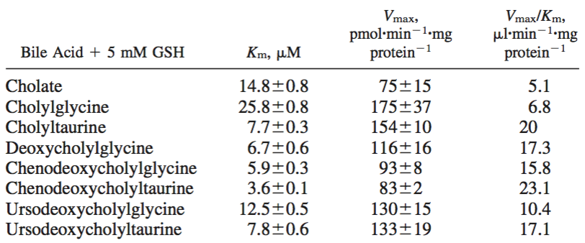

When suffered from cholestasis, MRP4 is upregulated. The two nuclear factors that seem important in this upregulation are aryl hydrocarbon receptor (AhR) and NF-E2-related factor 2 (Nrf2). In cholestasis both MRP4 mRNA and protein expression are higher. (Xu, Weerachayaphorn, Cai, Soroka, & Boyer, 2010) In rodents Nrf2 can be activated to increase expression of hepatic MRP4. The Nrf2 transcription factor is a regulator of cellular redox homeostasis. In a normal situation, Nrf2 is bound to actin-kelch-like-ECH-associated protein 1 (Keap1). As soon as these two are cleaved, Nrf2 moves to the nucleus and binds to a partner protein, often a Maf protein. This heterodimer then binds to antioxidant-responsive elements (AREs) and activates transcription of MRP4 (Xu et al., 2010). The second transcription factor is aryl hydrocarbon receptor (AhR). When AhR is activated, it moves to the nucleus and it forms a heterodimer with ARNT, which binds to xenobiotic responsive element (XRE) and induces transcription of MRP4 (Xu et al., 2010). Nrf2 and AhR are reciprocal, which means that the upregulation of one receptor leads to an decrease in the other receptor (Xu et al., 2010). The existence of this upregulation pathway in humans is not known.

OST α/β / SLC 51A/51B:
OST α/β is a sodium-independent amidated bile acid transporter that is functionally similar to BSEP while they are both trans-activated by FXR (Alrefai & Gill, 2007). The transporter is positively regulated by bile acids (P. a Dawson et al., 2009). Amidated forms of bile acids like cholic acid, chenodeoxycholic acid, deoxycholic acid, ursodeoxycholic acid are thought to be the better OST α/β substrates (Grandvuinet, Vestergaard, Rapin, & Steffansen, 2012). Other amidated bile acids such as lithocholic acid and glyco-amidated lithocholic acid sulfate are inhibitors of the transporter (Grandvuinet et al., 2012). Inhibition of OST α/β through amidated lithocholic acid and glyco-amidated lithocholic acid sulfate could lead to a decrease in the conversion of cholesterol into bile acids. This decreased bile acids synthesis, could lead to a lowering of the cholestatic condition (Rao et al., 2008). There is evidence that OST α/β undergoes adaptive regulation in response to cholestasis. This adaptive regulation is regulated by Fxr. This is a protective mechanism against cholestasis, an upregulation in OST α/β ensures that there is no bile salt accumulation (Boyer et al., 2006). OST α/β mRNA expression and protein expression is induced by Fxr and chenodeoxycholic acid. It requires heterodimerization of FXR with RXR alpha. The heterodimer can than bind to IR-1/FXREs to activate OST gene expression in the presence of bile acids. FXR is the most important regulator, but not the only one. Other transcription factors are responsible for the fine-tuning of the OST α/β expression. These transcription factors include small heterodimer partner (Shp) and liver receptor homolog-1 (Lrh-1) (figure 3) (Ballatori et al., 2009).

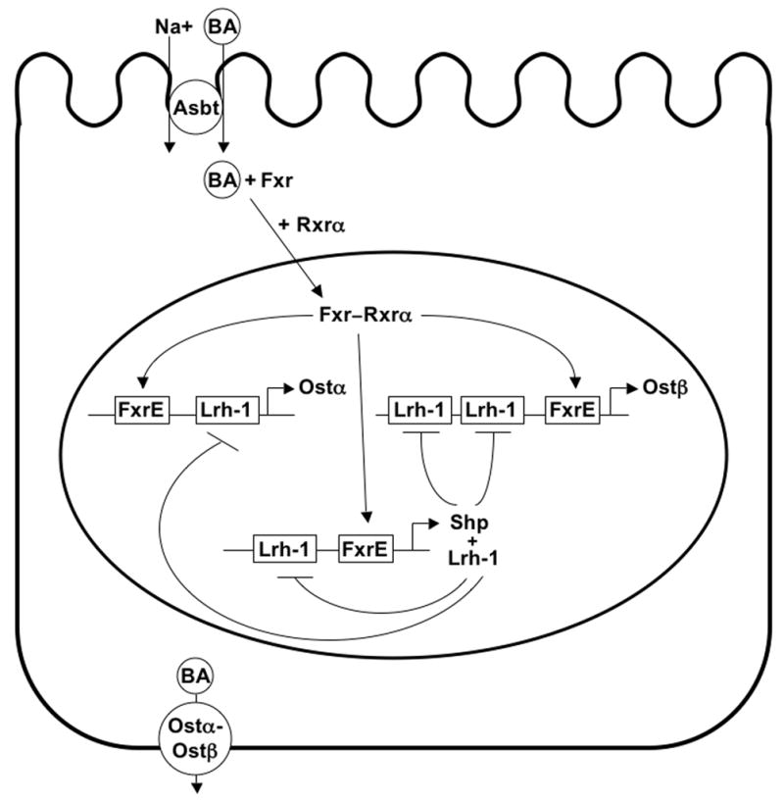
Figure 3: OST α/β regulation. Fxr and chenodeoxycholic acid bind which leads to heterodimerization of Fxr and Rxr alpha. The heterodimer activates OST gene expression in presence of bile acids.
(Ballatori et al., 2009)
Canalicular transporters

MRP2/ABCC2:
The MRP2 transporter is mainly expressed in the apical membrane and is seen as the most important conjugated bile acid transporter in the liver (Bakos et al., 2000). MRP2 helps with the export of conjugated bile acids. It can not transport amidated bile acids like BSEP does (Alrefai & Gill, 2007) (Klaassen & Aleksunes, 2010). Glucuronidated conjugates have MRP2s preference (König et al., 1999). The fact that MRP2 has a high Vmax and a high Km gives it a low affinity but also gives it also the possibility to adapt rapidly when necessary. So, that in case of cholestasis, this conjugated export pump is quickly redistributed into intracellular vesicles by endocytic recurrence (König et al., 1999). It concerns a Vmax of 100 pmol/mg membrane protein/min and a Km of 150 μM for glycocholic acid (Bodsó et al., 2003). The Km of glycocholic acid compared to that of BSEP is much higher, meaning the affinity for the bile acid in MRP2 is extremely low.

The expression of MRP2 can be regulated on transcription level, translation level and posttranscriptional level. Bile acids can inhibit their own synthesis by farnesoid X receptor (FXR)-dependent activation of SHP-1. Additionally, the activation of FXR via bile acids is a signal for transcription of MRP2. Pregnane X receptor (PXR) can also be activated by bile acids, this signal also stimulates transcription of MRP2 and triggers transcription of CYP3A. CYP3A is important in the hydroxylation and detoxification of bile acids. FXR is a heterodimer with RXR and is expressed in tissues where bile acids are transported. Ursodeoxycholic acid and tauroursodeoxycholic acid are weak activators for FXR and stimulators for PXR (figure 4) (Trauner & Boyer, 2003).

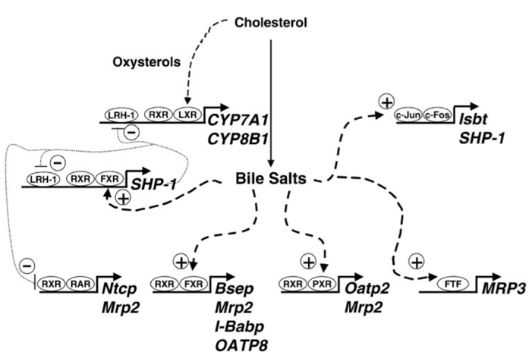
Figure 4: Transcriptional regulation of bile acid synthesis and transport. Bile acids inhibit their own synthesis by activation of SHP-1 via FXR, this suppresses transcription of CYP7A1 and CYP8B1. The uptake transporter Ntcp is suppressed through bile acid inhibition of RAR via the same pathway. BSEP and MRP2 stimulation is regulated through bile acid activation of FXR. PXR activation through bile acids starts the transcription of MRP2. LRH-1 / FTF is involved in MRP3 induction.
(Trauner & Boyer, 2003)

BCRP / ABCG2:
BCRP is an ATP-dependent efflux transporter located on the canalicular membrane and is important for both sulfated and non-sulfated bile acids (Blazquez et al., 2012). To be more precise, BCRP is concerned with transport of amidated- and not amidated cholic acid and sulfated taurolithocholic acid (Blazquez et al., 2012). These cholic acids are present in big amounts, but the BCRP transporter is only expressed in small amounts. To be precise 1:100 compared to BSEP in terms of mRNA. So BCRP does transport bile acids, but its magnitude is extremely low in healthy circumstances (Blazquez et al., 2012). The amount of BCRP transporters expressed in cholestasis is lowered in mice and unknown in humans.

The BCRP expression is regulated at a transcriptional level. The promotor regions of BCRP are called E1A and E1B/C, in which the last one is the most important. E1B/C contains no TATA-box and has multiple SP1 sites. The promotor can be activated and upregulated through several response elements for example the estrogen response element (ERE), the progesterone response element (PRE), the hypoxia response element (HRE), the antioxidant response element (ARE), the aryl hydrocarbon response element (AhRE), peroxisome proliferator-activated receptor gamma (PPARγ) and the active nuclear factor κB subunit (NFκB) response element. Downregulation of the BCRP is possible via the glucocorticoid receptor (GR) (Mao & Unadkat, 2015).

Collaboration in and between efflux transporters

Collaboration between efflux transporters needs to be discussed because these interactions are also important to prevent hepatic toxicity and possibly cholestasis. Collaboration between transporters is found between MRP2 and MRP3. MRP3 has showed to serve as an overflow system when MRP2 is impaired (König et al., 1999). In this way, when MRP2 is inhibited, toxic bile acids can still be transported over the membrane of the hepatocyte, but with a slight difference. Instead of transporting of the bile acids over the canalicular membrane, the bile acids are transported over the basolateral membrane, back into the blood flow, where it might cause pruritus. Besides collaboration, there are some other forms of co-operation to prevent from cholestasis, for example ursodeoxycholic acids and E₂17βG.

The amidated forms of ursodeoxycholic acid where recently discovered to interact with MRP2 in vitro and to activate its transport activity. The amidated forms of ursodeoxycholic acid increase MRP2-mediated transport at low concentrations, but decrease its activity at high concentrations. This is a biphasic affect that is due to competitive inhibition. The bile acids are able to stimulate exocytic insertion of MRP2 into the canalicular membrane and so increasing its transport activity, tauroursodeoxycholic acid seems to be the most effective activator (Gerk & Vore, 2002). The increase in transport activity results in a higher Vmax and a delayed saturation. MRP4 has also showed to transport amidated ursodeoxycholic acid. Similar to the MRP2 transporter, these bile acids are able to have a protecting function over the hepatocyte against the toxicity of bile acids (Rius et al., 2006).

MRP2 transport is also upregulated in presence of E₂17βG. E₂17βG stimulates the co-transport of bile acids and glucoronide conjugates into the bile. E₂17βG stimulates glycochenodeoxycholic acid most effective with two and a half fold stimulation but also stimulates glycocholic acid, taurodeoxycholic acid and taurochenodeoxycholic acid to a lesser extent (Bodsó et al., 2003). The presence of bile acids inhibits E₂17βG transport through MRP3. In comparison to MRP2, MRP3 has a much lower capacity for E₂17βG, but a much higher affinity (Bodsó et al., 2003).

Conclusion / Discussion:
The functions of six efflux transporters have been discussed in detail to estimate their ability to prevent from intrahepatic cholestasis and take over BSEP function.

One of the most well-known bile acid transporter next to BSEP is MRP2. Although MRP2 is a very good bile acid transporter, MRP2 transports only conjugated bile acids (Alrefai & Gill, 2007). The glucuronide- and sulfide- conjugated bile acids are transported into the bile canaliculi to the intestine and are there excreted through the feces. Through excretion, MRP2 can contribute to a decrease in concentration of toxic bile acids. The high Vmax and high Km give the transporter a quick regulation mechanism that can adapt fast when necessary (Bodsó et al., 2003). MRP2 has a high protein abundance in both the healthy liver as in the cholestatic liver (figure 4). In summery this means that MRP2 enables a decrease in conjugated toxic bile acid through excretion. Unfortunately it can not transport the same bile acids as BSEP while BSEP is an amidated bile acid transporter and MRP2 is not. MRP2 will due to this difference in bile acid specificity only take over a very minor part of BSEP bile acid transport.

MRP1, which has a strong substrate resemblance with MRP2 remains to have an unclear function in the liver. What is clear, is that it does not contribute largely to cholestatic conditions, because of its low presence on the basolateral membrane of the hepatocyte (figure 4) and its conjugated character.

MRP3 and MRP4 seem to be the more important ABC family efflux transporters due to their upregulation in cholestatic conditions. The low Vmax and low Km give MRP3 a high affinity for bile acids and slow upregulation during cholestasis (Bodsó et al., 2003). This slow upregulation is disadvantageous while fast progress may be urgent. After up-regulation this partially amidated bile acid transporter is present in high amounts, to serve as an overflow mechanism (König et al., 1999).
To protect the hepatocyte from toxic circumstances, MRP3 is upregulated so transport of bile acids back into the circulation is promoted. At the same time, bile acid uptake from the blood is inhibited (Trauner & Boyer, 2003). The conjugated character of the transporter gives it the possibility to transport bile acids back into the circulation, for urinal excretion (Boyer et al., 2006).

The transported lithocholic acid is very toxic. The bile acid is present in trace amounts and is amidated with a taurine group and conjugated with a sulfate group. This amidation decreases its toxicity. The conjugation makes the bile acid more toxic, but also makes the bile acids more suitable for urinal excretion. Due to the excretion, the exposure to the toxic bile acid is lowered. Even though lithocholic acid is present in trace amounts, for example tenfold accumulation of this bile acid has a far bigger toxic effect then a tenfold accumulation of the already in high amount present cholic acid. The transported sulfated taurochenodeoxycholic acid is present in large quantities, this is a primary bile acid with conjugated groups. Meaning that it is very toxic, but suitable for urinal excretion.

MRP3 is the first transporter we so far discussed that can export amidated bile acids, which might make it suitable as a replacement for BSEP. Unfortunately, MRP3 is not able to excrete the bile acids into the bile ducts, which might make it less suitable for BSEP replacement. This is because while the toxic state due to amidated bile acids in the hepatocyte will be lowered, the bile flow towards the duodenum will still be impaired. Leading to increased bile acid concentrations in the systemic circulation and a shortage of amidated bile acids in the duodenum leading to impaired intestinal functions.

MRP4 has a large resemblance to BSEP while it shares most of its substrates. When MRP3 and MRP4 are compared, MRP4 shows to be the strongest basolateral bile acid transporter and is especially important when biliary secretion is impaired, like in cholestasis (Rius et al., 2006). MRP4 has the same affinities for amidated bile acids as BSEP, therefor this transporter seems to be a good option for BSEP take over. Something that must be considered is the functional place of MRP4 in comparison to BSEP, because while BSEP is located on the canalicular side of the hepatocyte, MRP4 is located on the basolateral side. When MRP4 would take over BSEPs function, the bile acids will not get excreted into the bile ducts, but will be transported into the blood. The hepatotoxic state caused by elevated amidated bile acids in the hepatocyte would temporary be lowered. However the amidated bile acids are not excreted out of the body, because they do not have a sulfate or glucuronide group attached. Further requirements for a proper functionality of the transporter is GSH. When GSH is not available, MRP4 can not exercise its function properly (Rius et al., 2006). MRP4 has in case of glycocholic acid a Vmax higher than MRP2, but lower than MRP3 and a Km lower than both MRP2 and MRP3. This makes MRP4 not extremely fast in adapting to cholestatic conditions, but is does have a high affinity for its substrates.

OST α/β is a second good option for taking over BSEP function, because it also transports amidated bile acids and is upregulated during cholestasis. The transporter is capable of transporting large quantities primary bile acids. Additionally OST α/β is able to transport the more toxic secondary bile acids. These transporter features can possibly protect against hepatocellular toxicity in the human body (Grandvuinet et al., 2012). Furthermore, inhibition of OST α/β through amidated lithocholic acid and glycolithocholic acid sulfate could lead to a decrease in conversion of cholesterol into bile acids. This decreased bile acids synthesis, could lead to lowering the cholestatic condition (Rao et al., 2008). Additionally, the amidated bile acids will be transported into blood circulation instead of the bile ducts. This results in impaired bile flow and increased bile acid concentrations in the systemic circulation.

The BCRP transporter has a confirmed transport activity for both the unamidated, amidated and conjugated form of cholic acid and taurolithocholic acid. The cholic acids are all present in high amounts but are in its physiological concentrations not very toxic to the hepatocyte (Chiang, 2013). However, if during cholestasis the concentrations of these amidated cholic acids are highly upregulated, they can be just as toxic as the taurolithocholic acid. On the contrary, sulfated- and not-sulfated taurolithocholic is present in trace amounts, and is quite toxic (T. Li & Chiang, 2012) (Chiang, 2013). The sulfated conjugates will not be accumulated during BSEP induced cholestasis while these are not transported by BSEP (T. Li & Apte, 2015). Due to the low distribution of this transporter in the healthy liver, an important role in BSEP take over seems unlikely. In mice the BCRP transporter is downregulated during cholestasis (Mennone, Soroka, Harry, & Boyer, 2010). In theory, upregulation of the expression of the BCRP transporter could be an option in the prevention of cholestasis. So to overcome cholestasis drug-induced BCRP overexpression must considered. This overexpression must be specifically targeted to the hepatocytes, to prevent from adverse side effects in other organs. In earlier studies an increase of BCRP mRNA expression was obtained by the binding of 17β-estradiol with an estrogen response element in the BCRP promotor. The increased mRNA expression resulted in an increased BCRP protein expression (Ee, He, Ross, & Beck, 2005). In case of cholestasis, another problem may arise. Both BSEP and BCRP are inhibited through steroids due to the same sensitivity for some substrates. This means that drug-induced BCRP overexpression can only be functional when the 17β-estradiol upregulation is high enough to overcome the steroid inhibition.
(Blazquez et al., 2012).

To contribute to the decrease of cholestasis, the discussed uptake transporters are all downregulated during hepatotoxicity. Consequently, the transport of bile acids from the portal blood to the hepatocyte is diminished. Due to this measure, further accumulation of bile acids in the hepatocyte is prevented (Trauner & Boyer, 2003). The lowering of incoming bile acids decreases the bile flow and thus ensures an increase in the cholestatic state.

So far preventing cholestasis has been a difficult puzzle to solve. Overall, MRP4, OST α/β and BCRP can take over the amidated bile acid transport when BSEP is inhibited by cholestatic drugs. MRP4 and OST α/β have due to a large resemblance and high upregulation the biggest chance on functionally transporting amidated bile acids out of the hepatocyte. So MRP4 and OST α/β are most capable in taking over BSEPs function when it comes to detoxifying the hepatocyte from amidated bile acids. MRP4 and OST α/β do not transport the bile acids into the bile ducts, therefore these two alone can not keep a proper bile flow in the duodenum. Due to the transportation of the bile acids into the systemic circulation, the toxic environment will not be diminished. The toxic environment will only be moved to somewhere else in the body, and will come back to the liver after a while. Concluding that these two transporters despite their temporary lowering of the toxic state in the liver, can not restore the bile flow and can therefore not prevent from intrahepatic cholestasis. Which one of the two transporters is more important is difficult to estimate because no Km values of OST α/β where found. To answer this question, more research is needed. BCRP is the only option for the transport of amidated bile acids into the bile ducts. Therefore it is the best option for maintenance of the bile flow. This makes BCRP despite its low abundance a very important if not one of the most important bile acid transporters in BSEP inhibition. While BCRP does not adapt itself in cholestatic conditions, 17β-estradiol induced BCRP overexpression must considered as a future perspective. To see if 17β-estradiol induced overexpression of the transporter is helpful in cholestasis, further research should be conducted. For BCRP this means that it is not able to completely take over BSEP function, due to its low abundance. For the same reason, BCRP is not able to prevent from intrahepatic cholestasis. However, if in the future 17β-estradiol induced BCRP overexpression shows to be effective, this could help in the battle against intrahepatic cholestasis.
Unfortunately, cholestasis is not only BSEP dependent. That is why it is important to look for the other disease-causing mechanisms behind cholestasis. It is important to know that besides BSEP there also are certain molecular interactions that can lead to cholestasis. These are tight junction disruptions, altered membrane fluidity, compromised cytoskeleton and disturbed vesicle transport (figure 2). This means that upregulation of the BCRP transporter does not automatically means that cholestasis will be prevented. For example, a mutation in the tight junction protein 2 gene (TJP2) which leads to disruption of the tight junction structure, can lead to severe cholestasis (Sambrotta et al., 2014). The underlying mechanism is Claudin-1 which is located in the liver. Claudin-1 normally binds to the biliary canaliculus margins. The protein fails to localize in the absence of TJP2. Resulting in elongated tight junctions. So even though there are enough BCRP transporters that can transport the bile acids out of the hepatocyte, due to a disruption in the tight junction structure, the bile acids in the bile ducts exit the bile ducts via the elongated tight junctions. Upregulation of the BCRP transporter therefore might not increase the bile acid concentration in the bile canaliculi enough to restore the bile flow. Meaning that without extra therapy against the disrupted molecular interactions, cholestasis will most likely not be cured. After all there can be concluded that the cure for cholestasis must be sought in a multiple factor treatment. In which both the BCRP transporter is upregulated and the molecular interactions are taken into account.

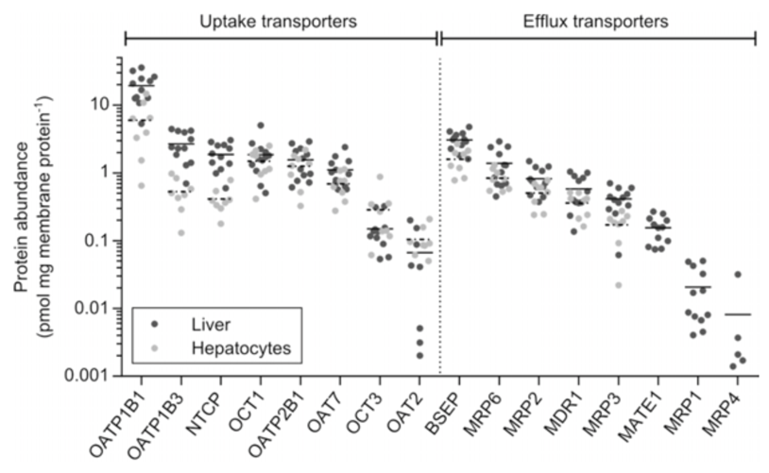
Figure 4: Protein abundance of 16 hepatic human transporters.
(Vildhede, 2015)

References

Adams, D. H. (2007). Sleisenger and Fordtran’s Gastrointestinal and Liver Disease. Gut (Vol. 56). https://doi.org/10.1016/B978-1-4160-6189-2.00095-0
Alrefai, W. A., & Gill, R. K. (2007). Bile acid transporters: Structure, function, regulation and pathophysiological implications. Pharmaceutical Research. https://doi.org/10.1007/s11095-007-9289-1
Anwer, M. S. (2014). Intracellular Signaling By Bile Acids. J Bioscci (Rajshari), 20, 1–23. https://doi.org/10.3329/jbs.v20i0.17647.INTRACELLULAR
Bakos, É., Evers, R., Sinkó, E., Váradi, A., Borst, P., & Sarkadi, B. (2000). Interactions of the human multidrug resistance proteins MRP1 and MRP2 with organic anions. Molecular Pharmacology, 57(4), 760–768. https://doi.org/10.1124/mol.57.4.760
Ballatori, N., Li, N., Fang, F., Boyer, J. L., Christian, W. V, & Hammond, C. L. (2009). OST alpha-OST beta: a key membrane transporter of bile acids and conjugated steroids. Frontiers in Bioscience (Landmark Edition), 14, 2829–44. https://doi.org/10.2735/3416
Bassari, R., & Koea, J. B. (2015). Jaundice associated pruritis: A review of pathophysiology and treatment. World Journal of Gastroenterology, 21(5), 1404–1413. https://doi.org/10.3748/wjg.v21.i5.1404
Blazquez, A. G., Briz, O., Romero, M. R., Rosales, R., Monte, M. J., Vaquero, J., … Marin, J. J. G. (2012). Characterization of the Role of ABCG2 as a Bile Acid Transporter in Liver and Placenta. Molecular Pharmacology, 81(2), 273 LP-283. Retrieved from http://molpharm.aspetjournals.org/content/81/2/273.abstract
Bodsó, A., Bakos, É., Szeri, F., Váradi, A., & Sarkadi, B. (2003). Differential modulation of the human liver conjugate transporters MRP2 and MRP3 by bile acids and organic anions. Journal of Biological Chemistry, 278(26), 23529–23537. https://doi.org/10.1074/jbc.M303515200
Boyer, J. L., Trauner, M., Mennone, A., Soroka, C. J., Cai, S.-Y., Moustafa, T., … Ballatori, N. (2006). Upregulation of a basolateral FXR-dependent bile acid efflux transporter OSTalpha-OSTbeta in cholestasis in humans and rodents. American Journal of Physiology. Gastrointestinal and Liver Physiology, 290(6), G1124-30. https://doi.org/10.1152/ajpgi.00539.2005
Byrne, J. A., Strautnieks, S. S., Mieli–Vergani, G., Higgins, C. F., Linton, K. J., & Thompson, R. J. (2017). The human bile salt export pump: Characterization of substrate specificity and identification of inhibitors. Gastroenterology, 123(5), 1649–1658. https://doi.org/10.1053/gast.2002.36591
Chiang, J. Y. L. (2013). Bile Acid Metabolism and Signaling. Comprehensive Physiology, 3(3), 1191–1212. https://doi.org/10.1002/cphy.c120023
Cho, S., Lu, M., He, X., Ee, P.-L. R., Bhat, U., Schneider, E., … Beck, W. T. (2011). Notch1 regulates the expression of the multidrug resistance gene ABCC1/MRP1 in cultured cancer cells. Proceedings of the National Academy of Sciences of the United States of America, 108(51), 20778–20783. https://doi.org/10.1073/pnas.1019452108
Dawson, P. A., & Karpen, S. J. (2014). Intestinal Transport and Metabolism of Bile Acids. Journal of Lipid Research. https://doi.org/10.1194/jlr.R054114
Dawson, P. a, Lan, T., & Rao, A. (2009). Bile acid transporters. Journal of Lipid Research, 50(12), 2340–57. https://doi.org/10.1194/jlr.R900012-JLR200
Ee, P. L. R., He, X., Ross, D. D., & Beck, W. T. (2005). Modulation of breast cancer resistance protein (&lt;em&gt;BCRP&lt;/em&gt;/&lt;em&gt;ABCG2&lt;/em&gt;) gene expression using RNA interference. Molecular Cancer Therapeutics, 3(12), 1577 LP-1584. Retrieved from http://mct.aacrjournals.org/content/3/12/1577.abstract
Geier, A., Wagner, M., Dietrich, C. G., & Trauner, M. (2007). Principles of hepatic organic anion transporter regulation during cholestasis, inflammation and liver regeneration. Biochimica et Biophysica Acta - Molecular Cell Research, 1773(3), 283–308. https://doi.org/10.1016/j.bbamcr.2006.04.014
Gerk, P. M., & Vore, M. (2002). Regulation of expression of the multidrug resistance-associated protein 2 (MRP2) and its role in drug disposition. J Pharmacol.Exp.Ther., 302(0022–3565 (Print)), 407–415.
Giannini, E. G., Testa, R., & Savarino, V. (2005). Liver enzyme alteration: a guide for clinicians. CMAJ : Canadian Medical Association Journal, 172(3), 367–379. https://doi.org/10.1503/cmaj.1040752
Grandvuinet, A. S., Vestergaard, H. T., Rapin, N., & Steffansen, B. (2012). Intestinal transporters for endogenic and pharmaceutical organic anions: The challenges of deriving in-vitro kinetic parameters for the prediction of clinically relevant drug-drug interactions. Journal of Pharmacy and Pharmacology. https://doi.org/10.1111/j.2042-7158.2012.01505.x
Holland, J. (2012). Liver structure and the flow of blood and bile. Retrieved from https://www.youtube.com/watch?v=P5_BxsbmXcA
Hollenstein, K., Dawson, R. J., & Locher, K. P. (2007). Structure and mechanism of ABC transporter proteins. Current Opinion in Structural Biology. https://doi.org/10.1016/j.sbi.2007.07.003
Jones, H., Alpini, G., & Francis, H. (2015). Bile acid signaling and biliary functions. Acta Pharmaceutica Sinica. B, 5(2), 123–128. https://doi.org/10.1016/j.apsb.2015.01.009
Keppler, D. (2014). The roles of MRP2, MRP3, OATP1B1, and OATP1B3 in conjugated hyperbilirubinemia. Drug Metabolism and Disposition. https://doi.org/10.1124/dmd.113.055772
Klaassen, C. D., & Aleksunes, L. M. (2010). Xenobiotic, Bile Acid, and Cholesterol Transporters: Function and Regulation. Pharmacological Reviews, 62(1), 1–96. https://doi.org/10.1124/pr.109.002014
Köck, K., & Brouwer, K. L. R. (2012). A perspective on efflux transport proteins in the liver. Clinical Pharmacology and Therapeutics, 92(5), 599–612. https://doi.org/10.1038/clpt.2012.79
König, J., Nies, A. T., Cui, Y., Leier, I., & Keppler, D. (1999). Conjugate export pumps of the multidrug resistance protein (MRP) family: localization, substrate specificity, and MRP2-mediated drug resistance. Biochimica et Biophysica Acta (BBA) - Biomembranes, 1461(2), 377–394. https://doi.org/http://dx.doi.org/10.1016/S0005-2736(99)00169-8
Kullak-Ublick, G. a, Stieger, B., Hagenbuch, B., & Meier, P. J. (2000). Hepatic transport of bile salts. Seminars in Liver Disease, 20(3), 273–292. https://doi.org/10.1055/s-2000-9426
Li, L., Yi, T., & Lam, C. W. K. (2014). Inhibition of human efflux transporter ABCC2 (MRP2) by self-emulsifying drug delivery system: Influences of concentration and combination of excipients. Journal of Pharmacy and Pharmaceutical Sciences, 17(4), 447–460.
Li, T., & Apte, U. (2015). Bile Acid Metabolism and Signaling in Cholestasis, Inflammation, and Cancer. In Advances in Pharmacology (Vol. 74, pp. 263–302). https://doi.org/10.1016/bs.apha.2015.04.003
Li, T., & Chiang, J. Y. L. (2012). Bile Acid signaling in liver metabolism and diseases. Journal of Lipids, 2012, 754067. https://doi.org/10.1155/2012/754067
Mao, Q., & Unadkat, J. D. (2015). Role of the Breast Cancer Resistance Protein (BCRP/ABCG2) in Drug Transport—an Update. The AAPS Journal, 17(1), 65–82. https://doi.org/10.1208/s12248-014-9668-6
Matern, S., Matern, H., Farthmann, E. H., & Gerok, W. (1984). Hepatic and extrahepatic glucuronidation of bile acids in man. Characterization of bile acid uridine 5’-diphosphate-glucuronosyltransferase in hepatic, renal, and intestinal microsomes. Journal of Clinical Investigation, 74(2), 402–410. https://doi.org/10.1172/JCI111435
Mennone, A., Soroka, C. J., Harry, K. M., & Boyer, J. L. (2010). Role of Breast Cancer Resistance Protein in the Adaptive Response to Cholestasis. Drug Metabolism and Disposition, 38(10), 1673–1678. https://doi.org/10.1124/dmd.110.034512
Monte, M. J., Marin, J. J. G., Antelo, A., Vazquez-tato, J., Monte, M. J., & Marin, J. J. G. (2009). Bile acids : Chemistry , physiology , and pathophysiology, 15, 804–816. https://doi.org/10.3748/wjg.15.804
Noé, J., Stieger, B., & Meier, P. J. (2002). Functional expression of the canalicular bile salt export pump of human liver. Gastroenterology, 123(5), 1659–1666. https://doi.org/10.1053/gast.2002.36587
Osmosis. (2015). Liver cholestasis - causes, symptoms, diagnosis, treatment & pathology. Retrieved February 6, 2017, from https://youtu.be/wCwKM4H7Ov4
Perez, M. J., & Britz, O. (2009). Bile-acid-induced cell injury and protection. World Journal of Gastroenterology, 15(14), 1677–1689. https://doi.org/10.3748/wjg.15.1677
Rao, A., Haywood, J., Craddock, A. L., Belinsky, M. G., Kruh, G. D., & Dawson, P. A. (2008). The organic solute transporter alpha-beta, Ostalpha-Ostbeta, is essential for intestinal bile acid transport and homeostasis. Proceedings of the National Academy of Sciences of the United States of America, 105(10), 3891–6. https://doi.org/10.1073/pnas.0712328105
Rius, M., Hummel-Eisenbeiss, J., Hofmann, A. F., & Keppler, D. (2006). Substrate specificity of human ABCC4 (MRP4)-mediated cotransport of bile acids and reduced glutathione. American Journal of Physiology - Gastrointestinal and Liver Physiology, 290(4), G640 LP-G649. Retrieved from http://ajpgi.physiology.org/content/290/4/G640.abstract
Roelofsen, H., Hooiveld, G. J., Koning, H., Havinga, R., Jansen, P. L., & Müller, M. (1999). Glutathione S-conjugate transport in hepatocytes entering the cell cycle is preserved by a switch in expression from the apical MRP2 to the basolateral MRP1 transporting protein. Journal of Cell Science, 112 ( Pt 9, 1395–1404. Retrieved from http://www.ncbi.nlm.nih.gov/pubmed/10194418
Sambrotta, M., Strautnieks, S., Papouli, E., Rushton, P., Clark, B. E., Parry, D. A., … Thompson, R. J. (2014). Mutations in TJP2 cause progressive cholestatic liver disease. Nature Genetics, 46(4), 326–328. https://doi.org/10.1038/ng.2918
Sodani, K., Patel, A., Kathawala, R. J., & Chen, Z.-S. (2012). Multidrug resistance associated proteins in multidrug resistance. Chinese Journal of Cancer, 31(2), 58–72. https://doi.org/10.5732/cjc.011.10329
Sticova, E., & Jirsa, M. (2013). New insights in bilirubin metabolism and their clinical implications. World Journal of Gastroenterology, 19(38), 6398–6407. https://doi.org/10.3748/wjg.v19.i38.6398
Suga, T., Yamaguchi, H., Sato, T., Maekawa, M., Goto, J., & Mano, N. (2017). Preference of Conjugated Bile Acids over Unconjugated Bile Acids as Substrates for OATP1B1 and OATP1B3. PLoS ONE, 12(1), e0169719. https://doi.org/10.1371/journal.pone.0169719
Thomas, C., Pellicciari, R., Pruzanski, M., Auwerx, J., & Schoonjans, K. (2008). Targeting bile-acid signalling for metabolic diseases. Nat Rev Drug Discov, 7(8), 678–693. Retrieved from http://dx.doi.org/10.1038/nrd2619
Trauner, M., & Boyer, J. L. (2003). Bile Salt Transporters: Molecular Characterization, Function, and Regulation. Physiological Reviews, 83(2), 633 LP-671. Retrieved from http://physrev.physiology.org/content/83/2/633.abstract
Vildhede, A. (2015). In vitro and in silico predictions of hepatic transporter-mediated drug clearance and drug-drug interactions in vivo.
Vinken, M., Landesmann, B., Goumenou, M., Vinken, S., Shah, I., Jaeschke, H., … Rogiers, V. (2013). Development of an adverse outcome pathway from drug-mediated bile salt export pump inhibition to cholestatic liver injury. Toxicological Sciences, 136(1), 97–106. https://doi.org/10.1093/toxsci/kft177
Von Dippe, P., Zhu, Q. S., & Levy, D. (2003). Cell surface expression and bile acid transport function of one topological form of m-epoxide hydrolase. Biochemical and Biophysical Research Communications, 309(4), 804–809. https://doi.org/10.1016/j.bbrc.2003.08.074
Xu, S., Weerachayaphorn, J., Cai, S.-Y., Soroka, C. J., & Boyer, J. L. (2010). Aryl hydrocarbon receptor and NF-E2-related factor 2 are key regulators of human MRP4 expression. American Journal of Physiology. Gastrointestinal and Liver Physiology, 299(1), G126–G135. https://doi.org/10.1152/ajpgi.00522.2010
Yang, H., & Duan, Z. (2016). Bile Acids and the Potential Role in Primary Biliary Cirrhosis. Digestion, 94(3), 145–153. Retrieved from http://www.karger.com/DOI/10.1159/000452300
Zhou, Y., Yuan, J., Li, Z., Wang, Z., Cheng, D., Du, Y., … Zhang, W. (2015). Genetic Polymorphisms and Function of the Organic Anion-Transporting Polypeptide 1A2 and Its Clinical Relevance in Drug Disposition. Pharmacology, 95(3–4), 201–208. Retrieved from http://www.karger.com/DOI/10.1159/000381313

